1.0 The startup screen looks like the first image below

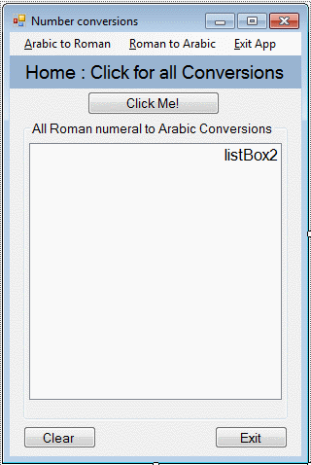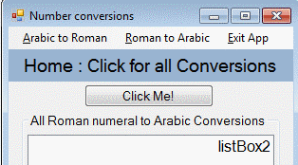

* 1. Clicking Click me, will immediately display 3999 Roman numeral to arabic conversions.
  2. Clicking Arabic to Roman at the top, will open the form below
  3. Clicking Roman to Arabic at the top will display the second form below

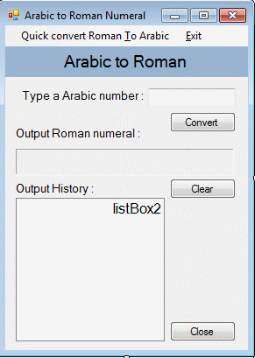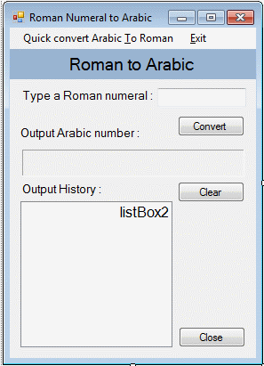

2.1 Clicking where the orange arrows are will open up the forms below

2.2 Enter your conversion in the text box by the blue arrows

2.3 After you type something in, click Convert where the black arrows are

2.4 RED arrows display your output conversion after you click the convert button

2.5 GREEN represents the clear button, which clears all data on that page

2.6 Purple shows the close button, which takes you back to the main menu

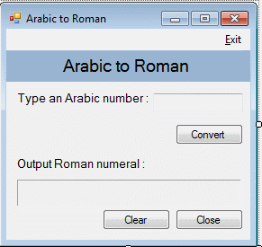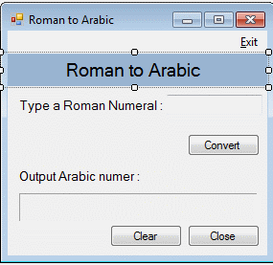

3.0 The two forms above are your quick convert forms, these convert just the same as the other two, however they do not save results after you perform a second conversion

3.1 ORANGE represents a text box, where you can input what you want to convert

3.2 BLACK represents the convert button, you click this after you have typed something in

3.3 RED represents where your conversion will be displayed

3.4 PURPLE represents the clear button, which allows the user to whipe all data from the form

3.5 GREEN represents close, which will take you back to the previous page