Synonyms, Linked Servers and Pass-Through Queries – Monday, November 5, 2018

**Synonyms**

Synonyms are database-level objects that function in much the same way as aliases within a query except that they remain within the database and accessible to queries and stored procedures.

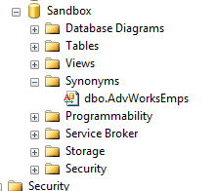Synonyms are actually objects within the database that can be found under their own heading within the database as shown here.

By using the synonym shown to the left, you can shorten the following query and make it more manageable.

select * from AdventureWorks2012.HumanResources.vEmployee;

select * from AdvWorksEmps;

You can create a synonym either through T-SQL or through the SSMS interface.

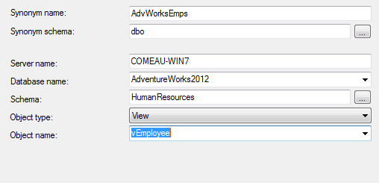CREATE SYNONYM AdvWorksEmps FOR AdventureWorks2012.HumanResources.vEmployee;

You can also right-click on the Synonyms header shown above and create a new object. Once the new synonym is saved, it cannot be altered – only dropped and re-created.

Synonyms should be defined sparingly and well-documented in any database design. Extensive use of synonyms in your code could make it hard to support as other developers will need to refer to the synonym definitions to know where the data is coming from.

For more information, use the following links for reference.

Synonyms (Microsoft Docs)  
<https://docs.microsoft.com/en-us/sql/relational-databases/synonyms/synonyms-database-engine?view=sql-server-2017>

CREATE SYNONYM statement  
<https://docs.microsoft.com/en-us/sql/t-sql/statements/create-synonym-transact-sql?view=sql-server-2017>

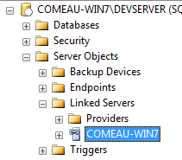**Linked Servers**

Synonyms can actually work across servers but you need a link between the servers to pull data from one server to another. SQL Server enables you to create links between various types of servers including other SQL Servers, Access databases, Excel files, Oracle databases, etc..

The sys.servers data dictionary view shows the servers that are currently accessible from your login.

select * from sys.servers

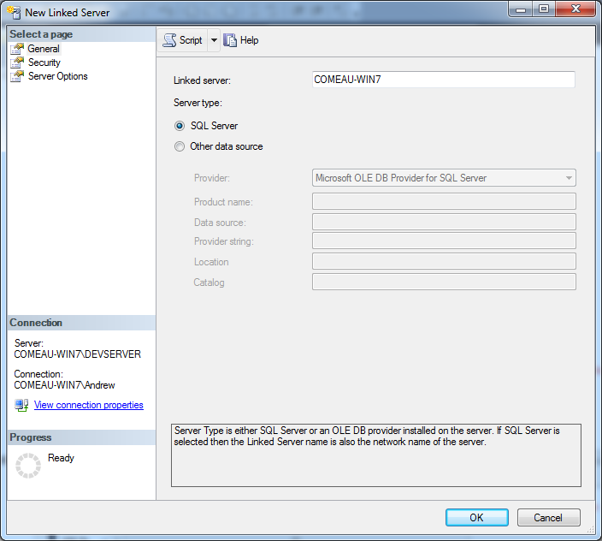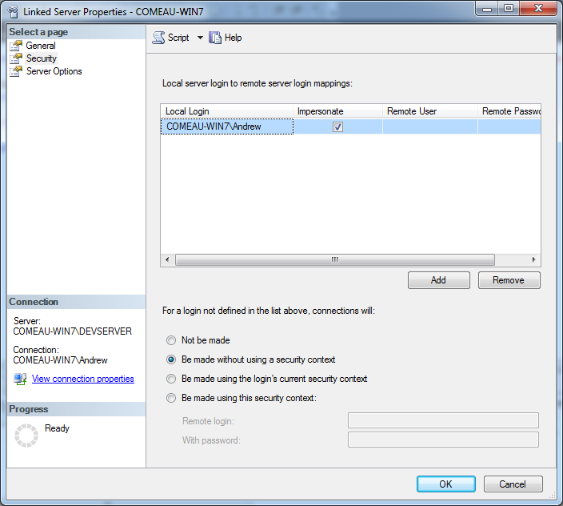The easiest way to create a linked server is to use SSMS. Under the server you want to link from, select Server Object and then Linked Servers as shown in the screenshot above.

The two screenshots to the left show the General and Security tabs of the New Linked Server wizard. Creating a link to another SQL Server is as simple as entering the server name and selecting “SQL Server” on the first page. Then supply a valid login for the linked server under the Security tab.

The system stored procedure sp_addlinkedserver can also be used. See <https://docs.microsoft.com/en-us/sql/relational-databases/system-stored-procedures/sp-addlinkedserver-transact-sql?view=sql-server-2017> for more information.

Once you’ve created the link, you can then run queries across the servers like this:

SELECT [FirstName], [MiddleName] ,[LastName]

FROM [COMEAU-WIN7] .[AdventureWorks2012] .[Person].[vAdditionalContactInfo]

Then you can create a new synonym to point to the resource on the other server as shown in the last section and shorten the query to something like this:

SELECT [FirstName],[MiddleName],[LastName] FROM AdvWorksEmp

Linked servers are also used sparingly since the users have to be mapped on both servers so there are additional security arrangements to manage and keep track of.

**Pass-Through Queries**

A pass-through query is one that is executed directly against a remote database rather than being processed through the database engine from which it originated. Using a pass-through query can improve performance but it is up to the developer to ensure that the syntax is correct since the local database won’t do any kind of filtering.

In SQL Server, the OPENQUERY keyword is used to submit pass-through queries against linked databases. You must have the linked server in place before it will work. A basic SELECT looks like this.

select * from openquery([COMEAU-WIN7], 'select LastName, FirstName from AdventureWorks2012.HumanResources.vEmployee');

It’s also possible to send UPDATE, INSERT and DELETE commands in a pass-through query. For more information, see the Microsoft Docs page.

<https://docs.microsoft.com/en-us/sql/t-sql/functions/openquery-transact-sql?view=sql-server-2017>