Assignment: Library Management System Design
Requirements:
Data Modeling:
- Identify the entities involved in the Library Management System, such as users, books, different copies of a book, authors, loans, fines, book reviews, etc, …
Teams should make analysis and observations from similar systems and come up with their designs.
- Define the attributes for each entity, ensuring that the data model captures all necessary information.
- Establish relationships between entities, considering factors like books and copies, loans and books and users, etc, ...
- Design an Entity-Relationship Diagram (ERD) to visually represent the entities, attributes, and relationships.
Database Design:
- Identify primary and foreign key constraints to maintain data integrity and enforce relationships between entities.
- Select appropriate data types for each attribute to ensure efficient storage and retrieval of data.
- Write SQL statements to create the necessary tables in the database, reflecting your designed schema.
- Provide basic CRUD queries to create, read, update, delete data.
- Populate the tables with representative sample data to simulate a functioning library
- Extra Functionalities:
  - Retrieve all books by a specific author.
  - Retrieve all books published in a specific year or range of years.
  - Retrieve all the expired loans.
  - Create fines for expired loans, and suspend user accounts when the fine is not paid on time.
  - Let users pay for their fines, and reopen their account if needed.
  - Determine the total number of books available in the library.
  - Find the average rating of books based on user reviews.
  - Calculate the number of books by each author.
  - Retrieve the top 10 most borrowed books.
  - Retrieve the latest books added to the library collection.
  - Retrieve all books with their corresponding author information.
  - Retrieve the details of top 10 users who have borrowed the most books.
  - Determine the number of books borrowed by users in a specific age range.
  - Reserve and return copies.
Deliverables:
- Entity-Relationship Diagram (ERD) representing the relationships between entities and attributes in the Library Management System.
- Normalized relational database schema for the Library Management System.
- SQL scripts or queries used to create tables and populate them with sample data in PostgreSQL.
- Documentation describing the indexing strategy, including the selected columns and their impact on query performance.
- Documentation describing the transaction design, scenarios tested, and the observed behavior of transactions.

- ERD(Entity Relationship Diagram)
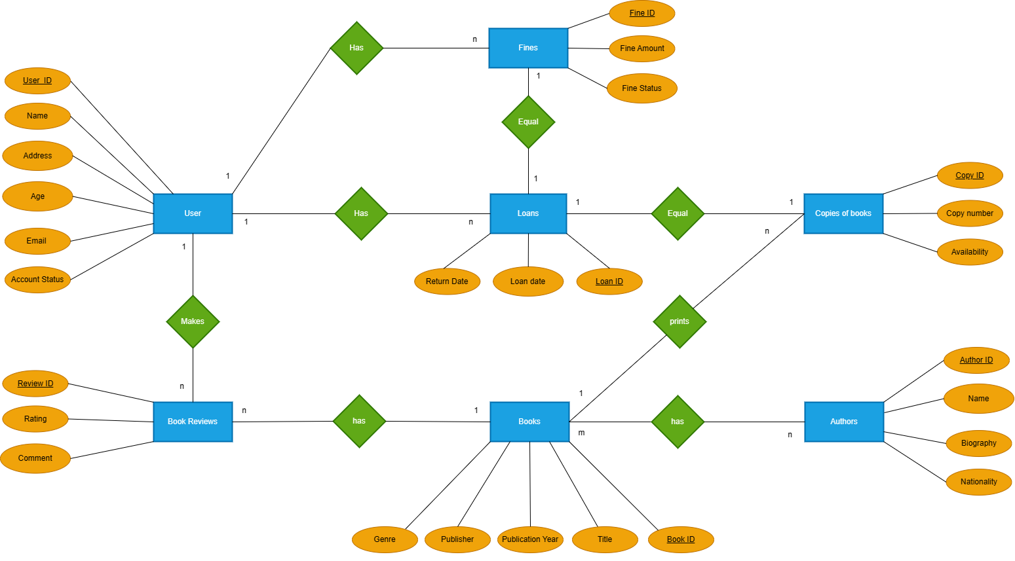

The ER Diagram explains the relationship among the entities present in the database. There are three main types of relationships in a database expressed using cardinality notation in an ER diagram.
- one-to-one.
- one-to-many.
- many-to-one
- many-to-many.

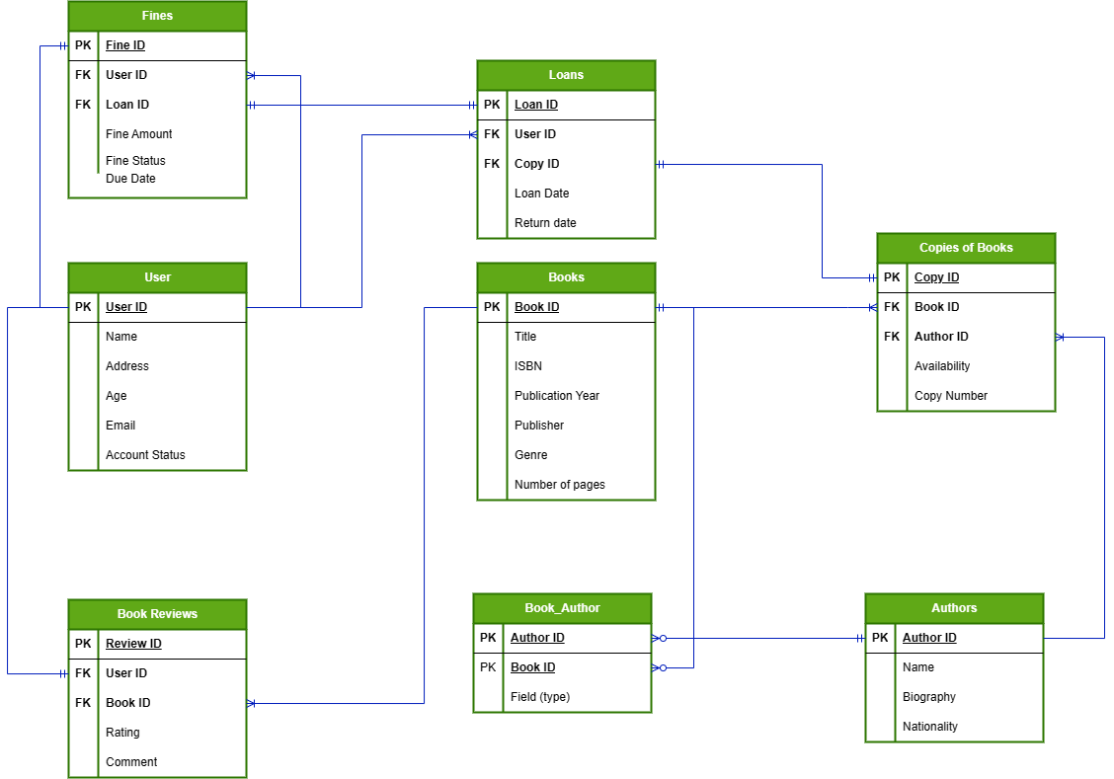

- Database Design
- Identify primary and foreign key constraints to maintain data integrity and enforce relationships between entities.
- Select appropriate data types for each attribute to ensure efficient storage and retrieval of data.
2.1 Write SQL statements to create the necessary tables in the database, reflecting your designed schema.

CREATE TABLE Users (
User_ID INTEGER PRIMARY KEY UNIQUE NOT NULL,
Name VARCHAR(100),
Address VARCHAR(150),
Age SMALLINT,
Email VARCHAR(150),
Account_status VARCHAR(50)
);

CREATE TABLE Books (
Book_ID INTEGER PRIMARY KEY UNIQUE NOT NULL,
Title VARCHAR(100),
ISBN VARCHAR(150),
Publication_year DATE,
Publisher VARCHAR(50),
Genre VARCHAR(50),
Number_of_pages SMALLINT
);

CREATE TABLE Authors (
Author_ID INTEGER PRIMARY KEY UNIQUE NOT NULL,
Author_name VARCHAR(50),
Biography VARCHAR(1500),
Nationality VARCHAR(50)
);

CREATE TABLE Book_reviews (
Review_ID INTEGER PRIMARY KEY UNIQUE NOT NULL,
Rating SMALLINT,
Comment VARCHAR(500),
User_ID INTEGER,
Book_ID INTEGER,
FOREIGN KEY (User_ID) REFERENCES Users(User_ID),
FOREIGN KEY (Book_ID) REFERENCES Books(Book_ID)
);

CREATE TABLE Book_author (
Author_ID INTEGER,
Book_ID INTEGER,
Field varchar(250),
FOREIGN KEY (Author_ID) REFERENCES Authors(Author_ID),
FOREIGN KEY (Book_ID) REFERENCES Books(Book_ID)
);

CREATE TABLE Copies_Of_Books (
Copy_ID INTEGER PRIMARY KEY UNIQUE NOT NULL,
Availability BOOLEAN,
Copy_Number SMALLINT,
Book_ID INTEGER,
Author_ID INTEGER,
FOREIGN KEY (Book_id) REFERENCES Books(Book_id),
FOREIGN KEY (Author_id) REFERENCES Authors(Author_id)
);

CREATE TABLE Loans (
Loan_ID INTEGER PRIMARY KEY UNIQUE NOT NULL,
Started_date DATE NOT NULL,
Returned_date DATE CHECK (Returned_date > Started_date),
Due_date DATE NOT NULL CHECK (Due_date > Started_date),
User_ID INTEGER,
Copy_ID INTEGER,
FOREIGN KEY (User_ID) REFERENCES Users(User_ID),
FOREIGN KEY (Copy_ID) REFERENCES Copies_Of_Books(Copy_ID)
);

CREATE TABLE Fines (
Fine_ID SERIAL PRIMARY KEY UNIQUE NOT NULL,
Fine_amount SMALLINT,
Fine_status VARCHAR(50),
Due_date DATE NOT NULL,
User_ID INTEGER,
Loan_ID INTEGER,
FOREIGN KEY (User_ID) REFERENCES Users(User_ID),
FOREIGN KEY (Loan_ID) REFERENCES Loans(Loan_ID)
);

- Provide basic CRUD queries to create, read, update, delete data.
select * from authors;
select * from book_author;
select * from book_reviews;
select * from books;
select * from copies_of_books;
select * from fines;
select * from loans;
select * from users;

- Populate the tables with representative sample data to simulate a functioning library
insert into authors(author_id, author_name, biography, nationality)
values
('00001', 'Stephen King', 'Stephen Edwin King is an American author of horror, supernatural fiction, suspense, crime, science-fiction, and fantasy novels. Described as the "King of Horror", his books have sold more than 350 million copies as of 2006, and many have been adapted into films, television series, miniseries, and comic books.', 'USA'),
('00002', 'J. K. Rowling', 'Joanne Rowling CH OBE FRSL, best known by her pen name J. K. Rowling, is a British author and philanthropist. She wrote Harry Potter, a seven-volume children''s fantasy series published from 1997 to 2007.', 'UK'),
('00003', 'Dan Brown', 'Daniel Gerhard Brown is an American author best known for his thriller novels, including the Robert Langdon novels Angels & Demons, The Da Vinci Code, The Lost Symbol, Inferno, and Origin. His novels are treasure hunts that usually take place over a period of 24 hours.', 'USA'),
('00004', 'Sam Johnson', 'Sam Johnson was an English playwright, poet and actor. He is regarded as the greatest writer in the English language and the world''s pre-eminent dramatist. He is often called England''s national poet and the "Bard of Avon".', 'Mexico'),
('00005', 'Richardo Eli', 'Richardo Eli was an Italian novelist. Her first novel, The Bluest Eye, was published in 1970. The critically acclaimed Song of Solomon brought her national attention and won the National Book Critics Circle Award.', 'Italy'),
('00006', 'Tina Kojonen', 'Tina Kojonen is a Finnish novelist known primarily for her six major novels, which interpret, critique, and comment upon the British landed gentry at the end of the 18th century. Austen''s plots often explore the dependence of women on marriage in the pursuit of favourable social standing and economic security.', 'Finland'),
('00007', 'Liisa Backman', 'Liisa Backman was a Swedish author of gothic fiction, erotic literature, and Christian literature. She was best known for her series of novels The Vampire Chronicles. The first book became the subject of a film adaptation—Interview with the Vampire.', 'Sweden'),
('00008', 'James West', 'James West was an English writer and social critic who created some of the world''s best-known fictional characters and is regarded by many as the greatest novelist of the Victorian era.', 'England'),
('00009', 'Monica Park', 'Monica Park is an American novelist, short story writer, poet, and social activist. In 1982, she became the first African-American woman to win the Pulitzer Prize for Fiction, which she was awarded for her novel The Color Purple.', 'USA'),
('00100','Elena Niels','Elena Niels was an English romance novelist and actress. She moved to Los Angeles in 1985 and spent most of her career there. She wrote 32 novels, all of which appeared on The New York Times bestsellers list. Her books have sold more than 500 million copies and have been translated into 40 languages. was an English romance novelist and actress. She moved to Los Angeles in 1985 and spent most of her career there. She wrote 32 novels, all of which appeared on The New York Times bestsellers list. Her books have sold more than 500 million copies and have been translated into 40 languages.','England'),
('00101', 'Jane Jerad', 'Jane Jerad is an Italian author of more than 225 romance novels. She writes as J. D. Robb for the In Death series and has also written under the pseudonyms Jill March and for publications in the U.K. as Sarah Hardesty. Roberts was the first author to be inducted into the Romance Writers of America Hall of Fame.', 'Italy'),
('00120', 'Solomon Fineman', 'Solomon Fineman is an American author, YouTuber, podcaster, and philanthropist. His books have more than 50 million copies in print worldwide, including The Fault in Our Stars, which is one of the best-selling books of all time.', 'USA'),
('00121', 'Abraham Newton', 'Abraham Newton was an American journalist, editor, author, playwright, founder of the National Lesbian and Gay Journalists Association, and founding member of the Robert C. Maynard Institute for Journalism Education. In 2005, he was inducted into the NLGJA Hall of Fame.', 'USA'),
('00130', 'Otega Adeyemi', 'Otega Adeyemi is a Nigerian-British popular author of children''s literature and short stories, a poet, and wartime fighter ace. His books have sold more than 300 million copies worldwide. Dahl has been called "one of the greatest storytellers for children of the 20th century".', 'Nigeria');

insert into books(book_id, title, isbn, publication_year, publisher, genre, number_of_pages)
values
('40205660','The little prince','0-7475-3269-9','1943-12-28','Editions Gallimard','novella',100),
('60372276','To Kill a Mockingbird', '978-0-446-31078-9', '1960-12-28', 'Warner Books', 'Fiction', 324),
('80331845','1984', '978-0-451-52493-5', '1949-12-28', 'Signet Classics', 'Dystopian Fiction', 328),
('10507584','The Great Gatsby', '978-0-7432-7356-5', '1925-12-28', 'Scribner', 'Classic Literature', 180),
('70346932','Pride and Prejudice', '978-0-14-143951-8', '1813-12-28', 'Penguin Classics', 'Classic Literature', 352),
('80205644','Harry Potter', '978-1-78110-166-0', '1997-12-28', 'Bloomsbury Publishing', 'Fantasy, Young Adult', 223),
('10474404','The Hobbit', '978-0-618-34625-8', '1937-12-28', 'Houghton Mifflin Harcourt', 'Fantasy', 310),
('70403512','The Catcher in the Rye', '978-0-316-76953-3', '1951-12-28', 'Little, Brown and Company', 'Fiction', 224),
('30427322','To the Lighthouse', '978-0-15-690739-2', '1927-12-28', 'Harcourt Brace & Company', 'Modernist Fiction', 209),
('00428549','The Alchemist', '978-0-06-231500-7', '1988-12-28', 'HarperOne', 'Fiction, Philosophy', 197),
('20541568','The Lord of the Rings', '978-0-618-05784-6', '1954-12-28', 'Houghton Mifflin Harcourt', 'Fantasy', 1178),
('30290362','Moby-Dick', '978-1-85411-008-0', '1851-12-28', 'Wordsworth Editions', 'Adventure Fiction', 544),
('50558152','Brave New World', '978-0-06-085052-4', '1932-12-28', 'Harper Perennial Modern Classics', 'Dystopian Fiction', 288),
('20468105','The Chronicles of Narnia', '978-0-06-023481-2', '1950-12-28', 'HarperCollins', 'Fantasy', 767);

insert into users(user_id, name, address, age, email, account_status)
values
('44006346','Juan','Oresunds Vej 2',22,'juan@gmail.com','Active'),
('44006123','Carlos','Jakobs Vej 21',21,'carlos@gmail.com','Inactive'),
('44006231','Jane','Kungs Vej 13',31,'jane@gmail.com','Active'),
('44005643','Pancho','Jagtvej Vej 56',19,'pancho@gmail.com','Active'),
('44008645','Maria','Aboulevarden Vej 11',28,'maria@gmail.com','Inactive'),
('44007823','Rudy','Blagardsgade 13',29,'rudy@gmail.com','Inactive'),
('44006345','Amalie','Norrebro 14 Vej',28,'amalie@gmail.com','Active'),
('44005678','Elena','Rosenors Alle 28',27,'elena@gmail.com','Active'),
('44009012','Daniele','Isbegata Vej 14',27,'dani@gmail.com','Inactive'),
('44005677','Emma','Norrebro 21 Vej 81',27,'emma@gmail.com','Active'),
('44005675','Niels','Ravnsborgade 11',27,'niels@gmail.com','Active');

insert into copies_of_books(copy_id, availability, copy_number, book_id, author_id)
values
('2002', TRUE, 20, '40205660', '00002'),
('2003', FALSE, 13, '60372276', '00001'),
('2004', TRUE, 11, '80331845', '00003'),
('2005', FALSE, 7, '10507584', '00005'),
('2006', TRUE, 22, '70346932', '00002'),
('2007', FALSE, 18, '10474404', '00003'),
('2008', TRUE, 14, '70403512', '00001'),
('2009', FALSE, 9, '30427322', '00004'),
('2010', TRUE, 10, '00428549', '00005'),
('2011', FALSE, 28, '20541568', '00004');

insert into loans(loan_id, started_date, returned_date, due_date, user_id, copy_id)
values
(1001, '2023-05-01', '2023-05-10', '2023-05-15', '44006346', '2002'),
(1002, '2023-05-02', '2023-05-11', '2023-05-18', '44006123', '2003'),
(1003, '2023-05-03', '2023-05-12', '2023-05-19', '44006231', '2004'),
(1004, '2023-05-04', '2023-05-13', '2023-05-20', '44005643', '2005'),
(1005, '2023-05-05', '2023-05-14', '2023-05-21', '44008645', '2006'),
(1006, '2023-05-06', '2023-05-15', '2023-05-22', '44007823', '2007'),
(1007, '2023-05-07', '2023-05-16', '2023-05-23', '44006345', '2008'),
(1008, '2023-05-08', '2023-05-17', '2023-05-24', '44005678', '2009'),
(1009, '2023-05-09', '2023-05-18', '2023-05-25', '44009012', '2010'),
(1010, '2023-05-10', null, '2023-05-26', '44005677', '2011');

insert into fines(fine_amount, fine_status, user_id, loan_id, due_date)
values
(50, 'Paid', '44006346', '1001', '2023-05-15'),
(30, 'Unpaid', '44006123', '1002', '2023-05-10'),
(20, 'Unpaid', '44006231', '1003', '2023-05-20'),
(15, 'Paid', '44005643', '1004', '2023-06-15'),
(25, 'Unpaid', '44008645', '1005', '2023-05-18'),
(10, 'Paid', '44007823', '1006', '2023-05-15'),
(40, 'Unpaid', '44006345', '1007', '2023-05-12'),
(35, 'Paid', '44005678', '1008', '2023-05-25'),
(5, 'Paid', '44009012', '1009', '2023-05-13'),
(20, 'Unpaid', '44005677', '1010', '2023-05-21');

INSERT INTO Book_reviews (Review_ID, Rating, Comment, User_ID, Book_ID)
VALUES
(1, 4, 'Great book!', 44006346, 40205660),
(2, 5, 'One of my favorites!', 44006231, 60372276),
(3, 3, 'Interesting concept but could be better executed.', 44005643, 80331845),
(4, 5, 'A timeless classic.', 44008645, 10507584),
(5, 4, 'Loved the characters and the romance.', 44007823, 70346932),
(6, 2, 'Not my cup of tea.', 44006345, 10474404),
(7, 5, 'Couldn''t put it down!', 44005678, 70403512),
(8, 4, 'Beautifully written.', 44009012, 30427322),
(9, 5, 'Life-changing.', 44005677, 00428549),
(10, 3, 'Enjoyable but forgettable.', 44005675, 20541568);

INSERT INTO Book_author (Author_ID, Book_ID, Field)
VALUES
('00001', '40205660', 'Fiction'),
('00002', '60372276', 'Mystery'),
('00003', '80331845', 'Science Fiction'),
('00005', '10507584', 'Fantasy'),
('00002', '70346932', 'Mystery'),
('00003', '10474404', 'Science Fiction'),
('00001', '70403512', 'Fiction'),
('00004', '30427322', 'Biography'),
('00005', '00428549', 'Fantasy'),
('00004', '20541568', 'Biography'),
('00008', '30290362', 'Self-Help'),
('00003', '50558152', 'Science Fiction'),
('00100', '20468105', 'History'),
('00101', '20468105', 'History'),
('00120', '20541568', 'Biography'),
('00121', '20541568', 'Biography'),
('00130', '30427322', 'Biography');
- Extra Functionalities
- Retrieve all books by a specific author.
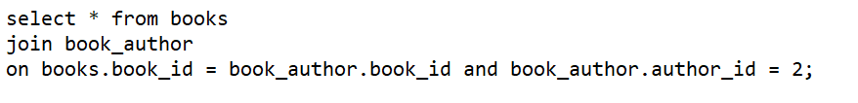

book_id | title | isbn | publication_year | publisher | genre | number_of_pages | author_id | book_id-2 | field
60372276 | To Kill a Mockingbird | 978-0-446-31078-9 | 1960-12-28 | Warner Books | Fiction | 324 | 2 | 60372276 | Mystery
70346932 | Pride and Prejudice | 978-0-14-143951-8 | 1813-12-28 | Penguin Classics | Classic Literature | 352 | 2 | 70346932 | Mystery

- Retrieve all books published in a specific year or range of years.

book_id | title | isbn | publication_year | publisher | genre | number_of_pages
40205660 | The little prince | 0-7475-3269-9 | 1943-12-28 | Editions Gallimard | novella | 100
80331845 | 1984 | 978-0-451-52493-5 | 1949-12-28 | Signet Classics | Dystopian Fiction | 328
10507584 | The Great Gatsby | 978-0-7432-7356-5 | 1925-12-28 | Scribner | Classic Literature | 180
10474404 | The Hobbit | 978-0-618-34625-8 | 1937-12-28 | Houghton Mifflin Harcourt | Fantasy | 310
30427322 | To the Lighthouse | 978-0-15-690739-2 | 1927-12-28 | Harcourt Brace & Company | Modernist Fiction | 209
50558152 | Brave New World | 978-0-06-085052-4 | 1932-12-28 | Harper Perennial Modern Classics | Dystopian Fiction | 288

- Retrieve all the expired loans.

loan_id | started_date | returned_date | due_date | user_id | copy_id
1010 | 2023-05-10 |  | 2023-05-26 | 44005677 | 2011

- Create fines for expired loans, and suspend user account when fine is not paid on time.
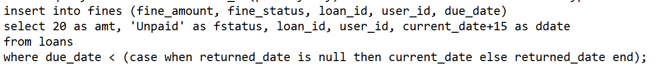
- Let users pay for their fines and reopen their account if needed.
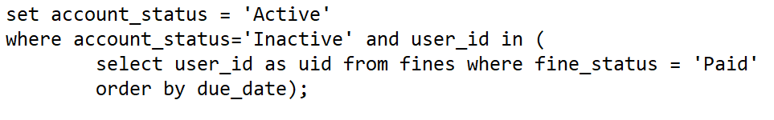

- Determine the total number of books available in the library.
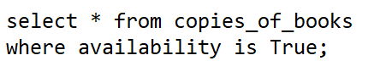

copy_id | availability | copy_number | book_id | author_id
2002 | TRUE | 20 | 40205660 | 2
2004 | TRUE | 11 | 80331845 | 3
2006 | TRUE | 22 | 70346932 | 2
2008 | TRUE | 14 | 70403512 | 1
2010 | TRUE | 10 | 428549 | 5

- Find the average rating of books based on user reviews.
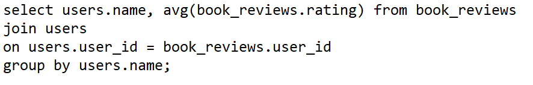

name | avg
Juan | 4
Rudy | 4
Jane | 5
Amalie | 2
Pancho | 3
Elena | 5
Daniele | 4
Emma | 5
Niels | 3
Maria | 5

- Calculate the number of books by each author.
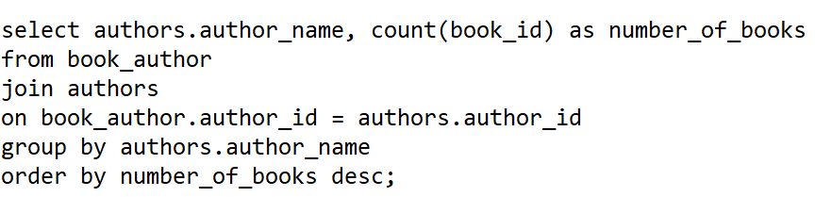

author_name | number_of_books
Dan Brown | 3
Stephen King | 2
Richardo Eli | 2
Sam Johnson | 2
J. K. Rowling | 2
Otega Adeyemi | 1
Elena Niels | 1
Solomon Fineman | 1
Jane Jerad | 1
James West | 1
Abraham Newton | 1

- Retrieve the top 10 most borrowed books.
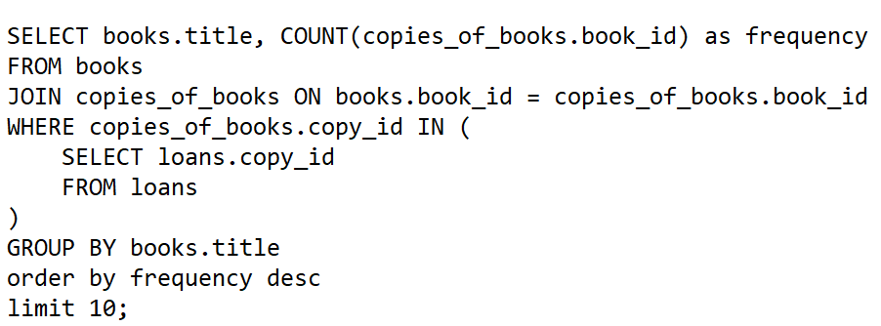

title | frequency
Pride and Prejudice | 1
The Alchemist | 1
1984 | 1
The little prince | 1
To Kill a Mockingbird | 1
The Hobbit | 1
The Catcher in the Rye | 1
To the Lighthouse | 1
The Lord of the Rings | 1
The Great Gatsby | 1

- Retrieve the latest books added to the library collection.
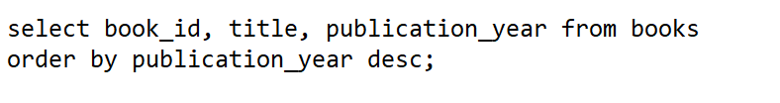

book_id | title | publication_year
80205644 | Harry Potter | 1997-12-28
428549 | The Alchemist | 1988-12-28
60372276 | To Kill a Mockingbird | 1960-12-28
20541568 | The Lord of the Rings | 1954-12-28
70403512 | The Catcher in the Rye | 1951-12-28
20468105 | The Chronicles of Narnia | 1950-12-28
80331845 | 1984 | 1949-12-28
40205660 | The little prince | 1943-12-28
10474404 | The Hobbit | 1937-12-28
50558152 | Brave New World | 1932-12-28
30427322 | To the Lighthouse | 1927-12-28
10507584 | The Great Gatsby | 1925-12-28
30290362 | Moby-Dick | 1851-12-28
70346932 | Pride and Prejudice | 1813-12-28

- Retrieve all books with their corresponding author information.
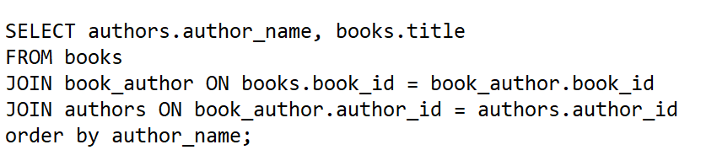

author_name | title
Abraham Newton | The Lord of the Rings
Dan Brown | The Hobbit
Dan Brown | Brave New World
Dan Brown | 1984
Elena Niels | The Chronicles of Narnia
J. K. Rowling | Pride and Prejudice
J. K. Rowling | To Kill a Mockingbird
James West | Moby-Dick
Jane Jerad | The Chronicles of Narnia
Otega Adeyemi | To the Lighthouse
Richardo Eli | The Alchemist
Richardo Eli | The Great Gatsby
Sam Johnson | The Lord of the Rings
Sam Johnson | To the Lighthouse
Solomon Fineman | The Lord of the Rings
Stephen King | The little prince
Stephen King | The Catcher in the Rye

- Retrieve the details of top 10 users who have borrowed the most books.
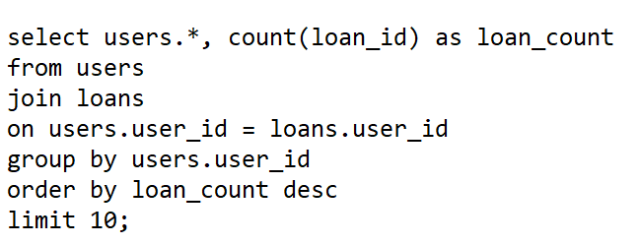
- Determine the number of books borrowed by users in a specific age range.
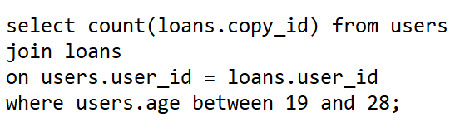

user_id | name | address | age | email | account_status | loan_count
44007823 | Rudy | Blagardsgade 13 | 29 | rudy@gmail.com | Inactive | 1
44006346 | Juan | Oresunds Vej 2 | 22 | juan@gmail.com | Active | 1
44006231 | Jane | Kungs Vej 13 | 31 | jane@gmail.com | Active | 1
44005677 | Emma | Norrebro 21 Vej 81 | 27 | emma@gmail.com | Active | 1
44006123 | Carlos | Jakobs Vej 21 | 21 | carlos@gmail.com | Inactive | 1
44009012 | Daniele | Isbegata Vej 14 | 27 | dani@gmail.com | Inactive | 1
44006345 | Amalie | Norrebro 14 Vej | 28 | amalie@gmail.com | Active | 1
44005643 | Pancho | Jagtvej Vej 56 | 19 | pancho@gmail.com | Active | 1
44005678 | Elena | Rosenors Alle 28 | 27 | elena@gmail.com | Active | 1
44008645 | Maria | Aboulevarden Vej 11 | 28 | maria@gmail.com | Inactive | 1

- Additional
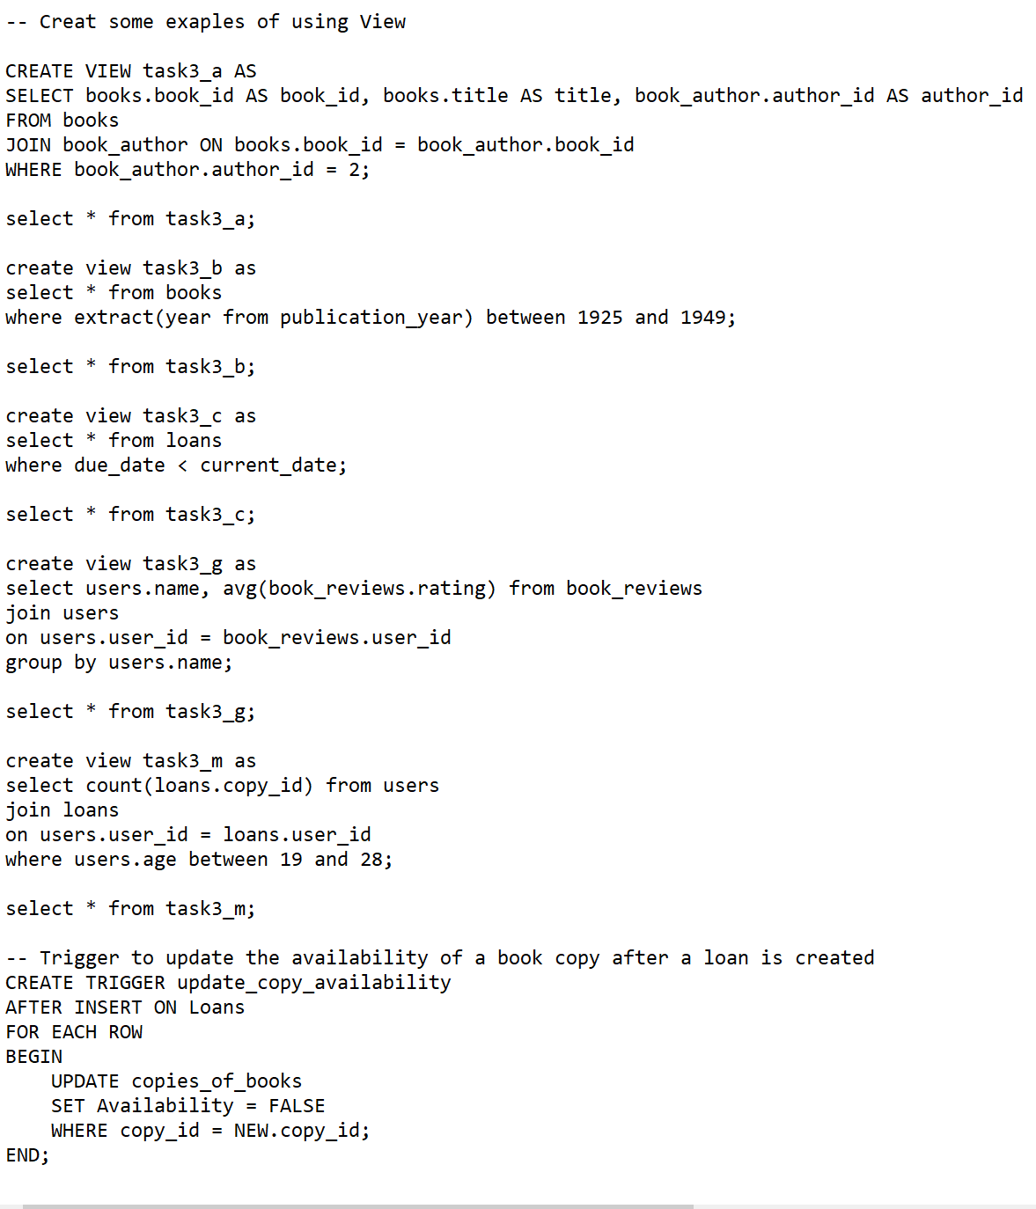

– Trigger to update the availability of a copy after a loan is created

CREATE OR REPLACE FUNCTION updatecopyfunc() RETURNS TRIGGER AS $$
BEGIN
UPDATE copies_of_books SET Availability = FALSE
WHERE copy_id=new.copy_id;
RETURN NEW;
END;
$$ LANGUAGE plpgsql;

CREATE TRIGGER update_copy_availability AFTER INSERT ON LOANS
FOR EACH ROW EXECUTE PROCEDURE updatecopyfunc();

Example:
insert into loans(loan_id, started_date, returned_date, due_date, user_id, copy_id)
values
(1011, '2023-06-14', null, '2023-06-29', '44007823', '2006')

select * from loans

select * from copies_of_books

