UNIVERSITY OF BUEA
[Faculty / College]
[Department]
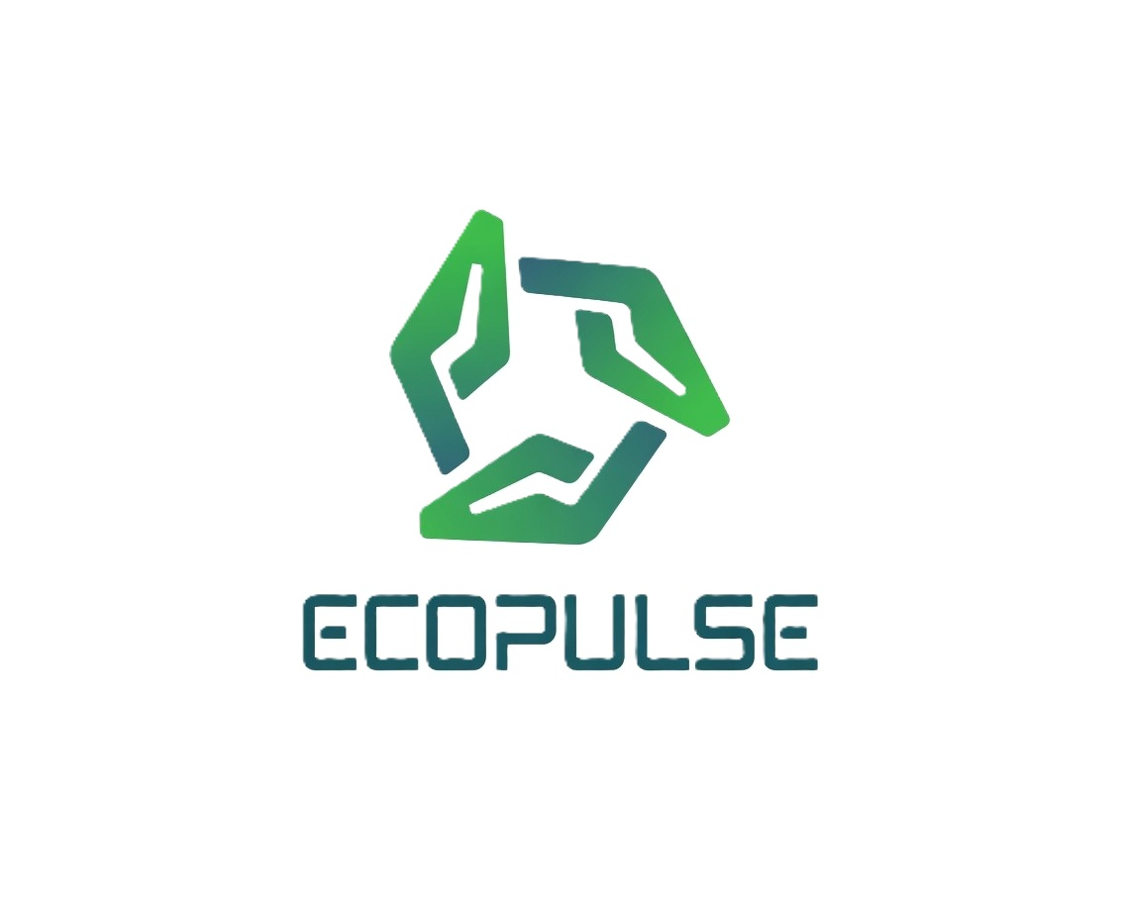
PROJECT PROPOSAL
EcoPulse: A Smart Waste Management Platform for Buea Municipality
A web dashboard and two mobile applications connecting municipal staff, waste collectors and residents
Submitted to the Head of Department in partial fulfilment of the requirements for the award of a Bachelor of Technology (B.Tech) degree in [Programme]
Presented by: [Full name]
Matriculation number: [Matriculation number]
Supervisor: [Supervisor’s name]
Academic year: [Academic year]
October 2026

Abstract
Waste collection in Buea is largely managed on paper and by phone. Collectors follow fixed rounds whether or not bins are full, residents have no formal way to report an overflowing bin, and the municipality keeps little record of what was collected, where, and by whom. This project proposes EcoPulse, a software platform that connects the three groups involved in waste collection. Municipal staff use a web dashboard to see bins and reports on a live map, assign each reported problem to a collector, review photographic proof of collection, and manage collectors, schedules and leave. Collectors use an Android app that shows their route and assigned reports, checks their GPS position, and asks them to photograph each cleaned spot. Residents use a separate Android app to report a full bin with a photo and location, follow the report until it is cleared, and see the collection schedule for their zone. The platform needs no special hardware beyond smartphones, uses free map data, and is designed for the conditions of Buea: unreliable connectivity, a bilingual population and many users with limited digital literacy.

1. Introduction

1.1 Background
Solid waste management is one of the most visible service challenges facing fast-growing cities in Sub-Saharan Africa. Urban populations are rising faster than municipal budgets and infrastructure, and the World Bank projects that waste generated in the region will more than triple by 2050 (Kaza et al., 2018). Secondary cities such as Buea, in the South West Region of Cameroon, feel this pressure directly: the town hosts the University of Buea and a growing student and resident population, while collection still depends on manual planning and informal communication.

1.2 Current situation in Buea
Collection in the municipality is organised around four zones: Molyko, Great Soppo, Bonduma and Buea Town. Day-to-day operations rely on:
- paper-based schedules and fixed collection rounds;
- phone calls between supervisors and collectors, which leave no record;
- no channel for residents to report an overflowing bin or a missed collection, or to know when it will be dealt with;
- little data for monitoring performance or planning resources.
EcoPulse is proposed as a practical, low-cost digital system that closes these gaps by giving each group a tool suited to its role, all connected to a single shared back end.

2. Problem Statement
Buea Municipality has no integrated digital system for managing waste collection. As a result:
- Collection is inefficient. Collectors follow fixed rounds regardless of how full bins are, so trucks visit bins that are nearly empty while others overflow.
- Communication is slow and untracked. Problems are reported by phone or not at all, and nobody can see whether a reported problem has been handled.
- There is no accountability. There is no reliable record of when a bin was emptied, by whom, or whether the work was actually done at that location.
- Residents are excluded. People who see an overflowing bin have no simple way to report it, and receive no feedback when they do.
- Decisions lack data. Supervisors have no history of collections, reports or response times on which to base planning.
The consequences are overflowing bins in busy areas such as markets and the university neighbourhood, health and environmental risks, wasted fuel and labour, and low public confidence in the collection service.

3. Aim and Objectives

3.1 Aim
To design, implement and evaluate a smart waste management platform that digitalises waste collection operations in Buea Municipality and connects municipal staff, waste collectors and residents.

3.2 Specific objectives
- Develop a web dashboard for municipal staff to monitor bins and community reports on a live map, assign reports to collectors, and manage collectors, schedules and leave.
- Develop an Android app for collectors that shows their route and assigned reports, supports navigation to each site, and records collections.
- Develop an Android app for residents to report a full or damaged bin with a photo and GPS location, follow the report’s progress, view the zone’s collection schedule and contact the municipality.
- Implement verifiable proof of collection: a photo of the cleaned spot taken at the site, checked against the report’s GPS location and approved or rejected by an administrator before the report is closed.
- Provide secure, role-based access suited to each group: email and password for collectors, staff accounts for administrators, and a lightweight, phone-based identity for residents that requires no email.
- Support real-time coordination through in-app chat, notifications and zone-wide announcements.
- Ensure quality and reliability through automated testing and continuous integration, and evaluate the system with prospective users.

4. Scope and Limitations

4.1 Scope
- The four collection zones of Buea Municipality: Molyko, Great Soppo, Bonduma and Buea Town.
- Three user groups: municipal staff (administrators), waste collectors and residents.
- Four software components: a REST API with its database, a web dashboard, and two Android applications, available in English and French.

4.2 Limitations
- Bin fill levels are not measured by sensors, which would require hardware the project cannot fund. They are estimated from residents’ reports, collectors’ observations and collection history.
- Route suggestions are based on priority and distance rather than full vehicle-routing optimisation.
- The system requires a mobile data connection; full offline operation is outside the current scope.
- Residents are identified by phone number and device rather than verified by SMS, because SMS verification requires a paid provider.

5. Significance of the Project
- For the municipality: a live, shared view of operations, faster response to reported problems, a verifiable record of work done, and data for planning staff, trucks and schedules.
- For collectors: clear daily tasks, navigation to each site, direct contact with supervisors, and fair recognition of completed work.
- For residents: a simple way to report problems, visible follow-up, and better knowledge of collection days, contributing to cleaner and healthier neighbourhoods.
- Academically: a complete, tested multi-application system that applies software engineering, mobile development, geolocation and cloud data management to a real local problem, and can be extended by future students.

6. Review of Existing Approaches
Smart waste management systems in cities such as Barcelona and Seoul typically combine fill-level sensors in bins, GPS tracking of trucks and cloud dashboards (Medvedev et al., 2015; Anagnostopoulos et al., 2017; Pardini et al., 2019). These systems improve efficiency but depend on sensor hardware, reliable power and connectivity, and recurring subscription costs.
Studies of waste management in developing countries highlight different constraints: limited municipal budgets, weak infrastructure, the importance of informal actors and the need to involve citizens (Guerrero et al., 2013; Wilson et al., 2012; Oduro-Appiah et al., 2017). At the same time, smartphone adoption in Sub-Saharan Africa continues to grow, which makes mobile-first solutions increasingly viable (GSMA, 2023).
Existing tools tend to fall into one of three groups: sensor-based platforms that are too costly for a municipality like Buea, commercial fleet and route management products designed for large cities in other contexts, and citizen-reporting apps that serve residents but give collectors and supervisors no tools. EcoPulse addresses this gap with a software-only, multi-stakeholder platform that works with existing infrastructure and the smartphones people already own.

7. Proposed System

7.1 Users and their roles
Table 1: Users of the system
User | Main tasks in EcoPulse
Administrator (municipal staff) | Monitor bins and reports on a map; assign reports to collectors; approve or reject proof photos; manage collectors, trucks, zones and schedules; review applications and leave requests; chat and send announcements.
Collector | Sign in with email and password; see the day’s route and assigned reports; navigate to sites; photograph cleaned spots as proof; chat with supervisors; request leave.
Resident | Report a full or damaged bin with photo and location; follow the report until it is cleared; view the zone’s collection schedule and reminders; chat with the municipality; apply to become a collector.

7.2 Main features
- Live map of bins and reports for each zone, using free OpenStreetMap data.
- Report assignment: an administrator assigns a resident’s report to a collector, with collectors working in the report’s zone suggested first; the collector is notified in the app.
- Proof of collection: the collector photographs the cleaned spot; the app records the GPS position and its distance from the report; the administrator approves the photo or rejects it with a reason, and the resident then sees the report as collected, together with the photo.
- Collector accounts: residents who apply to become collectors give an email address; on approval, the administrator issues a temporary password that the collector must replace at first sign-in.
- Leave management: collectors request leave from the app; administrators approve or decline it and are warned when other collectors in the same zone are off on the same days; the collector’s status changes automatically on the first and last day.
- Communication: in-app chat between administrators, collectors and residents, notifications, and zone-wide announcements.
- Schedules: collection days and waste types for each zone, with reminders for residents.

7.3 Design choices for the local context
- No email required for residents. Many residents, including older traders in the markets, do not use email; they identify themselves with a name and phone number only, and the app is tied to their device.
- Bilingual interface in English and French in both mobile apps.
- Low data use: photos are compressed on the phone before upload, and map data comes from OpenStreetMap at no cost.
- Large controls and plain language in the mobile apps, for users with limited experience of smartphones.
- No special hardware: the system relies only on smartphones and a web browser.
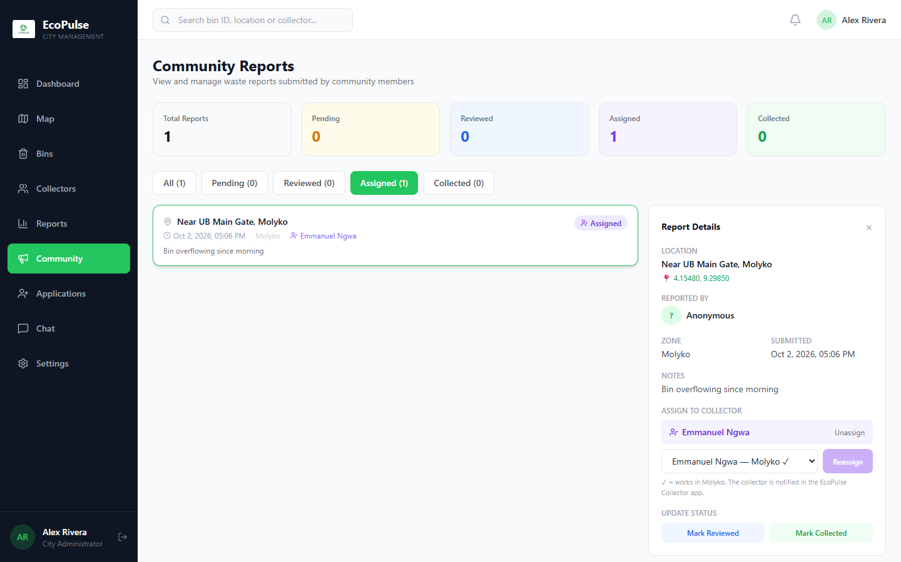
Figure 1: The dashboard’s Community Reports page: a resident’s report assigned to a collector in the same zone

8. Methodology

8.1 Development approach
The project follows an iterative and incremental approach. Requirements are gathered through observation of current collection practice, informal discussions with residents, collectors and municipal staff, and a review of existing systems. Each iteration delivers a working increment of the API, dashboard and apps, which is tested and reviewed before the next is planned. This allows the design to adapt to feedback, for example the decision that residents should not need an email address.

8.2 System architecture
EcoPulse uses a client–server architecture. A single REST API serves three client applications and stores all data in a MongoDB database (Figure 2). Clients communicate with the API over HTTPS using JSON. Administrators and collectors are authenticated with JSON Web Tokens (JWT); residents are identified by a random device token whose hash is stored on the server. A scheduled job on the server updates collectors’ status at the start and end of approved leave.
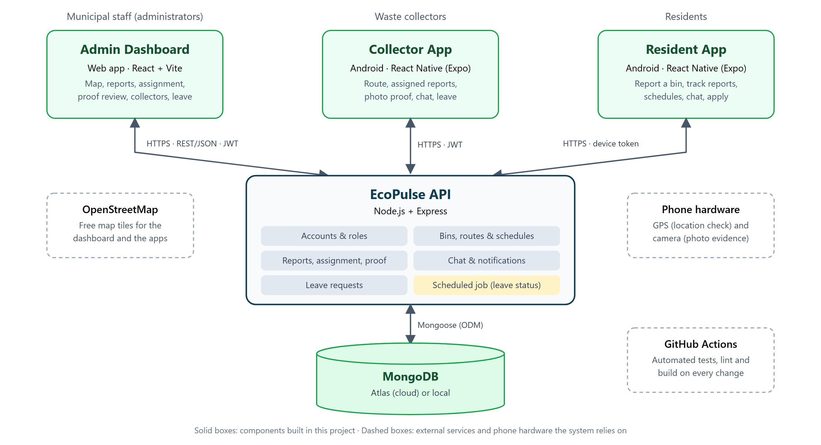
Figure 2: EcoPulse system architecture

8.3 Tools and technologies
Table 2: Tools and technologies
Component | Technology | Reason for the choice
API (back end) | Node.js, Express, Mongoose | One language (JavaScript) across the whole system; mature and widely documented.
Database | MongoDB (Atlas free tier or local) | Flexible documents suit reports, photos and chat; free cloud hosting is available.
Web dashboard | React, Vite, Tailwind CSS, Leaflet | Fast development, responsive design that works on desktop and phone, free maps.
Mobile apps | React Native with Expo (Android) | One code base for both apps; quick testing on real Android phones.
Maps | OpenStreetMap | Free map data; no paid API keys.
Security | JWT, bcrypt password hashing | Standard, well-tested approaches to authentication and password storage.
Quality assurance | Automated API tests, ESLint, GitHub Actions | Every change is tested automatically before it is merged.
Development tools | Visual Studio Code, Android Studio, Git and GitHub | Free tools; version control and backup of all work.

8.4 Data design
The main data entities are: administrators (staff accounts), collectors (profile, zone, truck, status and sign-in details), community users (residents), bins (location, zone and fill status), reports (photo, location, note, status, assigned collector, proof photo and review), schedules (collection days per zone), messages and notifications, collector applications, and leave requests.

8.5 Security and privacy
- Passwords are hashed with bcrypt and never returned by the API; collectors replace the temporary password they are given at first sign-in.
- Every endpoint checks the caller’s role, so a collector cannot use administrator functions, and residents can only see their own reports and conversations.
- Phone numbers are stored in one standard format (+237…), and only the personal data the service needs is collected.

8.6 Testing and evaluation
- Automated testing: four API test suites (about 145 checks) cover sign-in and passwords, access control, report assignment, proof photos and their review, applications and leave. They run automatically on GitHub Actions at every change, together with checks on the dashboard and both apps.
- Device testing: the mobile apps are tested on physical Android phones, and the dashboard at desktop and phone screen sizes.
- User evaluation: a small group of residents, collectors and municipal staff will complete typical tasks (reporting a bin, closing a report with a photo, assigning a report), followed by a short usability questionnaire. Results will be measured against the objectives in Section 3.

9. Expected Outcomes and Deliverables
- A working web dashboard for municipal staff.
- Two Android applications: one for collectors and one for residents.
- A documented REST API and database, deployable on free hosting tiers.
- Source code on GitHub with automated tests and continuous integration.
- User guides for each group, and a final project report.

10. Progress to Date
Development started early so that the proposal could be informed by a working prototype. The current state of each part is summarised below.
Table 3: Current status of the project
Component | Status
REST API and database | Implemented and covered by automated tests
Admin dashboard | Implemented, including report assignment, proof review, collector management and leave
Collector app | Implemented, including email sign-in, photo proof and leave requests
Resident app | Implemented; browsing without an account is being added
Automated tests and continuous integration | In place (GitHub Actions)
Push notifications when the app is closed | Planned
Bin fill-level estimation without sensors | Planned
Deployment and user evaluation | Planned

11. Work Plan
Table 4: Project schedule (indicative)
Phase | Activities | Period | Status
1. Study and requirements | Study of current practice; requirements; review of existing systems | Feb – Mar 2026 | Completed
2. Design and first prototype | Architecture and data design; first versions of the API, dashboard and both apps | Mar – Apr 2026 | Completed
3. Core features and hardening | Report assignment, proof photos, security improvements, email sign-in for collectors, leave management, automated tests | May – Oct 2026 | Completed
4. Remaining features | Push notifications, bin fill-level estimation, open browsing in the resident app | Oct – Nov 2026 | In progress
5. Deployment and evaluation | Deployment on free hosting; testing with users; corrections | Nov – Dec 2026 | Planned
6. Report and defence | Final report, user guides, presentation | Dec 2026 – Jan 2027 | Planned

12. Resources and Budget
The project is designed to run without licence or hosting costs.
Table 5: Resources required
Resource | Source | Cost
Laptop for development | Student’s own | None
Android phone for testing | Student’s own | None
Development software (Node.js, React, Expo, Android Studio, VS Code) | Free and open source | None
Database hosting | MongoDB Atlas free tier | None
Code hosting and automated testing | GitHub (free plan) | None
Maps | OpenStreetMap | None
Push notifications | Expo and Firebase free tiers | None
Internet data | Student’s own subscription | [Estimated amount]

13. Risks and Mitigation
Table 6: Main risks and how they are addressed
Risk | Mitigation
Unstable mobile internet in the field | Small data transfers; photos compressed on the phone; clear error messages and retry.
Limited digital literacy among some users | No email needed for residents; bilingual interface; large buttons; few steps per task.
Inaccurate GPS readings | Distance to the reported spot is recorded and shown to the administrator, who decides using the photo as well as the location.
False or careless reports | Photo required; reports tied to the reporting device; administrators review reports before assigning them.
No budget for bin sensors | Fill levels estimated in software from reports, collectors’ observations and collection history.
Limited access to the municipality for evaluation | Realistic demonstration data; evaluation with a small group of volunteer residents and collectors.

14. Conclusion
EcoPulse addresses a concrete problem in Buea: waste collection that is planned on paper, coordinated by phone and invisible to residents. By connecting municipal staff, collectors and residents through a web dashboard and two mobile apps, the platform makes collection more responsive, accountable and data-driven, at almost no cost to the municipality. A large part of the system has already been built and tested, which reduces the project’s risk. I respectfully request the Department’s approval to complete, evaluate and document EcoPulse as my final-year project.

References
Anagnostopoulos, T., Zaslavsky, A., Kolomvatsos, K., Medvedev, A., Amirian, P., Morley, J., & Hadjiefthymiades, S. (2017). Challenges and opportunities of waste management in IoT-enabled smart cities: A survey. IEEE Transactions on Sustainable Computing, 2(3), 275–289.
GSMA. (2023). The Mobile Economy: Sub-Saharan Africa 2023. GSMA Intelligence.
Guerrero, L. A., Maas, G., & Hogland, W. (2013). Solid waste management challenges for cities in developing countries. Waste Management, 33(1), 220–232.
Kaza, S., Yao, L., Bhada-Tata, P., & Van Woerden, F. (2018). What a Waste 2.0: A Global Snapshot of Solid Waste Management to 2050. Washington, DC: World Bank.
Medvedev, A., Fedchenkov, P., Zaslavsky, A., Anagnostopoulos, T., & Khoruzhnikov, S. (2015). Waste management as an IoT-enabled service in smart cities. In Internet of Things, Smart Spaces, and Next Generation Networks and Systems (pp. 104–115). Springer.
Oduro-Appiah, K., Afful, A., Donkor, E., & Nyarko, M. Y. (2017). Existing solid waste management system in three most populous metropolitan assemblies in Ghana. Journal of Sustainable Development of Energy, Water and Environment Systems, 5(3), 443–459.
Pardini, K., Rodrigues, J. J. P. C., Kozlov, S. A., Kumar, N., & Furtado, V. (2019). IoT-based solid waste management solutions: A survey. Journal of Sensor and Actuator Networks, 8(1), 5.
Wilson, D. C., Rodic, L., Scheinberg, A., Velis, C. A., & Alabaster, G. (2012). Comparative analysis of solid waste management in 20 cities. Waste Management & Research, 30(3), 237–254.

Approval
Student
I submit this proposal for approval as my final-year project.
Name: [Full name]
Signature: ______________________ Date: ________________
Supervisor
I have read this proposal and agree to supervise the project.
Name: [Supervisor’s name]
Signature: ______________________ Date: ________________
Head of Department
Decision: ☐ Approved ☐ Approved with corrections ☐ Not approved
Comments:

Name: ____________________________________
Signature: ______________________ Date: ________________

