Making Character Controller
First I tried to copy controller solution from
How to Create a Top Down Movement Character Controller in Unity | Scripting Tutorial
https://www.youtube.com/watch?v=-0GFb9l3NHM

Then I tried to copy from John Klima‘s controller only parts what I thought I needed, but something was not right.
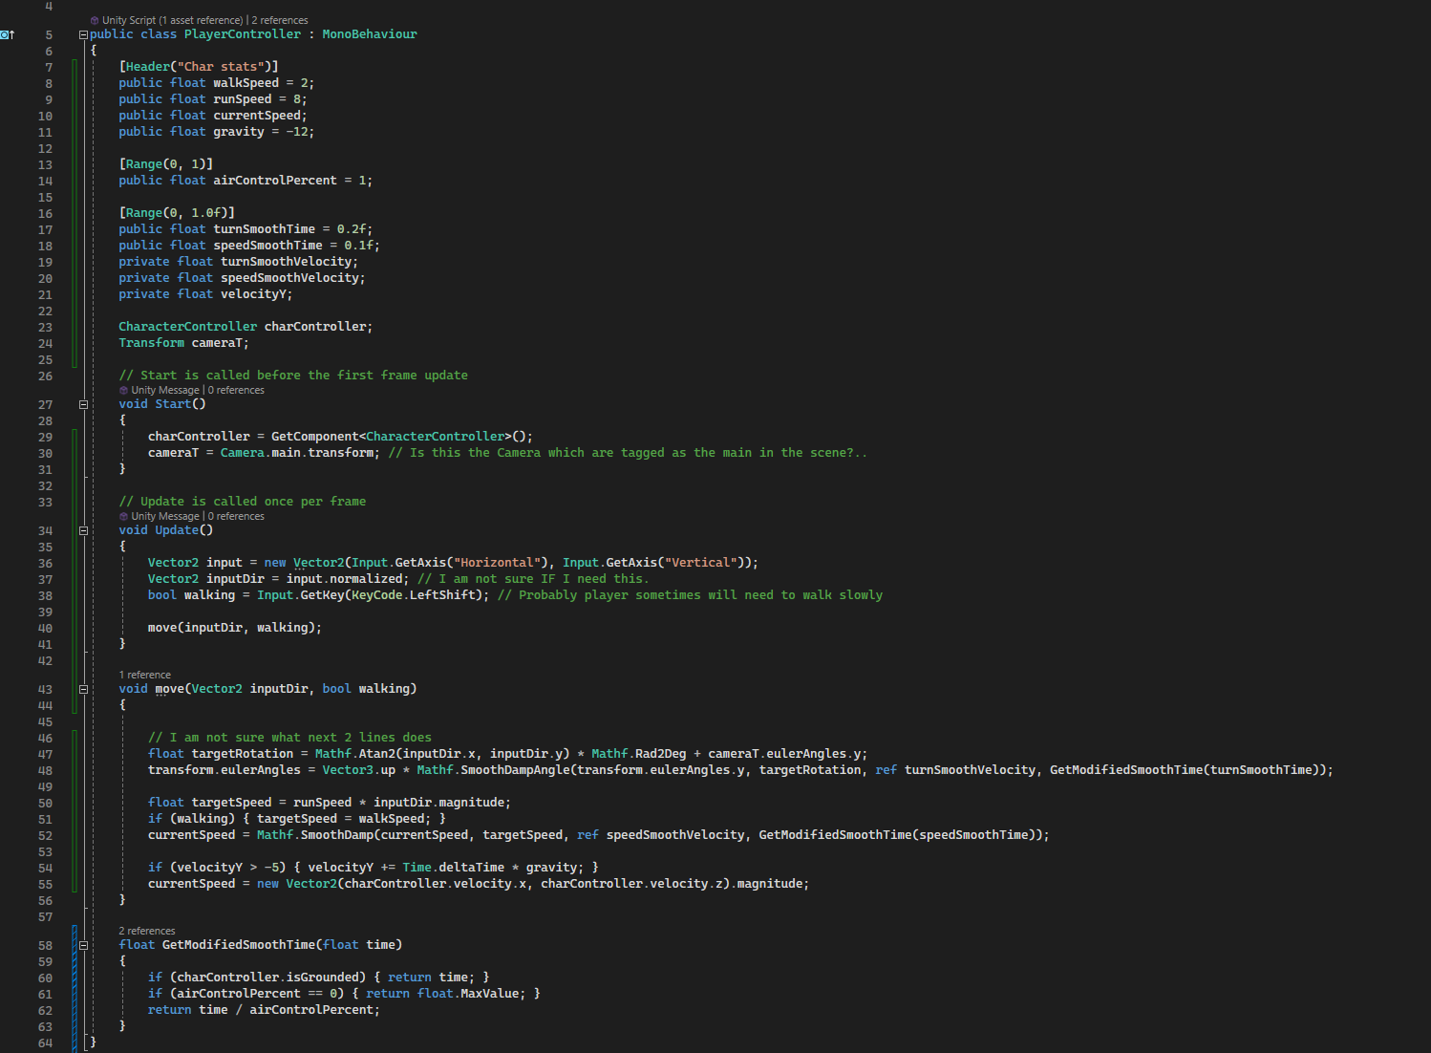

Camera controller taken from John Klima, had an issue of orbiting around character feet (where the character‘s pivot is). Looking for solution I almost accidently added this edit with two variables as in image_. Now the player can look what is in front of him.
Animations
I tried to copy animations scripts and set it up the same, but there was something wrong, animations wasn‘t swapping at it should. I just missed attaching the Player Animator script. Now animations work.
I also somehow swapped walk and run speed parameters, but as long as I work alone I don‘t see any need to fix it.

Level1
I started with a tunnel where the player supposedly come in through.
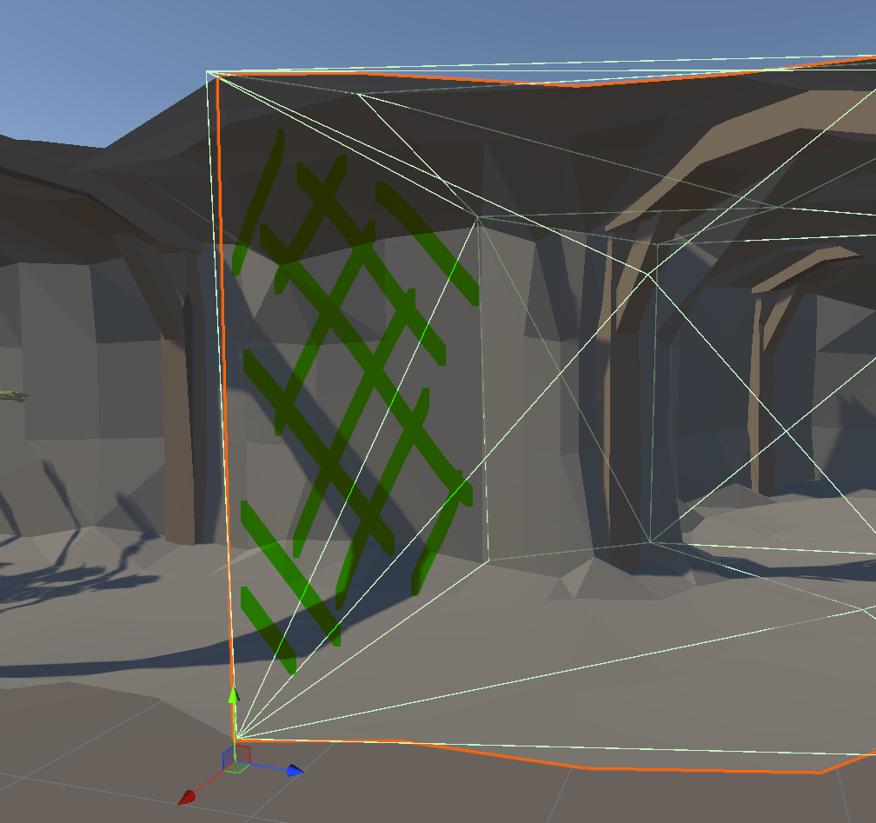
For some reason this section of tunnel asset has unpasable collider. Found that removing the prefab‘s collider and adding new mesh collider generates correct collision. But it is probably more resource consuming, as new one probably are much more complex. But for my small game it shouldn‘t be a problem.
Testing what kind of sockets would look appropriate.
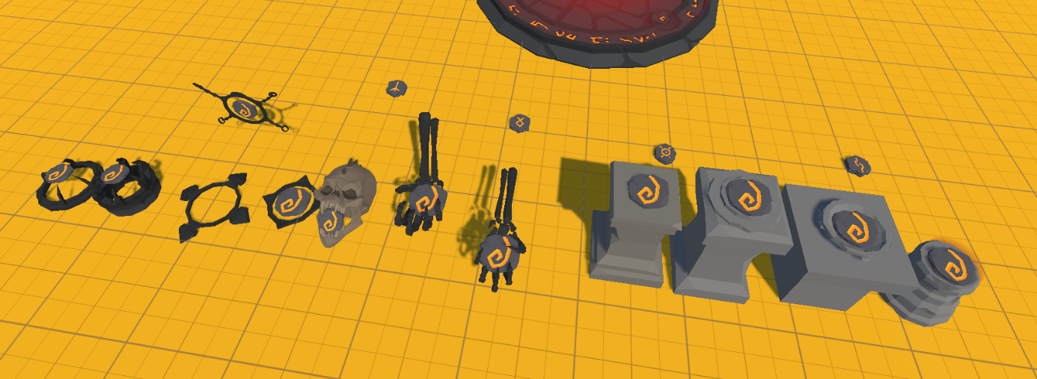

I need some kind of invenotry system to register what was picked up and what can be used.
I read and started to follow instructions from How to make an inventory system in Unity (https://gamedevbeginner.com/how-to-make-an-inventory-system-in-unity/), but soon realised that it is possibly too complicated for my needs. As I will have fixed amount of unchangeable items, which the player either have or not. I decided to try to have a simple script with a list of booleans to track what the player has at the moment.
TODO
- Design room 1
- Design room 2
- Design room 3
- Design room 4
- Design room 5
- Slots for runes
- Inventory system (some kind)
- Crystals in the tunnel (elsewhere) for light.

