ADT-Project Part 2

**PROJECT TITLE:** VIRTUAL BOOK STORAGE

**TEAM NAME:  Data Bandits (Group 6)**

**TEAM MEMBERS:**

* Rasaghna Kuturu : [rkuturu@iu.edu](mailto:rkuturu@iu.edu)
* Harsh Patel : [hsp2@iu.edu](https://indiana-my.sharepoint.com/personal/hsp2_iu_edu/Documents/Document.docx?web=1)
* Prit Nileshkumar Dhabaliya : [pdhabali@iu.edu](https://indiana-my.sharepoint.com/personal/hsp2_iu_edu/Documents/Document.docx?web=1)

1. **Conceptual Diagram for the database:**

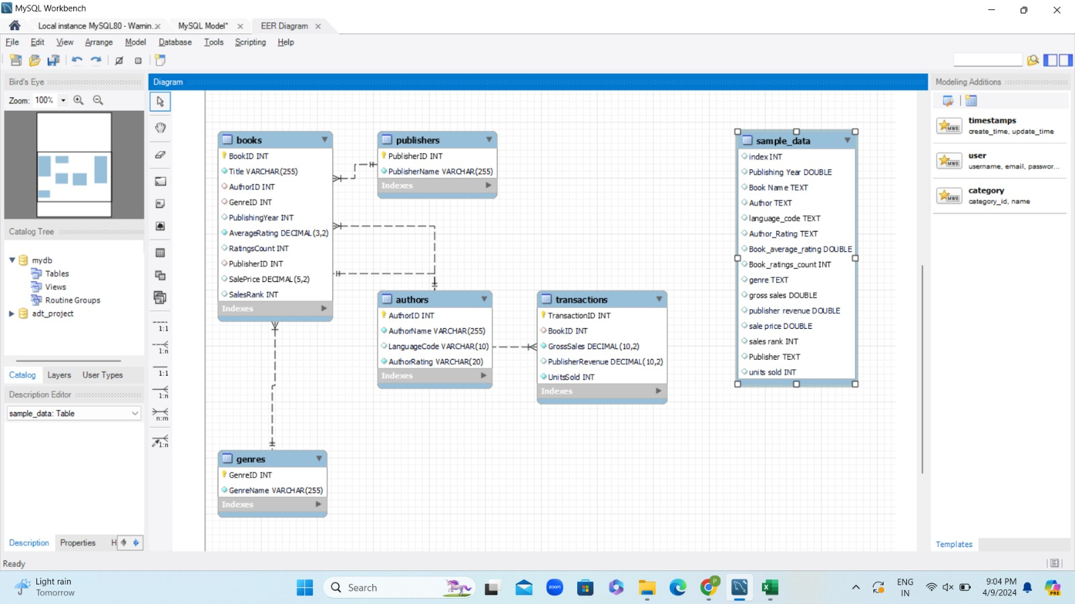

*Image 1: EER Diagram*

1. **Database:**
2. **Creating Tables:**

We created four tables: Authors, Genres, Publishers, and Transactions. Each table has its own unique primary key and foreign key constraints. These constraints are necessary to establish relationships between tables.

1. **Entities:**

* **Authors:** Represents the name of authors who write books. Each author has unique AuthorID and the table consists of Author Name, Language code, and Author rating.
* **Genres:** Represents different categories of genres of books. Each genre has a unique GenreID and GenreName.
* **Publishers:** Represents publishing companies. Each publisher has a unique PublisherID and PublisherName.
* **Books:** Represents books having unique BookID and attirbutes like Title, PublishingYear, AverageRating, RatingsCount, SalePrice, SalesRank. It also has foreign keys AuthorID, GenreID, and PublisherID referencing the Authors, Genres, and Publishers tables respectively.
* **Transactions:** Represents sales of books. Each transaction has a unique TransactionID and attributes such as BookID, SaleDate, GrossSales, PublisherRevenue, and UnitsSold.

1. **Relationship**:

Each book is linked to author, genre, and publisher through a foreign key relationship between the Authors, Genres, and Publishers tables and the Books table. Also each transaction in the Transactions table is linked to the book via a foreign key relationship with the Books table.

1. **Adding Unique Constraints:**

We added constraints in the table so that each column of the table have unique values. These constraints are added to AuthorName in Authors table, GenreName in Genres table, and PublisherName in Publishers table.

* **Primary Keys:** To ensure uniqueness and uniquely identify each record, the following primary keys are used in Authors, Genres, Books, Publishers
* **Transactions:** BookID in Books, TransactionID in Transactions, and AuthorID in Authors. Constraints on foreign keys are used to guarantee referential integrity between tables. For instance, the AuthorID, GenreID, and PublisherID columns in the Books table are references to the corresponding tables' AuthorID, GenreID, and PublisherID columns.
* **Unique Constraints:** To guarantee that the values in AuthorName in Authors, GenreName in Genres, and PublisherName in Publishers are unique within their respective tables, these fields are applied with unique constraints.

1. **Default Constraint:**

A default constraint is added to the PublisherRevenue column in the Transactions table to set a default value of 0.00 if no value is provided during insertion.

1. **Not Null Constraints:**

Some columns, such as AuthorName, GenreName, and PublisherName in their respective tables, and some important columns, such as GrossSales and UnitsSold in the Transactions table, are marked as NOT NULL in order to guarantee that certain fields cannot contain null values.

1. **Data Type Constraints:** Each column has a data type specified in order to enforce specific data formats. For example, VARCHAR is used for character strings of different lengths, DECIMAL is used for fixed-point numbers, and INT is used for integer values.
2. **Output of the queries:**

*Image 2: Output of Author table*

*Image 3: Output of Genres table*

*Image 4: Output of Publishers table*

*Image 5: Output of Books table*

*Image 6: Output of Transaction table*

1. **Overall Contribution Summary:**

|  |  |  |  |  |
| --- | --- | --- | --- | --- |
| **Sr. No.** | **Name** | **Task** | **Contribution** | **Time Spent (hrs)** |
| **1** | Harsh Patel | Database | 1. Dataset – Cleaning, Preprocessing, Normalizing, loading into database. 2. Write queries for Author, Genres and Publisher table. | 8 |
| **2** | Prit Dhabaliya | Code | 1. Write queries to create tables for Authors, Genres, Publishers, Books. 2. Build queries for the respective tables. | 9 |
| **3** | Rasaghna Kuturu | Conceptional Schema | 1. Draw the conceptual diagram. 2. Write queries to create Transaction table and queries for Transaction and Authors. | 8 |

1. **References:**
2. Josh Murrey (2018), Books. Retrieved from, <https://data.world/josh-nbu>.
3. Kaggle (2024). Books Sales and Rating from <https://www.kaggle.com/datasets/thedevastator/books-sales-and-ratings?resource=download>.
4. <https://www.emizentech.com/blog/how-to-develop-online-bookstore-mobile-app.html>
5. <https://help.tableau.com/current/pro/desktop/en-us/bookshop_data.htm>

**SHARING AND COMMUNICATION:**

* **COMMUNICATION AND SHARING:** Google meet is used for communication, and we share files through Outlook.

**GITHUB LINK:** <https://github.iu.edu/pdhabali/adt_project_hpr_data_bandits.git>