**Introduction**

We live in an exciting time where more and more everyday things are becoming smart. Appliances have sensors and can communicate to other things and can provide control to more things. The Internet of Things, IoT, is in a huge way and people are rapidly inventing new gadgets that enhances lives. The price of microcontrollers with the ability to talk over a network keeps dropping and developers can now tinker and build things inexpensively.

IoT based home automation project is done using low cost ESP8266 WiFi Module, It uses relays and few simple components, four electrical devices can be controlled and temperature can be monitored. Homes of the 21st century will become more and more self - controlled and automated due to the comfort it provides, especially when employed in a private home. A home automation system is a means that allow users to control electric appliances of varying kind. Many existing, well-established home automation systems are based on wired communication. This does not pose a problem until the system is planned well in advance and installed during the physical construction of the building. But for already existing buildings the implementation cost goes very high.

In contrast, Wireless systems can be of great help for automation systems. With the advancement of wireless technologies such as Wi-Fi, cloud networks in the recent past, wireless systems are used every day and everywhere. With advancement of Automation technology, life is getting simpler and easier in all aspects. In today’s world Automatic systems are being preferred over manual system. With the rapid increase in the number of users of internet over the past decade has made Internet a part and parcel of life, and IoT is the latest and emerging internet technology.

Internet of things is a growing network of everyday object from industrial machine to consumer goods that can share information and complete tasks while everybody is busy with other activities. Wireless Home Automation system (WHAS) using IoT is a system that uses computers or mobile devices to control basic home functions and features automatically through internet from anywhere around the world. An automated home is sometimes called a smart home. It is meant to save the electric power and human energy. The home automation system differs from other system by allowing the user to operate the system from anywhere around the world through internet connection.

Many people are always on the move from place to place due to business demands. Some people can spend a couple of days away from their home leaving all their household appliances without any kind of monitoring and control. Some devices are left plugged into power sockets whereas others are supposed to be plugged into and out of power sockets at different intervals depending on the time of the day. All this requires an individual to manually attend to each of the devices independently from time to time. All such monitoring and control can be done without necessarily being around or inside the home some devices if not controlled properly consume a lot of energy which leads to extra expenditure on electricity.

**Components**

1. Arduino Uno

Image:

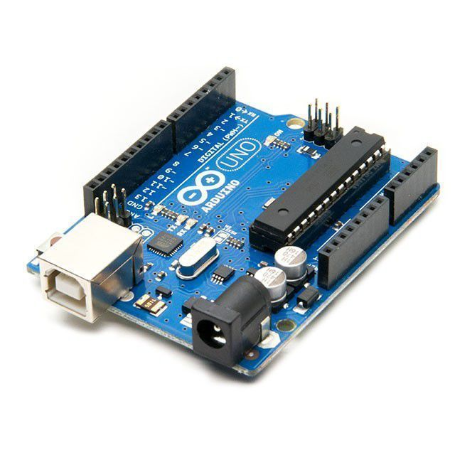

Description:

Arduino Uno is a microcontroller board based on the ATmega328P (datasheet). It has 14 digital input/output pins (of which 6 can be used as PWM outputs), 6 analog inputs, a 16 MHz quartz crystal, a USB connection, a power jack, an ICSP header and a reset button. It contains everything needed to support the microcontroller; simply connect it to a computer with a USB cable or power it with a AC-to-DC adapter or battery to get started.

1. NodeMCU(ESP8266)

Image:

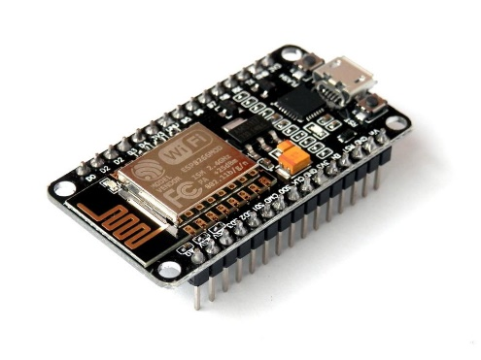

Description:

NodeMCU is an open source IoT platform. It includes firmware which runs on the ESP8266 Wi-Fi SoC from Espressif Systems, and hardware which is based on the ESP-12 module. The term "NodeMCU" by default refers to the firmware rather than the development kits. The firmware uses the Lua scripting language. It is based on the eLua project, and built on the Espressif Non-OS SDK for ESP8266. It uses many open source projects, such as lua-cjson and SPIFFS.

1. Light Bulb

Image:

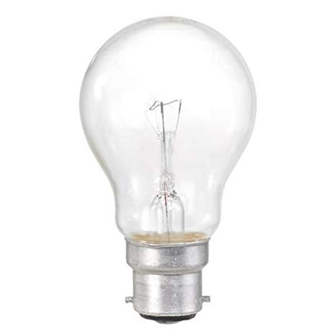

Description:

An incandescent light bulb, incandescent lamp or incandescent light globe is an electric light with a wire filament heated to such a high temperature that it glows with visible light (incandescence). The filament is protected from oxidation with a glass or fused quartz bulb that is filled with inert gas or a vacuum. In a halogen lamp, filament evaporation is slowed by a chemical process that redeposits metal onto the filament, thereby extending its life.

1. Fan

Image:

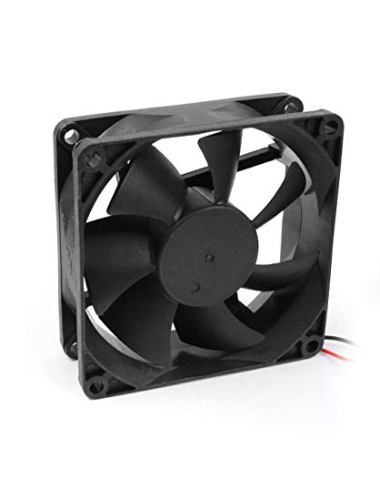

Description:

A computer fan is any fan inside, or attached to, a computer case used for active cooling. Fans are used to draw cooler air into the case from the outside, expel warm air from inside and move air across a heat sink to cool a particular component. Both axial and sometimes centrifugal (blower/squirrel-cage) fans are used in computers. Computer fans commonly come in standard sizes, and are powered and controlled using 3-pin or 4-pin fan connectors.

1. Relay

Image:

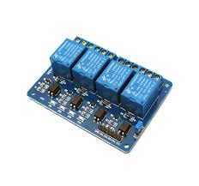

Description:

A relay is an electrically operated switch. It consists of a set of input terminals for a single or multiple control signals, and a set of operating contact terminals. The switch may have any number of contacts in multiple contact forms, such as make contacts, break contacts, or combinations thereof. Relays are used where it is necessary to control a circuit by an independent low-power signal, or where several circuits must be controlled by one signal. Relays were first used in long-distance telegraph circuits as signal repeaters: they refresh the signal coming in from one circuit by transmitting it on another circuit. Relays were used extensively in telephone exchanges and early computers to perform logical operations.

1. Mobile Phone with Blynk App

Image:

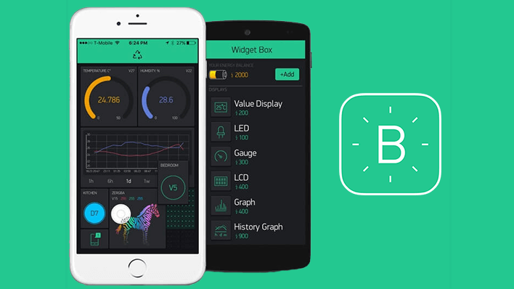

Description:

Blynk was designed for the Internet of Things. It can control hardware remotely, it can display sensor data, it can store data, vizualize it and do many other cool things.

There are three major components in the platform:

Blynk App - allows to you create amazing interfaces for your projects using various widgets we provide.

Blynk Server - responsible for all the communications between the smartphone and hardware. You can use our Blynk Cloud or run your private Blynk server locally. It’s open-source, could easily handle thousands of devices and can even be launched on a Raspberry Pi.

Blynk Libraries - for all the popular hardware platforms - enable communication with the server and process all the incoming and outcoming commands.

1. Servo Motor

Image:

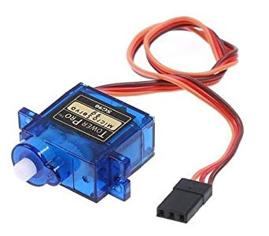

Description:

A servo motor is an electrical device which can push or rotate an object with great precision. If you want to rotate and object at some specific angles or distance, then you use servo motor. It is just made up of simple motor which run through servo mechanism. If motor is used is DC powered then it is called DC servo motor, and if it is AC powered motor then it is called AC servo motor. We can get a very high torque servo motor in a small and light weight packages. Doe to these features they are being used in many applications like toy car, RC helicopters and planes, Robotics, Machine etc.

1. Zinc Carbon Battery

Image:



Description:

A zinc–carbon battery is a dry cell primary battery that delivers about 1.5 volts of direct current from the electrochemical reaction between zinc and manganese dioxide. A carbon rod collects the current from the manganese dioxide electrode, giving the name to the cell. A dry cell is usually made from zinc which serves as the anode with a negative electrical polarity, while the inert carbon rod is the positive electrical pole cathode. General purpose batteries may use an aqueous paste of ammonium chloride as electrolyte, possibly mixed with some zinc chloride solution. Heavy duty types use a paste primarily composed of zinc chloride.

**Implementation**

**Architectural Diagram**

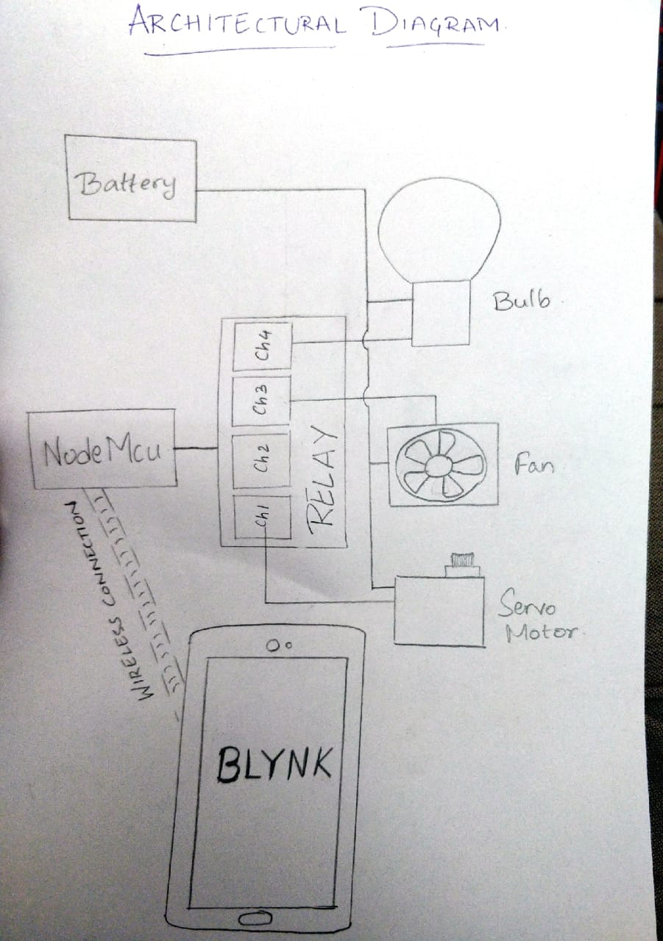

**Description:**

• NodeMcu ESP 8266 acts also as a microcontroller, while playing the role of connecting the hardware of the project to the internet.

• On the other hand, the NodeMcu is also connected to the Blynk app on the mobile via the internet.

• The relay acts as the power bridge between NodeMcu and the hardware.

• We make use of a 4 channel relay in our project.

• Each hardware component is connected to one channel of the relay.

• We are using three channels in the relay with bulb, fan and servo motor.

• The purpose of the servo motor is to act as a mechanism that opens a door automatically.

• Digital Pins of the nodeMcu are given as an input to the relay.

• When on/off signal is sent through the app, the signal on th digital pins gets active high/low respectively.

• The change in digital signal will activate / deactivate the relay channel accordingly.

• This in turn switches on/off the devices.

**Circuit Diagram:**

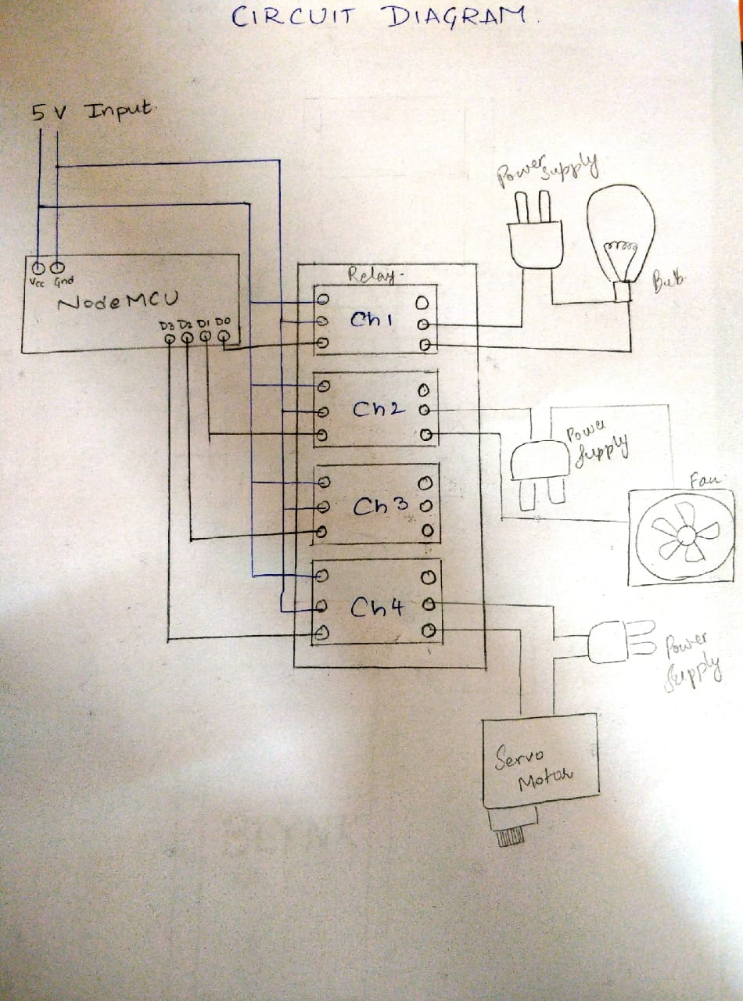

**Circuit Diagrams of all Related Components**

1. Arduino Uno

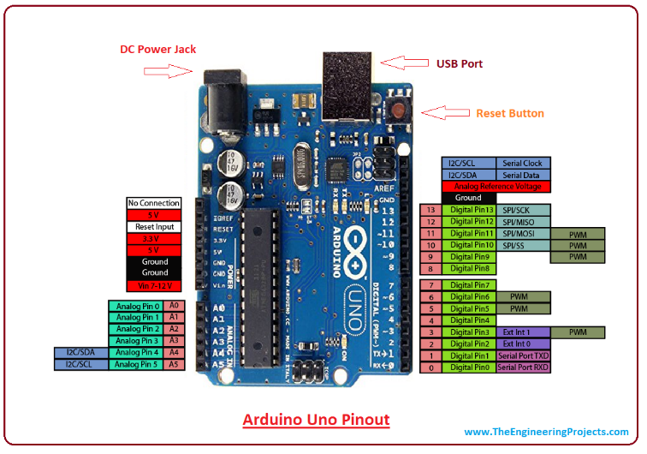

1. Servo Motor

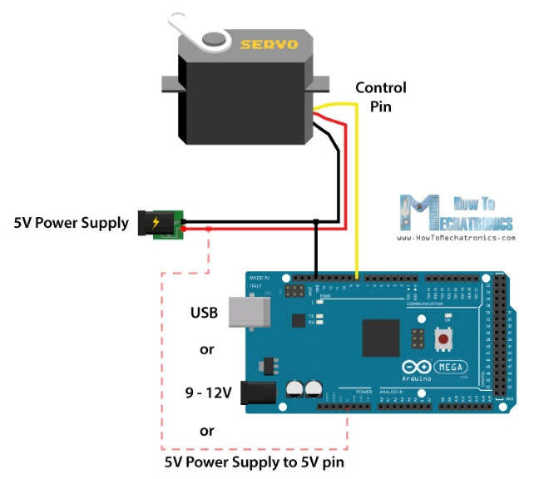

1. NodeMCU

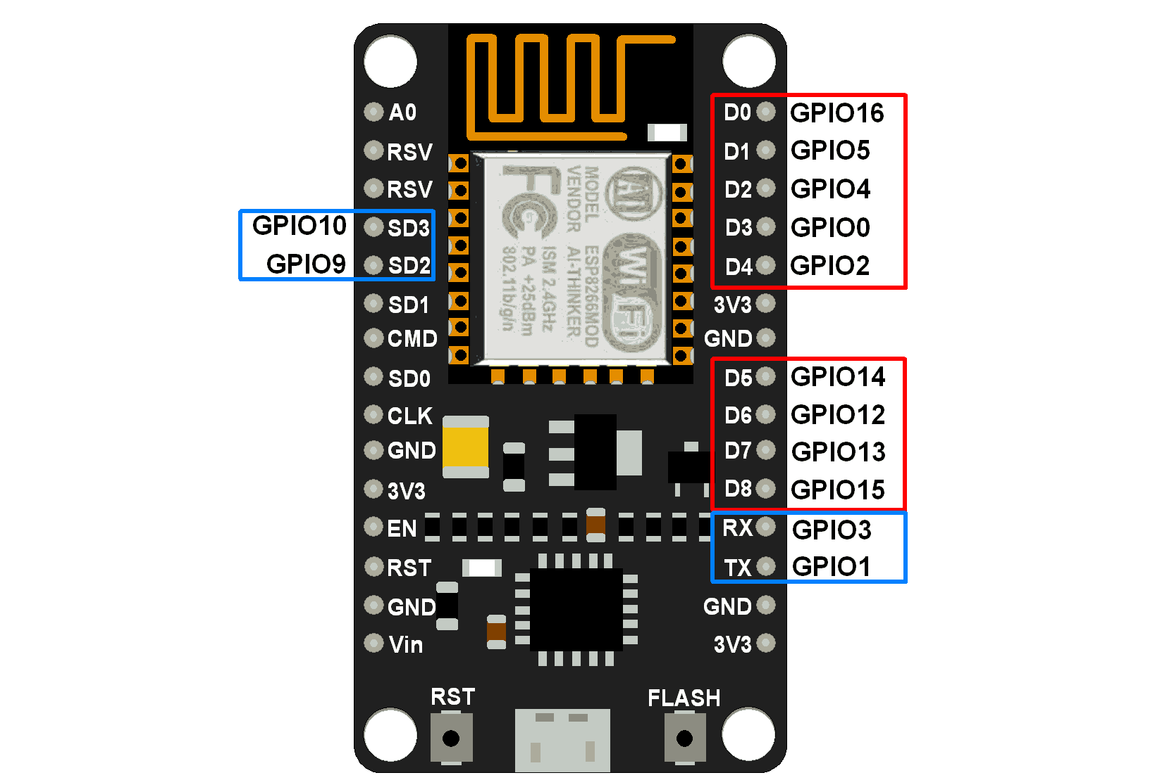

1. Relay

(4-channel)

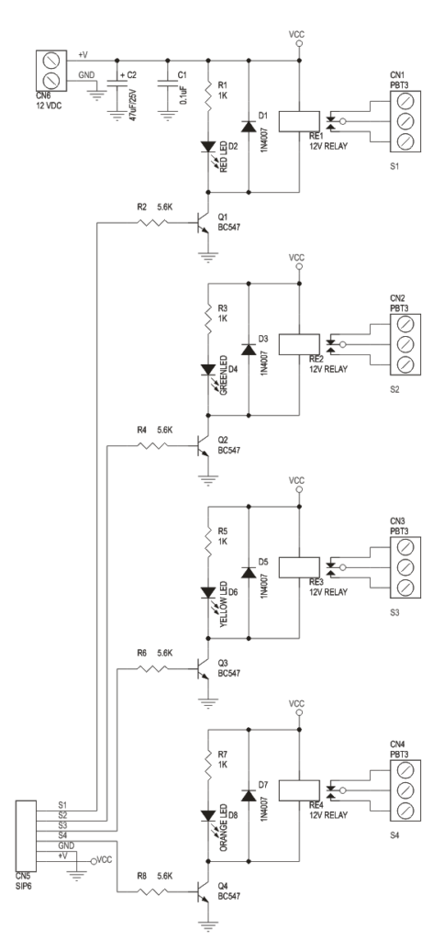

**Testing/Results And Analysis**

1. **Testing**

As the implementation was taking place, new errors or ideas for improvement have kept arising. The team has worked together to include the new ideas as best as it could along with debugging and clearing out the errors.

1. Arduino Uno

* Initial testing of Arduino was done to check if the board was in working condition. A simple LED blink code was executed.
* In the next phase, simple code was run to see if it can power up a servo motor. That was a success as well.

1. NodeMCU(ESP8266)

* Initial testing included a simple authentication success for wifi connection.
* Once wifi connection has been established, an LED blink code was executed here as well.
* Next, the connectivity between NodeMCU and the BLYNK app has been checked and corrected.

1. Light Bulb

* It did not impose much of errors. It was first checked with a dc battery supply if it was in working condition.

1. Fan

* The fan was also checked to see if it was in a working condition.
* The problem imposed by the fan was that it was not turning with respect to its motor. That problem has been fixed by fixing the electrical part of the fan to a firm surface.
* This allowed the fan to rotate without any interruptions.

1. Relay

* The prevailing problem with the relay was the connections. But this problem was eventually overcome.

1. Mobile Phone with Blynk App

* The phone was not connecting to the wifi module which brought to life a lot of doubts.
* The problem was efficiently handled as it was soon clear to us that it was a problem with the BLYNK libraries.

1. Servo Motor

* No problem arose with this part of the project.

**2. Results**

* NodeMCU was successfully connected to the internet.
* NodeMCU was successfully connected to the mobile app.
* The circuit was made without any errors.
* All hardware components were in working conditions.
* The cardboard miniature model has been made.
* The project is in a full working condition.

**3. Analysis**

* During the analysis of the program, it has come to notice that to change the state of the hardware components from on to off or from off to on, a relay had to be used.
* If a single channelled relay were to be used, all components would have switched on and off at the same time.
* We have also analysed the circuit and pin diagrams of the wifi module and the Arduino uno board for easier understanding of the working.
* The third thing that was analysed in the project was that the relay takes in digital inputs from the digital pins of the nodeMCU.

**Conclusion**

The project has proposed the idea of smart homes that can support a lot of home automation systems. A smart home contains a connection between wireless communication, sensors, monitoring and tracking. Smart homes are a huge system that includes multiple technologies and applications that can be used to provide security and control of the home easily.

This project discussed the designed modules like sensors' circuits, monitoring and tracking of the home through IP camera, mobile notifications and home navigator. In this project, an efficient approach for smart homes was proposed and implemented. C programming language and Arduino Uno microcontroller have been used to connect the sensors circuit to the home and to control them we use Blynk android app.

Central control for the entire home has been designed using three microcontroller system designs. These designs were for access control to the home, temperature validation, and control board system to connect all the security and control circuits together.

**Future Scope**

There are a variety of enhancements that could be made to this system to achieve greater accuracy in sensing and detection.

a) There are a lot of other sensors that can be used to increase the security and control of the home like pressure sensor that can be put outside the home to detect that someone will enter the home.

b) Changing the way of the automated notifications by using the GSM module to make this system more professional.

c) A smart garage that can measure the length of the car and choose which block to put the car into it and it will navigate the car through the garage to make the parking easy for the homeowner in his garage.

**References**

1. Arduino Tutorials. (https://create.arduino.cc/projecthub)
2. European Commission, “Internet of things in 2020 road map for the future, “Working Group RFID of the ETP EPOSS, Tech. Rep., May 2008, (<http://ec.europa.eu/informationsociety/policy/rfid/documents/iotprague2009.pdf>)
3. Wikipedia. Home automation. (<http://en.wikipedia.org/wiki/Home_automation>)
4. Tim Berners-Lee, "Information Management: A Proposal."CERN Wireless Sensor Networks: Concepts, Applications, Experimentation and Analysis"
5. Home Automation Using IOT. (<http://ijettjournal.org/Special%20issue/NCEITCS-2017/NCEITCS-141.pdf>)
6. Home Automation Using Internet of Things. (https://www.irjet.net/archives/V2/i3/Irjet-v2i3317.pdf)

**Annexure**

1. For configuration of NodeMCU

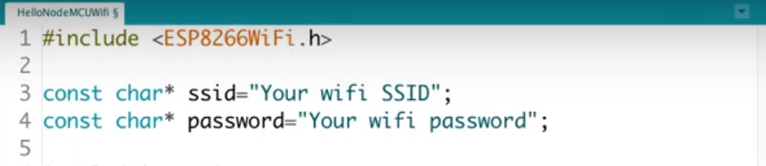

1. For configuration of buttons in BLYNK app

Step 1: Create a new project.

Step 2: Create “button” for bulb, fan and motor.

Step 3: Give correct GPIO pins of the NodeMCU which are correspondent to the hardware component.

Step 4: Name the buttons accordingly and check the whole setup.

Fig 8.2:Initial Page Fig 8.3: Fan Configuration

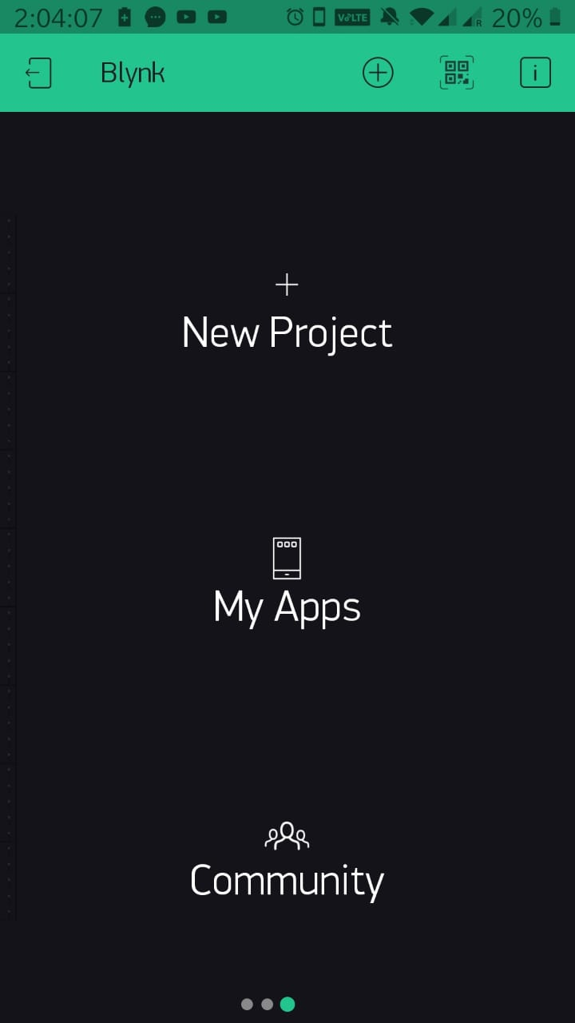 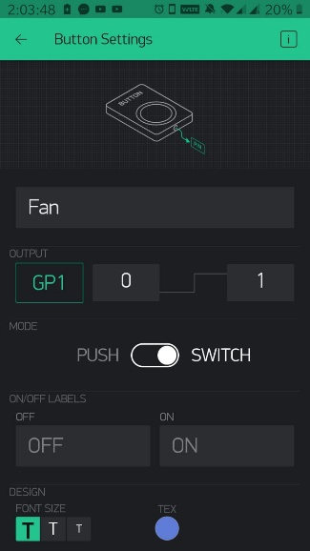

Fig 8.4:Motor Configuration Fig 8.5: Bulb Configuration

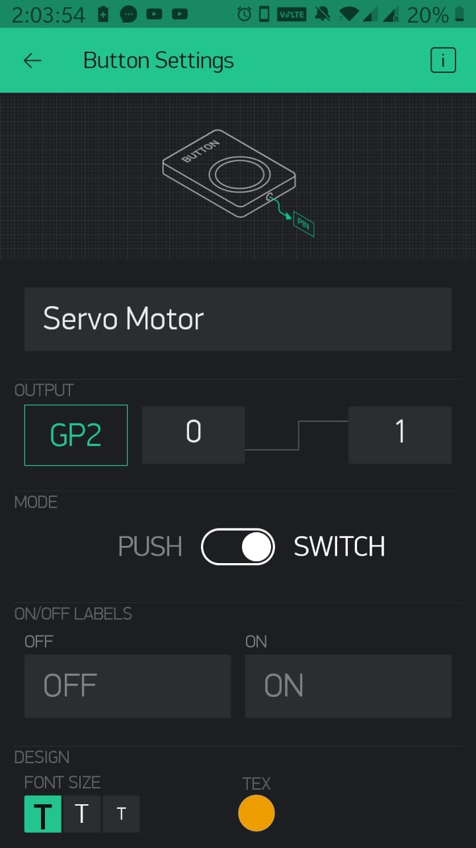 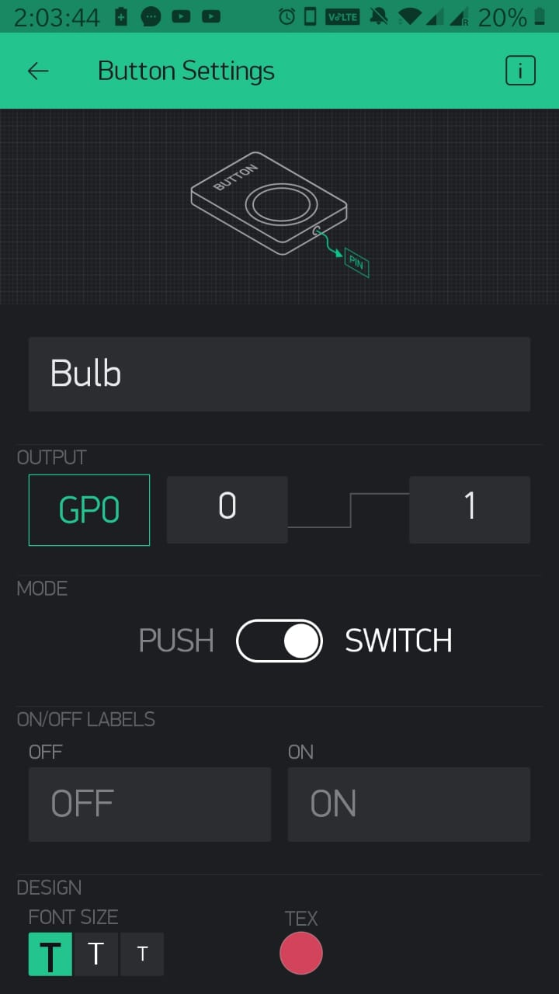

Fig 8.6: Final Page

