Project Requirement

This project is aimed at practicing the big data applications and analytics. A recommendation service system should be established to allow users navigating the large amount of data, and to make decisions based on the recommendations. This system manages all of its data at the back-end and supports browsing and searching interfaces over the Internet. These functionalities could be provided by integrating tools, associated with microservices considerations.

Each team will select the topic and distribute the workload based on the team decision.

All parts of the project should be done either individually or by a team of students. Teams will be established prior to the beginning of team assignments. Each team may have 4-8 people. Since the teamwork is the cornerstone of practical IT service world, it is important that you experience being a member of a virtual team in this collaborative learning environment.

Programming is NOT the focus of this project which should be linked directly to the user perspective/experience, or service-oriented tasks. In other words, as long as the system is available, useful, and effective, it does not matter on using whatever programming skills or languages.

Due time: Target to the mid-night of last class day.

Project Parts
Tentatively, this project could be broken down into five parts:

Part 1: Project Plan (15%)
A project plan should be generated to contain the necessary information as an IT project, such as project target, motivations, resource estimation, schedule arrangement, and etc.

Part 2: Data transformation (15%)
A volume of data should be collected and formatted. The data should be examined and designed as a data set for further utilization of big data analytics.

Part 3: Recommendation system (30%)
A recommendation service system should be designed and set up. The service system is the main development and testing platform. Once the service system is setup and running, users will be able to interact with back-end to obtain recommendations based on big data analytics.

Part 4: Implementing service interface (15%)
A service interface should be available to allow users interact with the recommendation system. The service should support queries both on numeric attributes (like birth day) and textual attributes (like skill/personality description) and allow simple keyword-based searches on textual attributes.

Part 5: Documents (25%)
Finally, the documents should be generated to wrap up the project and to guide users through a training procedure. The following items may be helpful:

- The system architecture diagrams and configurations.
- The user guides or operational menus for the service system.
- The potential training process/materials, such as demo, screenshots, or PowerPoint presentation.
- The source code and/or executable package.
- The report of project team work, including 1) name list team member; 2) task distribution for each individual, 3) amount of work for each role contribution.

Notes to Students

Selection of Partners
Students may implement the project individually or in teams of 4 – 8 people. The choice is up to each student, but please keeps the following rules in mind when you select your project partners:

An identical amount of work is expected and the same grading scale is used for individual and team projects. Faculty experience indicates that in general it is not necessarily easier or more productive to work in teams - it's largely a matter of personal preference and working style.

If you work in a team, choose your partners carefully. Teams are permitted to "divorce" at any time during the course (due to incompatibility, one partner dropping the course, or any other reason), and individual students may choose to team up as the project progresses, however students from divorced teams may not form new teams or join other teams. Put another way, if a student turns in any part of the project as part of a team, every later part of the project must be turned in individually or as part of the same team.

We will not entertain any complaints of the form "I did all the work and my partner did nothing." Choose your partner carefully!

If you work in a team, your work must be turned in jointly, as ONE submission. If we receive submissions from students in a team separately, they would get 10% off as a penalty. In addition, if the above separated submissions are different, the submission with a lower score prevails. Teamwork turned in as individual work will be considered as plagiarism and handled through official University channels.

Academic Honesty
Each of you is expected to submit your own original work, or the original work of your team in the project. On many occasions it is useful to ask others (the instructor, the TA, or other students) for hints or debugging help, or to talk generally about programming strategies. Such activity is both acceptable and encouraged, but you must indicate any assistance (human, online, or otherwise) that you received. Any assistance received that is not given proper citation will be considered plagiarism. In any event, you are responsible for coding, understanding, and being able to explain on your own or as a team all project work that you submit.

We will pursue aggressively all suspected cases of plagiarism, and they will be handled through official University channels. If you have any questions about this policy or about the degree to which we will pursue academic honesty violations, please discuss your concerns with the course instructor immediately.
Project Topic Samples (used by US college students)

Project Option 1
Stock Recommendation System

Motivation
- To help stock buyers to make wiser choices
- To find those who are very good at gaining profits from stocks (experts)
- Using user-based collaborative recommendation to find the similarity between the buyer and the expert
- Recommend the stock buyer some stocks from the most similar expert.
- To ease stock buyers from the heavy burden of looking through thousands of stocks and making a wise choice.

Dataset
NASDAQ Stock Exchange Data
● Yahoo Finance dataset for historical prices
● Simulated trading records of 100000 users

Algorithm
● User-based Collaborative Filtering with Inferred Tag
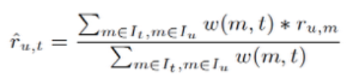

Tools
- Eclipse J2EE, Mahout, Maven, MySQL, PHP server

Progress
○ Implemented UI and database
○ Determine the algorithm—User-based Collaborative Filtering with Inferred Tag Ratings.

Expected Contributions
○ Achieve improved Collaborative Filtering algorithm with Inferred Tag Ratings.
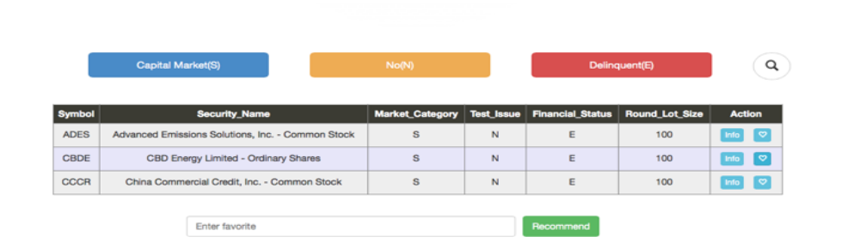
○ Present clients with sound stock recommendations based on the analysis of experts buying choices.
Project Option 2
Movie Exploration

Motivation
Audience preference:
I like comedies; I prefer blockbusters; I like Robert Downey Jr;
I’d like enjoy movies with my daughter; I ......

Direction for Producers:
What kind of movie customers would like to see?
Which actor is perfect match for this character?
Are there any qualities that make a memorable movie?

Dataset: online search
Tools: flexible
Algorithms:
Pig: process user profile

Cluster & Classification:
Make correlation among audience

Recommendation:
Make predication based upon the keywords, extractions and preferences

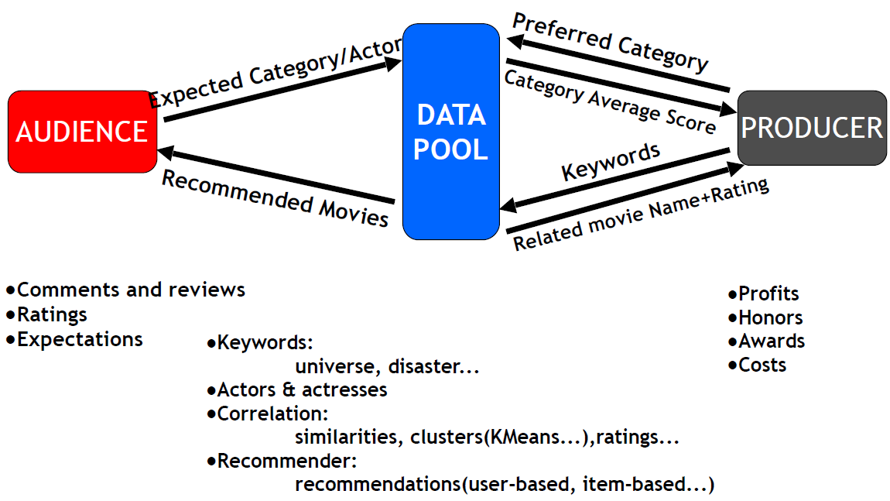
Expected Contributions

Project Option 3
Fantasy Basketball – Winning Strategy!

Motivation
Sports play a big role among people in USA. As a result, people spend more time on watching NBA, MLB, NFL...etc. for their leisure time. Within the last five years, ESPN and Yahoo release an online sports game of all the professional sports league for people to actually have a chance to form a simulated team online and compete with other gamers. The ranking of the online teams is based on the real world behavior of the players they pick for their teams. Therefore, drafting becomes a key factor for the victory of the game. We wish to provide a winning strategy for drafting. Moreover, we hope to provide a practical dynamic strategy for real NBA team to choose players.

Goal:
- Recommend a player for the online gamer every round
- Cluster all the players into different groups of different functionalities such as scoring, rebounding…etc.
- Rank the players inside each clustered group
- Give suggestion based on the present status of the online gamers

Dataset
- NBA player’s statistics
http://downloads.nbastuffer.com/nba-player-data-sets

or on the bottom of
https://www.nbastuffer.com/

Algorithms
- Clustering
- Kmeans clustering, f-kmeans clustering…etc
- PLA algorithms, Linear Regression…etc
- Classification, Recommendation

Tools
- Mahout, Matlab, and every resource provided from class

Progress
- Survey on the point system of Fantasy Basketball
- Search for all the dataset that might be useful to our recommendation
- Get familiar with all the tools and algorithms that we might use

Expected Contributions
- Set up a dynamic recommendation system for the game
- Help the gamer to build a balanced champion team for the game

Project Option 4
How to name your new-born baby (babies)?

Motivation
In this project, something (relatively) simple, but very important in terms of answering a real-life question could be worked on.

What name(s) should you give to your new-born baby (babies)? I would look at historical popular male/female baby names, and use the various Recommendation, as well as Classification and/or Clustering techniques to help the expecting parents to make the right name choice, so their children do not complain about having not-so-cool names for the rest of their lives.

Dataset
Popular male/female baby names going back to the 19th Century from the Social Security Administration.

Algorithms
User-based and Item-based Recommendation, Clustering and/or Classification

Tools
R
HDFS/Hive/PIG/HBase
Mahout

Expected Contributions
- Set up a dynamic “name” recommendation system for the users

Project Option 5
Exchange Rates Inquiry and Analysis

Motivation
With the international trade and commerce being of more importance, it's necessary not only for a specific group of industries but also for all of us to gain daily access to the updated currency rates.
With more convenience in getting the exchange rate information, which hopefully will be provided by our project, people are equipped with more related knowledge to make better decisions regarding to the currency market.

Dataset:
❖ Instant exchange rates from Bloomberg
❖ History exchange rates from http://www.livecharts.co.uk/historicaldata.php

Algorithm:
• We would forecast the exchange rate of currency in some targeted countries against US Dollar in a developed market, applying scalable model to forecast in real-time. And we would like to use RMSE to measure the reliability and accuracy of our prediction. Besides, by showing the statistical significance, such as P values, the repeatability of the outcome will then be proved.

Tools:
❖ Eclipse
❖ Tomcat
❖ Apache

Expected Contributions:
• Our project is initially designed to provide users with the following contents.
• Forward and cross exchange rates for most world currencies
• Both instant and history data
• Basic analysis of exchange rates including regression and K means
• Latest news about exchange rates

Key Factors Affecting Exchange Rate
PPP(Purchasing Power Parity)
INT(Interest Rate Differential)—Such as Libor
GDP(The Difference in GDP Growth Rates)
IGP(Income Growth Rate)
Relative Economic Strength—we may use factors like GDP and IGP to measure it quantitatively

Project Option 6
Google-Analytics, Graph – based Online Movie Recommendation System

Motivation
- To build our own movie website and implement the movie recommendation functionality.

Process Flow
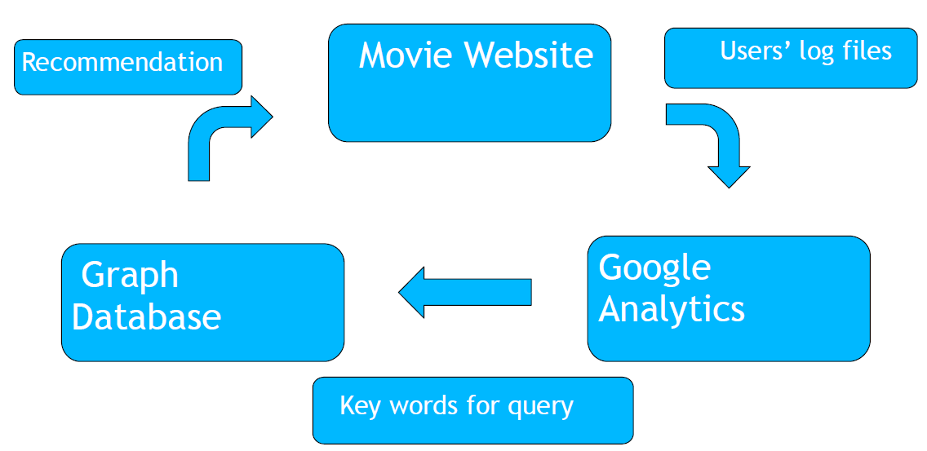
Dataset
MovieLens 1M dataset, which contains 1 million ratings from 6000 users on 4000 movies

- Algorithm
Various collaborative filtering algorithms, e.g. user-based recommendation, item-based recommendation etc.

- Tools
Web design - Dreamweaver / CoffeeCup
Users log file analysis - Google Analytics
Graph Database – Gremlin / Neo4j
Others – Mahout / Eclipse

Timeline:
Now -- 11/27/14: Movie website design and publish
11/28 – 12/04/14: Plug in Google Analytics in website and Analyze user log file
12/05 – 12/11/14: Generate Query for the Graph Database and update recommended movies on website

Expected Contributions:
- To build our own online movie website.
- To implement the movie recommendation functionality.
- To website analysis using Google Analytics

Project Option 7
STOCK FORECASTING USING HADOOP MAP-REDUCE

Motivation
• Stock Market has high profit and high risk features, on the stock market analysis and prediction research has been paid attention by people. The stock price trend is complex nonlinear function so the price has certain predictability
• Hadoop MapReduce is a latest framework specially designed for processing large datasets on distributed sources. Apache’s Hadoop is an implementation of MapReduce

Dataset

Algorithms:
• Pearson Correlation Similarity
• Euclidean Distance Similarity
• Stochastic Gradient Descent (SDG)

Tools:
• Hadoop
• Mahout
• Hbase

Expected Contributions:
We are going to analyze the dataset called Daily Holdings for All ProShares ETFs which contains tons of information collected from the stock exchange market. The first step
is to scrutinize the data and provide the stock which may go up potentially. With these screened stocks, suggest a certain user a potential stock which she/he may be interested in.

Project Option 8
Customer Complaint Analyses
Insights into Issues plaguing the Banking Sector

Motivation
➢ One of the biggest challenges for banks is minimizing customer attrition rate which is directly dependent on customer satisfaction.
➢ Customers are inclined to choose the banks who can be trusted for their services.
➢ Banks make their decisions based on a subset of data because of absence of scalable solutions.

In this project, a scalable design should be used to counter the above problems!

Dataset, Algorithm, Tools
➢Consumer Complaints Database: The dataset contains
Retail consumer complaints with banks and financial institutions (provided by Consumer Financial Protection Bureau). http://www.consumerfinance.gov/complaintdatabase/

➢Algorithms: Various Clustering and Classification Algorithms
➢Tools and Languages: Hadoop, Mahout, Java, Python

Expected Contributions
➢Major retail banking issues by state and match-analyze them based on geographic or socio-economic brackets.
➢Top concerns of consumers in various states.
➢Derive business impact of customer satisfaction or dissatisfaction with their complaints on the institution.
➢Propose likely solutions that can be deemed as “first response” for future complaints of similar nature.
➢Hypothesize a performance metric to apply to all complaints – can be used to prioritize complaints based on resolution time.

