**NAME: HUMPHERY MARVELOUS**

**LOW-FIDELITY PROTOTYPE TYPE WAS USED**

A SIMPLIFIED PROTOTYPE OF AN **AUTOMATED FOOTBALL MANAGEMENT SYSTEM FOR VC CUP IN UNIDEL**

**Key features of the System**

1. **Login & Registration:** Basic authentication for players, teams and admins.
2. **Match Schedule:** list of upcoming matches with team names and timing.
3. **Leaderboard:** displays top teams, points and other details.
4. **Update results in real-time:** Scores, team rankings, and statistics will be updated instantly.
5. **Notifications:** Alerts for upcoming matches, results and other updates.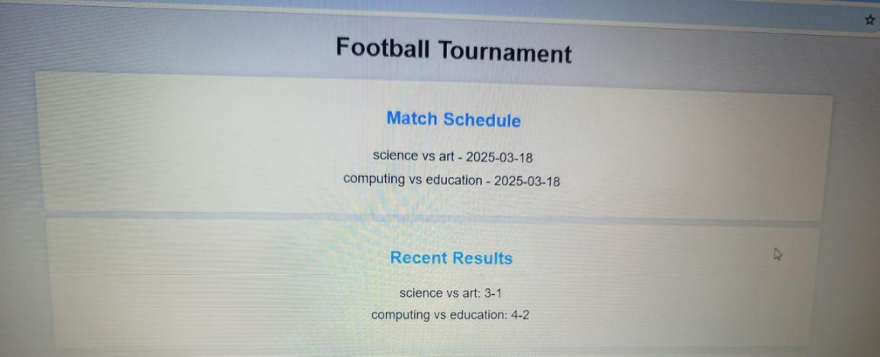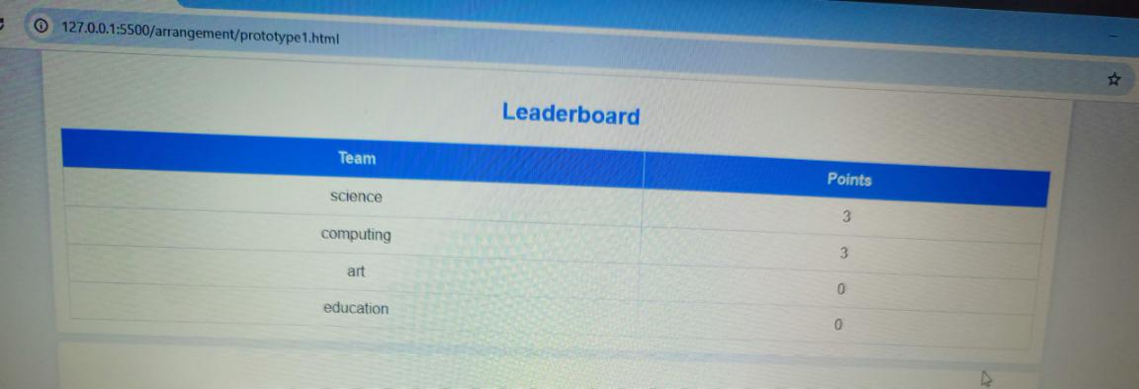
6. **Admin panel:** for adding teams, editing scores, and managing users

