Programme: MSc Big Data Technologies
Student Name: Radheshyam Subedi
Student ID: U2829927
Title: Structuring Resilience: Enhancing Hierarchical Multi-Agent Portfolio Optimization with Semantic Diversification via a Weight-Aware Lexical Ratio

Introduction
Modern Portfolio Theory (Markowitz, 1952) established that diversification is the primary way to reduce investment risk. Historically, the financial industry has used price covariance to measure this diversification. However, algorithmic trading has exposed a major flaw in this logic.
Currently, algorithms rely on Reinforcement Learning (RL) to manage portfolios. The problem is that Deep RL agents tend to "herd," concentrating capital into high-yield assets to maximize short-term rewards. Multi-Agent Reinforcement Learning (MARL) systems, like the MAPS framework (Lee et al., 2020), try to fix this by dividing the work among independent agents. But these systems still rely on price correlation to ensure the agents pick diverse stocks.
This is fundamentally flawed because price correlations are unstable. As Flint, Seymour, and Chikurunhe (2020) point out, assets that seem uncorrelated during a bull market will suddenly crash together during a panic—a concept known as tail dependence.
This document proposes a technical implementation of Semantic Diversification. Instead of relying on reactive price charts, I will use Natural Language Processing (NLP) to read static company 10-K business descriptions. By calculating a "Weight-Aware Lexical Ratio," the AI will learn what companies actually do. This research will demonstrate how using textual constraints in an RL environment forces the creation of portfolios that are structurally resilient to market shocks.

Statement of Problem
The core problem with algorithmic portfolio management is its total reliance on dynamic price data, which is highly unstable. When a systemic crisis hits, such as the Q1 2020 COVID-19 crash, historical price covariance completely breaks down. An AI agent might calculate that it holds a diverse portfolio of 50 stocks, but when panic selling starts, the math fails and the portfolio suffers catastrophic losses.
A common workaround is sector diversification. But sector diversification does not guarantee semantic diversification. Two companies in the Technology sector might have completely different business models, while a Tech company and an Automotive company might rely on the exact same fragile supply chain.
I ran a preliminary data analysis in a Jupyter Notebook to prove this flaw. I pulled data for the top 20 performing stocks in the S&P 500 and ran a correlation study comparing their price behavior against their semantic business descriptions. The Average Price Correlation was over 0.50 (highly correlated), but the Average Lexical Similarity was under 0.30 (highly diverse).
This proves that assets moving in lockstep on a price chart often possess completely different structural vulnerabilities. Standard MARL agents are blind to this. Because they ignore a company's persistent economic identity, they build fragile portfolios based on transient market sentiment. We need a system that penalizes agents for buying fundamentally similar companies, regardless of their stock charts.

Objectives
My primary goal is to build, train, and evaluate a Hierarchical MARL framework that uses textual data to restrict how the AI allocates capital.
Primary Objective: I will determine if a MARL system, constrained by a Weight-Aware Lexical Penalty, can achieve better risk-adjusted returns and a lower Conditional Value at Risk (CVaR) than standard price-based methods during market downturns.
To answer this, I will address three sub-objectives:
- Measure Tail-Risk Resilience: Establish whether static semantic data (10-K descriptions) acts as a more reliable signal for diversification than dynamic price data during the Q1 2020 crash.
- Conduct Trade-off Analysis: Test how changing the strength of the semantic penalty λ impacts the balance between total profit and portfolio concentration.
- Validate the Architecture: Prove that a "Manager-Worker" hierarchical setup successfully separates systemic risk (sector allocation) from idiosyncratic risk (individual stock selection).

Plan of Action
This section details how I will engineer the system and run the experiments to prove the hypothesis.
1. Data Ingestion and Processing
I will use the yfinance library to download daily OHLCV data for the S&P 500 constituents from January 2015 to January 2024. Simultaneously, I will extract the "Long Business Summaries" from the 10-K filings of these companies. I will process the text using TF-IDF vectorization to calculate a Cosine Similarity Matrix (S). This matrix provides a strict mathematical score representing how semantically similar any two companies are based on their actual operations.
2. Architecture and the Reward Function
The trading environment will be built using the Gymnasium library. The agents will be constructed using the Ensemble of Identical Independent Evaluators (EIIE) neural network topology (Jiang, Xu, and Liang, 2017). This structure shares weights across assets, preventing the AI from memorizing ticker symbols, and includes a Portfolio-Vector Memory (PVM) so the agent remembers its current exposure.
The critical novelty is the reward function. I am implementing a Weight-Aware Lexical Penalty and a Turnover Penalty. The environment penalizes the agent for holding similar companies, scaling the penalty based on actual capital exposure (w). It also penalizes excessive trading. The reward formula is:
R_total = R_portfolio - [ λ * Σ (w_i * w_j * S_ij) ] - [ γ * Σ |w_t - w_t-1| ]
Here, λ controls the strictness of the semantic rule, and γ represents the transaction cost penalty.
3. Training Strategy: Walk-Forward Validation
To prevent overfitting to non-stationary financial data, I will train the MADDPG algorithm using Walk-Forward Validation (Rolling Retraining). The model will train on a historical window (e.g., 2015–2019) and test on 2020. It will then absorb the 2020 data, retrain, and test on 2021, proving the agent can adapt to new regimes.
4. Experimental Framework and Robustness Checks
- Cross-Period Evaluation: I will segment testing into a Bull period (2017–2019), the COVID Crisis (2020), and a High-rate regime (2022–2023). For the 2020 crash, I will perform a Drawdown Decomposition to compare depth, frequency, and recovery speed.
- Risk and Concentration Metrics: I will calculate CVaR (95%), the Sortino Ratio, and the Calmar Ratio. To measure concentration, I will use the Herfindahl-Hirschman Index
$$HHI=∑w_{i}^{2}$$

and the Effective Number of Assets
$$N_{eff}=1/HHI$$
Allocation stability will be tracked via the standard deviation of portfolio weights.
- Ablation and Sensitivity Studies: I will run a Random Text Control experiment by shuffling the TF-IDF vectors and retraining the agent to prove the semantic structure is meaningful. I will also run a λ Sensitivity Analysis (λ = 0, 0.1, 0.5, 1.0) and a Correlation vs. Semantic Similarity study to prove price and text capture different structures.
- Visualizations: I will generate hierarchical clustering heatmaps to contrast the price-only MARL holdings versus the semantic MARL holdings, and plot lexical diversity as a time series.

Management Plan

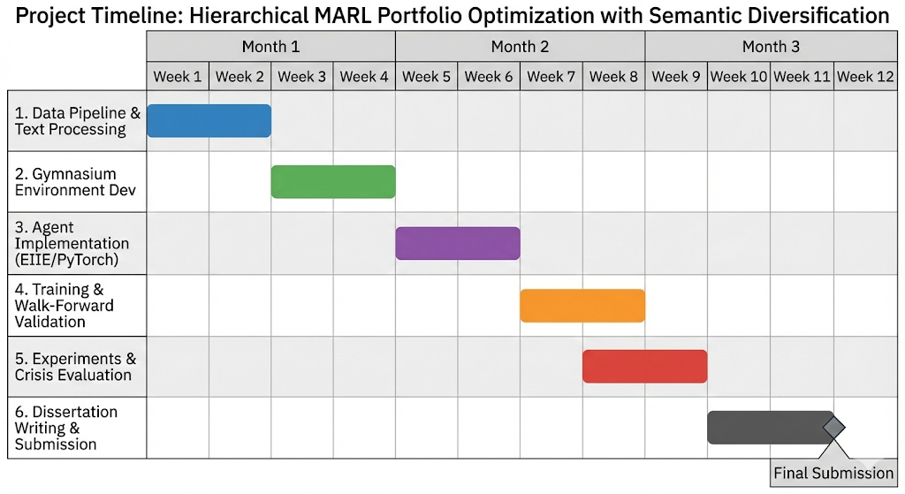
Figure 1 Gantt Chart
This research will take 12 weeks. The project relies entirely on open-source tools, meaning there are no financial costs. I will use the Yahoo Finance API for data ingestion and cloud-based GPU compute environments (Google Colab) for training. The software stack includes Python, PyTorch, Gymnasium, and Scikit-learn.
Schedule of Milestones:
- Weeks 1 to 2: Finalize data ingestion scripts and compute the TF-IDF Lexical Similarity Matrix.
- Weeks 3 to 4: Build the LexicalPortfolioEnv (Gymnasium) and code the Weight-Aware and Turnover reward functions.
- Weeks 5 to 6: Code the EIIE network and PVM mechanism in PyTorch; connect Manager and Worker agents.
- Weeks 7 to 8: Start MADDPG training loops, execute Walk-Forward validation, and tune hyperparameters.
- Weeks 9 to 10: Run cross-period tests, calculate tail-risk metrics (CVaR, HHI), and execute the Random Text Control study.
- Weeks 11 to 12: Generate final visualizations (cluster heatmaps, drawdown profiles) and finish the dissertation manuscript.
As a student in the MSc Big Data Technologies program, I have the required technical background, including proficiency in Python, PyTorch deep learning models, and Reinforcement Learning mathematics.

Conclusion
Multi-Agent Reinforcement Learning is highly effective for portfolio optimization, but relying on unstable price covariance leaves portfolios exposed to systemic tail-risks. This proposal outlines a direct, NLP-driven method to fix this flaw. By building a Hierarchical MARL environment that enforces structural diversification through a Weight-Aware Lexical Ratio, this research will mathematically force AI agents to build resilience against market crashes and sudden regime shifts.

References
Flint, E., Seymour, A. and Chikurunhe, F. (2020) 'Defining and measuring portfolio diversification', South African Actuarial Journal, 20, pp. 17-48.
Jiang, Z., Xu, D. and Liang, J. (2017) 'A Deep Reinforcement Learning Framework for the Financial Portfolio Management Problem', arXiv preprint arXiv:1706.10059.
Lee, J., Kim, R., Yi, S.W. and Kang, J. (2020) 'MAPS: Multi-agent reinforcement learning-based portfolio management system', Proceedings of the IJCAI Special Track on AI in FinTech.
Liu, X.Y., Yang, H., Chen, Q., Zhang, R., Yang, L., Xiao, B. and Wang, C.D. (2020) 'FinRL: A Deep Reinforcement Learning Library for Automated Stock Trading in Quantitative Finance', arXiv preprint arXiv:2011.09607.
Loughran, T. and McDonald, B. (2011) 'When is a Liability not a Liability? Textual Analysis, Dictionaries, and 10-Ks', The Journal of Finance, 66(1), pp. 35-65.
Lowe, R., Wu, Y., Tamar, A., Harb, J., Abbeel, P. and Mordatch, I. (2017) 'Multi-Agent Actor-Critic for Mixed Cooperative-Competitive Environments', Advances in Neural Information Processing Systems, 30.
Markowitz, H. (1952) 'Portfolio Selection', The Journal of Finance, 7(1), pp. 77-91.
Mohseni, S.F., Arian, H. and Bégin, J.F. (2024) 'The lexical ratio: A new perspective on portfolio diversification', arXiv preprint arXiv:2411.06080.

