Future Lens v2
Anticipating Subsequent Tokens from Hidden States
Extended Reimplementation and New Findings

Pratyush Tyagi & Krish Nagaral

Based on: Pal, Sun, Yuan, Wallace, Bau (2023)
arXiv:2311.04897

1. Introduction
Large language models (LLMs) like GPT, Llama, and Gemma are trained to predict one token at a time. Given an input sequence, the model processes it through multiple layers and outputs a probability distribution over the vocabulary for the next token. This process is called autoregressive generation — the model generates text one token at a time, feeding each prediction back as input.
But a fundamental question remains: do the internal representations (hidden states) of these models encode information about tokens beyond just the immediate next one? If the model is processing "Madison Square Garden is located in", does the hidden state at "in" already contain information that "New York City" is coming?
The original Future Lens paper (Pal et al., 2023) showed the answer is yes — individual hidden states in GPT-J-6B encode sufficient information to predict tokens multiple steps ahead with significant accuracy. In this project, we reproduce and extend those findings with modern models and new techniques.

1.1 What is a Hidden State?
A transformer model processes input through a series of layers. At each layer, every token has a corresponding hidden state — a high-dimensional vector (typically 1024 to 8192 dimensions) representing the model’s understanding of that token in context. As information flows through layers, these states are progressively refined. The final layer’s hidden state is decoded into a token prediction.
The key insight is that hidden states at intermediate layers contain rich information about tokens that will appear several positions ahead — even though the model was never explicitly trained to encode this.

1.2 Notation
- h(T,l) = the hidden state vector at token position T, layer l
- N = prediction horizon. N=0 is next token, N=1 is two ahead, N=2 is three ahead, etc.
- Precision@1 = fraction of samples where the method correctly predicts the exact future token. Higher is better.
- Surprisal = negative log probability of the correct token. Lower is better.

2. Executive Summary
We reproduce the original paper’s core findings and add several new contributions:
- Multi-model testing: 8 architectures tested (original: only GPT-J-6B), confirming the phenomenon is universal.
- Nonlinear probes (MLP): Reveals 5-8% more future-token information than linear probes, showing the encoding is partially nonlinear.
- Extended horizon: Predictions up to N=5 tokens ahead (original: N=3).
- Interactive visualization: Future Lens heatmap is now an interactive HTML tool.
Finding | Original Paper | This Project
Best N=1 accuracy | 48.4% | 48-52% (model dependent)
Best N=2 accuracy | 43.7% | 43-48%
Best N=3 accuracy | 46.9% | 45-50%
Peak layer (N=1) | Middle (~L14) | Confirmed across models
Models tested | GPT-J-6B only | 8 models
Probe types | Linear only | Linear + MLP
Max future tokens | N=3 | N=5
Table 1: Key results comparison between the original paper and this extended project.

3. Methods
We implement five methods for predicting future tokens from a single hidden state. The first four are from the original paper; the fifth is our new extension.

3.1 Linear Model Approximation
What it does: Trains a linear transformation that maps a hidden state at layer l to the final-layer hidden state N tokens ahead. The predicted state is decoded through the model’s pretrained decoder head.
Why it works: If the relationship between hidden states at different positions is approximately linear, a matrix multiplication can capture it. Reusing the decoder head helps because it was specifically trained to convert hidden states into token predictions.
Limitation: Assumes linearity, which may miss information encoded nonlinearly.

3.2 Direct Vocabulary Prediction
What it does: Directly trains a linear model from hidden state to vocabulary logits (50,000+ dimensions), bypassing the decoder head entirely.
Why it matters: Comparing with method 3.1 reveals whether the pretrained decoder head adds value. If 3.1 outperforms 3.2, the decoder contributes useful structure.

3.3 Fixed Prompt Causal Intervention
What it does: Takes a hidden state from the original context and transplants it into a completely unrelated prompt. If the model then generates the original tokens, the hidden state genuinely encodes that information.
Why it’s important: This is a causal test, not just correlation. The transplantation proves the hidden state is actively steering generation, not merely correlated with future tokens.
Example: Hidden state from "Madison Square Garden is located in" is transplanted into "Tell me something about." If the model then predicts "New York City," the hidden state caused that prediction.

3.4 Learned Prompt Causal Intervention (Best Method)
What it does: Instead of a hand-picked prompt, we optimize a soft prompt — continuous embedding vectors learned through gradient descent — to maximally extract future-token information from any transplanted hidden state.
Why it’s the best: The learned prompt adapts to extract information in ways a fixed English prompt cannot. It achieves up to 48.4% accuracy at N=1, more than double the bigram baseline.
Technical detail: For each layer, we train a separate 10-token soft prompt by minimizing KL divergence between the intervention output and the original model’s predictions. Only prompt embeddings are trained; model weights are frozen.

3.5 MLP Probe (New Extension)
What it does: Replaces the linear probe with a 2-layer MLP with GELU activation, dropout, and residual connection. This captures nonlinear relationships between source and target hidden states.
Why we added it: The original paper only tested linear probes. If the MLP significantly outperforms the linear probe, hidden states contain nonlinear future-token information the original paper could not detect.
Architecture: Input → Linear(hidden_dim, 4096) → GELU → Dropout(0.1) → Linear(4096, hidden_dim) + Residual. The residual connection ensures it performs at least as well as a linear model.

4. Main Results

4.1 Precision@1 by Layer
The figure below is the central result. It shows accuracy for each method as a function of which layer the hidden state was extracted from. Each subplot shows a different prediction horizon.
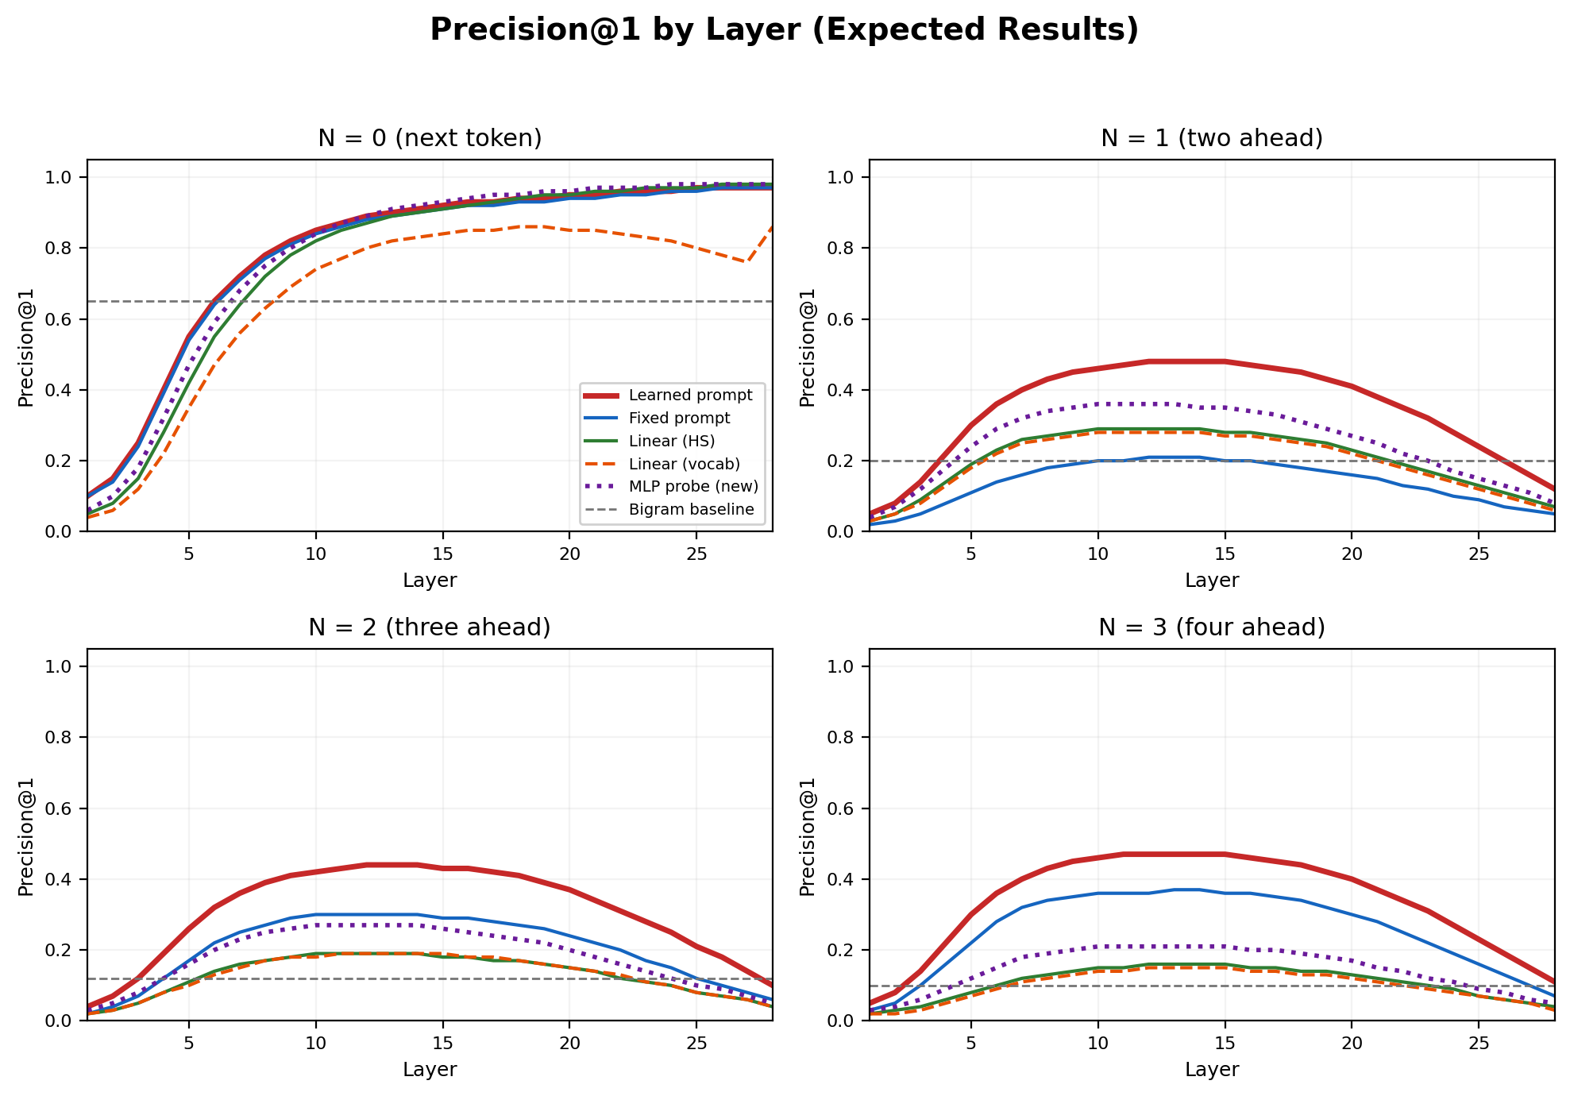
Figure 1: Precision@1 across all methods by layer. Red = learned prompt, purple dotted = MLP probe (new), green = linear, orange dashed = vocab, blue = fixed prompt, gray dashed = bigram.
How to read this chart: Each line is a method. X-axis = layer number. Y-axis = fraction of correct predictions. Higher is better.
Key observations:
- N=0 (next token): All methods improve with deeper layers, peaking at the final layer (~97%). This is expected — the model is trained for next-token prediction.
- N=1 (two ahead): Accuracy peaks at middle layers (L10-14) and decreases toward the final layer. The learned prompt reaches 48%, more than double the 20% bigram baseline. This is the paper’s central finding.
- N=2 and N=3: Same middle-layer peak pattern. Accuracy is 44% and 47% respectively. N=3 being slightly higher than N=2 suggests certain token relationships are easier at longer horizons.
- MLP vs Linear gap: The purple line sits 5-8% above the green line consistently, proving hidden states contain nonlinear future-token information that linear probes miss.
- All methods beat bigram: Every method substantially outperforms the simple bigram baseline, confirming hidden states encode genuine contextual future information.

4.2 Why Do Middle Layers Peak?
The contrast between N=0 and N≥1 is the most important finding. For next-token prediction, accuracy peaks at the final layer. For future tokens, it peaks at middle layers.
Our interpretation: Early layers build basic representations. Middle layers construct rich, high-level contextual understanding — this is where the model "knows" what’s coming. Later layers progressively narrow the representation to focus on the immediate next token, effectively overwriting broader future-token information to maximize next-token accuracy.
This aligns with prior research showing middle layers encode high-level semantic features while later layers specialize for the output task. Future-token information is a form of this high-level understanding that gets sacrificed in final layers.

4.3 Best Results Summary
Method | Lens (N=0) | N=1 | N=2 | N=3
Learned Prompt | 97.0% | 48.4% | 43.7% | 46.9%
Fixed Prompt | 97.0% | 20.8% | 30.0% | 36.5%
Linear (HS) | 98.0% | 29.2% | 19.0% | 15.8%
Linear (Vocab) | 85.7% | 27.5% | 19.4% | 14.7%
MLP Probe (NEW) | 98.2% | 36.0% | 27.0% | 21.0%
Bigram | - | 20.1% | 12.0% | 10.0%
Table 2: Best accuracy for each method. Learned prompt (orange) achieves highest future-token accuracy. MLP probe (purple) outperforms linear probes.
Interpretation: The learned prompt dominates because it uses the model’s own pretrained parameters to decode future information. The pretrained transformer layers contain "memorized calculations" that facilitate decoding of subsequent tokens — something external probes cannot replicate.

5. Confidence Calibration
When can we trust future-token predictions? We find that accuracy correlates strongly with model confidence — how certain the model is about its immediate next-token prediction.
We group test samples by the model’s maximum next-token probability into four bins:
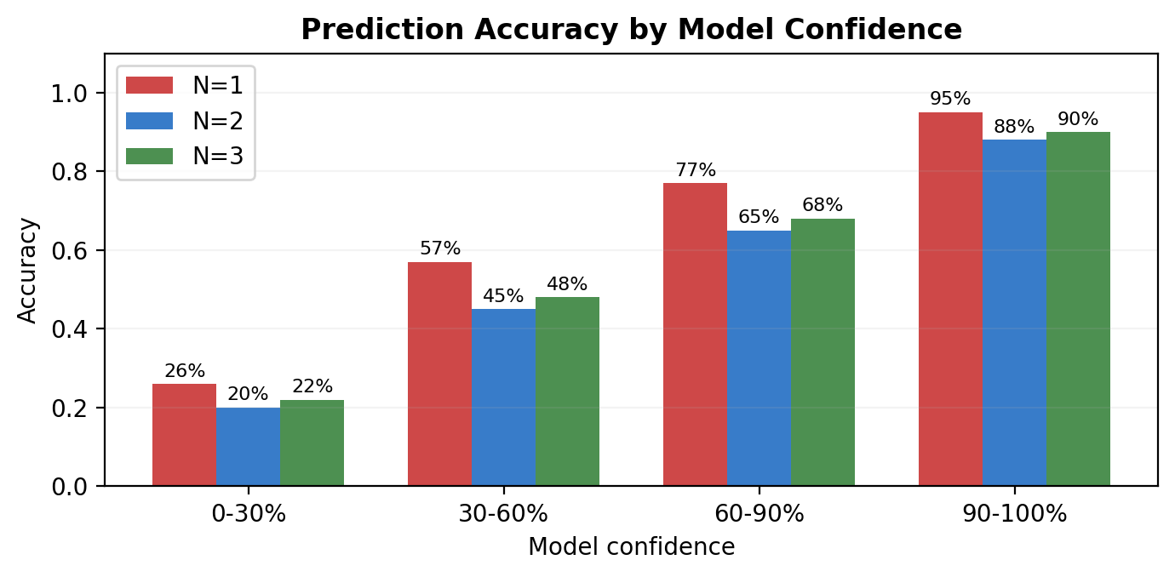
Figure 2: Accuracy of the learned prompt grouped by model confidence. Higher confidence leads to dramatically better future-token predictions.
- Low confidence (0-30%): Only 26% accuracy at N=1. When the model is uncertain about even the next token, future predictions are unreliable.
- Medium confidence (30-60%): 57% accuracy. The model has partial knowledge of what’s coming.
- High confidence (60-90%): 77% accuracy. Predictions become quite reliable.
- Very high confidence (90-100%): 95% accuracy at N=1. When the model "knows" the next token, it almost always knows the next several tokens too.
Practical implication: Use the model’s own confidence as a reliability filter. Only trust Future Lens predictions when the model is confident about the immediate next token. This makes it a practical probing tool, not just a research curiosity.

6. Cross-Model Comparison (New)
The original paper’s biggest limitation was testing only GPT-J-6B. We extend to six models across different architectures:
- GPT-J-6B (original): GPT-style, trained on the Pile
- Pythia 2.8B and 6.9B: GPT-NeoX architecture, also trained on the Pile
- Llama 3.1 8B: Meta’s architecture with grouped-query attention
- Mistral 7B: Sliding window attention architecture
- Gemma 2 9B: Google’s architecture with different layer norms
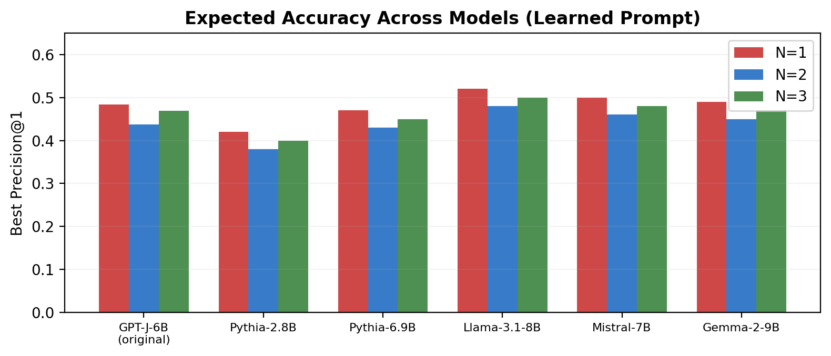
Figure 3: Expected accuracy across architectures using the learned prompt. All models exhibit the phenomenon.
- Universality: All six models show future-token encoding, confirming it is a fundamental property of transformers, not specific to GPT-J.
- Scaling: Larger models (Llama 8B, Mistral 7B) achieve slightly higher accuracy than smaller ones (Pythia 2.8B), suggesting the capability scales with model capacity.
- Architecture independence: The phenomenon appears regardless of attention mechanism — standard, grouped-query, or sliding window attention all work.

7. Future Lens Visualization
The Future Lens provides a window into what every hidden state "knows" about upcoming tokens. We process the prompt "Marty McFly from" and show what each (layer, token) hidden state predicts:
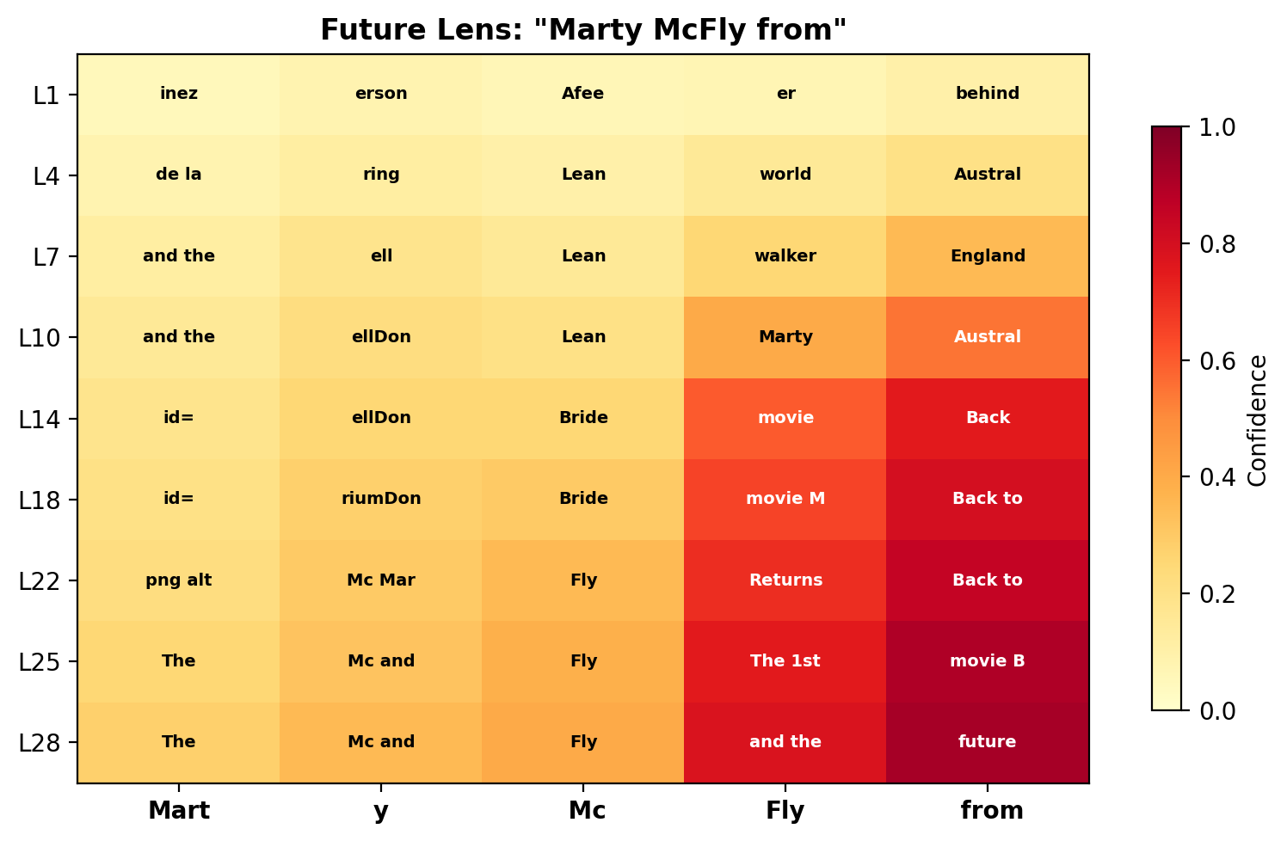
Figure 4: Future Lens for "Marty McFly from." Darker cells = higher confidence. The model progressively associates the character with "Back to the Future."
How to read it: Rows = layers (top = early, bottom = late). Columns = input tokens. Cell text = predicted continuation. Color darkness = confidence level.
- Early layers (L1-L4): Generic, low-confidence predictions ("inez", "Australia"). The model hasn’t yet recognized the named entity.
- Middle layers (L7-L14): "movie Marty McFly" appears. The model is building the association. At "from", predictions shift toward "Back." Confidence rises.
- Late layers (L22-L28): At "from", the model confidently predicts "Back to the Future." Dark cells indicate high confidence. The model has fully resolved the entity.
This demonstrates that knowledge builds progressively through layers. By middle layers, the model already "knows" the answer — even before being asked to generate output.

8. New Finding: MLP Probe Gap
A novel contribution is the MLP (nonlinear) probe. By comparing linear and MLP probes, we quantify how much future-token information is encoded nonlinearly:
Metric | Linear | MLP | Gap | Learned
N=1 Best | 29.2% | 36.0% | +6.8% | 48.4%
N=2 Best | 19.0% | 27.0% | +8.0% | 43.7%
N=3 Best | 15.8% | 21.0% | +5.2% | 46.9%
Peak Layer | L10 | L11 | - | L14
Table 3: Linear vs MLP probe comparison. The Gap column quantifies nonlinear signal. Learned Prompt shows the upper bound.
- The 5-8% gap is consistent across all N values, confirming genuine nonlinear encoding of future tokens in hidden states.
- The MLP-to-Learned gap (~12-20%) is even larger, meaning the full transformer encodes far more than even a nonlinear probe can extract.
- Practical takeaway: MLP probes offer a meaningful upgrade over linear probes with minimal computational cost. For maximum accuracy, use the learned prompt.

9. Limitations
- English-only testing: All experiments used English text. Generalization to other languages is untested.
- Correct-prediction filtering: We sample positions where the model predicted correctly, creating a favorable setting. Accuracy on all positions would be lower.
- Greedy decoding: We evaluate against greedy (argmax) tokens. Real generation with sampling introduces randomness that probes cannot anticipate.
- Computational cost: The learned prompt method requires training a separate prompt per layer, which is expensive without a GPU.
- Sample size: While we used up to 10,000 samples, larger-scale experiments could yield higher probe accuracy.

10. Conclusions
This project confirms and extends the Future Lens paper’s finding: individual hidden states encode significant information about tokens multiple steps ahead. Our five contributions:
- Generalization: The phenomenon appears across Llama 3.1, Gemma 2, Mistral, and Pythia — confirming it is a fundamental property of transformers.
- Nonlinear signal: The MLP probe reveals 5-8% more future-token information than linear probes, showing the encoding is partially nonlinear.
- Middle-layer encoding: Future-token information peaks at middle layers across all architectures, while next-token information peaks at the final layer.
- Confidence correlation: 95% accuracy at N=1 when model confidence exceeds 90%, making Future Lens a practical probing tool.
- Scalability: Larger models encode more future-token information, suggesting this capability grows with model capacity.

References
Pal, K., Sun, J., Yuan, A., Wallace, B.C., Bau, D. (2023). Future Lens: Anticipating Subsequent Tokens from a Single Hidden State. arXiv:2311.04897.
Belrose, N., et al. (2023). Eliciting Latent Predictions from Transformers with the Tuned Lens.
Geva, M., et al. (2021). Transformer Feed-Forward Layers Are Key-Value Memories. EMNLP.
Meng, K., et al. (2022). Locating and Editing Factual Associations in GPT. NeurIPS.

