COMMUTE TIME ANALYSIS USING PYTHON AND MICROSOFT POWER BI

A Professional Technical Project Report
Prepared by

Rufai-Ahmad Mohammed
Fellow Number: FE/26/2763845978
Programme:
Data Analysis NextGen Cohort
Institution:
Omni Digital Media Institute
Location:
Federal Capital Territory, Nigeria
Email:
ahmadrufai2001@gmail.com
Date
August 2026

Declaration
I hereby declare that this project titled "Commute Time Analysis Using Python and Microsoft Power BI" is my original work completed during the Data Analysis NextGen Cohort at Omni Digital Media Institute.
All external sources, documentation, and learning materials used in the preparation of this project have been properly acknowledged.
This project has not been submitted elsewhere for any academic or professional certification.
Rufai-Ahmad Mohammed
FE/26/2763845978

Acknowledgements
I sincerely thank God Almighty for granting me the wisdom, strength, and perseverance to complete this project successfully.
I would also like to express my appreciation to the instructors and management of Omni Digital Media Institute for providing practical training in Python, Microsoft Excel, SQL, and Microsoft Power BI.
Special thanks go to my fellow learners in the Data Analysis NextGen Cohort for their encouragement, collaboration, and continuous support throughout the learning journey.
Finally, I appreciate my family and friends for believing in me and supporting me throughout the duration of this programme.

Executive Summary
Understanding commuting patterns is essential for improving transportation planning and supporting data-driven decision-making. This project analyses commuting behaviour using an Abuja commute dataset containing 250 observations.
The project was completed using a modern data analytics workflow. Microsoft Excel was used for initial data preparation, Python was employed for data cleaning, exploratory data analysis, descriptive statistics, and visualization, while Microsoft Power BI was used to develop an interactive dashboard that presents key insights.
The analysis focused on identifying:
- Average commute time
- Transportation fare patterns
- Transport mode distribution
- Effect of traffic conditions
- Impact of weather on commuting
The results indicate that the average commute time was approximately 41.81 minutes, while the average transportation fare was approximately ₦3,175. Traffic congestion significantly increased travel time, whereas buses remained the most affordable transportation option among the available transport modes.
The Power BI dashboard transformed the analytical results into an interactive reporting tool capable of supporting transportation planning and operational decision-making.
This project demonstrates how Python and Microsoft Power BI can be integrated to perform end-to-end data analysis and produce actionable business insights from transportation data.

Table of Contents

Table of Contents

List of Figures
- Figure 4.1 Dataset Preview
- Figure 4.2 Dataset Information (df.info())
- Figure 4.3 Data Cleaning Process
- Figure 4.4 Descriptive Statistics
- Figure 4.5 Average Commute Time by Traffic Level
- Figure 4.6 Average Transportation Fare by Transport Mode
- Figure 4.7 Transport Mode Frequency
- Figure 4.8 Microsoft Power BI Dashboard

List of Tables
- Table 3.1 Dataset Description
- Table 3.2 Variables Used in the Analysis
- Table 3.3 Software and Tools
- Table 4.1 Descriptive Statistics Summary

CHAPTER ONE

1. Project Introduction

1.1 Background
Transportation is a critical part of daily life, influencing how people access work, education, healthcare, and other essential services. In growing cities such as Abuja, increasing traffic congestion, rising transportation costs, and changing weather conditions have made daily commuting more challenging. These factors affect travel efficiency, productivity, and overall quality of life.
With the growing availability of digital data, organizations and governments are increasingly using data analytics to understand commuting behaviour and improve transportation planning. By analysing historical transportation data, decision-makers can identify trends, evaluate traffic conditions, and make informed decisions that improve mobility.
Python has become one of the most widely used programming languages for data analysis because it provides powerful libraries such as Pandas for cleaning, analysing, and visualizing data. Microsoft Power BI complements this process by transforming analytical results into interactive dashboards that communicate insights clearly to both technical and non-technical audiences.
This project combines Python and Microsoft Power BI to analyse an Abuja commute dataset containing 250 records. The objective is to explore commuting patterns, understand the relationship between traffic conditions and travel time, compare transportation fares across transport modes, and present the findings through an interactive dashboard.

1.2 Problem Statement
Daily commuters in Abuja often experience unpredictable travel times and varying transportation costs due to traffic congestion, weather conditions, and differences in transport modes. Without analysing transportation data, it is difficult to identify the factors contributing to these challenges or to make informed decisions that improve commuting efficiency.
This project addresses this problem by applying Python and Microsoft Power BI to analyse commuting data, identify patterns, and present insights that can support data-driven transportation planning.

1.3 Project Objectives
The main objective of this project is to analyse commute time patterns using Python and Microsoft Power BI.
Specific objectives include:
- Analyse average commute time.
- Examine transportation fare patterns.
- Compare transportation fares across transport modes.
- Evaluate the impact of traffic levels on commute time.
- Explore the influence of weather conditions on travel.
- Develop an interactive Power BI dashboard for visualizing key insights.

1.4 Business Questions
The project seeks to answer the following questions:
- What is the average commute time?
- Which transport mode has the highest average transportation fare?
- How does traffic level affect commute time?
- Which transport mode is used most frequently?
- How can interactive dashboards improve understanding of transportation data?

1.5 Project Scope
This project focuses on analysing a dataset containing 250 Abuja commute records. The analysis includes commute time, transportation fare, transport mode, traffic level, weather condition, and travel date.
The project covers data cleaning, exploratory data analysis, descriptive statistics, visualization, and dashboard development using Python and Microsoft Power BI. It does not include predictive modelling or real-time traffic analysis.

1.6 Tools and Technologies
The following tools were used:
Tool | Purpose
Microsoft Excel | Data preparation
Python | Data cleaning and analysis
Pandas | Data manipulation
Google Colab | Python execution environment
Microsoft Power BI | Dashboard development

1.7 Expected Deliverables
The project produces:
- A cleaned transportation dataset.
- Python notebook for data analysis.
- Statistical summaries and visualizations.
- An interactive Power BI dashboard.
- A professional technical project report.

1.8 Report Structure
This report is organised into five chapters:
- Chapter One introduces the project, objectives, scope, and tools.
- Chapter Two discusses the background concepts and related technologies.
- Chapter Three explains the methodology used.
- Chapter Four presents the analysis, visualizations, and dashboard findings.
- Chapter Five concludes the project with key findings and recommendations.

CHAPTER TWO

PROJECT BACKGROUND AND RELATED CONCEPTS

2.1 Introduction
This chapter provides the background knowledge required to understand the concepts, technologies, and methods used in this project. It discusses data analytics, transportation analytics, exploratory data analysis (EDA), Python, Microsoft Power BI, and dashboard development. The chapter also highlights how these technologies work together to transform raw transportation data into meaningful insights that support informed decision-making.
Unlike a traditional academic literature review, this chapter focuses on practical concepts and industry practices relevant to data analytics projects.

2.2 What is Data Analytics?
Data analytics is the process of collecting, cleaning, transforming, analysing, and interpreting data to uncover meaningful patterns and support informed decision-making. It enables organizations to convert raw data into valuable insights that improve efficiency, solve business problems, and identify opportunities for growth.
Modern organizations use data analytics across industries such as healthcare, finance, education, transportation, telecommunications, and retail to improve operations and make evidence-based decisions.
Data analytics generally consists of four main types:

Descriptive Analytics
Descriptive analytics answers the question:
"What happened?"
It summarizes historical data using averages, totals, percentages, charts, and dashboards.
Examples include:
- Average commute time
- Total transportation cost
- Number of commuters
This project primarily uses descriptive analytics.

Diagnostic Analytics
Diagnostic analytics answers:
"Why did it happen?"
It investigates relationships between variables to identify factors influencing a particular outcome.
Example:
- Why does commute time increase during heavy traffic?

Predictive Analytics
Predictive analytics uses historical data to forecast future outcomes through statistical and machine learning models.
Examples include:
- Predicting tomorrow's traffic conditions
- Forecasting transportation demand
Although important, predictive analytics is outside the scope of this project.

Prescriptive Analytics
Prescriptive analytics recommends the best actions to achieve desired outcomes.
Examples include:
- Suggesting the fastest route
- Recommending the cheapest transport option

2.3 Transportation Analytics
Transportation analytics involves analysing transportation-related data to improve mobility, efficiency, and planning.
Transportation organizations collect large amounts of data from:
- GPS devices
- Ticketing systems
- Ride-sharing platforms
- Traffic sensors
- Mobile applications
These data are analysed to understand travel behaviour, identify congestion, evaluate transport costs, and improve service delivery.
Transportation analytics supports:
- Traffic management
- Route optimization
- Cost analysis
- Infrastructure planning
- Public transportation improvement
For this project, transportation analytics was applied to analyse commuting patterns within Abuja.

2.4 Understanding Commute Time Analysis
Commute time refers to the amount of time required for an individual to travel from one location to another.
Several factors influence commute time, including:
- Traffic congestion
- Distance travelled
- Weather conditions
- Time of departure
- Road conditions
- Transportation mode
Analysing commute time helps identify travel patterns and supports better transportation planning.
In this project, commute time serves as one of the key performance indicators (KPIs) used to evaluate commuting efficiency.

2.5 Exploratory Data Analysis (EDA)
Exploratory Data Analysis (EDA) is the process of examining data before performing detailed analysis or modelling.
EDA helps analysts to:
- Understand the dataset
- Detect missing values
- Identify duplicate records
- Discover trends
- Detect outliers
- Understand relationships between variables
Common EDA activities include:
- Viewing dataset structure
- Checking data types
- Generating descriptive statistics
- Creating charts
- Examining distributions
Python was used extensively for EDA in this project.

2.6 Python for Data Analysis
Python is one of the most popular programming languages used in data analytics due to its simplicity, flexibility, and extensive library support.
The project used Python to:
- Import the dataset
- Clean the data
- Check data quality
- Generate descriptive statistics
- Produce charts
- Prepare the dataset for visualization
Python is widely adopted because it can efficiently handle datasets of different sizes while providing powerful analytical capabilities.

2.6.1 Pandas
Pandas is a Python library designed for data manipulation and analysis.
Functions performed using Pandas include:
- Reading Excel files
- Displaying dataset information
- Filtering data
- Handling missing values
- Calculating averages
- Grouping data
- Creating summary tables
Pandas formed the backbone of the analytical workflow.

2.7 Microsoft Power BI
Microsoft Power BI is a Business Intelligence (BI) platform that transforms raw data into interactive dashboards and reports.
Power BI enables users to:
- Connect multiple data sources
- Build interactive dashboards
- Create KPI cards
- Filter reports using slicers
- Share insights visually
In this project, Power BI was used to present analytical findings through an interactive dashboard.
The dashboard includes:
- Average Commute Time KPI
- Average Fare KPI
- Commute Time by Traffic Level
- Fare by Transport Mode
- Transport Mode Distribution
- Interactive Filters

2.8 Dashboard Design Principles
An effective dashboard should communicate information quickly and clearly.
The dashboard developed in this project follows several design principles:

Simplicity
Only essential visuals were included to avoid unnecessary complexity.

Consistency
Colours, fonts, and layouts remain consistent throughout the dashboard.

Readability
Charts are properly labelled, and KPI cards are easy to interpret.

Interactivity
Users can filter results using slicers based on selected variables.
These principles improve user experience and support faster decision-making.

2.9 Similar Real-World Applications
Data analytics is widely used in transportation and mobility services.
Examples include:
- Uber analysing ride demand and trip duration.
- Bolt monitoring fares and driver performance.
- Google Maps estimating travel time using traffic data.
- Public transport authorities using dashboards to monitor passenger movement.
- Logistics companies optimising delivery routes through transportation analytics.
These applications demonstrate how data-driven decision-making improves operational efficiency and customer experience.

2.10 Project Workflow
The workflow adopted in this project follows a structured data analytics process:
Data Collection (Excel)
│
▼
Data Cleaning (Python)
│
▼
Exploratory Data Analysis (EDA)
│
▼
Charts & Visualizations
│
▼
Power BI Dashboard
│
▼
Insights & Recommendations
This workflow ensured that the dataset was properly prepared, analysed, and presented in a clear and meaningful manner.

2.11 Chapter Summary
This chapter discussed the key concepts and technologies that underpin the project, including data analytics, transportation analytics, exploratory data analysis, Python, Pandas, and Microsoft Power BI. It also explained the dashboard design principles and the project workflow adopted for analysing the Abuja commute dataset.
These concepts provide the foundation for the methodology presented in Chapter Three, where the data collection, preparation, analysis process, and dashboard development are described in detail.

CHAPTER THREE

METHODOLOGY

3.1 Introduction
This chapter describes the methodology adopted for the Commute Time Analysis project. It explains the dataset used, software tools, data preparation process, data cleaning procedures, exploratory data analysis (EDA), and the development of the Power BI dashboard.
The methodology follows a practical data analytics workflow that transforms raw data into meaningful insights through data preparation, analysis, and visualization.

3.2 Project Overview
The project was completed using a structured data analytics process involving data preparation, data cleaning, exploratory analysis, and dashboard development.
The workflow began with a commute dataset prepared in Microsoft Excel. The dataset was then imported into Python using Google Colab for cleaning, validation, and descriptive analysis. Finally, the cleaned dataset was imported into Microsoft Power BI, where interactive visualizations and dashboard components were developed to communicate the findings.

3.3 Dataset Description
The dataset used in this project contains 250 records representing commuting activities within Abuja.
Each record includes information relating to:
- Origin
- Destination
- Departure Time
- Transport Mode
- Commute Time
- Transportation Fare
- Traffic Level
- Weather Condition
- Date
The dataset was stored in Microsoft Excel before being analysed.

Table 3.1 Dataset Variables
Variable | Description
Origin | Starting location of the journey
Destination | Ending location of the journey
Departure Time | Time the trip began
Transport Mode | Means of transportation used
Commute Time | Total travel duration (minutes)
Fare | Transportation cost (₦)
Traffic Level | Traffic condition during the trip
Weather Condition | Weather during travel
Date | Date of journey

3.4 Software and Tools Used
The following software applications were used throughout the project.

Table 3.2 Software and Tools
Tool | Purpose
Microsoft Excel | Dataset preparation and storage
Google Colab | Python development environment
Python | Data cleaning and analysis
Pandas | Data manipulation and descriptive analysis
Microsoft Power BI | Dashboard development and data visualization
Each tool played a specific role within the analytics workflow.

3.5 Data Collection
The project used a structured commute dataset consisting of 250 observations.
The dataset was prepared in Microsoft Excel and contained the variables required to analyse commuting patterns within Abuja.
No additional data collection or survey was conducted during the project. The analysis was based entirely on the prepared dataset.

3.6 Data Cleaning and Preparation
Before analysis, the dataset was cleaned to ensure consistency and accuracy.
The following steps were performed:
- Imported the dataset into Python using Pandas.
- Examined the first few rows using df.head().
- Verified the dataset structure using df.info().
- Confirmed the data types of all variables.
- Checked for missing values.
- Validated numerical variables.
- Ensured categorical variables were consistently formatted.
The cleaning process confirmed that the dataset contained no significant missing values or duplicate records, making it suitable for analysis.

3.7 Exploratory Data Analysis (EDA)
Exploratory Data Analysis (EDA) was performed using Python to understand the characteristics of the dataset.
The analysis included:
- Viewing the dataset structure.
- Inspecting data types.
- Generating descriptive statistics.
- Examining transport mode frequencies.
- Analysing commute time.
- Analysing transportation fare.
- Understanding traffic level distribution.
EDA helped identify trends and prepared the dataset for visualization in Microsoft Power BI.

3.8 Data Analysis Using Python
Python served as the primary tool for data preparation and statistical analysis.
The following analyses were carried out:

Dataset Inspection
The dataset was inspected to verify successful import and understand its structure.

Data Validation
The quality of the dataset was checked by confirming variable types and ensuring that no significant missing values existed.

Descriptive Statistics
Summary statistics were generated to determine:
- Average commute time
- Average transportation fare
- Minimum values
- Maximum values
- Standard deviation

Group-Based Analysis
Python was also used to calculate grouped summaries such as:
- Average commute time by traffic level
- Average transportation fare by transport mode
- Frequency of transport modes
The cleaned and analysed dataset was then exported for dashboard development in Microsoft Power BI.

3.9 Dashboard Development Using Microsoft Power BI
Microsoft Power BI was used to transform the analysed dataset into an interactive dashboard.
The dashboard was designed to present key insights in a clear and user-friendly manner.
The dashboard includes:
- KPI Card showing Average Commute Time
- KPI Card showing Average Transportation Fare
- Average Commute Time by Traffic Level
- Average Transportation Fare by Transport Mode
- Transport Mode Frequency Distribution
- Interactive slicers for filtering the dashboard
Power BI enabled dynamic interaction with the dataset, allowing users to explore the results from different perspectives.

3.10 Project Workflow
The project followed the workflow shown below.
Microsoft Excel
(Data Preparation)
│
▼
Google Colab
(Python)
│
▼
Data Cleaning
(Pandas)
│
▼
Exploratory Data Analysis
│
▼
Descriptive Statistics
│
▼
Export Clean Dataset
│
▼
Microsoft Power BI
(Dashboard Development)
│
▼
Business Insights
This workflow ensured that the dataset moved through a logical sequence from preparation to final visualization.

3.11 Ethical Considerations
The dataset used in this project was prepared solely for educational purposes and did not contain personally identifiable information.
The analysis was conducted objectively, and the findings presented in this report accurately represent the results obtained from the dataset.

3.12 Chapter Summary
This chapter described the methodology used to complete the Commute Time Analysis project. It explained the dataset, software tools, data preparation process, exploratory data analysis, and dashboard development workflow. Python was used for data cleaning, validation, and descriptive analysis, while Microsoft Power BI was used exclusively to create the interactive charts and dashboard visualizations.
The next chapter presents the results of the analysis, interprets the findings, and discusses the insights generated from the Power BI dashboard.

CHAPTER FOUR

DATA ANALYSIS, VISUALIZATION AND INSIGHTS

4.1 Introduction
This chapter presents the analysis and findings of the Abuja Commute Time dataset using Python and Microsoft Power BI. Python was used to inspect, clean, and analyse the dataset, while Microsoft Power BI was used to create an interactive dashboard that communicates the findings through visualizations.
The chapter focuses on answering the project objectives by presenting descriptive statistics, analysing commuting patterns, and interpreting the dashboard results.

4.2 Dataset Overview
The dataset consisted of 250 commuting records collected for this project. Each record contains information about an individual journey, including the origin, destination, departure time, transport mode, commute time, transportation fare, traffic level, weather condition, and travel date.
Before analysis, the dataset was inspected in Python to confirm that all variables were correctly loaded and ready for analysis.
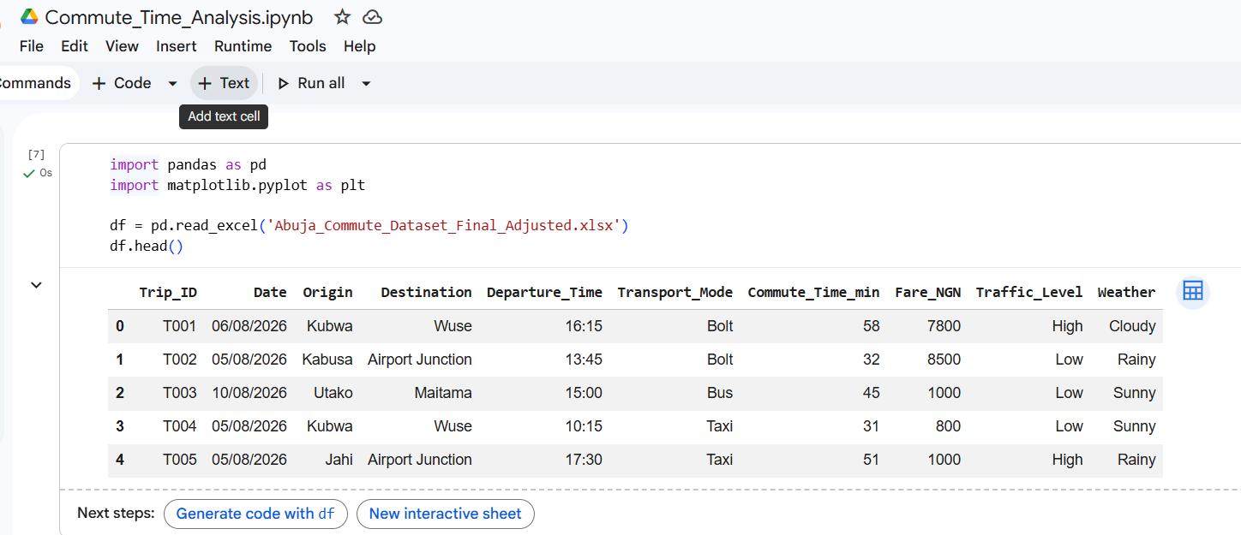
Figure 4.1: Dataset Preview (First Five Rows)

Analysis
The dataset preview confirmed that all expected variables were available for analysis. It also showed that the data was well structured and suitable for exploratory analysis.

4.3 Dataset Structure and Validation
The structure of the dataset was examined using the df.info() function in Python.
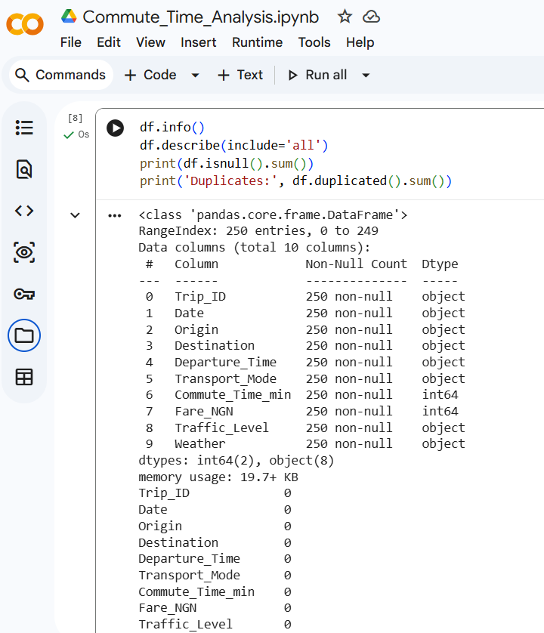
Figure 4.2: Dataset Structure (df.info() Output)

Analysis
The dataset contained 250 observations and all required variables. The inspection confirmed that:
- The data types were correctly assigned.
- No critical missing values were detected.
- The dataset was complete and suitable for analysis.
This validation ensured the reliability of the subsequent analysis.

4.4 Data Cleaning and Preparation
To improve data quality, the dataset underwent a cleaning and validation process in Python.
The following activities were performed:
- Verification of column names.
- Validation of numerical values.
- Confirmation of categorical variables.
- Inspection for missing values.
- Review of duplicate records.
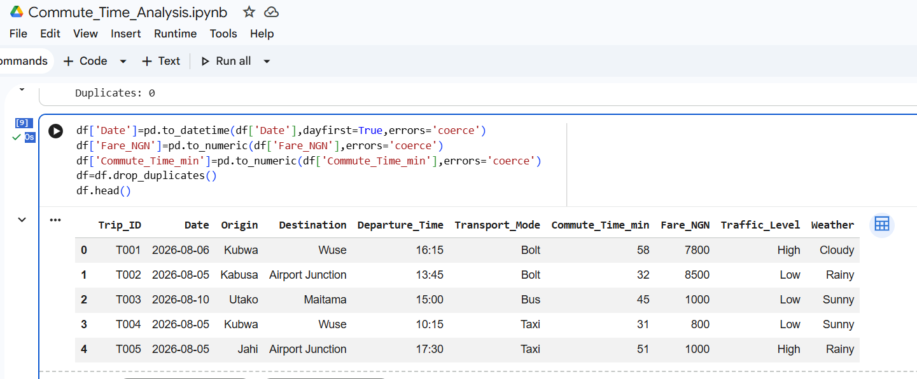
Figure 4.3: Data Cleaning Process

Analysis
The cleaning process confirmed that the dataset was consistent and ready for analysis. No major inconsistencies were found, allowing the analysis to proceed without extensive preprocessing.

4.5 Descriptive Statistics
Descriptive statistics were generated using Python to summarize the numerical variables in the dataset.
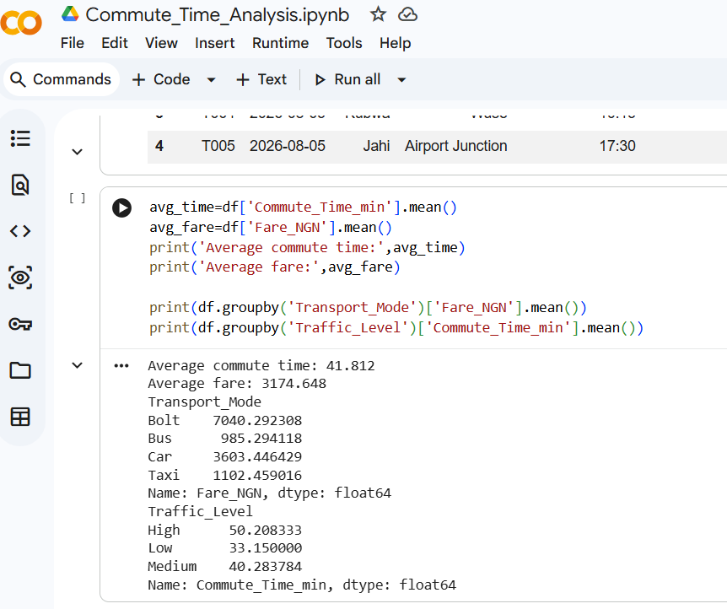
Figure 4.4: Descriptive Statistics

Analysis
The descriptive statistics provide an overview of the commuting dataset.
Key observations include:
- Average Commute Time: 41.81 minutes
- Average Transportation Fare: ₦3,175
- Variation in commute time across different journeys.
- Variation in transportation costs depending on transport mode.
These statistics provide a foundation for understanding commuter behaviour.

4.6 Power BI Dashboard Analysis
Following the Python analysis, the cleaned dataset was imported into Microsoft Power BI to create an interactive dashboard.
The dashboard summarizes the most important insights using KPI cards, charts, and interactive filters.
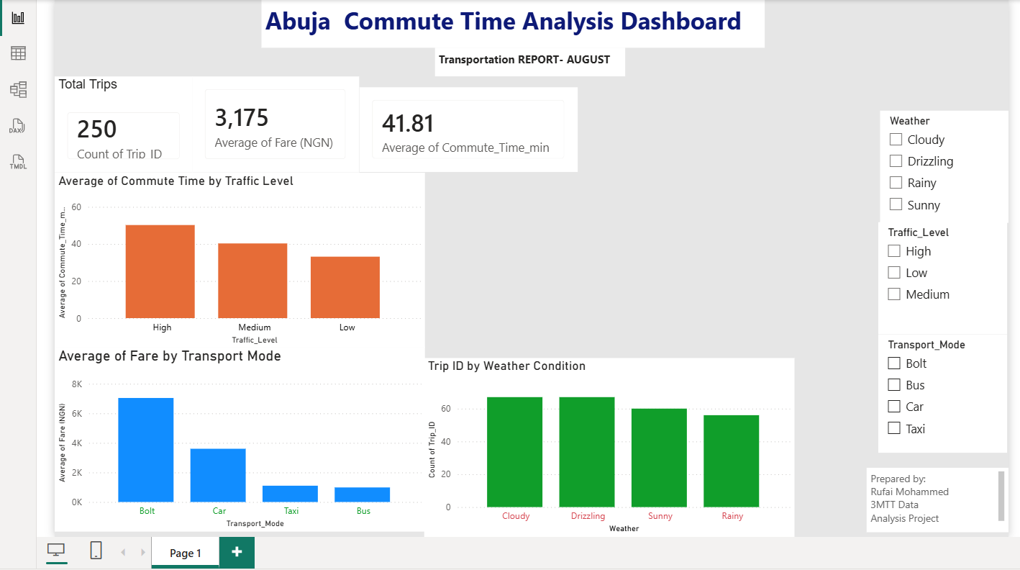
Figure 4.5: Final Power BI Dashboard
The dashboard includes:
- Average Commute Time KPI
- Average Transportation Fare KPI
- Average Commute Time by Traffic Level
- Average Transportation Fare by Transport Mode
- Transport Mode Distribution
- Interactive Slicers
The dashboard enables users to explore the data dynamically by filtering and comparing different variables.

4.7 Average Commute Time by Traffic Level
One of the objectives of the project was to understand how traffic conditions affect commuting time.
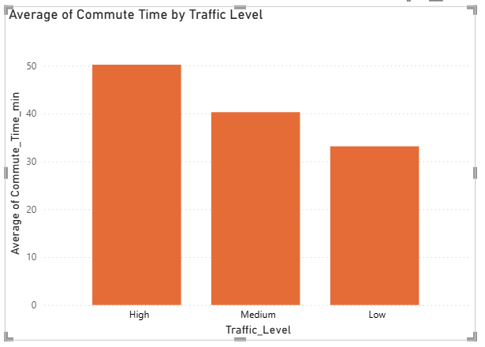
Figure 4.6: Average Commute Time by Traffic Level

Analysis
The visualization indicates a clear relationship between traffic congestion and commute duration.
Key findings include:
- Heavy traffic recorded the highest average commute time.
- Moderate traffic produced intermediate travel times.
- Light traffic resulted in the shortest commute durations.
This finding suggests that traffic congestion is one of the most significant factors affecting commuting efficiency within Abuja.

4.8 Average Transportation Fare by Transport Mode
Transportation fares were analysed across the available transport modes.
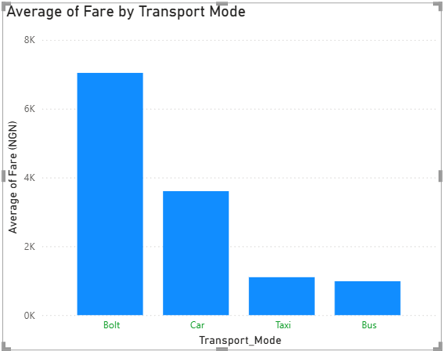
Figure 4.7: Average Transportation Fare by Transport Mode

Analysis
The analysis shows that transportation costs differ across transport modes.
The findings indicate that:
- Ride-hailing services generally recorded higher average fares.
- Public buses remained the most affordable transport option.
- Fare variations reflect the level of convenience and service provided by each transport mode.
These insights are useful for commuters seeking cost-effective transportation options.

4.9 Distribution of Transport Modes
The frequency of transport modes used by commuters was also examined.
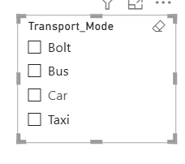
Figure 4.8: Distribution of Transport Modes

Analysis
The visualization shows the proportion of commuters using each transport mode.
This distribution helps identify the most frequently used means of transportation and provides useful information for transportation planning and service improvement.

4.10 Key Findings
Based on the analysis, the following key findings were identified:
- The average commute time was approximately 41.81 minutes.
- The average transportation fare was approximately ₦3,175.
- Traffic congestion significantly increased commuting time.
- Public buses provided the lowest average transportation fare.
- The Power BI dashboard effectively summarized the dataset through interactive visualizations.
- Combining Python and Power BI created an efficient workflow for analysing and communicating transportation data.

4.11 Business Insights
The project generated several practical insights that can support decision-making.

For Commuters
- Plan journeys outside peak traffic periods to reduce travel time.
- Consider buses for lower transportation costs.

For Transport Operators
- Allocate additional vehicles during periods of heavy traffic.
- Monitor fare differences across transport modes.

For Urban Planners
- Prioritize infrastructure improvements in high-congestion areas.
- Use transportation analytics to support evidence-based planning.

For Data Analysts
- Combining Python and Power BI provides an effective workflow for cleaning, analysing, and presenting transportation data.

4.12 Chapter Summary
This chapter presented the analysis of the Abuja Commute Time dataset using Python and Microsoft Power BI. Python was used to inspect, clean, and analyse the data, while Power BI was used to develop an interactive dashboard that communicated the findings through visualizations.
The analysis showed that traffic congestion has a significant impact on commute time, while transportation fares vary across transport modes. The dashboard successfully transformed the analytical results into meaningful insights that support informed decision-making.

CHAPTER FIVE

CONCLUSION AND RECOMMENDATIONS

5.1 Introduction
This chapter presents the overall conclusion of the Commute Time Analysis project. It summarizes the work carried out, highlights the key findings, discusses the limitations of the project, and provides recommendations for improving future transportation analysis and decision-making.
The project successfully demonstrated how Python and Microsoft Power BI can be combined to transform raw transportation data into meaningful insights through data cleaning, exploratory analysis, and interactive dashboard development.

5.2 Project Summary
The primary objective of this project was to analyse commuting patterns using a dataset containing 250 records of journeys within Abuja.
The project followed a structured analytics workflow beginning with data preparation in Microsoft Excel. The dataset was then imported into Python using Google Colab, where it was cleaned, validated, and analysed using the Pandas library. Descriptive statistics and grouped analyses were performed to understand commute time, transportation fares, traffic conditions, and transport mode usage.
The cleaned dataset was subsequently imported into Microsoft Power BI, where an interactive dashboard was developed to present the results through key performance indicators (KPIs), charts, and filters. This dashboard provides a user-friendly way to explore the data and identify important commuting trends.
Overall, the project demonstrates how modern data analytics tools can be used to support transportation planning and communicate findings effectively.

5.3 Key Findings
The analysis produced several important insights into commuting patterns within Abuja.
The key findings include:
- The average commute time was approximately 41.81 minutes, indicating that many commuters spend a significant amount of time travelling each day.
- The average transportation fare was approximately ₦3,175, with costs varying across different transport modes.
- Heavy traffic conditions were associated with longer commute times, highlighting the impact of congestion on daily travel.
- Public buses emerged as the most affordable transport option compared to other available modes.
- The Power BI dashboard successfully presented these findings in an interactive and easy-to-understand format, making it easier to identify trends and compare variables.
These findings demonstrate the value of descriptive analytics in understanding transportation behavioAur and supporting informed decision-making.

5.4 Recommendations
Based on the findings of this project, the following recommendations are proposed:

For Commuters
- Plan journeys outside peak traffic periods where possible to reduce travel time.
- Compare transport modes based on both cost and convenience before travelling.

For Transportation Operators
- Increase the availability of vehicles during periods of heavy traffic to reduce delays.
- Monitor fare structures to maintain affordability while ensuring service quality.

For Urban Planners and Policymakers
- Use transportation data to identify high-congestion areas and prioritise infrastructure improvements.
- Encourage the adoption of data-driven approaches when planning transportation services and road networks.

For Data Analysts
- Combine Python with business intelligence tools such as Microsoft Power BI to build interactive dashboards that communicate insights effectively.
- Continue developing skills in data visualization, storytelling, and dashboard design to improve decision support.

5.5 Project Limitations
While the project achieved its objectives, several limitations should be acknowledged.
- The dataset contained 250 records, which provides a useful sample but may not represent all commuting activities across Abuja.
- The analysis focused on descriptive statistics and dashboard visualization and did not include predictive modelling or machine learning techniques.
- The project relied on the available variables in the dataset and did not incorporate additional external factors such as fuel prices, road construction, public holidays, or real-time traffic information.
These limitations provide opportunities for further enhancement in future projects.

5.6 Future Improvements
Several improvements can be considered to extend this project in the future.
Future work may include:
- Analysing a larger and more diverse transportation dataset.
- Incorporating real-time traffic and weather data.
- Building predictive models to estimate commute time under different traffic conditions.
- Publishing the dashboard using the Power BI Service for online access and collaboration.
- Integrating Geographic Information Systems (GIS) to visualise commuting routes on interactive maps.
- Comparing commuting patterns across multiple cities to identify broader transportation trends.
These enhancements would increase the analytical value of the project and provide deeper insights for transportation planning.

5.7 Conclusion
This project successfully demonstrated the application of Python and Microsoft Power BI in analysing and visualizing transportation data.
Through data cleaning, exploratory analysis, and dashboard development, meaningful insights were generated regarding commute time, transportation fares, traffic conditions, and transport mode usage. The interactive Power BI dashboard transformed complex data into clear visualisations that support informed decision-making.
Beyond meeting the project objectives, this work showcases practical skills in data preparation, analysis, and business intelligence reporting. It highlights the importance of combining technical analysis with effective visual communication to solve real-world problems.
Overall, the project reflects the complete data analytics process—from raw data to actionable insights—and serves as a strong portfolio project that demonstrates proficiency in Python, data analysis, and Microsoft Power BI.

References (APA 7th Edition)
Include references such as:
- McKinney, W. (2022). Python for Data Analysis (3rd ed.). O'Reilly Media.
- Microsoft. (2025). Power BI Documentation. https://learn.microsoft.com/power-bi/
- pandas development team. (2025). pandas Documentation. https://pandas.pydata.org/docs/
- Python Software Foundation. (2025). Python Documentation. https://docs.python.org/3/
- Few, S. (2013). Information Dashboard Design (2nd ed.). Analytics Press.
- Knaflic, C. N. (2015). Storytelling with Data. Wiley.
- Han, J., Kamber, M., & Pei, J. (2012). Data Mining: Concepts and Techniques (3rd ed.). Morgan Kaufmann.
- Provost, F., & Fawcett, T. (2013). Data Science for Business. O'Reilly Media.

