**Assign IP to eth0 (wired) on Raspberry Pi**

**Lab 1-1**

Ipconfig to get ips

Ipconfig /all to get more information, such as MAC Addresses

**Lab 2-1**

Time to live exceeded for IP 17

* Pinged 10.10.10.20 - it worked
* Pinged 127.0.0.1 - it worked

Pinging 192.168.0.xx is not working

**Day 2**

Assign IP to eth0 (wired).

Right click wireless symbol, “Wireless and Wired network settings”

iPv4 address: 192.168.100.xx (Pi number)

**This time it worked, but nobody else got theirs to work, so we didn’t do anything.**

**Lab 2-2**

Physical address static

Wireless address is dynamic

**Raspberry Pi**

**MAC addresses are 6-byte (48-bits) in length, and are written in MM:MM:MM:SS:SS:SS format. The first 3-bytes are ID number of the manufacturer, which is assigned by an Internet standards body. The second 3-bytes are serial number assigned by the manufacturer**

**Lab 3-1**

**MAC Addresses can be found in the info box below when clicking on the packets.**

**ARPs send out messages**

The ARP request says “Who has 192.168.3.250? Tell 192.168.3.133”

The ARP reply says “192.168.3.250 is at ec:13:db:c8:8e:81”

**Ifconfig Linux**

**Lab 3-2**

**Pinging google grants the same MAC address as the default gateway.**

**Packet Tracer**

Do not save files with same starting letter as others. Or else PC will crash\

**Lab 4-1**

Use Carbon Straight through cables to connect switches to PCs.

**Lab 4-2**

>enable

Show mac-address-table

Do this to see the MAC addresses of PCs in Packet Tracer

**Lab 4-3**

Note for Lab 4-3, had trouble with switch - router connections today.

Remember to turn on “on” button in router from now on in this situation

**Kahoot Notes/Quiz Review:**

NIC’s will only “pay attention to” packets that have it’s MAC as the Destination AMC address

Most popular topology: Star

What “layer” of the OSI model do Hubs operate at? **1**

Hub = networking device, used to connect devices together, sends everything in, whatever goes in goes out.

Network switches **cannot** keep track of IP addresses and Physical Port

When switches don’t know a Destination MAC address - they flood the packet to all ports

Systems on a local network find out each other’s MAC addresses by asking with ARP

CAM table - keeps track of MAC addresses and ports connected to router

The source and Destination MAC addresses in a packet DO change when they cross a router.

A foster 202 workstation is connecting to 8.8.8.8, it will arp to the default gateway

All devices in the same Layer 2 Network are in the same Broadcast Domain

OSI Model:

1. Layer 1 - Physical.
2. Layer 2 - Data Link.
3. Layer 3 - Network.
4. Layer 4 - Transport.
5. Layer 5 - Session.
6. Layer 6 - Presentation.
7. Layer 7 - Application.

Note: OSI model is easier to remember in reverse.

A MAC Address has 48 bits

First 3 parts of MAC are “Organizational Unit Identifier” (OUI)

NICs are interested in Layer 2 MAC Addresses

Hubs are layer 1 devices, send packets to all [ports, and are used in star topologies. They do not only read MAC Addresses

Switch table = MAC and Port addresses

ARP is used to resolve layer 2 addresses from layer 3 addresses

**Lab 5-1**

Need to use a different cable to connect routers - Fiber.

If a router doesn’t have enough ethernet ports, add more to the physical representation in the settings/config menu by clicking on it.

**Notes:**

/24 = first 24 bits are turned on EX: 255.255.255.0 / 192.168.10.0

/16 = EX: 255.255.0.0 and 192.168.0.0

Etc.

Always two less IPs usable for hosts than are available for use overall.

**Lab 6-1**

**Lab 6-2**

**Subnetting notes:**

2^x = # of subnets

Class C Subnet Mask = 255.255.255.0 - A.K.A. - x.x.x.0/24

2^y = total IPs remaining

EX: Sub Mask = /24, create 4 subnets

x = 2

y = 6

/22, 4 subnets

X = 2

Y = 8

**Subnetting practice:**

153.104.30.15/22

IP: 1001 1001 . 0110 1000 . 0001 1110 . 0000 1111

Subnet Mask: 1111 1111 . 1111 1111 . 1111 1100 . 0000 0000

Network Address: 1001 1001 . 0110 1000 . 0001 1100 . 0000 0000

IP = 153.104.30.15

Subnet Mask = 255.255.192.0

Network Address = 153.104.28.0

Broadcast Address = 153.104.30.15

**Subnet Practice 2:**

172.16.2.0

Required hosts: 50

CIDR = /26

IP: 10101100 . 00010000 . 00000010 . 00000000

SM: 11111111 . 11111111 . 11111111 . 11000000

NA: 10101100 . 00010000 . 00000010 . 00000000

172.16.2.0

255.255.255.192

172.16.2.0

Net. Add: 172.16.2.0

First host: 172.16.2.1

Last host: 172.16.2.63

Broadcast: 172.16.2.64

Usable IPs per network: 62

**Subnet Practice 3:**

172.16.2.0

Required hosts: 300

CIDR = 23

IP: 10101100 . 00010000 . 00000010 . 00000000

SM: 11111111 . 11111111 . 11111110 . 00000000

NA: 10101100 . 00010000 . 00000010 . 00000000

172.16.2.0

255.255.254.0

172.16.2.0

Net. Add: 172.16.2.0

First host: 172.16.2.1

Last host: 172.16.3.254

Broadcast: 172.16.3.255

**Midterm Review:**

* LAN network in packet tracer, see lab 6-2

**Misc Notes:**

ICMP not meant to send pings, just llog data

Traceroute sends 3 signals to each hop

**Static Routing Notes:**

Connect two routers by making their interfaces into another network.

1100 0111

**Lab 9-1:**

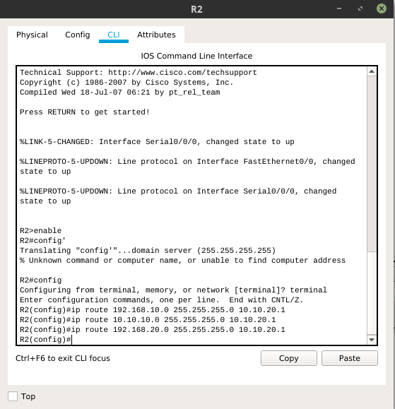

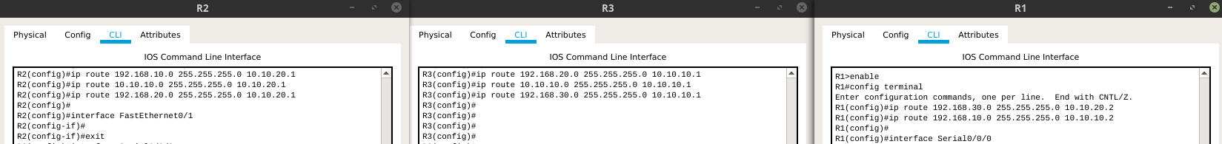

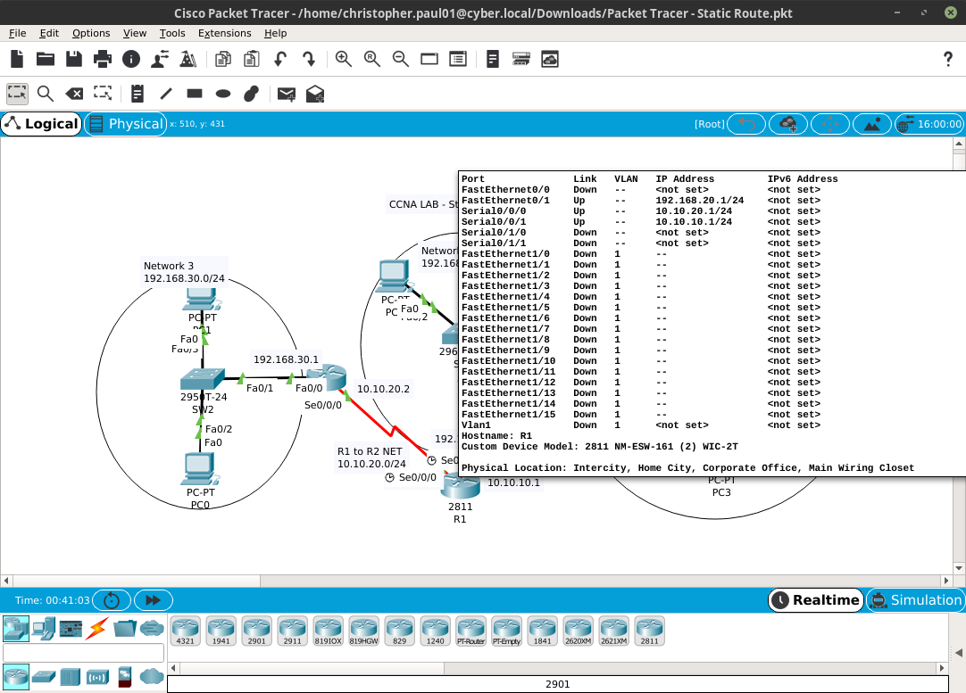

**Lab 10-1:**

To configure RIP on Packet Tracer, go into the router’s command, type “enable”,

type “config terminal”,

Type “router rip”

Type “Version 2”

Type “network (ip address of connected networks)

Do this last step for as many networks as the router has.

**Kahoot Notes 2nd ZEdition:**

Switches include MAC address and IP

Routing protocol in organization = IGP

Router broadcasts RIPv2 every 60 seconds

Virtual LAN configured to communicate as if connected to the same wire

**How to configure a VLAN:**

**LaB 11-1:**

1. On 1st Floor Switch, Go to Config/VLAN Database and add the VLANs the switch will support:
   * VLAN Number: 10 Name: ENG
   * VLAN Number: 20 Name: MKT
   * VLAN Number: 30 Name: ACT
2. Then, configure which ports are in which VLAN from Config tab by changing the VLAN number for the Access Port configuration per interface
   * FastEthernet 0/1 can be VLAN 10 (ENG)
   * FastEthernet 0/2 can be VLAN 20 (MKT)
   * FastEthernet 0/3 can be VLAN 30 (ACT)
3. Then, configure the Trunk port that will be used to connect the switch to the 2nd Floor Switch
   * GigabitEthernet 0/1 change to Trunk and add VLANs 10, 20, and 30 (leaving the other default VLANs checked is fine)
4. Repeat 1-3 on 2nd Floor and 3rd Floor switches
   * Note: On 2nd Floor switch, you will need to configure both GigabitEthernet 0/1 and Gigabit/Ethernet 0/2 as Trunk ports (step 3) as it connects to two switches

II. Connect Devices

1. Assign Appropriate IP configurations to the PC's
   * ENG network is 192.168.10.0/24 and the default gateway will be 192.168.10.1
   * MKT network is 192.168.20.0/24 and the default gateway will be 192.168.20.1
   * ACT network is 192.168.30.0/24 and the default gateway will be 192.168.30.1
   * Remember, every PC needs a unique address
2. Connect PC's to the switch on their floor.
   * Make sure to connect the PC to the Port on the switch that is in their VLAN!
3. Connect switches to each other using Crossover Cables and the configured Trunk ports

**Lab 11-2:**

Router-on-a-stick:

A router connected to a network via a single logical or physical connection to a single switch that can forward packets across separate VLANs on the entire network.

**Lab 10-2:**

Reaffirming how to use RIP to connect networks.