Revisar-conjunto-de-datos.R
TRABAJO
2026-09-01
# Blas Avitia Arellano
# 2327168
# 18/08/2026
#Importar Datos----
# Función read.csv importa datos de excel a R
IE <- read.csv("Vivero.csv", header = T)
IE$Tratamiento <- as.factor(IE$Tratamiento)
# Revisar-----
# Revisar solo una porción de datos
head(IE) # Primeras filas de BD IE
## planta IE Tratamiento
## 1 1 0.80 Ctrl
## 2 2 0.66 Ctrl
## 3 3 0.65 Ctrl
## 4 4 0.87 Ctrl
## 5 5 0.63 Ctrl
## 6 6 0.94 Ctrl
tail(IE) # Ultimas filas de BD IE
## planta IE Tratamiento
## 37 37 0.88 Fert
## 38 38 1.15 Fert
## 39 39 0.88 Fert
## 40 40 0.78 Fert
## 41 41 1.16 Fert
## 42 42 0.91 Fert
# Graficar----
hist(IE$IE,
main = "",
xlab = "Índice",
ylab = "Frecuencia",
ylim = c(0,12),
col = "lightblue")
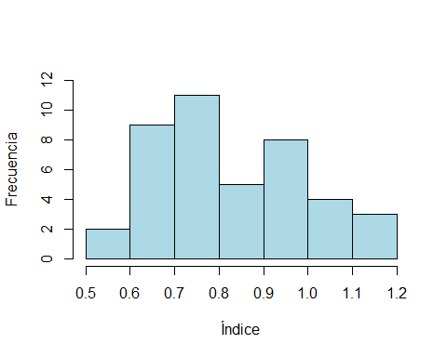
# Normalidad datos ----
shapiro.test(IE$IE)
##
## Shapiro-Wilk normality test
##
## data: IE$IE
## W = 0.96225, p-value = 0.1777
mean(IE$IE)
## [1] 0.8371429
sd(IE$IE)
## [1] 0.1650319
var(IE$IE)
## [1] 0.02723554
fivenum(IE$IE)
## [1] 0.550 0.700 0.795 0.940 1.160
# Boxplot ----
boxplot(IE$IE ~ IE$Tratamiento,
col = "red",
xlab = "Tratamientos",
ylab = "Índice")
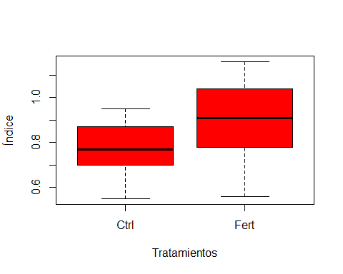
# Revisar homogeneidad de varianzas----
bartlett.test(IE$IE ~ IE$Tratamiento)
##
## Bartlett test of homogeneity of variances
##
## data: IE$IE by IE$Tratamiento
## Bartlett's K-squared = 3.7423, df = 1, p-value = 0.05305
df_ctrl <- subset(IE, Tratamiento == "Ctrl")
df_fert <- subset(IE, Tratamiento == "Fert")
shapiro.test(df_ctrl$IE)
##
## Shapiro-Wilk normality test
##
## data: df_ctrl$IE
## W = 0.9532, p-value = 0.3908
shapiro.test(df_fert$IE)
##
## Shapiro-Wilk normality test
##
## data: df_fert$IE
## W = 0.95339, p-value = 0.3941
# Revisar homogeneidad de varianzas----
bartlett.test(IE$IE ~ IE$Tratamiento)
##
## Bartlett test of homogeneity of variances
##
## data: IE$IE by IE$Tratamiento
## Bartlett's K-squared = 3.7423, df = 1, p-value = 0.05305
df_ctrl <- subset(IE, Tratamiento == "Ctrl")
df_fert <- subset(IE, Tratamiento == "Fert")
#Grupo control
shapiro.test(df_ctrl$IE)
##
## Shapiro-Wilk normality test
##
## data: df_ctrl$IE
## W = 0.9532, p-value = 0.3908
shapiro.test(df_fert$IE)
##
## Shapiro-Wilk normality test
##
## data: df_fert$IE
## W = 0.95339, p-value = 0.3941
#Grupo Fertilizante
qqnorm(df_ctrl$IE); qqline(df_ctrl$IE)
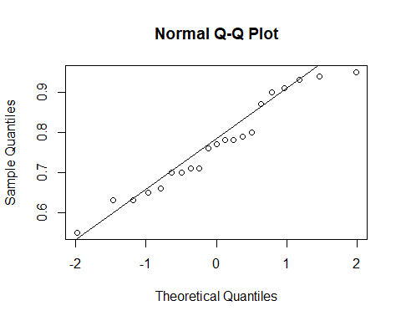
qqnorm(df_fert$IE); qqline(df_fert$IE)
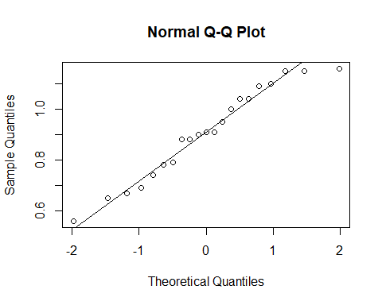
t.test(IE$IE ~ IE$Tratamiento, var.equal = TRUE)
##
## Two Sample t-test
##
## data: IE$IE by IE$Tratamiento
## t = -2.9813, df = 40, p-value = 0.004868
## alternative hypothesis: true difference in means between group Ctrl and group Fert is not equal to 0
## 95 percent confidence interval:
## -0.23331192 -0.04478332
## sample estimates:
## mean in group Ctrl mean in group Fert
## 0.7676190 0.9066667
t.test(df_ctrl$IE , df_fert$IE)
##
## Welch Two Sample t-test
##
## data: df_ctrl$IE and df_fert$IE
## t = -2.9813, df = 34.056, p-value = 0.00527
## alternative hypothesis: true difference in means is not equal to 0
## 95 percent confidence interval:
## -0.23382707 -0.04426816
## sample estimates:
## mean of x mean of y
## 0.7676190 0.9066667
t.test(IE$IE ~ IE$Tratamiento, var.equal = TRUE, alternative ="less")
##
## Two Sample t-test
##
## data: IE$IE by IE$Tratamiento
## t = -2.9813, df = 40, p-value = 0.002434
## alternative hypothesis: true difference in means between group Ctrl and group Fert is less than 0
## 95 percent confidence interval:
## -Inf -0.06051169
## sample estimates:
## mean in group Ctrl mean in group Fert
## 0.7676190 0.9066667
# Dependientes o apareados
#Ctrl vamos a asumir que es antes de fertilizar
#Fert asumimos un mes después de fertilizar las mismas plantas
t.test(df_ctrl$IE, df_fert$IE, paired = TRUE)
##
## Paired t-test
##
## data: df_ctrl$IE and df_fert$IE
## t = -3.0736, df = 20, p-value = 0.005993
## alternative hypothesis: true mean difference is not equal to 0
## 95 percent confidence interval:
## -0.23341577 -0.04467947
## sample estimates:
## mean difference
## -0.1390476
#Prueba de una sola muestra
boxplot(IE$IE)
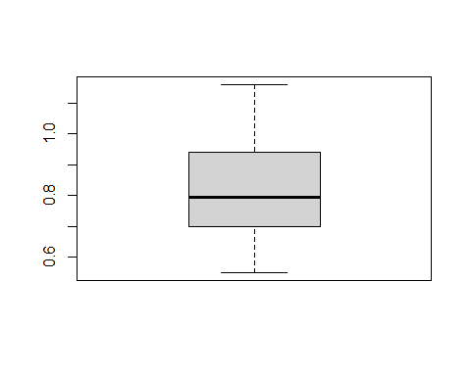
t.test(IE$IE, mu = 0.95, alternative ="less")
##
## One Sample t-test
##
## data: IE$IE
## t = -4.4319, df = 41, p-value = 3.411e-05
## alternative hypothesis: true mean is less than 0.95
## 95 percent confidence interval:
## -Inf 0.8799973
## sample estimates:
## mean of x
## 0.8371429
t.test(IE$IE, mu = 0.88, alternative ="two.sided")
##
## One Sample t-test
##
## data: IE$IE
## t = -1.683, df = 41, p-value = 0.09998
## alternative hypothesis: true mean is not equal to 0.88
## 95 percent confidence interval:
## 0.7857153 0.8885704
## sample estimates:
## mean of x
## 0.8371429

