|  |
| --- |
| NGwKs & U GOT DIED |
| Quidditch |
| **The Side-Scroller** |
| Version #1.0  All work Copyright © 2013 by NGwKs Games & U GOT DIED.  All rights reserved. |
| **Paige Harvey & Jonathon Hodder** |
|  |

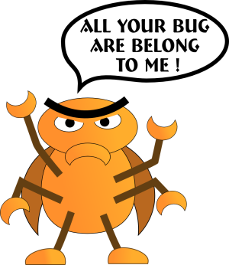

|  |
| --- |
| August 5th 2013 |

**Table of Contents**

*Version History* 3

*Game Overview* 4

*Game-play Mechanics* 4

*Controls* 4

*Interface Sketch* 5

*Screen Descriptions* 5

*Game World* 5

*Levels* 6

*Characters* 6

*Enemies* 6

*Weapons* 6

*Scoring* 7

*Sound index* 7

*Art Index* 7

**Version History**

Version 0.1 – *Quidditch.py*  
 Created *Harry* class.  
 ‘Gravity’ in effect.  
 Using old images from U GOT DIED’s Balloon Man

Version 0.2 – *Quidditch.py*  
 Created *Quaffle* class  
 Still using old images

Version 0.3 – *Quidditch.py*  
 Created *OppFlier* class  
 Still using old images

Version 0.4 – *Quidditch.py*  
 Created *Bludger* class

Version 0.5 – *Quidditch.py*  
 Created *Snitch* class

Version 0.6 – *Quidditch.py*  
 Worked out logic for collisions

Version 0.7 – *Quidditch.py*  
 Worked out scoring logic

Version 0.8 – *Quidditch.py* Added the **intro()** and **gameOver()** functions

Version 1.0 – *Quidditch.py* Added new graphics and soundtrack  
 Tweaked collision, scoring and the AI movements of all classes  
 Created *pitchBackground* class  
 Added level difficulty  
 Consolidated game over functions into **gameOver()**

1. **Game Overview**This is a basic side-scrolling style game themed after JK Rowling’s *Harry Potter* Quidditch. The User controls Harry (a Gryffindor Seeker) and is tasked with catching the Snitch all the while dodging Bludgers and players from the other team. There are three levels of difficulty in this game, this is based off the team the User chooses to play against. The higher the difficulty the more obstacles the User must dodge.
2. **Game Play Mechanic**

This game is written with python 2.7 and pygame 1.9.

The game uses seven sprite classes and three functions for gameplay. The **main()** function merely starts the game, sending the functionality of the program into the **intro()** function. From there the **game()** function is called. This is where the bulk of the gameplay programming is contained. When the game is over **gameOver()** is called, and the User is sent back to **intro()**.

This game also uses the *Buttons.py* to create buttons. This program was created by NGwKs and is used with permission of the owner.

For further details regarding controls, scoring, art and sound please refer to those sections of the document.

1. **Controls**

This program uses the arrow keys (*Up, Left* and *Right*) and once or twice the mouse to control the game.

The mouse is used while in the Introduction screen and in the Game Over screen.

The arrows keys are what the User uses to control the character. The *Up* or *Spacebar* is connected to the vertical movement of the character. *Left* and *Right* keys control the left and right movements of the character. *Escape* can be used while in the menus to exit the game.

1. 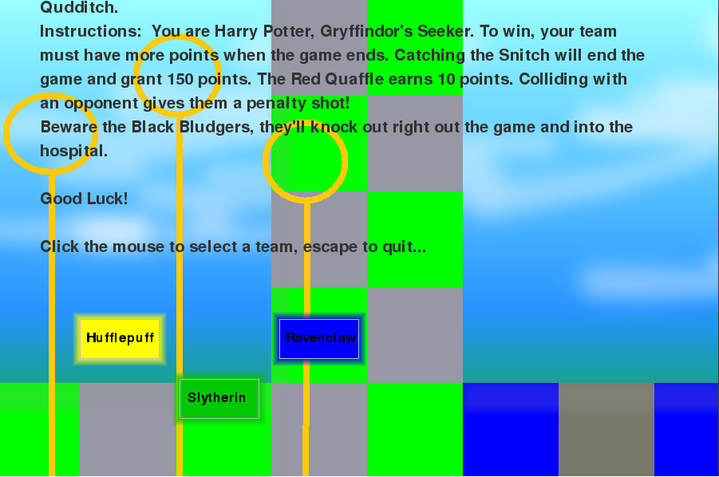**Interface Sketch**The initial load of the program has basic description of how to play the game as well as three buttons. These buttons determine the difficulty the User faces. *Hufflepuff* is easy, *Ravenclaw* medium, and *Slytherin* is hard. Clicking any of the three will take the User into gameplay.
2. 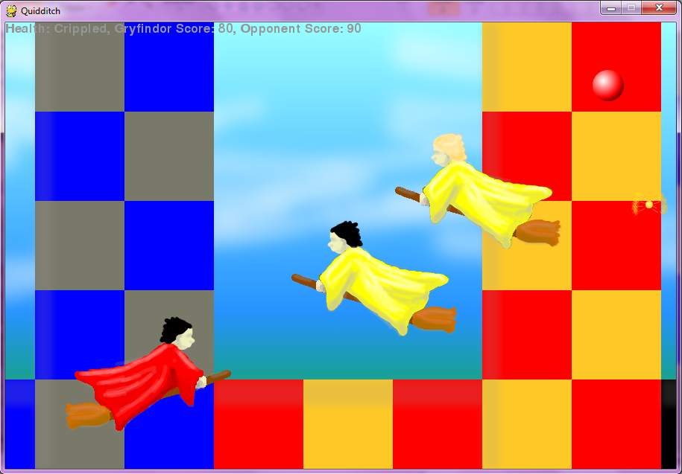**Menu and Screen Descriptions**

During gameplay the User controls *Harry* who wears red. The other Team wears the colour of their house (yellow for *Hufflepuff*, blue for *Ravenclaw* and green for *Slytherin*).

In the top corner are the stats; *Harry’s* health, and the current score.

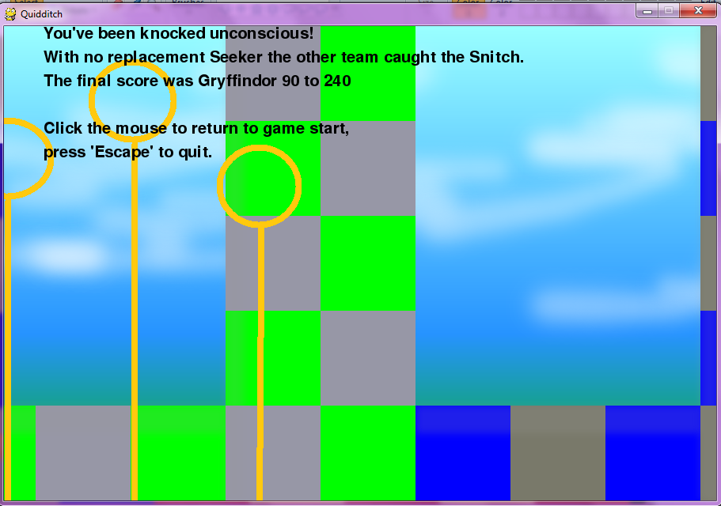

Gameplay will end in a number of ways, but once it has ended an explanation will show on the Game Over screen.

1. **Game World**

This game is essentially a sports game in a side-scroller. The rules and scoring of this game were derived from the actual rules and scoring as determined by the International Quidditch Association (IQA). However, these rules were simplified for ease of gameplay.

The User plays are Gryffindor’s Seeker against the other three House teams. They are to catch the Snitch the end gameplay. Catching the Quaffle, avoiding the Bludgers and other Opponents are all hazards of gameplay.

1. **Levels**

There are three levels of difficulty in this game. Each of the three teams is a different difficulty.

*Hufflepuff* is considered Easy. There can only ever be two Opponents on screen at a time. There is only ever one Bludger, which appears after a long interval. The Quaffle appears very often. With less to dodge finding the Snitch and winning is easy.

*Ravenclaw* is considered Medium. This time there are four Opponents flying. There is still only one Bludger but is appears more often. The Quaffle spends less time on screen. While the Snitch’s appearance is not altered, there is more to dodge and fewer chances to gain points.

*Slytherin* is considered Hard. All five Opponents can be on screen, both Bludgers are loose, and the Quaffle spends even less time on screen. All in all, there is lots to dodge and less the catch. While the Snitch may appear often the User may not be in a position to catch it.

1. **Character**

The User plays as *Harry,* who is Gryffindor’s Seeker. The Seeker’s job is to catch the Snitch and end the game. The game will not end until the Snitch is caught. *Harry* wears red robes and flies a broom.

1. **Enemies**

In this game ‘enemies’ are more ‘opponents’. There are three opponent teams; *Hufflepuff, Ravenclaw* and *Slytherin*. Each wears a different colour of robe. *Hufflepuff* is yellow, *Ravenclaw* is blue, and *Slytherin* is green.

1. **Weapons**

There are no weapons as such in this game. The User can take damage from the Bludgers, but they are more a natural hazard than a weapon. Also, the User is unable to attack his Opponents because this is a sport and any outright weaponry (other than a Bludger Bat) is forbidden. As the User plays a Seeker not a Beater their character is not equipped with a Bludger Bat.

1. **Scoring**

The scoring in this game is simple, it is how a win or loss is determined that is complex.

According to IQA rules a team scores 10 points anytime the Quaffle goes through a goal hoop. To simplify this in the game, every time *Harry* catches the Quaffle Gryffindor earns 10 points.

Running into an opposing player is a foul and calls for a penalty shot on goal. Using this rule, any time *Harry* collides with an opponent they earn 10 points from the penalty shot.

The Seeker that catches the Snitch ends the match and earns 150 points for their team. The winner of the match is whoever has the greatest number of points. It is possible for the team who caught the Snitch to ultimately lose the match. As such this is a possible outcome in the game.

In the Hogwarts Quidditch Tournament there are no Reserve Players. Thus should a player be knocked unconscious that team will play at a disadvantage until either the match ends or the player recovers. In this game if *Harry* is knocked out the other team catches the Snitch and earns 150 points.

1. **Sound Index**

This program uses the following sounds:  
*snitchBlow.wav* – When the Snitch is caught  
*balloonPop.wav* – When *Harry* runs into Bludgers and opponents *coinSound.wav* – When *Harry* catches Quaffles

(Borrowed from the Mario coin sound files) *earth.wav* – Background music to be played during intro, gameplay, and game over.  
(Borrowed from *Assassin’s Creed 2* soundtrack by **Jesper Kyd**.)

1. **Art / Multimedia Index**

These are the images used in this game. First *Harry* and the balls, then the opponents and finally the background field.

|  |  |  |  |
| --- | --- | --- | --- |
| Harry.png | *Harry.png* | Snitch.png | *Snitch.png* |
| Bludger.png | *Bludger.png* | Quaffle.png | *Quaffle.png* |

|  |  |  |  |
| --- | --- | --- | --- |
| *H1.png* | *H1.png* | *H1.png* | *H2.png* |
| *H1.png* | *R1.png* | *H1.png* | *R2.png* |
| *H1.png* | *R3.png* | *H1.png* | *R3.png* |
| *H1.png* | *S1.png* | *H1.png* | *S2.png* |
| *H1.png* | *S3.png* | *H1.png* | *S4.png* |
| *H1.png* | *S5.png* |  |  |
| *Pitch.png (12900 pixels wide)* | | | |

