**3. (10 points ) Consider a chain of processes P1, P2, ..., Pn implementing a multitiered client-server architecture. Process Pi is client of process Pi+1, and Pi will return a reply to Pi-1 only after receiving a reply from Pi+1. What are the main problems with this organization when taking a look at the request-reply performance at process P1?**

**Answer: The main problems with this organization is very slow or getting stuck when it processes a large data. The reason is that P1 has to wait for P2, P3, and so on until Pn is processed, and then it wait for reply chain from Pn, Pn-1, Pn-2, … Besides, if one Pi in chain gets stuck, then whole chain will be stuck or failed.**

**4. Show the B-trees of order four resulted from loading the following sets of keys (each letter is a key) in order:**

**a. C G J X**

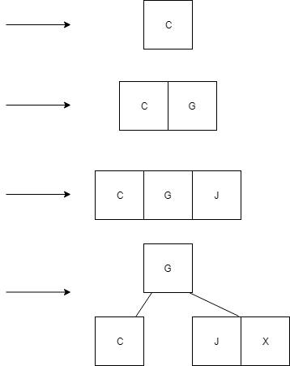

**b. C G J X N S U O A E B H I**

**Continuing from previous**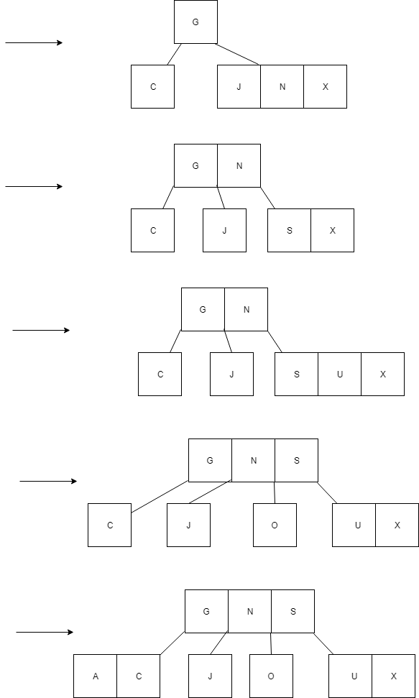

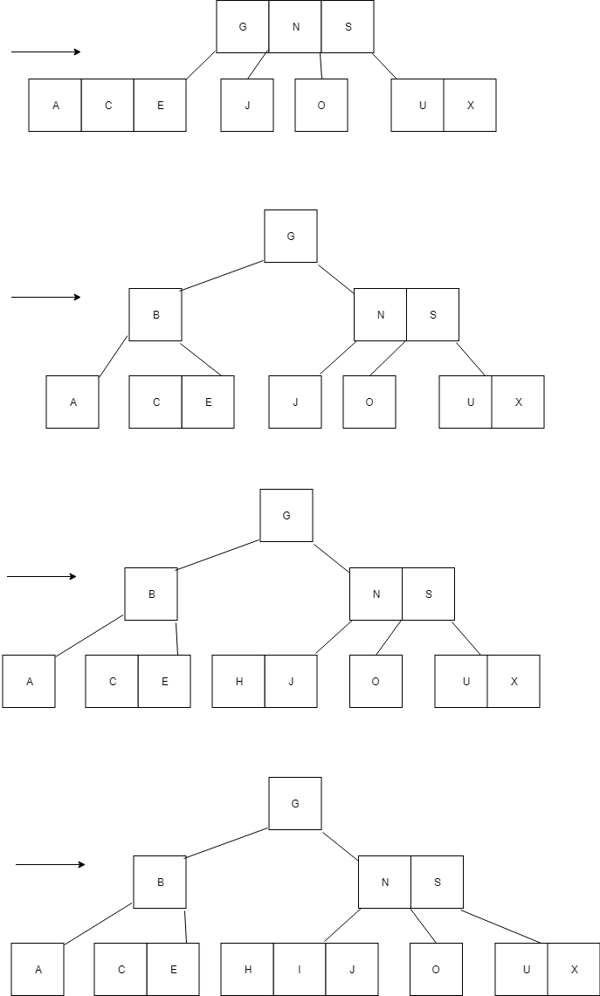

1. **C G J X N S U O A E B H I F**

**Continuing from previous**

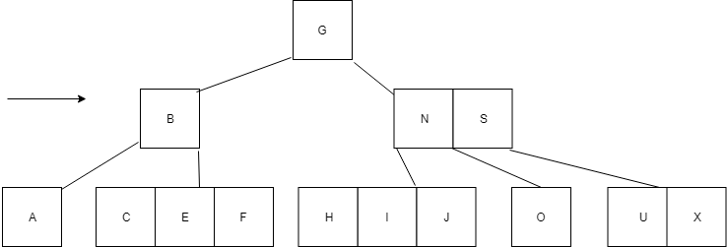

1. **C G J X N S U O A E B H I F K L Q R T V U W Z**

**Continuing from previous**

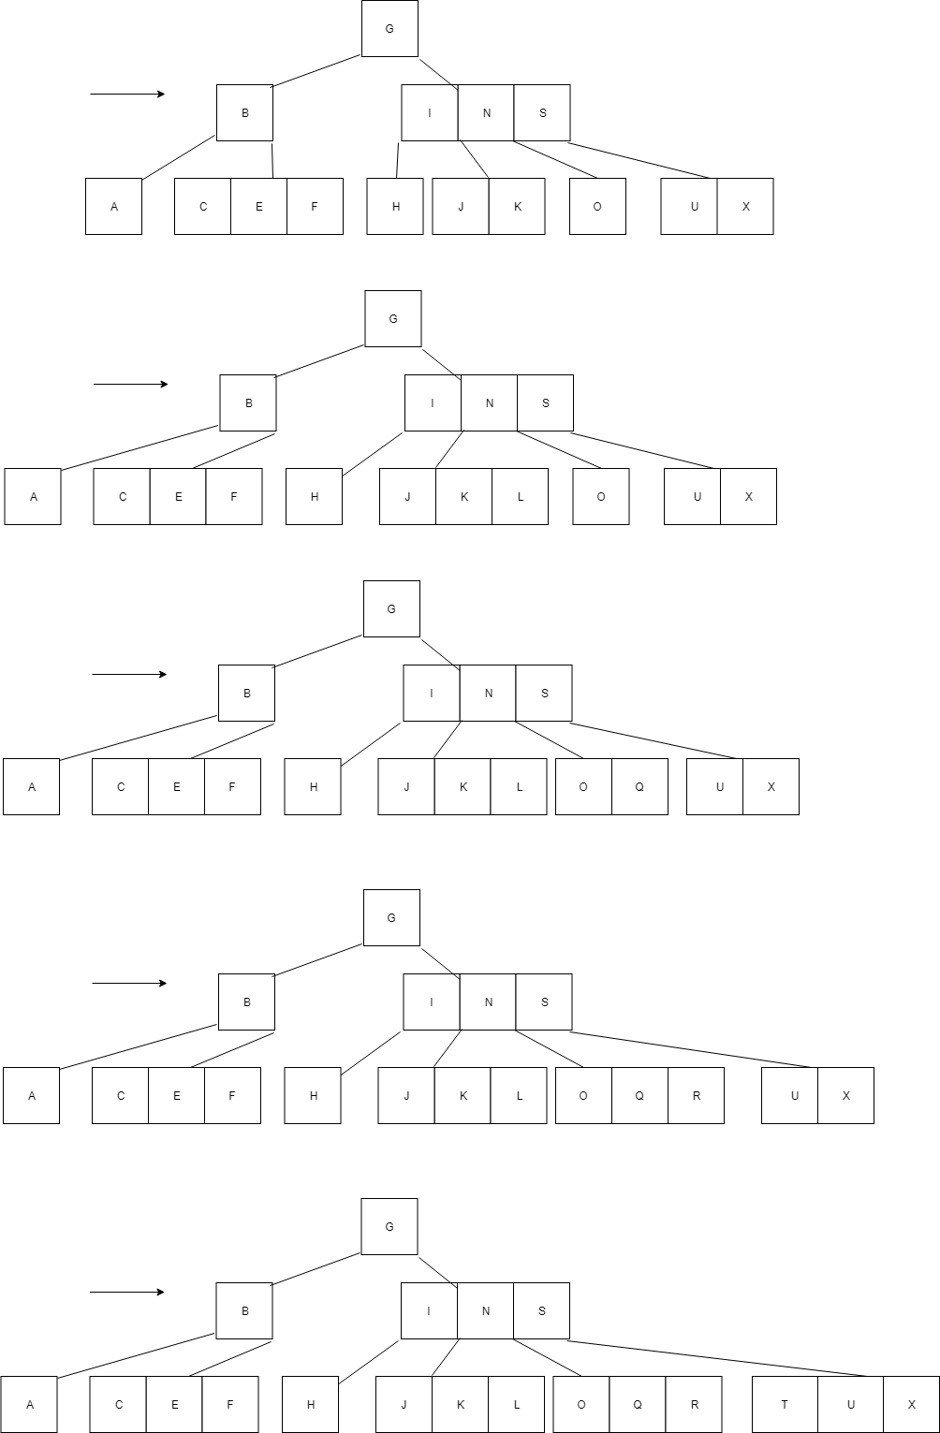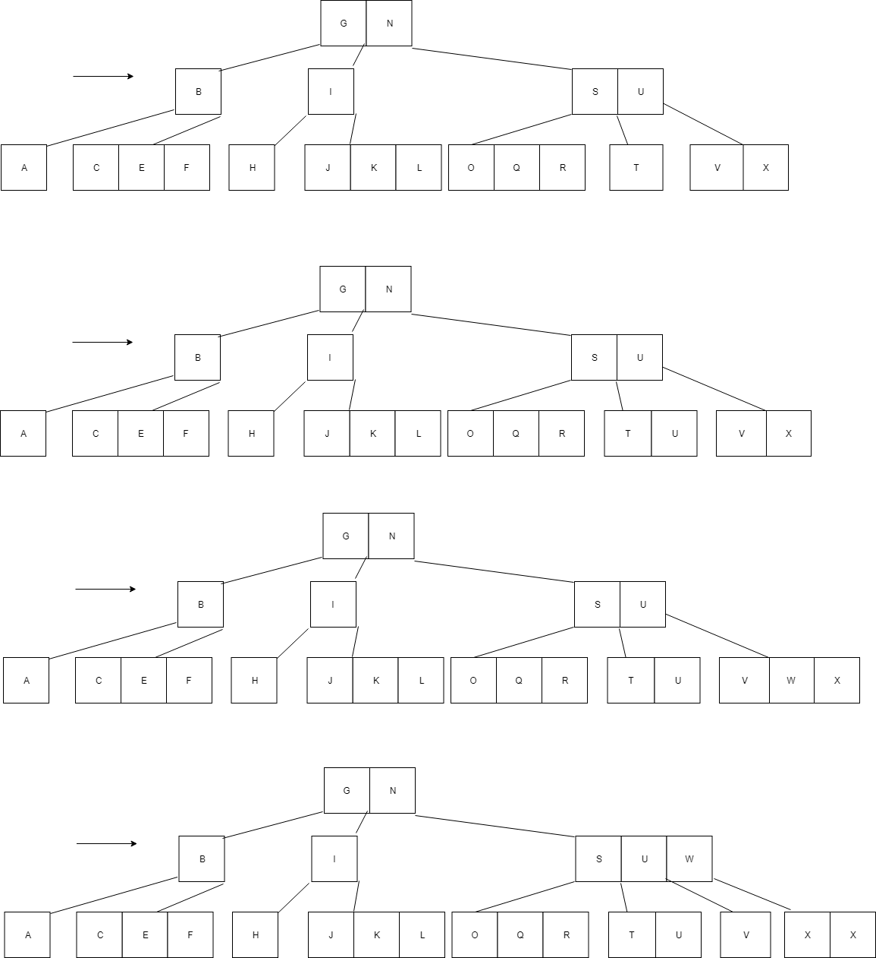

( 10 points )   
Given a B-tree of order 256,

1. what is the maximum number of children from a node?
   * + 256
2. excluding the root and the leaves, what is the minimum number of children from a node?
   * + 256/2 = 128
3. what is the minimum number of children from the root?
   * + 2
4. What is the maximum depth of the tree if it contains 100 000 keys?
   * + Max = log((n+1)/2) where d = min number of children from node except root and leaf. N = number of entries
     + N = 100,000
     + D = (m/2) = 256/2 = 128
     + Max = log128((100,000+1)/2)
     + Max = log128(50000.5)
     + Using base conversion lobb(y) /log10(b)
     + Max = log10(50000.5/log10(128)
     + Max = 4.69897/2.107099
     + Max = 2.2299487