Eric Blasko

Tong Yu

CSE 461

March 1, 2019

Homework #3

1. **( 20 points )   
   A DHT Chord network uses 4 bits (i.e. *m* = 4 ) to identify machines and keys of entities. At a certain time, machines with identifiers 2, 5, 9, and 11 are attached to and active in the network.**
   1. **Draw a diagram to show the machine ids and keys of the network.**
   2. **Find the finger table of each of the machines.**
   3. **An application running in node 11 is looking for the entity with key value 7. Find the route the system takes to get to the node that has the entity. Show your steps clearly and draw the route on your diagram.**

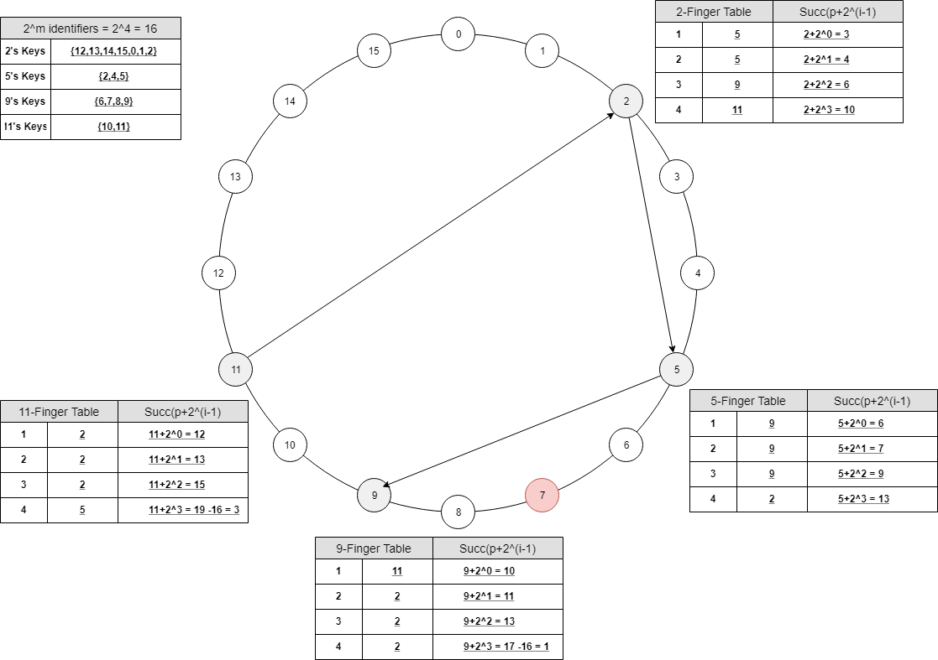

Starting from node 11, it would search linearly from all the nodes. This would go from node 11 to node 2, from node 2 to node 5, from node 5 to node 9. The key value 7 would be found in node 9.

1. **( 10 points )**
   1. **Would you consider a URL such as *http://www.acme.org/index.html*to be location independent? What about *http://www.acme.nl/index.html*?**

Answer:

Both names can be location independent. The first one however, gives fewer hints on the location of the named entity. This is because .org stands for organization whereas .nl stands for Netherlands. Regardless, location independent means that the name of the entity is independent of its address. By just considering a name, nothing can be said about the address of the associated entity.

* 1. **Consider the behavior of two machines in a distributed system. Both have clocks that are supposed to tick 1000 times per millisecond. One of them actually does, but the other ticks only 990 times per millisecond. If UTC updates come in once a minute, what is the maximum clock skew that will occur?**

Answer:

The second clock ticks 990,000 times per second, giving an error of 10 msec per second. In a minute this error has grown to be 600 msec. Another was of looking at this is that the second clock is one percent slower, so after a minute it is off by 0.01*60 sec = 600 msec.

1. **( 10 points )   
     
   If each process uses a different value for d in the Lamport's clock and vector clock equations, will the logical clocks and vector clocks schemes satisfy the total order relation => and the relation:**

**a → b iff ta < tb**

**Explain your argument in detail.**

Answer:

For the condition to be true, then

1. In the same process Pi for any two events a and b, if a happens before b, then Ci(a)< Cj(b).
2. In process Pi if event a is the even of a sending message, and event b is the event of receiving that same message in a different process Pj the Ci(a)< Cj(b).

So Yes, it will satisfy the total order relation. If event a happens before event b, then the timestamp of a should be less than the clock of value b. This cannot be said for a condition such as C(a)<C(b), then a→b.

1. **( 10 points )   
   Suppose Process P1 has events**

**e11, e12, e13, e14, e15 e16 e17**

**P2 has events**

**e21, e22, e23, e24, e25, e26,**

**P3 has events**

**e31, e32, e33, e34, e35 e36**

**There are message transits from e12 to e22, e24 to e15, e21 to e32, e35 to e25. Suppose the vector time clocks for e11, e21, and e31 are**

|  |  |  |  |  |  |  |  |  |  |  |
| --- | --- | --- | --- | --- | --- | --- | --- | --- | --- | --- |
| **http://cse.csusb.edu/tongyu/courses/cs461/images/4matrixleft.gif** | **1 0 0** | **http://cse.csusb.edu/tongyu/courses/cs461/images/4matrixright.gif** | **,** | **http://cse.csusb.edu/tongyu/courses/cs461/images/4matrixleft.gif** | **0 1 0** | **http://cse.csusb.edu/tongyu/courses/cs461/images/4matrixright.gif** | **,** | **http://cse.csusb.edu/tongyu/courses/cs461/images/4matrixleft.gif** | **0 0 1** | **http://cse.csusb.edu/tongyu/courses/cs461/images/4matrixright.gif** |

**respectively.**

**a) Draw a diagram to show all the transitions and events.**

**b) Find the vector clocks of all the events.**

**c) Give an example for each of the following:**

**i) a strongly consistent state**

**ii) a consistent but not strongly consistent state**

**iii) an inconsistent state**

**Your global state should be consisted of the the events given ( e.g. e11 ) but should not contain any event that is sending ( e.g. e12 ) or receiving a message ( e.g. e22 ).**

