Selenium Web Driver Locators:
As part of Automation, Selenium Performs actions (such as click, typing) on the Page HTML Elements.
The Locators are the way to identify an HTML element on a web page.
Selenium WebDriver uses any of the below locators to identify the element on the page and performs the Action

Locator Types:
(In the order they are recommended to be used.)
ID
Xpath

CSS Selector
name
Class Name
Tag Name
Link Text
Partial Link Text

How to locate web elements-

<input type="text" placeholder="Username" id= “inputUsername” value=" ">

(Input -> tag name, Red-> attribute, Green-> attribute associated value.)

By Css Selector-
- <input type="text" placeholder="Username” value=" ">
- Input [placeholder=’ Username’]

- Class name
  - tagname.classname
  - Ex: Button.signInBtn
  - Ex: .error

- Id ->
  - tagname#id
  - Ex; input#inputUsername

- Tagname[attribute=’value’]

- Child items
  - //Tagname[@attribute=’value’]:nth-child(index)
  - Parenttagname childtagname

- Regular expression
  - input[type*='pass']

- tagname

By Xpath –
- <input type="text" placeholder="Name">

- //Tagname[@attribute=’value’]
  - Ex: //input[@placeholder=’ Username’’]

- //Tagname[@attribute=’value’][index]

- //tagname

- Regular expression
  - //button[contains(@class,'submit')].

- Child items
  - //header/div/button[1]/following-sibling::button[1]
  - //header/div/button[1]/parent::div
  - //parentTagname/childTagname

Basic Selenium Web Scraper:
- package com.rahulshettylearning.theinternet;
- import java.time.Duration;
- import org.openqa.selenium.By;
- import org.openqa.selenium.WebDriver;
- import org.openqa.selenium.edge.EdgeDriver;

- public class WebScraper {
- public static void main (String args[]) {
- System.setProperty("webdriver.edge.driver", "src\\main\\resources\\msedgedriver.exe");
- WebDriver driver = new EdgeDriver();
- driver.get("https://rahulshettyacademy.com/locatorspractice/");
- String s = driver.getTitle();
- System.out.println(s);
- System.out.println(driver.getCurrentUrl());
- //driver.close(); // closes the current window
- //driver.quit(); // closes all the associated windows
- }
- }

All types of locators’ example:
https://rahulshettyacademy.com/locatorspractice/
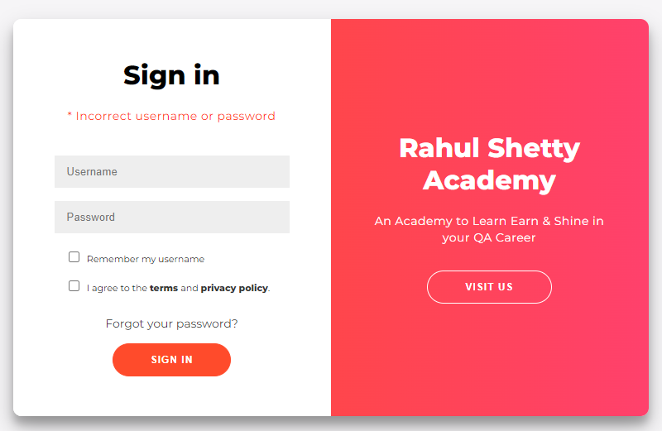
For this example, we are going to automate this log in page.
- package com.rahulshettylearning.theinternet;

- // Example one

- // Visit "https://rahulshettyacademy.com/locatorspractice/" for the HTML.
- // Use Selector hub or similar extension to validate the locators
- // or can also use browser console to validate CSS (use $) or Xpath (Use $x) locators.

- import java.util.concurrent.TimeUnit;
- import org.openqa.selenium.By;
- import org.openqa.selenium.WebDriver;
- import org.openqa.selenium.edge.EdgeDriver;

- public class LocatorPractice {

- public static void main(String args[]) {

- // Setting the system property to our msedgedriver.
- System.setProperty("webdriver.edge.driver", "src\\main\\resources\\msedgedriver.exe");
- WebDriver driver = new EdgeDriver();
- // A way other than Thread.sleep(2000) to make the program wait for some time
- // before each step.
- driver.manage().timeouts().implicitlyWait(5, TimeUnit.SECONDS);
- // A way to instruct the driver to open the given URL address.
- driver.get("https://rahulshettyacademy.com/locatorspractice/");

- // different locators with example
- driver.findElement(By.id("inputUsername")).sendKeys("Pritam Ganguly");
- // driver.findElement(By.name("inputPassword")).sendKeys("name1234");
- driver.findElement(By.cssSelector("input[name='inputPassword']")).sendKeys("testpasss");
- driver.findElement(By.className("submit")).click();
- System.out.println(driver.findElement(By.cssSelector("p.error")).getText());
- driver.findElement(By.linkText("Forgot your password?")).click();
- driver.findElement(By.xpath("//input[@placeholder='Name']")).sendKeys("John");
- // We can also use parent-child way to locate elements.
- // driver.findElement(By.xpath("//input[@type='text'][2]")).sendKeys("John@gmail.com");
- driver.findElement(By.cssSelector("input[type='text']:nth-child(3)")).sendKeys("John@rsa.com");
- driver.findElement(By.xpath("//form/input[3]")).sendKeys("9836596771");
- // Only need to do the following for the class locators.
- driver.findElement(By.cssSelector(".reset-pwd-btn")).click();
- // We can also directly use HTML tags in cssSelector.
- System.out.println(driver.findElement(By.cssSelector("form p")).getText());
- driver.findElement(By.xpath("//div[@class='forgot-pwd-btn-conainer']/button[1]")).click();
- // Only need to do the following for the class locators.
- driver.findElement(By.cssSelector("#inputUsername")).sendKeys("Pritam");
- // We can also use regex expression in our locator. For example,
- driver.findElement(By.cssSelector("input[type*='pass']")).sendKeys("rahulshettyacademy");
- driver.findElement(By.xpath("//button[contains(@class,'submit')]")).click();

- }
- }

Using locators with programming:
For this example, we are going to create password from forget password screen and then use the new password to log in.
- package com.rahulshettylearning.theinternet;

- //Example two

- //Visit "https://rahulshettyacademy.com/locatorspractice/" for the HTML.
- //Use Selector hub or similar extension to validate the locators
- //or can also use browser console to validate CSS (use $) or Xpath (Use $x) locators.

- import java.util.concurrent.TimeUnit;
- import org.openqa.selenium.By;
- import org.openqa.selenium.WebDriver;
- import org.openqa.selenium.edge.EdgeDriver;
- import org.testng.Assert;

- public class LocatorPractice2 {

- public static void main(String[] args) throws InterruptedException {

- System.setProperty("webdriver.edge.driver", "src\\main\\resources\\msedgedriver.exe");
- WebDriver driver = new EdgeDriver();
- driver.manage().timeouts().implicitlyWait(5, TimeUnit.SECONDS);

- String name = "Pritam";
- String pass = getPassWord(driver);

- driver.get("https://rahulshettyacademy.com/locatorspractice/");
- driver.findElement(By.id("inputUsername")).sendKeys(name);
- driver.findElement(By.cssSelector("input[name='inputPassword']")).sendKeys(pass);
- driver.findElement(By.className("submit")).click();
- //Way to make the script wait for some time.
- Thread.sleep(3000);
- System.out.println(driver.findElement(By.tagName("p")).getText());
- Assert.assertEquals(driver.findElement(By.tagName("P")).getText(), "You are successfully logged in.");
- Assert.assertEquals(driver.findElement(By.cssSelector("div[class='login-container'] h2")).getText(), "Hello "+name+",");
- //We can also locate using text through xpath. However it is not advisable.
- driver.findElement(By.xpath("//button[text()='Log Out']")).click();
- driver.close();

- }
- //A method to generate password from forget your password screen.
- public static String getPassWord(WebDriver driver) throws InterruptedException {

- driver.get("https://rahulshettyacademy.com/locatorspractice/");
- driver.findElement(By.linkText("Forgot your password?")).click();
- Thread.sleep(2000);
- driver.findElement(By.xpath("//button[@class='reset-pwd-btn']")).click();
- String pass = driver.findElement(By.xpath("//p[@class='infoMsg']")).getText();
- return pass.split("'")[1];

- }

- }

Use of child-sibling relation:
https://rahulshettyacademy.com/AutomationPractice/
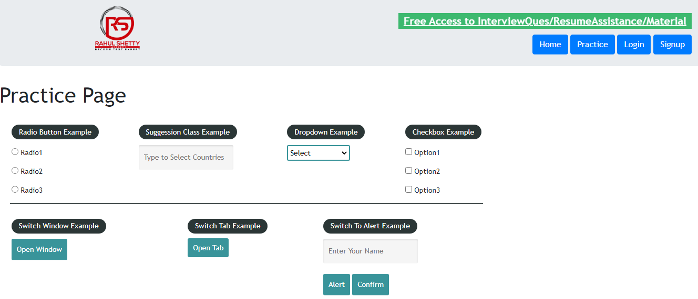
A simple example to demonstrate usage of child-sibling relation in locating web elements.

- package com.rahulshettylearning.theinternet;
- import java.util.concurrent.TimeUnit;
- import org.openqa.selenium.By;
- import org.openqa.selenium.WebDriver;
- import org.openqa.selenium.edge.EdgeDriver;

- public class LocatorPractice3 {
- public static void main(String[] args) {
- // TODO Auto-generated method stub
- System.setProperty("webdriver.edge.driver", "src\\main\\resources\\msedgedriver.exe");
- WebDriver driver = new EdgeDriver();
- driver.manage().timeouts().implicitlyWait(3, TimeUnit.SECONDS);
- driver.get("https://rahulshettyacademy.com/AutomationPractice/");
- System.out.println(driver.findElement(By.xpath("//header/div/button[1]/following-sibling::button[1]")).getText());
- System.out.println(driver.findElement(By.xpath("//header/div/button[1]/parent::div/button[2]")).getText());
- driver.close();
- }
- }

Locating different kinds of Drop-down:
https://rahulshettyacademy.com/dropdownsPractise/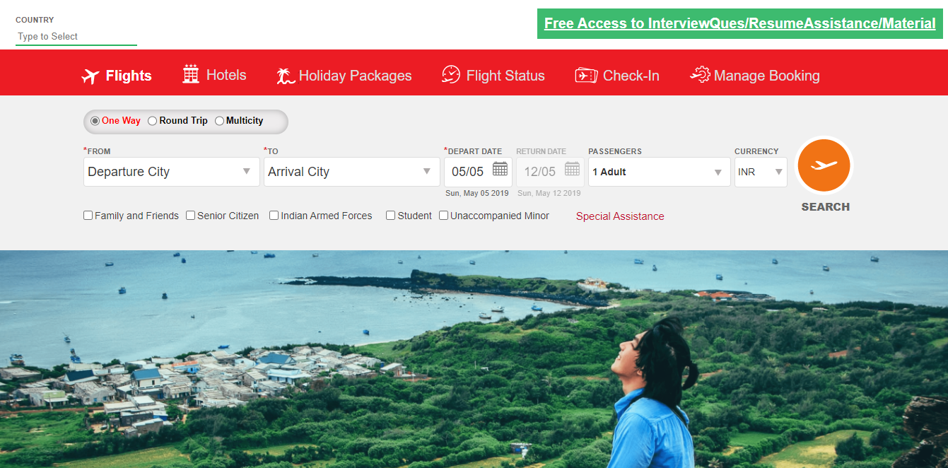
For this example, we are going to try and locate different type of drop-down web elements.

- package com.rahulshettylearning.theinternet;
- //Example four.

- //Visit "https://rahulshettyacademy.com/dropdownsPractise" for the HTML.
- //Use Selector hub or similar extension to validate the locators
- //or can also use browser console to validate CSS (use $) or Xpath (Use $x) locators.

- import java.util.List;
- import org.openqa.selenium.By;
- import org.openqa.selenium.WebDriver;
- import org.openqa.selenium.WebElement;
- import org.openqa.selenium.edge.EdgeDriver;
- import org.openqa.selenium.support.ui.Select;
- import org.testng.Assert;

- public class LocatorPractice4 {

- public static void main(String[] args) throws InterruptedException {

- System.setProperty("webdriver.edge.driver", "src\\main\\resources\\msedgedriver.exe");
- WebDriver driver = new EdgeDriver();
- driver.get("https://rahulshettyacademy.com/dropdownsPractise");
- WebElement staticdropdown = driver.findElement(By.id("ctl00_mainContent_DropDownListCurrency"));

- //We can locate static drop down in the following ways.
- Select dropdown = new Select(staticdropdown);
- dropdown.selectByIndex(3);
- System.out.println(dropdown.getFirstSelectedOption().getText());
- dropdown.selectByVisibleText("AED");
- System.out.println(dropdown.getFirstSelectedOption().getText());
- dropdown.selectByValue("INR");
- System.out.println(dropdown.getFirstSelectedOption().getText());
- //For dynamic we can locate in our usual way
- driver.findElement(By.xpath("//div[@id='divpaxinfo']")).click();
- Thread.sleep(2000);
- //Loop to click element multiple times
- int i = 5;
- while (--i > 0) {
- driver.findElement(By.xpath("//span[@id='hrefIncAdt']")).click();
- }
- //Assert statements are for validations.
- Assert.assertEquals(driver.findElement(By.xpath("//div[@id='divpaxinfo']")).getText(), "5 Adult");
- System.out.println(driver.findElement(By.xpath("//div[@id='divpaxinfo']")).getText());

- //For start and end destinations locators.
- //Start destination locator.
- driver.findElement(By.xpath("//input[@id='ctl00_mainContent_ddl_originStation1_CTXT']")).click();
- driver.findElement(By.xpath("//a[@value='CCU']")).click();
- Thread.sleep(2000);
- //End destination locator.
- //Note that we need to select the second element as the first instance is still there.
- // driver.findElement(By.xpath("(//a[@value='PNQ'])[2]")).click();
- // div[@id='ctl00_mainContent_ddl_destinationStation1_CTNR'] //a[@value='PNQ']
- //Rather than using index we can use the following parent-child relation.
- driver.findElement(By.xpath("//div[@id='ctl00_mainContent_ddl_destinationStation1_CTNR'] //a[@value='PNQ']"))
- .click();
- Thread.sleep(2000);
- //For calendar drop down.
- // driver.findElement(By.xpath("//a[@class='ui-state-default ui-state-highlight
- // ui-state-active']")).click();
- //For auto suggestive drop down.
- driver.findElement(By.xpath("//input[@id='autosuggest']")).sendKeys("in");
- Thread.sleep(3000);
- List<WebElement> options = driver.findElements(By.xpath("//li[@class='ui-menu-item']/a"));
- for (WebElement e : options) {
- if (e.getText().equals("India")) {
- e.click();
- break;
- }
- }
- //For check box and radio elements.
- // System.out.println(driver.findElement(By.xpath("//input[@id='ctl00_mainContent_chk_SeniorCitizenDiscount']")).isSelected());
- // System.out.println(driver.findElement(By.xpath("//input[@id='ctl00_mainContent_chk_SeniorCitizenDiscount']")).isSelected());

- Assert.assertFalse(driver.findElement(By.xpath("//input[@id='ctl00_mainContent_chk_SeniorCitizenDiscount']"))
- .isSelected());
- driver.findElement(By.xpath("//input[@id='ctl00_mainContent_chk_SeniorCitizenDiscount']")).click();
- Assert.assertTrue(driver.findElement(By.xpath("//input[@id='ctl00_mainContent_chk_SeniorCitizenDiscount']"))
- .isSelected());
- System.out.println(driver.findElements(By.xpath("//input[@type='checkbox']")).size());
- driver.findElement(By.id("ctl00_mainContent_rbtnl_Trip_1")).click();
- String st = driver.findElement(By.xpath("//div[@id='Div1']")).getAttribute("Style");
- System.out.println(st);
- Assert.assertTrue(driver.findElement(By.id("Div1")).getAttribute("Style").contains("1"));
- driver.findElement(By.id("ctl00_mainContent_rbtnl_Trip_0")).click();
- driver.findElement(By.xpath("(//input[@type='submit'])[1]")).click();

- }

- }

Handling alert:
https://rahulshettyacademy.com/AutomationPractice/

For this example, we will try interacting with alerts.

- package com.rahulshettylearning.theinternet;

- //Example Five

- //Visit "https://rahulshettyacademy.com/locatorspractice/" for the HTML.
- //Use Selector hub or similar extension to validate the locators
- //or can also use browser console to validate CSS (use $) or Xpath (Use $x) locators.
- import org.openqa.selenium.By;
- import org.openqa.selenium.WebDriver;
- import org.openqa.selenium.edge.EdgeDriver;

- public class LocatorPractice5 {

- public static void main(String[] args) {
- System.setProperty("webdriver.edge.driver", "src\\main\\resources\\msedgedriver.exe");
- WebDriver driver = new EdgeDriver();
- driver.get("https://rahulshettyacademy.com/AutomationPractice/");
- //We cannot interact with alert directly as it's not part of HTML.
- driver.findElement(By.id("name")).sendKeys("Pritam Ganguly");
- driver.findElement(By.cssSelector("[id='alertbtn']")).click();
- System.out.println(driver.switchTo().alert().getText());
- driver.switchTo().alert().accept();
- driver.findElement(By.cssSelector("[id='confirmbtn']")).click();
- System.out.println(driver.switchTo().alert().getText());
- driver.switchTo().alert().dismiss();

- }

- }

Retail website automation:
https://rahulshettyacademy.com/seleniumPractise/
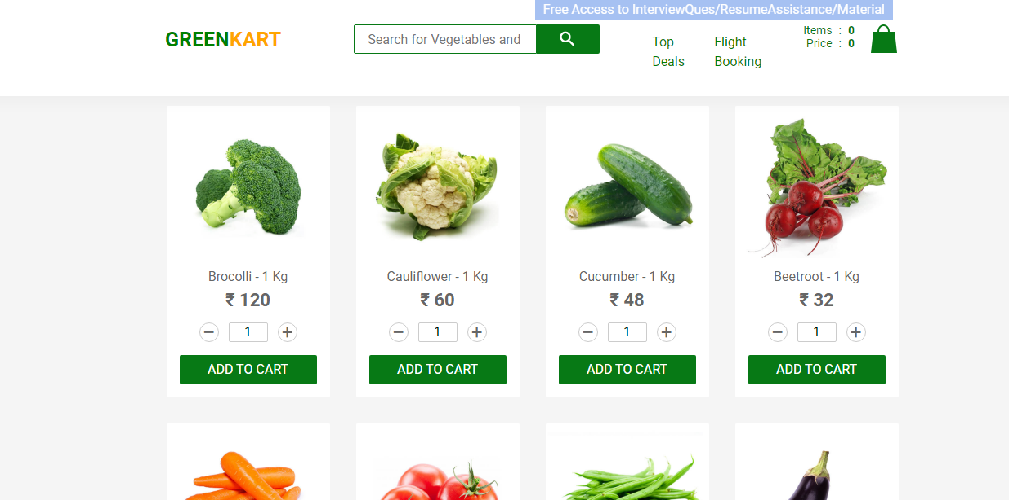

For this example, we will try to automate a retail website.
- package com.rahulshettylearning.theinternet;

- import java.util.Arrays;
- import java.util.List;
- import org.openqa.selenium.By;
- import org.openqa.selenium.WebDriver;
- import org.openqa.selenium.WebElement;
- import org.openqa.selenium.edge.EdgeDriver;

- public class Retailautomation {

- public static void main(String[] args) throws InterruptedException {

- System.setProperty("webdriver.edge.driver", "src\\main\\resources\\msedgedriver.exe");
- WebDriver driver = new EdgeDriver();
- // List of items that we are looking to buy.
- String[] grocerry = { "Raspberry", "Almonds", "Pears" };

- driver.get("https://rahulshettyacademy.com/seleniumPractise/");
- Thread.sleep(2000);

- List<WebElement> li = driver.findElements(By.xpath("//h4[@class='product-name']"));
- List<String> grocerryList = Arrays.asList(grocerry);

- for (int i = 0; i < li.size(); i++) {
- String item = li.get(i).getText().split("-")[0].trim();
- if (grocerryList.contains(item)) {

- // Reason why we should not use text in our locators.
- // With out the Thread.sleep, this won't work as 'ADD TO CART' text changes to
- // 'ADDED' as soon as it's clicked, so it will manipulate the list and it's indexes.
- // driver.findElement(By.xpath("(//button[text()='ADD TO CART'])"+"["+(i+1)+"]")).click();
- // Thread.sleep(6000);
- // Thats why it's always better to use xpath.
- driver.findElement(
- By.xpath("(//div[@class='product-action']/button[@type='button'])" + "[" + (i + 1) + "]"))
- .click();

- }
- }

- }

- }}

Synchronization in Selenium:

Implicit Wait
Specifies the amount of time the driver should wait when searching for an element if it is not immediately present.
Is not able to detect performance issue as the wait time is fixed for all the elements.

Explicit Wait
Specifies the amount of time the driver should wait when searching for a specific element if it is not immediately present.

Thread.sleep
Puts the JAVA thread to sleep.
Fluent Wait
Is a type of explicit wait. Fluent wait finds the WebDriver repeatedly with regular interval of time until the time out or the object gets found.
Unlike WebDriverWait in case of fluent wait we have to build customized wait methods based on condition.

Synchronization usage:
https://rahulshettyacademy.com/seleniumPractise/

For this example, we will update the previous code with different synchronization methods.

- package com.rahulshettylearning.theinternet;

- import java.util.Arrays;
- import java.util.List;
- import java.util.concurrent.TimeUnit;

- import org.openqa.selenium.By;
- import org.openqa.selenium.WebDriver;
- import org.openqa.selenium.WebElement;
- import org.openqa.selenium.edge.EdgeDriver;
- import org.openqa.selenium.support.ui.ExpectedConditions;
- import org.openqa.selenium.support.ui.WebDriverWait;

- public class Retailautomation {

- public static void main(String[] args) throws InterruptedException {

- System.setProperty("webdriver.edge.driver", "src\\main\\resources\\msedgedriver.exe");
- WebDriver driver = new EdgeDriver();
- // List of items that we are looking to buy.
- String[] grocerry = { "Raspberry", "Almonds", "Pears" };

- //Implicit wait
- //driver.manage().timeouts().implicitlyWait(5, TimeUnit.SECONDS);

- //Explicit wait
- WebDriverWait w = new WebDriverWait(driver, 5);

- driver.get("https://rahulshettyacademy.com/seleniumPractise/");
- Thread.sleep(2000);

- addItem(driver,grocerry);

- driver.findElement(By.xpath("//img[@alt='Cart']")).click();
- driver.findElement(By.xpath("//button[text()='PROCEED TO CHECKOUT']")).click();
- //Explicit wait
- w.until(ExpectedConditions.visibilityOfElementLocated(By.xpath("//input[@class='promoCode']")));
- driver.findElement(By.xpath("//input[@class='promoCode']")).sendKeys("rahulshettyacademy");
- driver.findElement(By.xpath("//button[@class='promoBtn']")).click();
- //Explicit wait
- w.until(ExpectedConditions.visibilityOfElementLocated(By.xpath("//span[@class='promoInfo']")));
- System.out.println(driver.findElement(By.xpath("//span[@class='promoInfo']")).getText());

- }

- public static void addItem(WebDriver driver, String[] grocerry) {
- List<WebElement> li = driver.findElements(By.xpath("//h4[@class='product-name']"));
- List<String> grocerryList = Arrays.asList(grocerry);

- for (int i = 0; i < li.size(); i++) {
- String item = li.get(i).getText().split("-")[0].trim();
- if (grocerryList.contains(item)) {

- // Reason why we should not use text in our locators.
- // With out the Thread.sleep, this won't work as 'ADD TO CART' text changes to
- // 'ADDED' as soon as it's clicked, so it will manipulate the list and it's indexes.
- // driver.findElement(By.xpath("(//button[text()='ADD TO CART'])"+"["+(i+1)+"]")).click();
- // Thread.sleep(6000);
- // Thats why it's always better to use xpath.
- driver.findElement(
- By.xpath("(//div[@class='product-action']/button[@type='button'])" + "[" + (i + 1) + "]"))
- .click();

- }
- }
- }

- }

Project:
For this project we are going to create an end-to-end test automation for the following retail website. https://rahulshettyacademy.com/loginpagePractise/
- package com.rahulshettylearning.theinternet;

- import java.util.List;

- import org.openqa.selenium.By;
- import org.openqa.selenium.WebDriver;
- import org.openqa.selenium.WebElement;
- import org.openqa.selenium.edge.EdgeDriver;
- import org.openqa.selenium.support.ui.ExpectedConditions;
- import org.openqa.selenium.support.ui.Select;
- import org.openqa.selenium.support.ui.WebDriverWait;

- public class LoginPageAutomation {

- public static void main(String[] args) throws InterruptedException {
- System.setProperty("webdriver.edge.driver", "src\\main\\resources\\msedgedriver.exe");
- WebDriver driver = new EdgeDriver();

- WebDriverWait wt5Sec = new WebDriverWait(driver, 5);

- driver.get("https://rahulshettyacademy.com/loginpagePractise/");
- driver.findElement(By.id("username")).sendKeys("rahulshettyacademy");
- driver.findElement(By.id("password")).sendKeys("learning");
- driver.findElement(By.xpath("(//span[@class='checkmark'])[2]")).click();
- wt5Sec.until(ExpectedConditions.visibilityOfElementLocated(By.xpath("//button[@id='okayBtn']")));
- // System.out.println(driver.switchTo().alert().getText());
- driver.findElement(By.xpath("//button[@id='okayBtn']")).click();
- Select dropdown = new Select(driver.findElement(By.xpath("//select[@class='form-control']")));
- dropdown.selectByVisibleText("Consultant");
- driver.findElement(By.id("terms")).click();
- driver.findElement(By.id("signInBtn")).click();
- wt5Sec.until(ExpectedConditions.visibilityOfElementLocated(By.xpath("//button[@class='btn btn-info']")));
- List<WebElement> li = driver.findElements(By.xpath("//button[@class='btn btn-info']"));
- for (WebElement e : li) {
- e.click();
- }
- driver.findElement(By.xpath("//a[@class='nav-link btn btn-primary']")).click();
- wt5Sec.until(ExpectedConditions.visibilityOfElementLocated(By.xpath("//button[@class='btn btn-success']")));
- driver.findElement(By.xpath("//button[@class='btn btn-success']")).click();
- wt5Sec.until(ExpectedConditions.visibilityOfElementLocated(By.id("country")));
- driver.findElement(By.id("country")).sendKeys("IN");
- wt5Sec.until(ExpectedConditions.visibilityOfElementLocated(By.xpath("//a[text()='India']")));
- driver.findElement(By.xpath("//a[text()='India']")).click();
- driver.findElement(By.xpath("//label[@for='checkbox2']")).click();
- driver.findElement(By.xpath("//input[@type='submit']")).click();
- }

- }

Synchronization usage Cont.:
https://the-internet.herokuapp.com/dynamic_loading/1

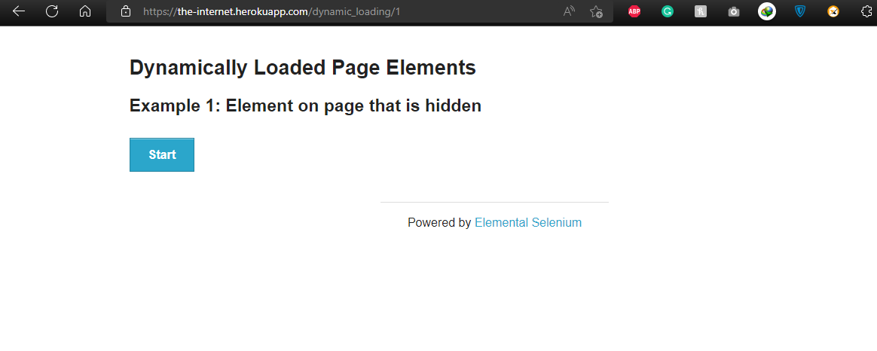
For this we will see an example of Fluent wait in action.

- package com.rahulshettylearning.theinternet;

- import java.time.Duration;
- import java.util.NoSuchElementException;
- import java.util.function.Function;

- import org.openqa.selenium.By;
- import org.openqa.selenium.WebDriver;
- import org.openqa.selenium.WebElement;
- import org.openqa.selenium.edge.EdgeDriver;
- import org.openqa.selenium.support.ui.FluentWait;
- import org.openqa.selenium.support.ui.Wait;

- public class FluentWaitTest {

- public static void main(String[] args) throws InterruptedException {

- System.setProperty("webdriver.edge.driver", "src\\main\\resources\\msedgedriver.exe");
- WebDriver driver = new EdgeDriver();
- driver.get("https://the-internet.herokuapp.com/dynamic_loading/1");

- driver.findElement(By.xpath("//div[@id='start']/button")).click();
- Thread.sleep(5000);
- Wait<WebDriver> wait = new FluentWait<WebDriver>(driver).withTimeout(Duration.ofSeconds(30))
- .pollingEvery(Duration.ofSeconds(3)).ignoring(NoSuchElementException.class);

- wait.until(new Function<WebDriver, WebElement>() {
- public WebElement apply(WebDriver driver) {
- if (driver.findElement(By.xpath("//div[@id='finish']/h4")).isDisplayed()) {
- return driver.findElement(By.xpath("//div[@id='finish']/h4"));
- }
- return null;
- }
- });

- System.out.println(driver.findElement(By.xpath("//div[@id='finish']/h4")).getText());

- }

- }

Use of Action class:
https://www.amazon.in/
For this example, we will demonstrate various mouse as keyboard functions that we can automate using the Action class of Selenium framework.

- package com.rahulshettylearning.theinternet;

- import org.openqa.selenium.By;
- import org.openqa.selenium.Keys;
- import org.openqa.selenium.WebDriver;
- import org.openqa.selenium.edge.EdgeDriver;
- import org.openqa.selenium.interactions.Actions;

- public class ActionExample {

- public static void main(String[] args) {
- System.setProperty("webdriver.edge.driver", "src\\main\\resources\\msedgedriver.exe");
- WebDriver driver = new EdgeDriver();
- driver.get("https://www.amazon.in/");
- Actions a = new Actions(driver);
- a.moveToElement(driver.findElement(By.xpath("//span[@id='nav-link-accountList-nav-line-1']"))).build()
- .perform();
- a.moveToElement(driver.findElement(By.id("twotabsearchtextbox"))).click().keyDown(Keys.SHIFT).sendKeys("hello")
- .build().perform();

- a.moveToElement(driver.findElement(By.xpath("//span[@id='nav-link-accountList-nav-line-1']"))).contextClick()
- .build().perform();
- }

- }

Window handling concept:
https://rahulshettyacademy.com/loginpagePractise/
For this example, we will see how we can work with parent and child windows.

- package com.rahulshettylearning.theinternet;

- import org.openqa.selenium.By;
- import org.openqa.selenium.WebDriver;
- import org.openqa.selenium.edge.EdgeDriver;
- import java.util.Iterator;
- import java.util.Set;
- import org.openqa.selenium.By;
- import org.openqa.selenium.WebDriver;

- public class WidowHandlers {

- public static void main(String[] args) {
- // TODO Auto-generated method stub

- System.setProperty("webdriver.edge.driver", "src\\main\\resources\\msedgedriver.exe");
- WebDriver driver = new EdgeDriver();

- driver.get("https://rahulshettyacademy.com/loginpagePractise/#");

- driver.findElement(By.cssSelector(".blinkingText")).click();

- Set<String> windows = driver.getWindowHandles(); // [parentid,childid,subchildId]

- Iterator<String> it = windows.iterator();

- String parentId = it.next();

- String childId = it.next();

- driver.switchTo().window(childId);

- System.out.println(driver.findElement(By.cssSelector(".im-para.red")).getText());

- driver.findElement(By.cssSelector(".im-para.red")).getText();

- String emailId = driver.findElement(By.cssSelector(".im-para.red")).getText().split("at")[1].trim()
- .split(" ")[0];
- //closed the child tab.
- driver.close();

- driver.switchTo().window(parentId);

- driver.findElement(By.id("username")).sendKeys(emailId);

- }

- }

Frame handling concept:
Droppable | jQuery UI
For this example, we will automate a drag and drop operation inside a frame.

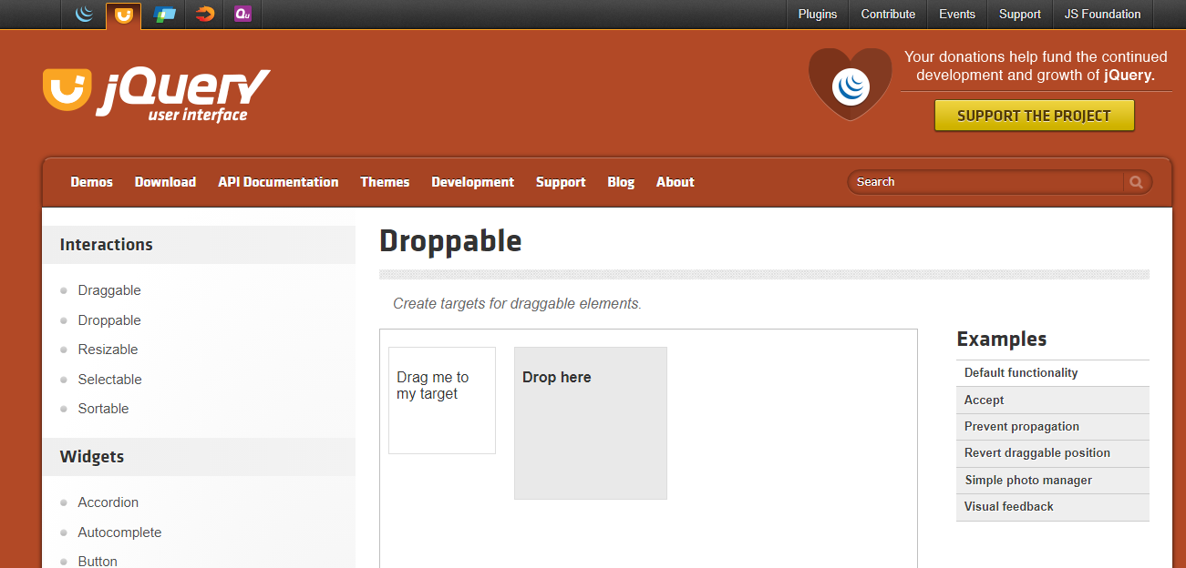

- package com.rahulshettylearning.theinternet;

- import org.openqa.selenium.By;
- import org.openqa.selenium.WebDriver;
- import org.openqa.selenium.edge.EdgeDriver;
- import org.openqa.selenium.interactions.Actions;
- import org.openqa.selenium.support.ui.WebDriverWait;

- public class Frames {

- public static void main(String[] args) {
- System.setProperty("webdriver.edge.driver", "src\\main\\resources\\msedgedriver.exe");
- WebDriver driver = new EdgeDriver();
- WebDriverWait wait5sec = new WebDriverWait(driver, 5);

- driver.get("https://jqueryui.com/droppable/");
- driver.switchTo().frame(driver.findElement(By.xpath("//iframe[@class='demo-frame']")));
- Actions a = new Actions(driver);
- a.dragAndDrop(driver.findElement(By.id("draggable")), driver.findElement(By.id("droppable"))).build().perform();

- }

- }

Exercise:
Practice Page (rahulshettyacademy.com)
For this example, we will open all the link from the footer section and will get the titles of all the new pages.

- package com.rahulshettylearning.theinternet;

- import java.util.Iterator;
- import java.util.Set;

- import org.openqa.selenium.By;
- import org.openqa.selenium.Keys;
- import org.openqa.selenium.WebDriver;
- import org.openqa.selenium.WebElement;
- import org.openqa.selenium.edge.EdgeDriver;

- public class LinkTest {

- public static void main(String[] args) throws InterruptedException {

- System.setProperty("webdriver.edge.driver", "src\\main\\resources\\msedgedriver.exe");
- WebDriver driver = new EdgeDriver();
- driver.get("https://rahulshettyacademy.com/AutomationPractice/");

- driver.get("http://qaclickacademy.com/practice.php");

- System.out.println(driver.findElements(By.tagName("a")).size());

- WebElement footerdriver = driver.findElement(By.id("gf-BIG"));// Limiting webdriver scope

- System.out.println(footerdriver.findElements(By.tagName("a")).size());

- // 3-
- WebElement coloumndriver = footerdriver.findElement(By.xpath("//table/tbody/tr/td[1]/ul"));
- System.out.println(coloumndriver.findElements(By.tagName("a")).size());

- // 4- click on each link in the column and check if the pages are opening-
- for (int i = 1; i < coloumndriver.findElements(By.tagName("a")).size(); i++) {

- String clickonlinkTab = Keys.chord(Keys.CONTROL, Keys.ENTER);

- coloumndriver.findElements(By.tagName("a")).get(i).sendKeys(clickonlinkTab);
- Thread.sleep(5000L);

- } // opens all the tabs
- Set<String> abc = driver.getWindowHandles();// 4
- Iterator<String> it = abc.iterator();

- while (it.hasNext()) {

- driver.switchTo().window(it.next());
- System.out.println(driver.getTitle());

- }}}
Handling calendar UI:
Charter Flights, Charter Flight Booking, Charter Planes Ticket Booking (makemytrip.com)
Following example will demonstrate how we can handle calendar UI.
package com.rahulshettylearning.theinternet;

import java.util.List;
import java.util.concurrent.TimeUnit;
import org.openqa.selenium.By;
import org.openqa.selenium.WebDriver;
import org.openqa.selenium.WebElement;
import org.openqa.selenium.edge.EdgeDriver;

public class CalenderUIAutomation {

public static void main(String[] args) throws InterruptedException {

System.setProperty("webdriver.edge.driver", "src\\main\\resources\\msedgedriver.exe");
WebDriver driver = new EdgeDriver();
driver.manage().timeouts().implicitlyWait(5, TimeUnit.SECONDS);
driver.get("https://www.makemytrip.com/charter-flights/");
driver.manage().window().maximize();

// Select Date 23th February 2023

String day = "23";
String month = "February 2023";

driver.findElement(By.xpath("//li[@data-cy='account']")).click();
driver.findElement(By.xpath("//div[@class='cfsw_inputBox dates inactiveWidget ']")).click();
Thread.sleep(2000);

while (!driver.findElement(By.xpath("(//div[@class='DayPicker-Caption']/div)[1]")).getText().contains(month)) {

driver.findElement(By.xpath("//span[@class='DayPicker-NavButton DayPicker-NavButton--next']")).click();

}

List<WebElement> daysList = driver.findElements(By.xpath("//div[@class='DayPicker-Day']"));

for (WebElement e : daysList) {
String text = (e.getAttribute("aria-label"));
if (text.contains(day)) {
e.click();
break;
}

}

}

}

Handling scrolling on page and grid element:
Charter Flights, Charter Flight Booking, Charter Planes Ticket Booking (makemytrip.com)
Following example will demonstrate how we can handle
1. Scrolling on Page
2. Scrolling on grid element such as table
3. Accessing grid elements
import org.openqa.selenium.By;
import org.openqa.selenium.JavascriptExecutor;
import org.openqa.selenium.WebDriver;
import org.openqa.selenium.WebElement;
import org.openqa.selenium.edge.EdgeDriver;
import org.testng.Assert;

public class ScrollFunction {

public static void main(String[] args) {

System.setProperty("webdriver.edge.driver", "src\\main\\resources\\msedgedriver.exe");
WebDriver driver = new EdgeDriver();
driver.manage().timeouts().implicitlyWait(5, TimeUnit.SECONDS);

driver.get("https://rahulshettyacademy.com/AutomationPractice/");
JavascriptExecutor js = (JavascriptExecutor) driver;

// For page scrolling
js.executeScript("window.scrollBy(0,500)");

// for Element scrolling
js.executeScript("document.querySelector('.tableFixHead').scrollTop=5000");

List<WebElement> elements = driver.findElements(By.xpath("//div[@class='tableFixHead']//td[4]"));

int sum = 0;

for (WebElement e : elements) {
sum += Integer.parseInt(e.getText());
}

// System.out.println(sum);
;
int pageSum = Integer
.parseInt(driver.findElement(By.xpath("//div[@class='totalAmount']")).getText().split(":")[1].trim());

// System.out.println(pageSum);

Assert.assertEquals(sum, pageSum);
driver.close();

}

}

Handling window and cookies:
package com.rahulshettylearning.theinternet;

import java.util.concurrent.TimeUnit;

import org.openqa.selenium.WebDriver;
import org.openqa.selenium.edge.EdgeDriver;

public class WindowAndCookies {

public static void main(String[] args) {
System.setProperty("webdriver.edge.driver", "src\\main\\resources\\msedgedriver.exe");
WebDriver driver = new EdgeDriver();
driver.manage().timeouts().implicitlyWait(5, TimeUnit.SECONDS);
driver.manage().window().maximize();
driver.manage().deleteAllCookies();
driver.manage().deleteCookieNamed("SessionKey");

driver.get("https://www.google.com");

}

}

Strategy to verify all the Links:
Practice Page (rahulshettyacademy.com)
If a link is not working it will send status code greater than 400. We are going to utilize this in our strategy.
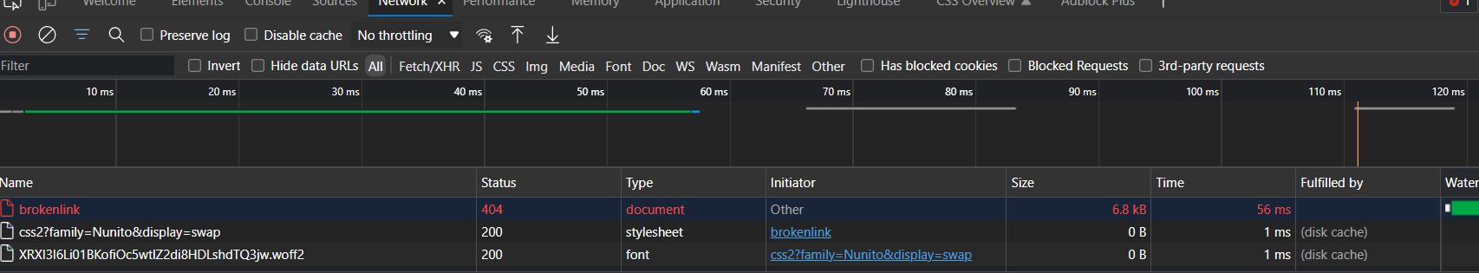
Rather that using Asset we are going to use SoftAssert that will continue executing the code even after assertion fails.
package com.rahulshettylearning.theinternet;

import java.io.IOException;
import java.net.HttpURLConnection;
import java.net.MalformedURLException;
import java.net.URL;
import java.util.List;
import java.util.concurrent.TimeUnit;

import org.openqa.selenium.By;
import org.openqa.selenium.WebDriver;
import org.openqa.selenium.WebElement;
import org.openqa.selenium.edge.EdgeDriver;
import org.testng.asserts.SoftAssert;

public class CheckBrokenLinks {

public static void main(String[] args) throws MalformedURLException, IOException {
System.setProperty("webdriver.edge.driver", "src\\main\\resources\\msedgedriver.exe");
WebDriver driver = new EdgeDriver();
driver.manage().timeouts().implicitlyWait(5, TimeUnit.SECONDS);
driver.manage().window().maximize();
SoftAssert a = new SoftAssert();

driver.get("https://rahulshettyacademy.com/AutomationPractice/");
List<WebElement> li = driver.findElements(By.xpath("//li[@class='gf-li']/a"));

for (WebElement i : li) {
String linkText = i.getAttribute("href");
HttpURLConnection conn = (HttpURLConnection) new URL(linkText).openConnection();
conn.setRequestMethod("HEAD");
conn.connect();
int resCount = conn.getResponseCode();
// if the response code is greater than 400 then the link is not working.
// SoftAsserting will continue even after failing the assertion test.

// System.out.println(resCount);

a.assertTrue(resCount < 400, "The link with Text" + i.getText() + " is broken with code" + resCount);

}
driver.close();

}

}

Stream API and lambda expression:
By using stream, we can perform various aggregate operations on the data returned from collections class by drastically reducing the complexity of the code.
- Create a Stream
- Perform Intermediate operation.
- Perform Terminal Operation.
long count2 = ls.stream().filter(s -> s.startsWith("P")).count();
Lambda expression introduces the new arrow operator in java - >. It divides the Lambda expression into two parts. s -> s.startsWith("P")
- The left side specifies the parameters
- The right side specifies the action of the lambda expression.
Here’s an example of how stream and lambda expression simplifies a code block.
package com.rahulshettylearning.theinternet;

import java.util.ArrayList;
import java.util.Arrays;
import java.util.List;
import java.util.stream.Collectors;
import java.util.stream.Stream;
import org.testng.Assert;

public class JavaStreams {

public static void main(String[] args) {

List<String> ls = new ArrayList<>();
ls.add("Pritam");
ls.add("Prantik");
ls.add("Indrasis");
ls.add("Subhojit");

int count = 0;
for (String s : ls) {
if (s.startsWith("P"))
count++;
}
System.out.println(count);
// Using Stream API
long count2 = ls.stream().filter(s -> s.startsWith("P")).count();
System.out.println(count2);

ls.stream().filter(x -> x.length() > 6).limit(2).forEach(s -> System.out.println(s));

Stream.of("Apple", "JackFruit", "Bananan", "Mango")
.forEach(s -> System.out.println("String length is " + s.length()));

Arrays.asList("Australia", "Azarbizan", "Armenia", "India", "Spain", "France").stream()
.filter(s -> s.startsWith("A")).sorted().map(s -> s.toUpperCase()).forEach(s -> System.out.println(s));

Stream<String> st1 = Stream.of("Adam", "Lavid", "David");
Stream<String> st2 = Stream.of("Lisa", "Yor", "Natasha");
Stream<String> mergedStream = Stream.concat(st1, st2);

// mergedStream.forEach(s->System.out.println(s));
// Cannot reuse the stream after it's been acted upon or closed.

boolean verify = mergedStream.anyMatch(s -> s.equalsIgnoreCase("lisa"));

Assert.assertTrue(verify);

List<String> collectedList = Arrays.asList("Australia", "Azarbizan", "Armenia", "India", "Spain", "France")
.stream().filter(s -> s.startsWith("A")).sorted().map(s -> s.toUpperCase())
.collect(Collectors.toList());
System.out.println(collectedList.toString());

List<Integer> values = Arrays.asList(1, 2, 3, 4, 7, 5, 6, 9, 10, 10, 9, 9, 4, 3, 5);

values.stream().sorted().distinct().forEach(n -> System.out.println(n));

System.out.println(values.stream().sorted().collect(Collectors.toList()).get(2));

}

}

Web Table sorting:
GreenKart - veg and fruits kart (rahulshettyacademy.com)
Here is an example of how stream can help us in sorting web tables.
package com.rahulshettylearning.theinternet;
import java.util.List;
import java.util.concurrent.TimeUnit;
import java.util.stream.Collectors;
import org.openqa.selenium.By;
import org.openqa.selenium.WebDriver;
import org.openqa.selenium.WebElement;
import org.openqa.selenium.edge.EdgeDriver;
import org.testng.Assert;

public class JavaSortedStream {

public static void main(String[] args) {
System.setProperty("webdriver.edge.driver", "src\\main\\resources\\msedgedriver.exe");
WebDriver driver = new EdgeDriver();
driver.manage().timeouts().implicitlyWait(5, TimeUnit.SECONDS);

driver.get("https://rahulshettyacademy.com/seleniumPractise/#/offers");

driver.findElement(By.xpath("//tr/th[1]")).click();

List<WebElement> vegNames = driver.findElements(By.xpath("//tr/td[1]"));

List<String> orginalList = vegNames.stream().map(s -> s.getText()).collect(Collectors.toList());

List<String> sortedList = orginalList.stream().sorted().collect(Collectors.toList());

Assert.assertEquals(orginalList, sortedList);

List<String> li;

do {
List<WebElement> vegList = driver.findElements(By.xpath("//tr/td[1]"));
li = vegList.stream().filter(s -> s.getText().contains("Rice")).map(s -> getPrice(s))
.collect(Collectors.toList());
if (li.size() < 1) {
driver.findElement(By.xpath("//a[@aria-label='Next']")).click();
}

} while (li.size() < 1);
li.forEach(s -> System.out.println(s));
// driver.close();

driver.findElement(By.id("search-field")).sendKeys("Rice");
List<WebElement> veggies = driver.findElements(By.xpath("//tr/td[1]"));
List<WebElement> sortedList2 = veggies.stream().filter(s->s.getText().contains("Rice")).collect(Collectors.toList());

Assert.assertEquals(veggies.size(), sortedList2.size());

}

private static String getPrice(WebElement w) {
return w.findElement(By.xpath("following-sibling::td[1]")).getText();
}

}

Handling of expired HTTP certification errors:
Here is an example of how we can handle expires HTTP certification errors.
package com.rahulshettylearning.theinternet;

import java.util.HashMap;
import java.util.Map;
import org.openqa.selenium.WebDriver;
import org.openqa.selenium.chrome.ChromeDriver;
import org.openqa.selenium.chrome.ChromeOptions;

public class CertificateAlerts {

public static void main(String[] args) {

ChromeOptions options = new ChromeOptions();

org.openqa.selenium.Proxy proxy = new org.openqa.selenium.Proxy();
proxy.setHttpProxy("ipaddress:4444");
options.setCapability("proxy", proxy);

Map<String, Object> prefs = new HashMap<String, Object>();
prefs.put("download.default_directory", "/directory/path");

options.setExperimentalOption("prefs", prefs);

// FirefoxOptions options1 = new FirefoxOptions();
// options1.setAcceptInsecureCerts(true);
// EdgeOptions options2 = new EdgeOptions();

options.setAcceptInsecureCerts(true);

System.setProperty("webdriver.chrome.driver", "src\\\\main\\\\resources\\\\chromedriver.exe");
WebDriver driver = new ChromeDriver(options);
driver.get("https://expired.badssl.com/");
System.out.println(driver.getTitle());

}

}

Relative locator feature in Selenium 4:
package com.rahulshettylearning.theinternet;

import org.openqa.selenium.By;
import org.openqa.selenium.WebDriver;
import org.openqa.selenium.WebElement;
import org.openqa.selenium.edge.EdgeDriver;
import static org.openqa.selenium.support.locators.RelativeLocator.*;

public class RelativeLocator {

public static void main(String[] args) {
System.setProperty("webdriver.edge.driver", "src\\main\\resources\\msedgedriver.exe");
WebDriver driver = new EdgeDriver();
driver.get("https://rahulshettyacademy.com/angularpractice/");

WebElement nameInput = driver.findElement(By.xpath("(//input[@name='name'])[1]"));
System.out.println(driver.findElement(with(By.tagName("label")).above(nameInput)).getText());

WebElement dateofBirth = driver.findElement(By.cssSelector("[for='dateofBirth']"));

driver.findElement(with(By.tagName("input")).below(dateofBirth)).click();

WebElement iceCreamLabel = driver
.findElement(By.xpath("//label[text()='Check me out if you Love IceCreams!']"));

driver.findElement(with(By.tagName("input")).toLeftOf(iceCreamLabel)).click();

WebElement rdb = driver.findElement(By.id("inlineRadio1"));

System.out.println(driver.findElement(with(By.tagName("label")).toRightOf(rdb)).getText());

}

}

Other Features Introduced in Selenium 4:
package com.rahulshettylearning.theinternet;

import java.io.IOException;
import java.util.Iterator;
import java.util.Set;

import org.openqa.selenium.By;
import org.openqa.selenium.WebDriver;
import org.openqa.selenium.WebElement;
import org.openqa.selenium.WindowType;
import org.openqa.selenium.edge.EdgeDriver;

public class InvokingMultipleWindow {

public static void main(String[] args) throws IOException {
System.setProperty("webdriver.edge.driver", "src\\main\\resources\\msedgedriver.exe");
WebDriver driver = new EdgeDriver();
driver.get("https://rahulshettyacademy.com/angularpractice/");

// Switching Window

driver.switchTo().newWindow(WindowType.WINDOW);

Set<String> handles = driver.getWindowHandles();
Iterator<String> it = handles.iterator();
String parentWindowId = it.next();
String childWindow = it.next();
driver.switchTo().window(childWindow);

driver.get("https://rahulshettyacademy.com/");
String courseName = driver
.findElements(By.xpath("//a[contains(@href,'https://courses.rahulshettyacademy.com/p')]")).get(1)
.getText();
driver.close();
driver.switchTo().window(parentWindowId);

WebElement name = driver.findElement(By.xpath("(//input[@name='name'])[1]"));

// Height and weight

System.out.println(name.getRect().getDimension().getHeight());
System.out.println(name.getRect().getDimension().getWidth());

name.sendKeys(courseName);

}

}

