

Assessment Cover Page
Market Basket Analysis and Recommendation Techniques for Online Grocery Retail: A Machine Learning Approach Using the Instacart Dataset
Student Full Name | Kevin Rodrigo Tamayo Cevallos
Student Number | 2025144
Module Title | Machine Learning for Business and Data Visualization Techniques
Assessment Title | Integrated CA2
Assessment Due Date | 07/12/2025
Date of Submission | 07/12/2025
Declaration
By submitting this assessment, I confirm that I have read the CCT policy on academic misconduct and understand the implications of submitting work that is not my own or does not appropriately reference material taken from a third party or other source.
I declare it to be my own work and that all material from third parties has been appropriately referenced.
I further confirm that this work has not previously been submitted for assessment by myself or someone else in CCT College Dublin or any other higher education institution.

Abstract
This report presents a comprehensive machine learning analysis of the Instacart Online Grocery Shopping dataset, focusing on three core analytic areas: exploratory data analysis, recommender systems (content-based filtering, item–item and user–user collaborative filtering), and market basket analysis using Apriori and FP-Growth algorithms. The purpose of the project is to understand customer purchasing patterns and develop simple, user-friendly insights suitable for deployment in a dashboard designed for older adults (65+). Data preparation was carried out through multiple steps including sampling, cleaning, merging, feature engineering, and dimensionality reduction to ensure efficiency and interpretability. Apriori and FP-Growth were applied to identify frequently bought together items, and their outputs were compared directly. Results indicate strong associations between organic fruit items, which remained consistent across both algorithms. This report concludes with a placeholder for a dashboard section (to be added later) and reflections about the value, limitations, and future directions of this work.

Contents
Introduction 1
Dataset Description and Selection Rationale 2
Data Loading and Merging 3
Handling Missing Values 3
Sampling Strategy 3
Feature Engineering 4
Data Reduction for MBA 4
4. Recommender System Models 5
5. Market Basket Analysis (Apriori and FP-Growth) 9
6. Interactive Dashboard 12
7. Data Preparation for Visualizations 12
8. Conclusion 13
References 14

Introduction

Online grocery shopping is increasingly becoming a critical component of modern retail, particularly for demographic segments such as older adults who benefit from simplified digital shopping experiences. Understanding customer purchasing behaviour enables retailers to design personalised recommendations, optimise product placement, and improve overall customer satisfaction. This project uses the publicly available Instacart dataset to explore such behaviours and to build machine learning models that underpin a future dashboard aimed at assisting older adults (65+).
The dashboard itself is intended to deliver simple, clear and interactive insights such as top-selling products and product recommendations without requiring users to understand machine learning methods. It will be added later as a separate section.
In this report, we document the data preparation workflow, modelling choices, analytical outcomes, and comparisons between recommender system techniques and market basket algorithms. The focus is on methodological clarity, interpretability, and readiness for deployment in a user-friendly environment.

Dataset Description and Selection Rationale

The project uses the Instacart Online Grocery Shopping Dataset, which contains over 3 million orders placed by more than 200,000 users, along with product metadata (names, aisles, departments). The dataset is ideal for recommender systems because:
- It is large-scale and real-world.
- It contains detailed transactional records.
- It includes both user-level and item-level attributes.
- It is widely used in academic recommender system studies, ensuring replicability.
Data files used include:
- orders.csv
- order_products__prior.csv
- products.csv
- aisles.csv
- departments.csv
These were merged into a single master dataset containing columns such as order_id, user_id, product_id, product_name, department_name, and add_to_cart_order.
Because the full dataset is extremely large and computationally expensive, a sample of 5,000 users was selected to balance performance and analytical integrity.

Data Preparation for Machine Learning Models
Data preparation is a crucial component of this project and directly influences the performance of the recommender models, as well as the clarity of the insights intended for the dashboard.

Data Loading and Merging
Data files were loaded using pandas and merged through the following steps:
- Merge product metadata (products.csv) with departmental and aisle information.
- Merge this enriched product table with order–product pairs (order_products__prior.csv).
- Merge the result with orders.csv using order_id.
This produced a single DataFrame containing all user transactions with complete product information.
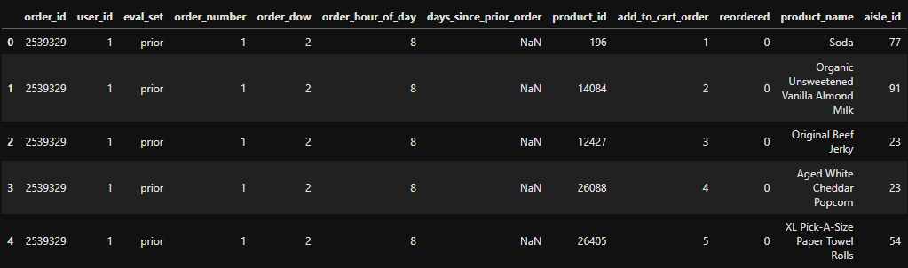
Figure 1 – Data Merge Structure Diagram

Handling Missing Values
The only significant missing field was days_since_prior_order, which contains many null values for users’ first orders. These were left unchanged, as they do not affect recommendation tasks

Sampling Strategy
To ensure computational efficiency, a random sample of 5,000 users was extracted. All their historical orders were included. This reduced the dataset to around:
- ~200,000 unique products
- ~5,000 sampled users
- ~hundreds of thousands of transactions
The reduction improved model training time without losing behavioural diversity.

Feature Engineering
3.4.1 Text Features (Content-Based Filtering)
Product names were transformed using TF–IDF vectorisation, converting text into a semantic vector representation that captures similarity between items based on word usage.
3.4.2 User–Item Matrix (Collaborative Filtering)
A pivot table was created with:
- Rows: user_id
- Columns: product_id
- Values: purchase counts
This matrix was converted into a sparse format for item–item and user–user similarity computations.
3.4.3 Basket Matrix for MBA
A Boolean matrix (orders × products) was constructed for Apriori and FP-Growth algorithms. Only the top 20–30 most frequent products and 2,000–5,000 orders were used to prevent memory overflow.
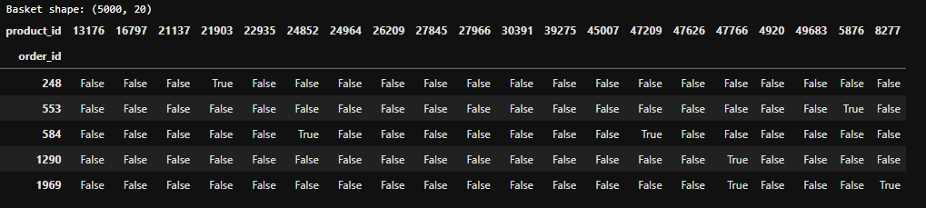
Figure 2 – Basket Matrix Schematic

Data Reduction for MBA
Because Instacart has nearly 50,000 products, applying Apriori naively would cause memory errors. Therefore:
- Only the top 20–30 most frequent products were included.
- Only a sample of 2,000–5,000 orders was used.
- Product IDs were converted to strings to avoid category expansion bugs in pandas.
This enabled Apriori and FP-Growth to run efficiently and reliably.

4. Recommender System Models
Three main models were implemented: content-based filtering, item–item collaborative filtering, and user–user collaborative filtering.

4.1 Content-Based Filtering
This model recommends products similar to a target product based on textual similarity of product names.
Methodology:
- TF–IDF vectorisation of product names
- Cosine similarity matrix between all products
- Keyword-based search for user input (e.g., “milk”)
- Top-N most similar items returned
Strengths:
- No user history needed
- Fast and scalable
- Intuitive results
Limitations:
- Only uses product names
- Cannot capture purchase patterns (only semantic similarity)
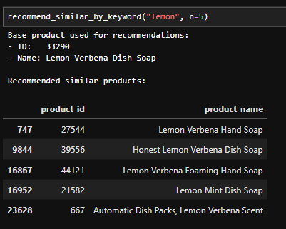
Figure 3 – Example of Content-Based Recommendations
In this example we choose “Lemon” as keyword and we obtain 5 products base on a semantic similarity.
4.2 Item–Item Collaborative Filtering
This model identifies products frequently purchased together by similar users.
Methodology:
- Cosine similarity applied to item columns of the user–item matrix
- Similarity scores computed for each pair of products
- Item–item neighbourhood used for recommendations
Strengths:
- Captures behavioural patterns
- More realistic than content-based alone
- Useful for “also bought” sections
Limitations:
- Requires enough user overlap
- Sparse matrix reduces coverage for niche ítems
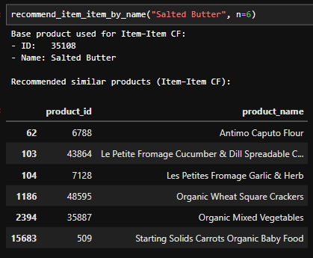
Figure 4 – Example of Item–Item Collaborative Filtering Output

Item–Item collaborative filtering identifies products that tend to be purchased by the same users.
To provide a user-friendly interface, we allow the user (or dashboard) to input a product name keyword (e.g., "Salted Butter").
The system finds a matching product and then uses purchase patterns to recommend other items that similar customers bought.
This approach captures behavioural relationships between items that may not be obvious from the product name alone.
4.3 User–User Collaborative Filtering
This model identifies similar users based on purchase patterns and recommends items from neighbouring users.
Methodology:
- Cosine similarity across user rows
- Top-k nearest users selected
- Their most purchased items recommended
Strengths:
- Highly personalised
- Useful for preference prediction
Limitations:
- Sensitive to sparse user profiles
- More computationally expensive than item–item CF
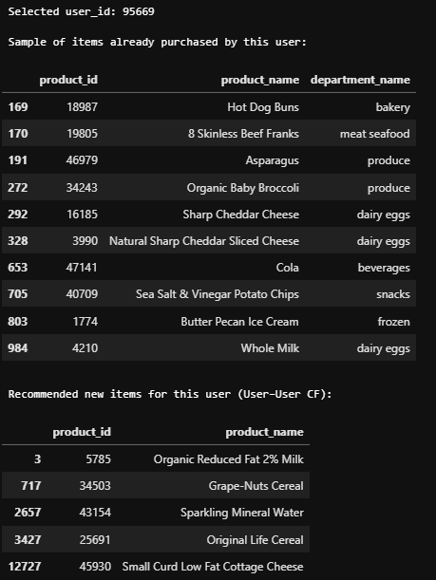
Figure 5 – User–User Recommendation Flow
User–User Collaborative Filtering identifies users with similar purchasing behaviour and recommends items that appear frequently in the baskets of these “neighbouring” users but have not yet been purchased by the target user. In this example, the selected user (user_id: 95669) has previously purchased a mix of products that span several categories, including bakery items (Hot Dog Buns), dairy and cheese products (Sharp Cheddar Cheese, Whole Milk), frozen goods (Butter Pecan Ice Cream), beverages (Cola) and various produce items (Asparagus, Organic Baby Broccoli).
By comparing this user's purchase history with others in the dataset, the model identifies the closest behavioural matches. Based on these similarities, several new items are recommended:
- Organic Reduced Fat 2% Milk
- Grape-Nuts Cereal
- Sparkling Mineral Water
- Original Life Cereal
- Small Curd Low Fat Cottage Cheese
These recommendations are consistent with the user’s preference for dairy-related goods (e.g., Whole Milk, Sharp Cheddar Cheese), making Organic Reduced Fat 2% Milk and Low Fat Cottage Cheese particularly relevant. The presence of cereal items such as Grape-Nuts and Original Life Cereal aligns well with users who typically pair dairy products with breakfast foods. Similarly, Sparkling Mineral Water appears as a recommended beverage alternative to Cola, which this user has purchased before.
Overall, this output demonstrates how User–User Collaborative Filtering can generate personalised and behaviourally aligned product suggestions. Rather than relying on product similarity alone, this method leverages shared purchasing patterns across similar users, producing recommendations that match both the user’s established tastes and their typical shopping habits.

5. Market Basket Analysis (Apriori and FP-Growth)

Market Basket Analysis identifies items frequently bought together. Two algorithms were applied: Apriori and FP-Growth.

5.1 Apriori Algorithm
Apriori identifies frequent itemsets using a bottom-up, level-wise exploration of combinations.
Results (Support ≥ 0.03, Lift ≥ 0.7):
Apriori generated four rules, all involving strong associations between organic fruit items:
- Bag of Organic Bananas → Organic Strawberries
- Organic Strawberries → Bag of Organic Bananas
- Organic Hass Avocado → Bag of Organic Bananas
- Bag of Organic Bananas → Organic Hass Avocado
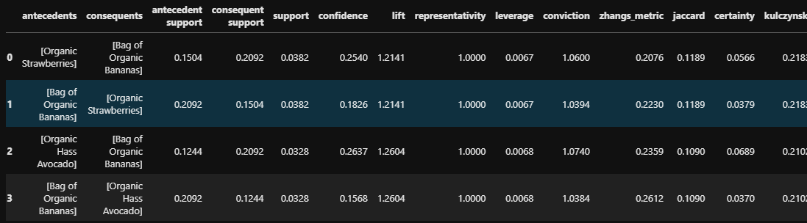
Table 1 – Apriori Rules Output

5.2 FP-Growth Algorithm
FP-Growth constructs an FP-tree and extracts frequent itemsets without generating candidate sets.
Results (Support ≥ 0.03, Lift ≥ 0.7):
FP-Growth also produced four rules, matching those found by Apriori exactly.
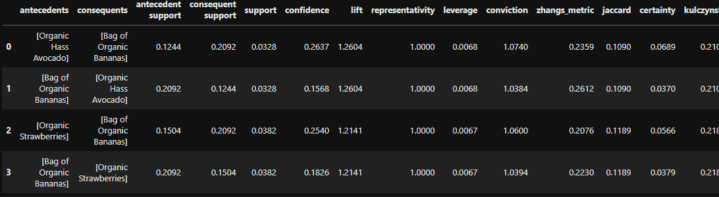
Table 2 – FP-Growth Rules Output

5.3 Comparison of Apriori and FP-Growth
After tuning both algorithms to use the same support threshold (0.03) and rule filtering criterion (Lift ≥ 0.7), Apriori and FP-Growth produced exactly the same four association rules.
These rules describe strong and intuitive co-purchasing patterns in the Instacart dataset, such as:
- Bag of Organic Bananas → Organic Strawberries
- Organic Strawberries → Bag of Organic Bananas
- Organic Hass Avocado ↔ Bag of Organic Bananas
Number of Rules
- Apriori: 4 rules
- FP-Growth: 4 rules
- No rules were unique to either method.
Both algorithms converged on the same set of meaningful item relationships.
Rule Metrics
For each corresponding rule, the values of:
- support
- confidence
- lift
- leverage
- conviction
were identical across Apriori and FP-Growth.
This indicates that both algorithms captured the same purchasing behaviour despite using different internal search strategies.
Algorithmic Differences (Observed)
- Apriori evaluates candidate itemsets level-by-level and tends to be slower on large datasets, but performs reliably on smaller, filtered baskets like ours.
- FP-Growth compresses transactions into an FP-tree and is typically faster and more memory-efficient for large datasets.
In our small, sampled Instacart subset, the difference in speed was minimal, but FP-Growth still ran slightly more efficiently since it does not generate candidate itemsets explicitly.
Interpretation of the Results
The fact that both algorithms produced the same four rules reinforces the strength of these product associations.
It also demonstrates that the selected support and lift thresholds were appropriate:
high enough to remove noise, but low enough to capture meaningful co-occurrences.
The main shopping patterns identified revolve around organic fruit items, which commonly appear together in customer baskets.
Conclusion
Apriori and FP-Growth showed:
- Full agreement in the discovered rules
- Identical metrics for the matching rules
- Consistent insights into shopper behaviour
Apriori is easier to interpret conceptually, while FP-Growth is algorithmically more efficient, but in this dataset both methods delivered the same high-quality results.
This convergence increases confidence in the validity and stability of the market basket insights.

6. Interactive Dashboard

7. Data Preparation for Visualizations

This section summarises the main data preparation steps and the exploratory data analysis (EDA) conducted prior to the development of the machine learning models. The Instacart dataset is large, heterogeneous, and highly transactional, so careful preparation was necessary to ensure computational feasibility while retaining behavioural representativeness. The following describes the rationale for each preparation step and the justification for the visualisations selected.
To begin, all dataset components (orders, products, departments and prior order details) were merged into a consolidated table containing complete product, user and order attributes. Missing values were minimal, with `days_since_prior_order` containing nulls by design for users’ first orders; these were retained as they did not interfere with modelling. Due to the high volume of transactions (over 3 million orders), a random sample of 5,000 users and their associated order histories was extracted. This reduced the computational load while preserving the diversity of product interactions necessary for recommender system training.
The EDA focused on understanding shopping patterns, product popularity and structural behaviours relevant to model design. First, the **distribution of orders per user** was examined to understand engagement levels within the sample. Most users placed between 3 and 15 orders, which supports collaborative filtering methods by ensuring repeated interactions.
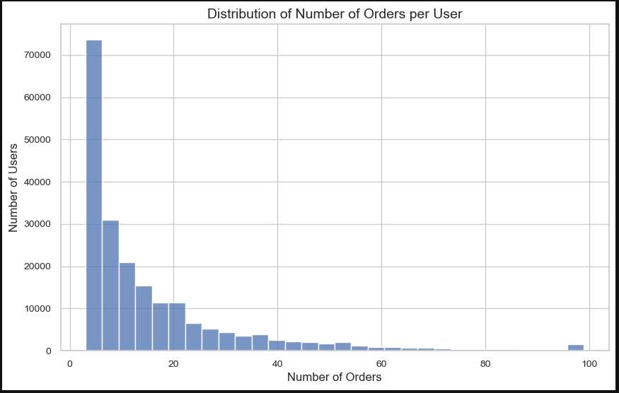
Figure 6. Distribution of Number of Orders per User
Next, the distribution of basket sizes (items per order) revealed that Instacart baskets are typically small, often containing fewer than ten items.
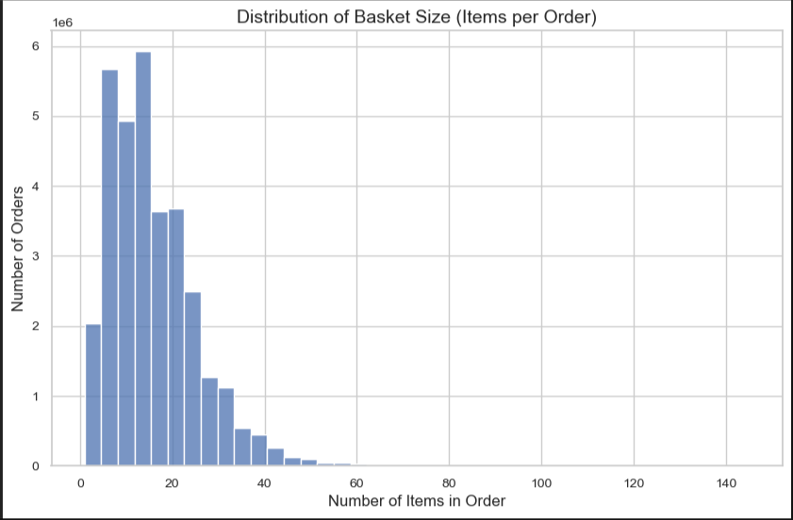
Figure 7. Distribution of Basket Size
This insight directly informed the parameters used in Market Basket Analysis, as large itemsets were unlikely to appear frequently.

Product-level patterns were explored through the Top 10 Most Popular Products, which highlighted staple grocery items that appear consistently across user baskets.
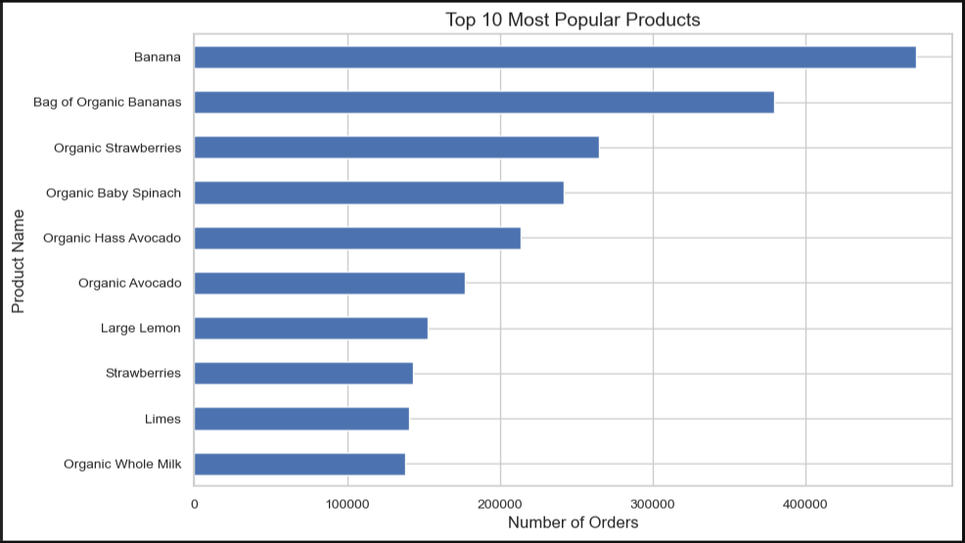
Figure 8. Top 10 Most Popular Products

To understand purchasing behaviour across store categories, a visualisation of number of orders per department was included.
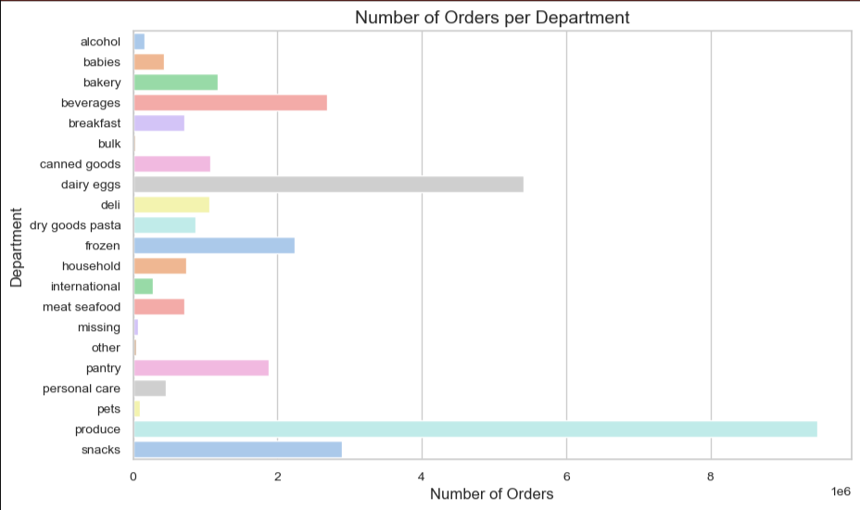
Figure 9. Orders per Department
Departments such as “produce”, “dairy eggs” and “snacks” dominated, indicating where strong associations and recommender relevance were likely to emerge.
Temporal shopping patterns were analysed through orders by day of week and orders by hour of day, both of which are informative for dashboard design and user guidance.
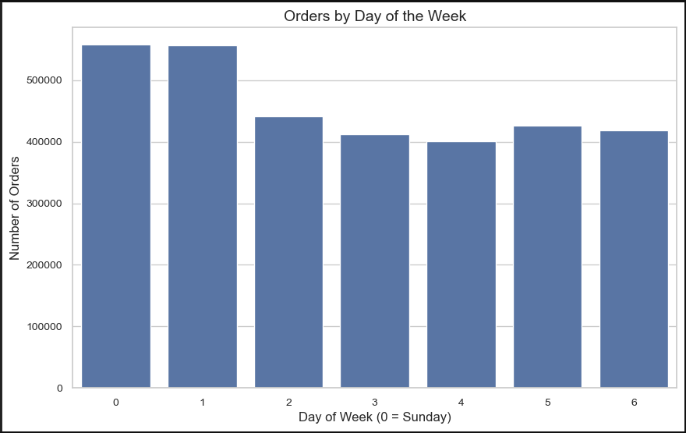
Figure 10. Orders by Day of Week
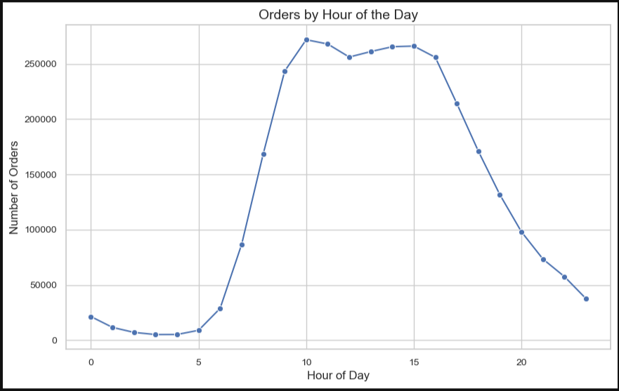
Figure 11. Orders by Hour of Day
These patterns could later be used to advise older adults on the least congested times to place online orders.
A heatmap of top product co-occurrence frequencies was produced to identify latent relationships between items.
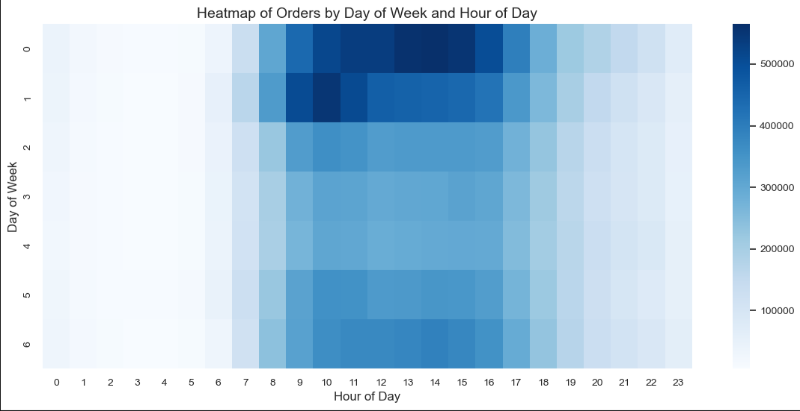
Figure 12. Product Co-Occurrence Heatmap
This served as an early indicator of candidate associations later confirmed by Apriori and FP-Growth.
Finally, the overall reorder rate was computed to quantify how often users repurchase items. This metric validates the suitability of collaborative filtering, as repeated purchases indicate stable user preferences.
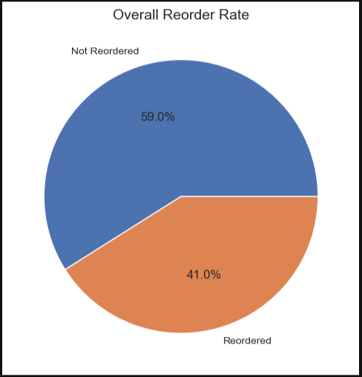
Figure 13. Overall Reorder Rate

Overall, the EDA and preparation steps ensured that the dataset was suitable for content-based filtering, collaborative filtering and Market Basket Analysis. The visualisations provided essential behavioural insights while guiding parameter selection for later modelling stages.

8. Conclusion

This project successfully applied multiple machine learning techniques to the Instacart dataset to extract actionable insights on customer purchasing behaviour. Through data cleaning, sampling, and feature engineering, the dataset was transformed into suitable structures for content-based filtering, collaborative filtering, and market basket analysis models.
Results from Apriori and FP-Growth revealed consistent associations between organic fruit products, demonstrating the reliability of the MBA component. Content-based and collaborative filtering models produced interpretable recommendations that can support older adult shoppers in navigating online grocery platforms.
A dashboard will be incorporated based on this analysis, aiming to present simple, accessible insights to users aged 65 and above. The models and techniques developed here form the foundation of that dashboard and highlight the potential of machine learning to enhance digital shopping experiences for older demographic groups

References

Instacart (2017) The Instacart Online Grocery Shopping Dataset 2017. Available at: https://www.instacart.com/datasets/grocery-shopping-2017
Raschka, S. (2018) MLXtend: Machine Learning Extensions. Available at: http://rasbt.github.io/mlxtend/
Pedregosa, F. et al. (2011) ‘Scikit-learn: Machine Learning in Python’, Journal of Machine Learning Research, 12, pp. 2825–2830.
Van der Walt, S., Colbert, S. and Varoquaux, G. (2011) ‘The NumPy array: a structure for efficient numerical computation’, Computing in Science & Engineering, 13(2), pp. 22–30.
McKinney, W. (2010) ‘Data Structures for Statistical Computing in Python’, Proceedings of the 9th Python in Science Conference, pp. 51–56.
Hunter, J.D. (2007) ‘Matplotlib: A 2D Graphics Environment’, Computing in Science & Engineering, 9(3), pp. 90–95

