Run Bunny, Run

Documentation

MA. GuadaLupe Macedo vázquez

2020

Contenido

Introduction 2

Game Concept 2

Game genre 2

Purpose 2

Gameplay 2

Visual Style 3

Game Mechanics 3

Gameplay 3

Interface 4

Diagrams 4

# Introduction

This is the videogame design documentation for “Run Bunny, Run” a PC game, a challenge by Amber Studio. The purpose of this document is to record the elements, mechanic, etc. that will be used in the development of the project.

## Game Concept

If you are a bunny sure that you loved carrots and for this reason you should go to the forest to take some of this but in your road you can find some objects that can help you to buy something or objects that can scared you…and maybe, maybe could die.

## Game genre

The game genre for this game is as follows

**Endless runner:** consist of keeping the character running as long as possible, is easy to game because you only need run and dodge somethings.

## Purpose

The purpose of this game is to test my skills to complete the challenge the Amber Studio, where you have seven days to create a video game.

## Gameplay

In this section shows the gameplay of the project, including the elements that you can find in your endless runner.

* **Mobility**: you can move the character with the left, right arrow keys.
* **Traps and obstacles:** on your way you might find some cutted trees and hunter traps too, and sure you don't want to be dinner.
* **Rabbit meat:** if you are a rabbit and you find rabbit meat you will be so scared that you will slow down, but run bunny, run.
* **Carrots:** you accelerate your speed, because if you find a carrot there are sure to be two ... or more
* **Coins:** you can buy things in the store ... yes you are a rabbit but you know how the coin works.

## Visual Style

Since your main character is a rabbit, a cute style has been chosen. Both the character and the items are in 2D.

# Game Mechanics

## Gameplay

**Traps and obstacles:** you will collide with the cutted trees and if you collect a trap you will lose a life.

**Rabbit meat:** If you pick up a rabbit meat then your speed will be reduce.

**Carrots:** you accelerate your speed.

**Coins:** you can buy something for example a new character if you want so you can choose which character to play. The coins are accumulative, so the coins you collect in each game will be increased in your balance.

# Interface

This section describes some diagrams that explain how certain processes are added. Some screenshots of the video game are also added.

## Diagrams

In the below image (Illustration 1) we can see the process that the videogame follows.

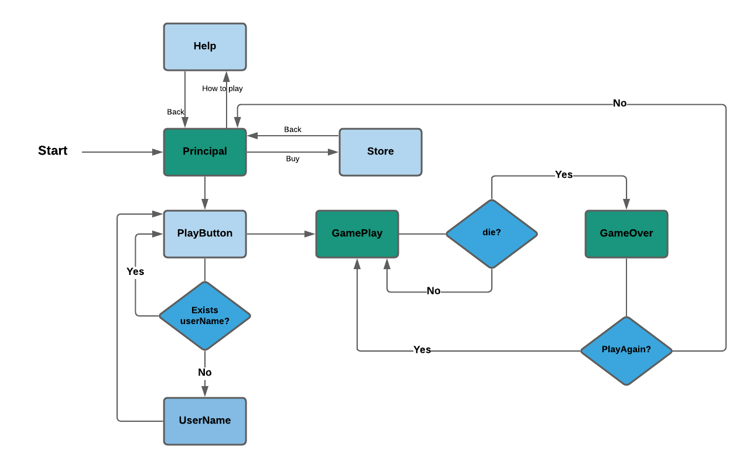

Ilustración 1 diagram1

In the main screen you have three options:

* **Help:** in this view you have an Image to show you how to play (Illustration3).
* **Store:** in this section you can buy the objects available if your money is enough and you can wear or remove the character that you bought (Illustration4)
* **Play button** (Illustration5) when you select "PlayButton", the game asks for a username (this only happens once after your username will be stored). After typing your username, press the button again and start the game

The game play (Illustration 6) will be active if you have life otherwise the gameOver view will be activated (Illustration 7).

In the next image (Illustration 2) we can see how works the Scriptable Object for this game.

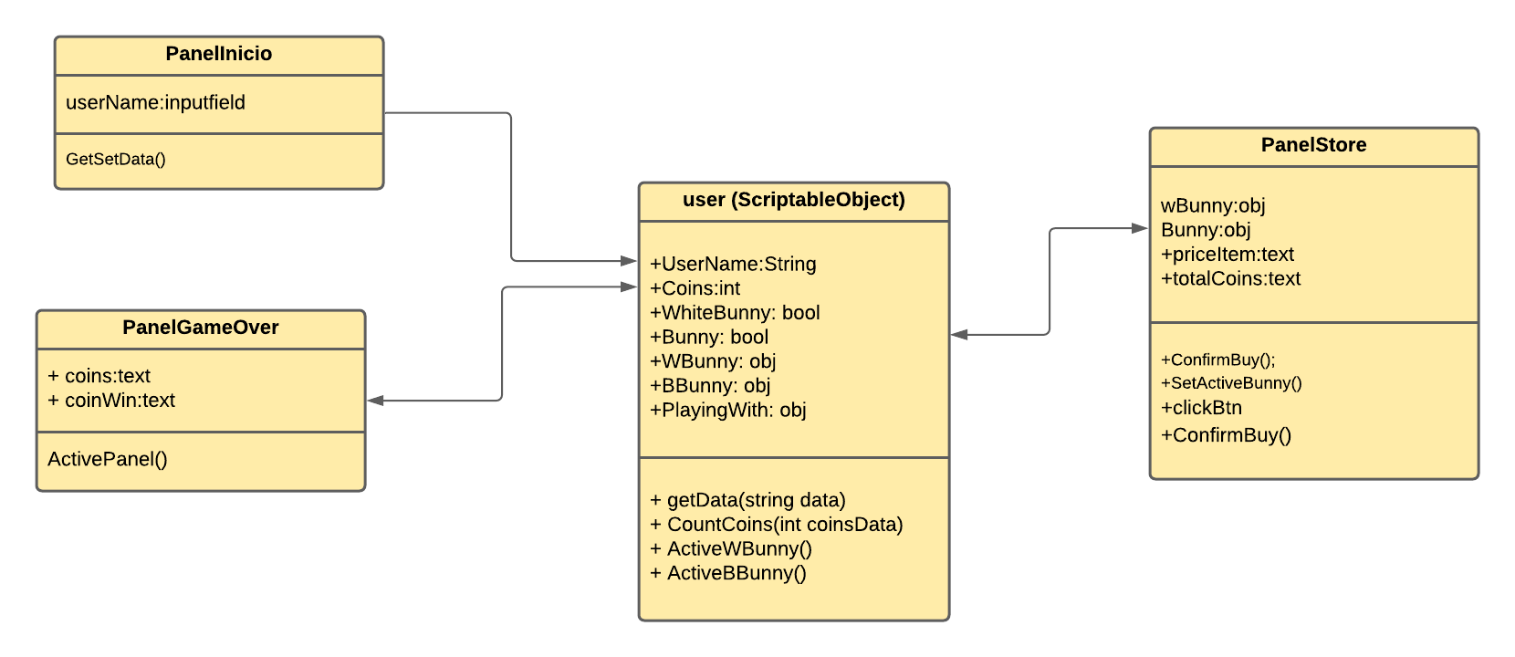

Ilustración 2 ScriptableObject UML diagram

We need to store your appreciated information and to do it we use “ScriptableObject”, in this case we will save your user name, coins and the bools variables to know if you already buy a character available.

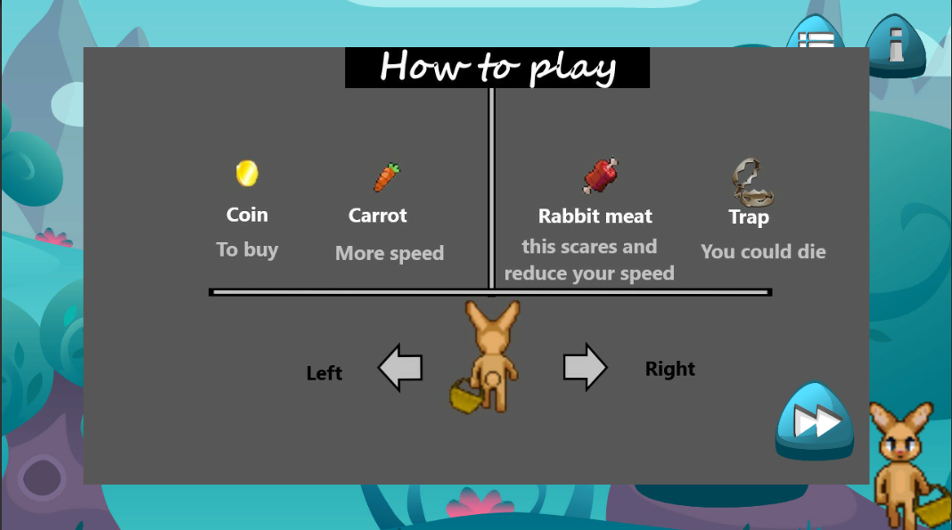

Ilustración 3 Help

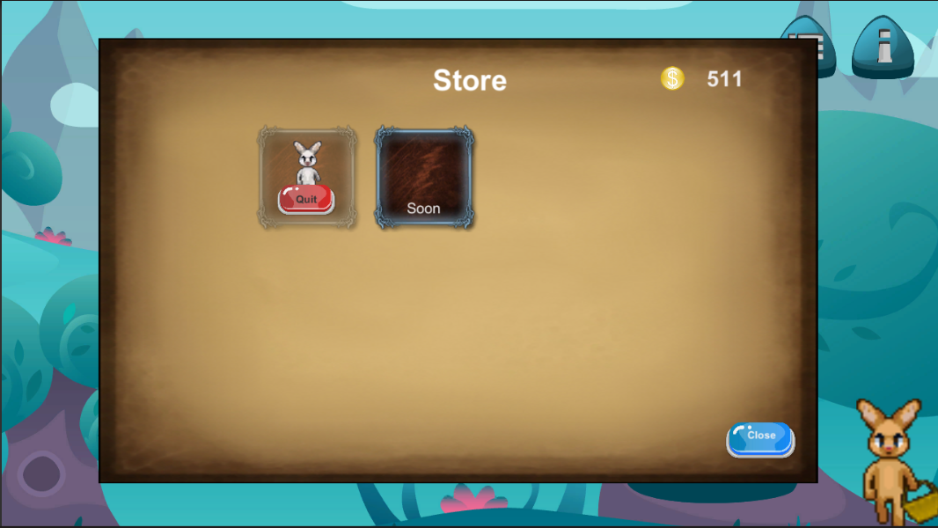

Ilustración 4 Store with item bought

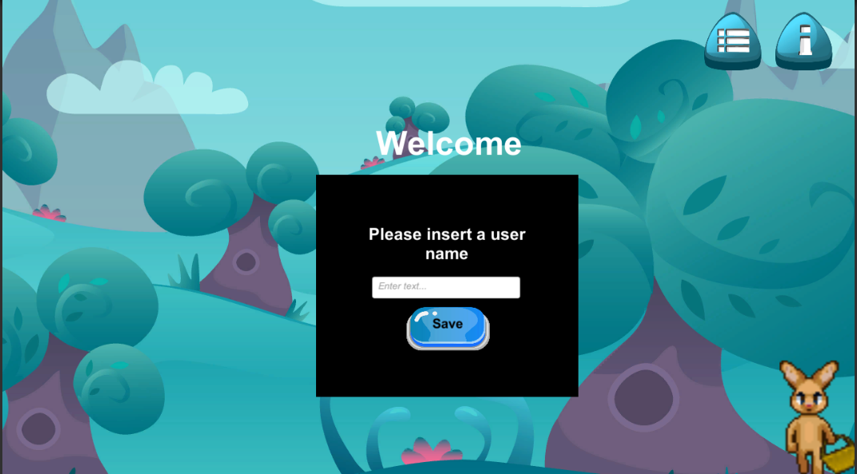

Ilustración 5 UserName

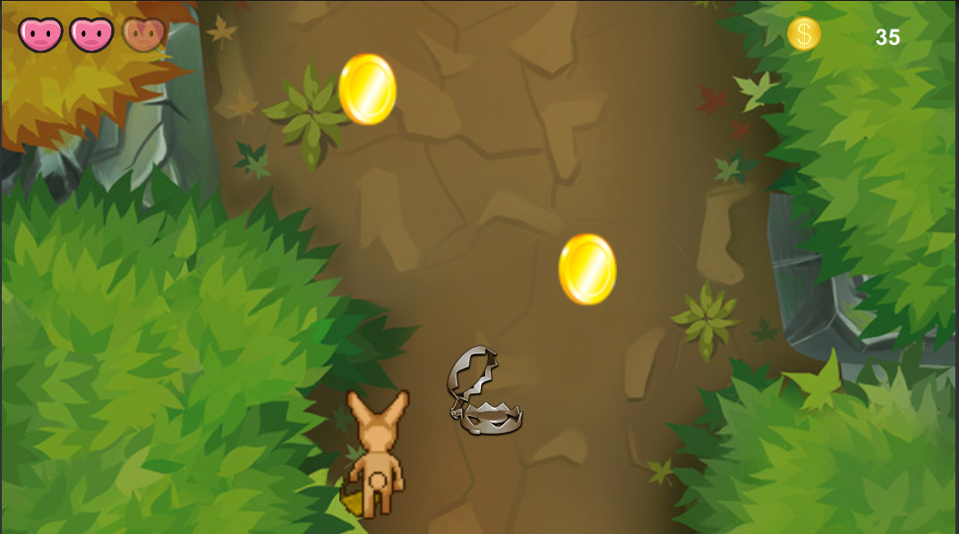

Ilustración 6 GamePlay

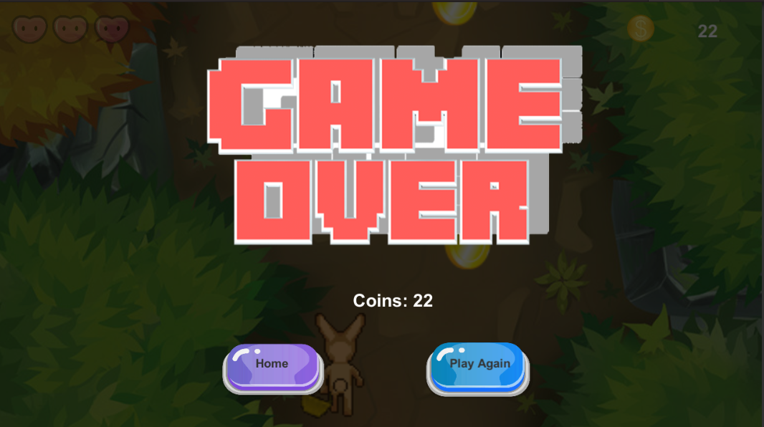

Ilustración 7 GameOver