# Prerequisites

Configure SSH Keygen To the Remote Hosts:

From Machine 1 (Which the Scripts are in)

Important: Do not give Password to the Keygen file

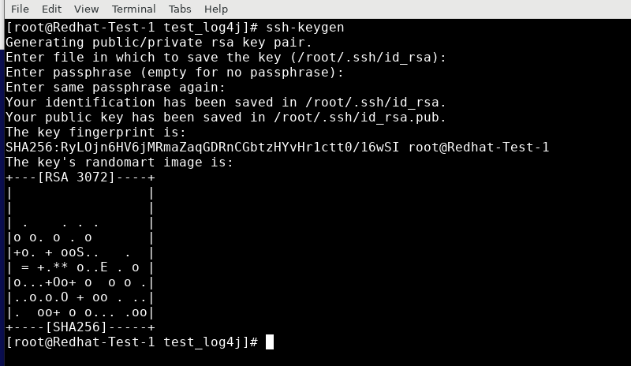

Coping Keys to Remote Server (Machine 2)

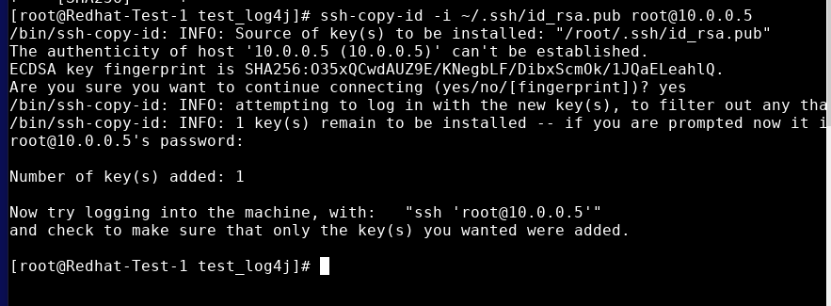

# The Test Setup

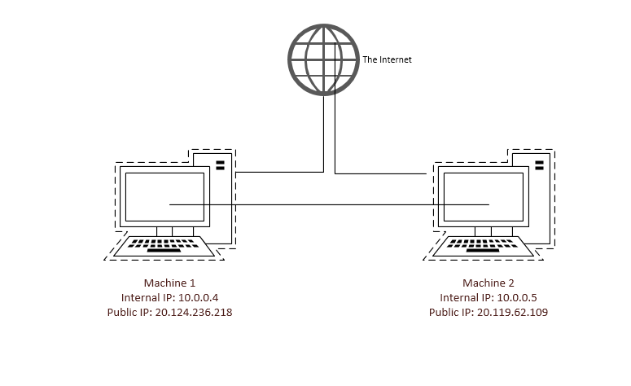

# Remote Access

All the Linux VM has enabled XRDP and can login through Remote Desktop Client.

Please see how to install RDP client in linux PC: <https://www.digitalcitizen.life/connecting-windows-remote-desktop-ubuntu/>

Credentials:

|  |  |
| --- | --- |
| Machine 1 | Machine 2 |
| IP:20.124.236.218 | IP: 20.119.62.109 |
| RDP Port: 3389 / SSH Port:22 | RDP Port: 3389 / SSH Port: 22 |
| Username: root | Username: root |
| Password: root | Password: root |

# Script

#!/bin/sh

#Varibales Used:

LOGROOT="/var/log/test_log4j"

LOG="$LOGROOT/"

ARCHIVE="$LOGROOT/Archive/$(date -d "7 days ago" '+%d-%m-%y')_To_$(date +"%d-%m-%Y")"

#Create Archive Directory if Not Created Already

mkdir -p $ARCHIVE

#Find Log Files Older Than 7 Days and Copy to Archive Directory

find $LOG/* -mtime +7 -type f -print -exec cp {} $ARCHIVE \;

#This Compares Anything Missing on the Copied Files

find $LOG/* -mtime +7 -type f -exec bash -c 'diff $t.out -rq --no-dereference "$@" "/var/log/test_log4j/Archive/$(date -d "7 days ago" '+%d-%m-%y')_To_$(date +"%d-%m-%Y")"| grep "[<>]" | sed "s/>/\t/g;s/<//g"' bash {} \;

#Tar Zip Copied Directory

tar -czvf $ARCHIVE/$(date -d "7 days ago" '+%d-%m-%y')_To_$(date +"%d-%m-%Y").tar.gz $ARCHIVE

#Remove Older Files in Original Log Directory

find $LOGROOT/* -mtime +30 -type f -print -exec rm -R {} \;

#Delete Files in Archived Directory After Tar Currently Not Enabled

find $ ARCHIVE/* -exec rm -R {} \;

echo "Done Localhost Moving to Remote Host"

#Define Servers to Remotly Login and Execute Archiving Example: servers=("10.0.0.2" "10.0.0.3")

servers=("10.0.0.5");

for s in "${servers[@]}"; do

echo "sshing root@${s} to run ${script}"

(ssh -t -t root@${s} < /root/Desktop/Script/test.txt)&

done

wait

The Below file needs to be in same Directory as in the Script with name test.txt Thus has the instructions to do in Remote Host

LOGROOT="/var/log/test_log4j"

LOG="$LOGROOT/"

ARCHIVE="$LOGROOT/Archive/$(date -d "7 days ago" '+%d-%m-%y')_To_$(date +"%d-%m-%Y")"

mkdir -p $ARCHIVE

find $LOG/* -mtime +7 -type f -print -exec cp {} $ARCHIVE \;

find $LOG/* -mtime +7 -type f -exec bash -c 'diff $t.out -rq --no-dereference "$@" "/var/log/test_log4j/Archive/$(date -d "7 days ago" '+%d-%m-%y')_To_$(date +"%d-%m-%Y")"| grep "[<>]" | sed "s/>/\t/g;s/<//g"' bash {} \;

tar -czvf $ARCHIVE/$(date -d "7 days ago" '+%d-%m-%y')_To_$(date +"%d-%m-%Y").tar.gz $ARCHIVE

find $LOGROOT/* -mtime +30 -type f -print -exec rm -R {} \;

echo "Remote Host Done"

exit 0

# Directory Structure Created By the Script

"/var/log/test_log4j

|-----> Archive

|-------> <File with 7 Days From The Date of Run>

|------><File with 7 Days From The Date of Run>.tar.gz

# Testing

In Machine 1 and 2 Create two log files with older dates inside "/var/log/test_log4j”

This can change also needs to change in Script and .txt file as well

# touch -a -m -t 202111011205.09 log-2021-11-01.log

Guide on command: <https://www.geeksforgeeks.org/touch-command-in-linux-with-examples/>

The Script is already copied to Machine 1 /root/Desktop/Script