IoT based Energy-Efficient System for Smart Irrigation System

Raju Patela, Devansh Tewarib, Adarsh Kumar Upadhyayb, Parth Dedhiab, Aneesh Raskarb, Sahil Khodkeb

a. Associate Professor at School of Electronics Engineering, Vellore Institute of Technology Chennai Campus, Vandalur - Kelambakkam Road, Chennai-600127, Tamil Nadu, India.

b. Students at School of Computer Science Engineering, Vellore Institute of Technology Chennai Campus, Vandalur - Kelambakkam Road, Chennai-600127, Tamil Nadu, India.

|  |  |
| --- | --- |
| **Article Info** | **Abstract** |
| **Keywords:**  IoT (Internet of Things)  Smart crop irrigation  Real-time data sensing  Machine Learning (ML)  Decision Tree (DT)  Support Vector Machines (SVM)  Logistic Regression (LR)  Accuracy  Precision  Recall  F1-Score | Agriculture plays a crucial role in Indian economy and is the highest employing sector in India contributing about 20.2% of the GDP (Gross Domestic Product). Water is one of the most scare resources for many farmers in India and the existing irrigation methods often rely on energy-intensive practices. To help provide solution to the problem, we have developed a smart energy efficient irrigation system that can improve crop growth by irrigating them based on the trained model predictions, helping farmers in optimizing their water usage. The IoT system proposed is a unique method for irrigation using ML which is created with the help of precise crop data and real-time sensor data. The proposed system irrigates crops based on their particular requirements which helps minimizing water wastage and helps with crop development. In order to optimize water usage, the system primarily uses an intricate and sophisticated artificial intelligence (AI) model that carefully examines sensor data and makes automatic irrigation decisions. [1],[2] |

### 

### **1. Introduction**

Agriculture being the primary occupation in India and largest populated country in the world has to face water shortage hence using water resources in agriculture becomes a major task, this paper presents a system that helps to optimize the water usage by controlling the motor pump with the help of IoT and machine learning model. The population of the world is expected to increase from 7.2 billion to over 10 billion by 2050, which could lead to a shortage of food [1].

The system proposed consists of different sensors to gather real-time data for temperature humidity and soil moisture. The ML model is trained using the user input crop type and its data. All this information plays a very important role to improve the scheduling of the water during the irrigation process. Crop type data, along with historical data from the system, can also provide insights into the estimated number of days required for crop cultivation and harvest. This information helps farmers to plan their operations effectively and make informed decisions about resource allocation. In the realm of smart agriculture, IoT-enabled systems play a crucial role in monitoring and managing agricultural processes [2].

we have tried various machine learning model that can accurately predict whether the soil requires water and accordingly turn on the water pump, out of all the machine learning models decision tree proved to have the maximum accuracy the main aim of the model is to determine whether to water the crops or not based on the real time data, environment conditions and history of the crop data ,whether the motor should be on or off for irrigation purpose is controlled by the output received by the ML model.

We have also used BLYNK mobile, application where the data received in real time can be presented visually using the BLYNK dashboard which helps the farmers monitor the soil moisture and temperature and humidity continuously remotely

Sensor data is presented on a user-friendly dashboard within the app, offering real-time insights into with the help of this IoT framework, integration of sensors, decision tree automation, and mobile app monitoring, farmers can now implement sustainable irrigation techniques with ease and efficiency. The flow chart shown in Figure 1 showcase the flow of the project.

##### 

##### **Figure 1**. Flow chart of the model

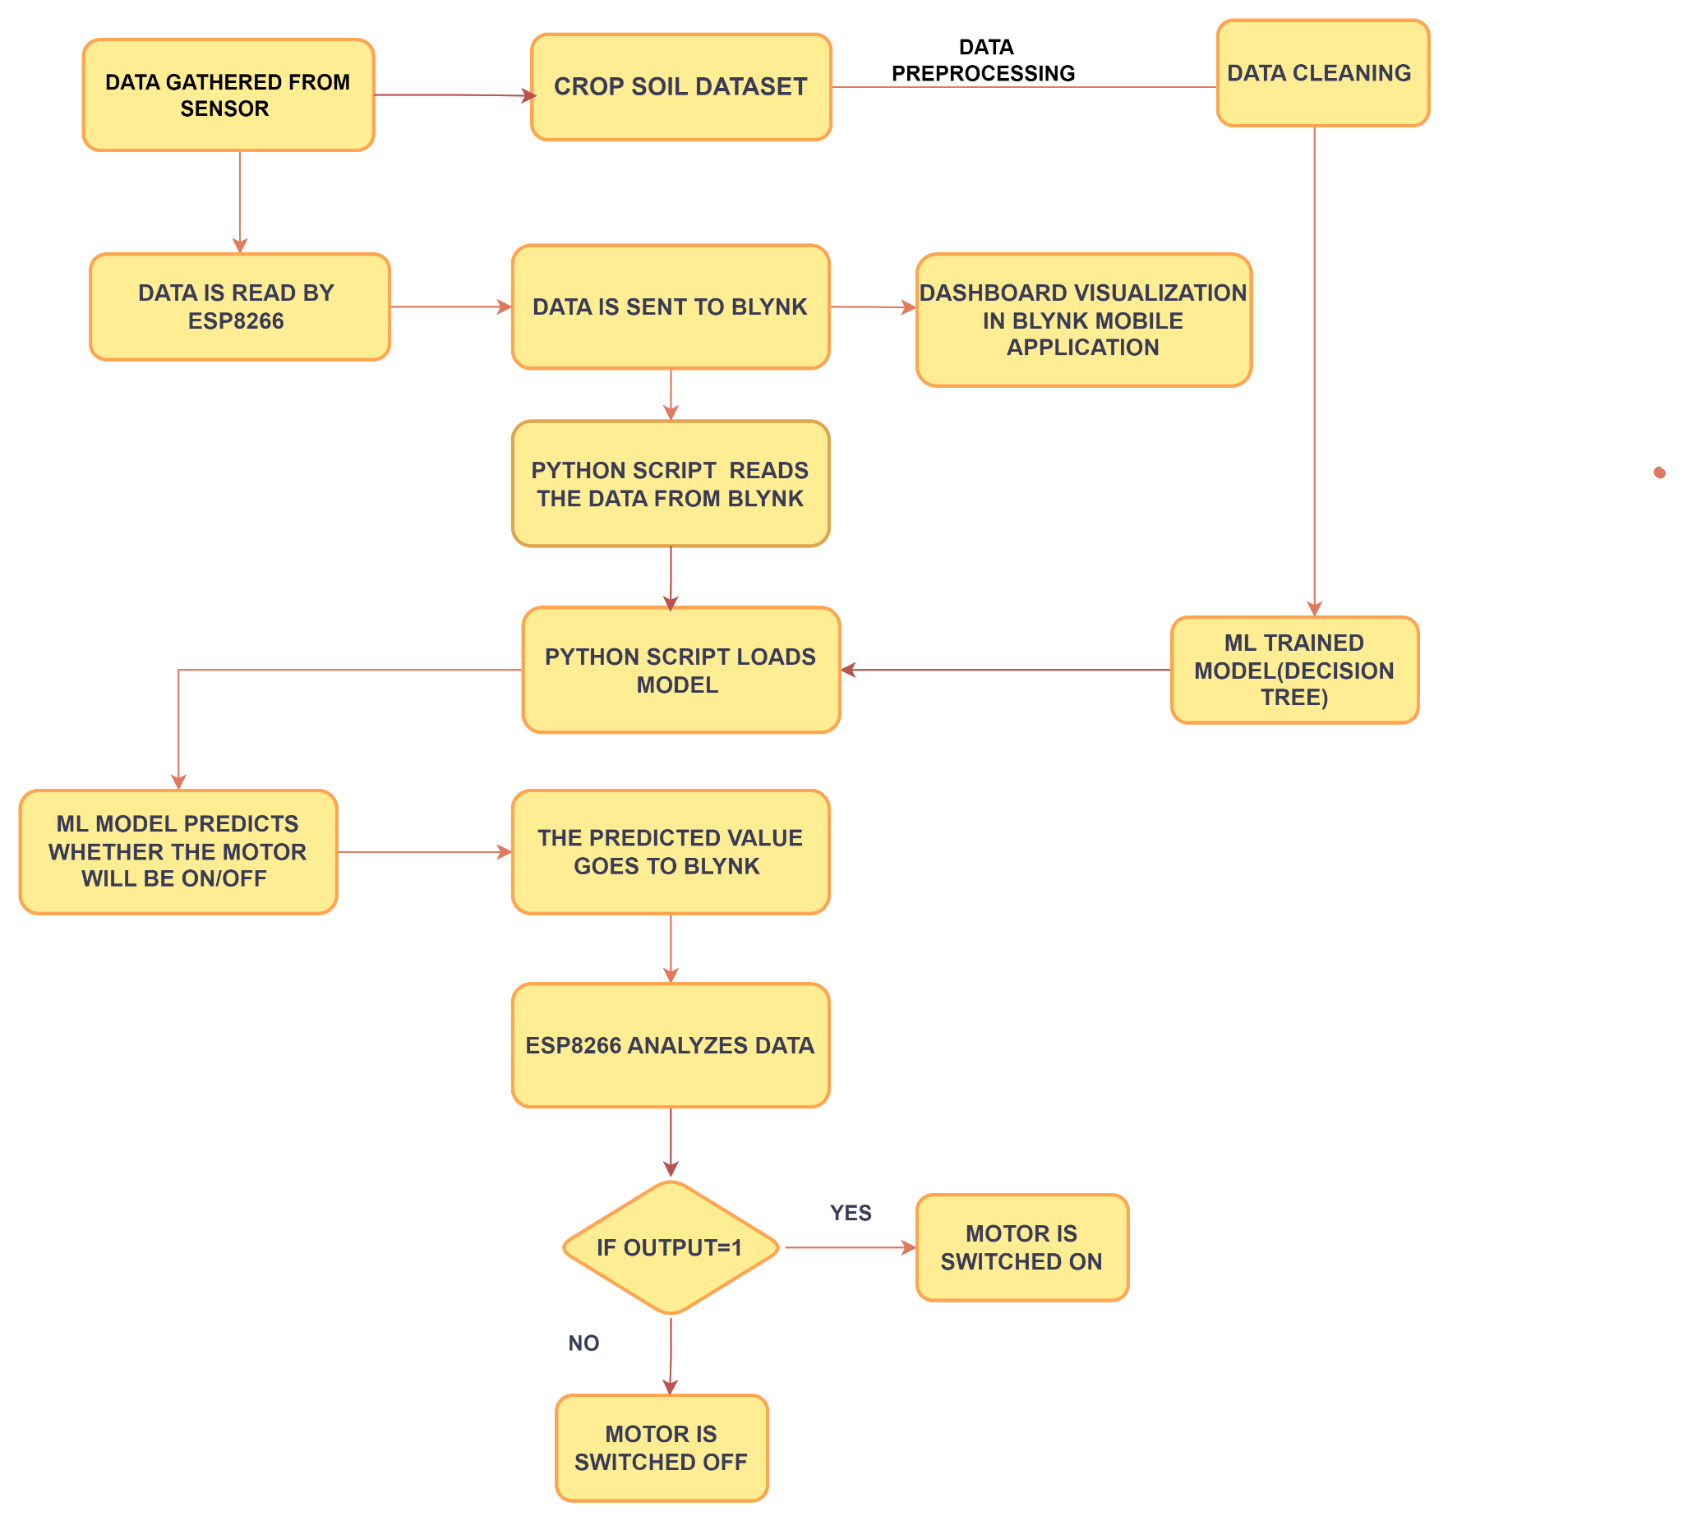

### **2. Design and Architecture of Different ML Model****s**

We tested and experimented with various machine learning models like DT, SVM, and LR to automate irrigation based on real-time data obtained from the field and the crop information. The comparison of the effectiveness of all the 3 tested ML models has been depicted in  [Table 1](https://docs.google.com/document/d/1UsB8nEYUKY8gsTBhIAnefxkS_y_Ll96gpr28K5acbGI/edit#heading=h.hgkyxcvxp88k). We could conclude from the results as depicted below that the DT performed the best on the input data compared to the other two ML models. All the four evaluation parameters which are accuracy, precision, recall and F1 score of the tested ML models have been visualized in [Figure 2.1](https://docs.google.com/document/d/1UsB8nEYUKY8gsTBhIAnefxkS_y_Ll96gpr28K5acbGI/edit#heading=h.3qnbts59035i).

##### **Table 1**. Comparison between all tested AI models.

|  |  |  |  |  |
| --- | --- | --- | --- | --- |
| **AI Model** | **Accuracy** | **Precision** | **Recall** | **F1** |
| **Logistic Regression** | 0.881 | 0.75 | 1.0 | 0.857 |
| **Decision Tree** | 0.92 | 0.85 | 0.94 | 0.89 |
| **Support Vector Machine** | 0.861 | 0.72 | 1.0 | 0.837 |

##### 

##### **Figure 2.1**. Visualization of the model efficiency parameters

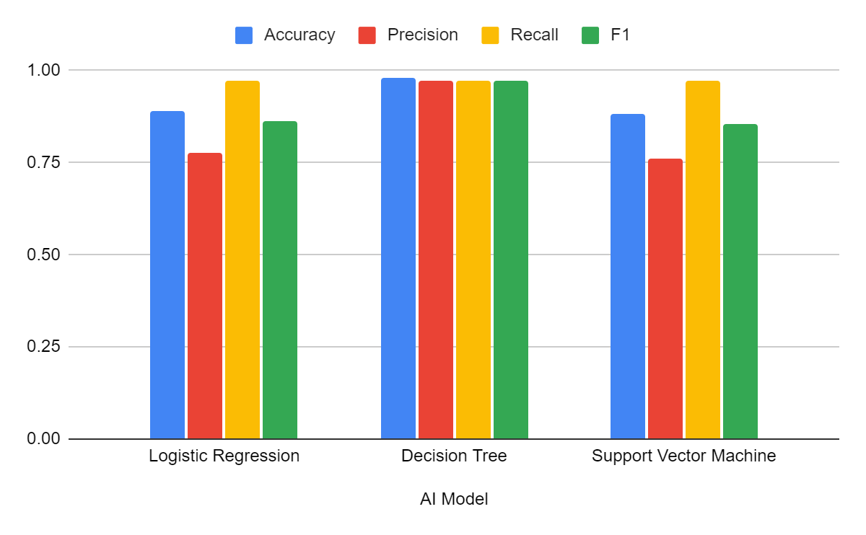

The DT model used in our project works as the brains behind the entire system. It takes decision based on the readings taken from sensors placed in the field. The sensors are connected to an ESP8266 which reads data such as soil moisture levels, surrounding temperature and humidity. The users will have to specify the crop which they are cultivating in their farm. All this data is analysed and used to design the irrigation schedule for the particular crop which is being cultivated in the farm.

The efficiency of the DT model which we used completely depends on the dataset used to train it. The dataset includes previous records of data readings from the farm such as soil moisture, temperature, humidity, days required for crops to fully cultivate, water requirement information for different crop types, and successful irrigation practices leading to best crop growth. The model analyses this data, maps relationships between the data, crop type, and successful irrigation event. The used dataset has been visualized in [Figure 2.2](https://docs.google.com/document/d/1UsB8nEYUKY8gsTBhIAnefxkS_y_Ll96gpr28K5acbGI/edit#heading=h.5bmuufjzpwh). It is a useful tool to see whether the data is good enough to make good decisions about irrigation.

The DT model is visually clear and easy to understand, so farmers can understand how the model decides when to water the crops. The model is also very flexible as it easily allows the accommodation of new crops. It also can adjust to different environmental conditions. The model is also computationally efficient, which allows it to take real-time decisions on low-end devices.

##### **Figure 2.2**. Visualization of the dataset

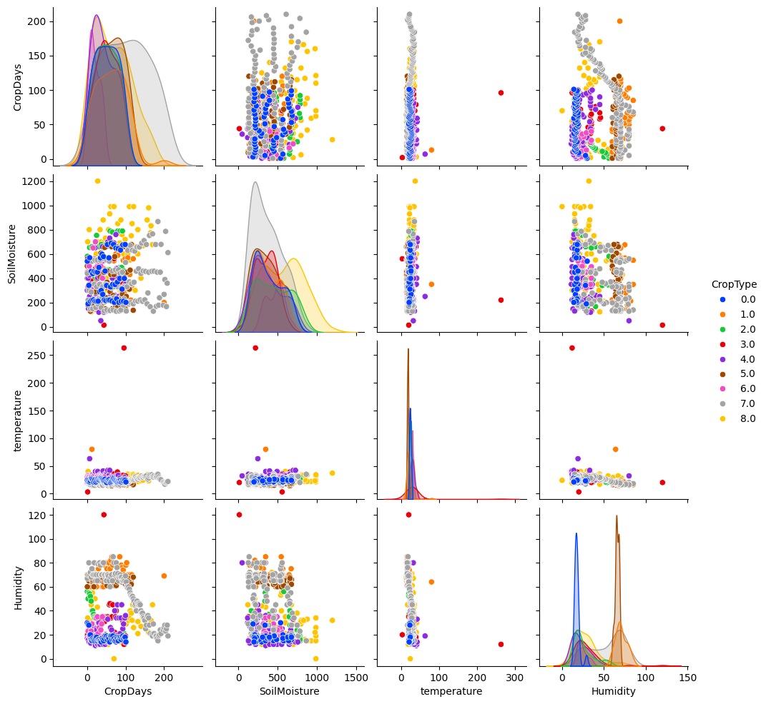

### 

### **3. Irrigation System Circuit Design**

The Blynk cloud platform receives the sensor data read periodically from the ESP8266 code, which functions as an intermediate between the script which will read and analyze the data. 2.4GHz Wi-Fi is used to connect the ESP8266 module to the internet to be able to send the data to the Blynk platform which then sends it to the mobile application and ML model.

We set the pin configuration, Wi-Fi and Blynk connection and a timer to periodically read sensor data. The void loop () continuously runs, checking the connection to the Blynk platform and the timer. When the timer runs out, sendSensor () function is called. The sendSensor function attempts to read sensor data (FC-28 and DHT) and send them to designated virtual pins in your Blynk project if successful. Debugging messages are printed to the serial monitor to help you monitor sensor readings. 3.1 shows the practical implementation of the irrigation system using the specified hardware components.

##### 

##### **Figure 3.1**. Execution of Irrigation system connections

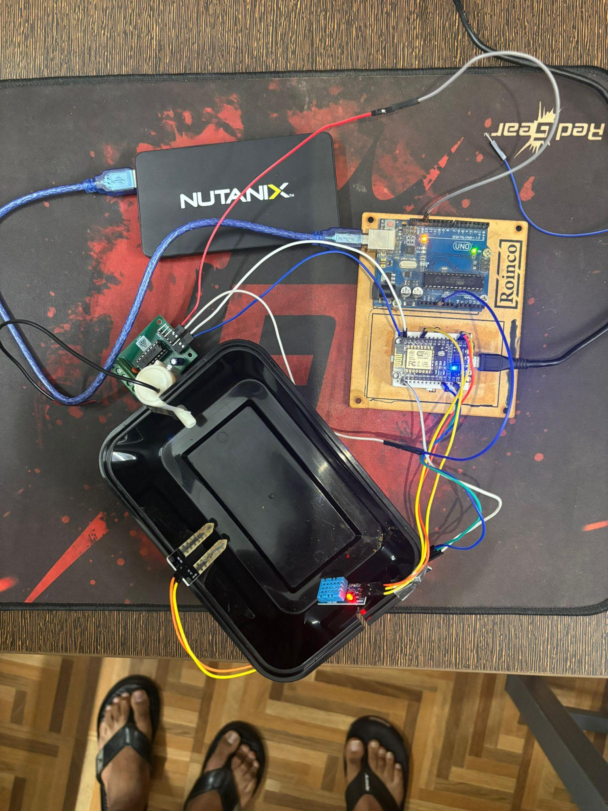

The ML model takes in all the sensor data as input and gives a prediction about the state of the farm. If the moisture is below threshold level it activates the pump connected to the motor driver. Arduino Uno is used to power the motor driver as the motor requires 5V input voltage and ESP8266 supplies a maximum voltage of 3V. The input pins of the motor driver (L293D) are connected to ESP8266 and the VCC and GND pins are connected to the Arduino Uno. The detailed overview of the irrigation system circuit design is shown in Figure 3.2.

**Figure 3.2**. System Circuit Diagram

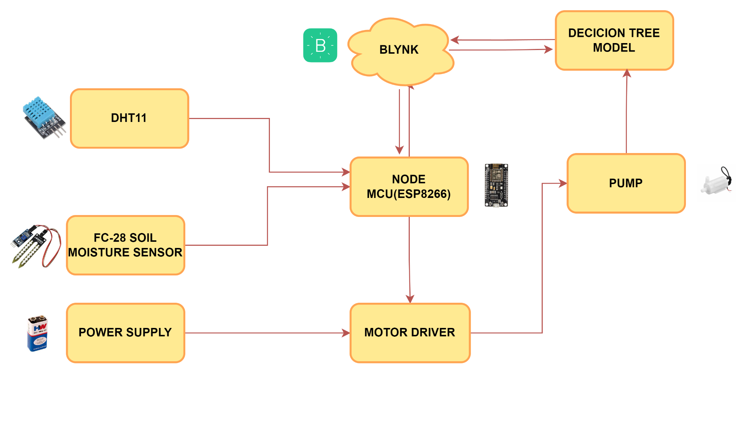

### **4. Five-fold Cross Validation**

Each of the three models DT, SVM and LR are validated on the dataset. The dataset is divided into five equal folds and then each model is trained on four-fold and tested on the last fold. This process is repeated five times for each model. The above process helps to check the scalability and flexibility of model for different scenarios and gives us a good insight into the model performance. It helps to check if the model picks up the trends and patterns in the data. The validation results for each model are depicted below in Figure 4.1, 4.2 and 4.3. From the results we can see that DT provides the most reliable results compared to all models.

##### **Figure 4.1** 5-fold validation for DT

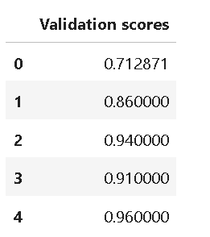

##### **Figure 4.2** 5-fold validation for SVM

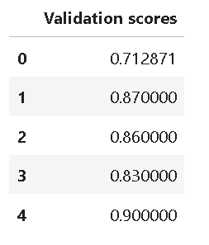

##### **Figure 4.3** 5-fold validation for LR

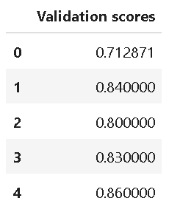

### **5. Result and Discussion**

The proposed system established stable real-time data collection from ESP8266 using DHT11 (for temperature and humidity) and soil moisture sensor (for moisture content in the soil). Using Blynk IoT mobile application the data was neatly visualized in a user-friendly manner, leaving the selection of crop type to the user. The pre-trained DT model was giving accurate results as intended, taking the sensor data as input parameters along with crop type and days and gave the output as one or zero to control the irrigation system based on the code algorithm. The initial miniature working prototype of the system demonstrated the real-time application of the automated irrigation systems working capability adjusting the flow of water through the pump based on the sensor reading taken while simultaneously displaying the values helping in monitoring the plant condition and helping them to grow properly.

To test the performance of the proposed irrigation system, we evaluated the accuracy of DT, SVM, LR for the same dataset. The models were able to accurately predict the output based on real-time sensor data, with an accuracy of over 92%, 86% and 88% respectively. Confusion Matrix which depicts Precision, Recall, F1-score and Accuracy for the three models is show in Figure 5.1, 5.2 and 5.3.It showcases the effectiveness of different models in automating the irrigation system and improving water conservation. Along with accuracy, this also evaluated the efficiency of the system. The system was able to process sensor data and make irrigation decisions in real-time, without any significant delay. This ensures that water is delivered to crops as needed, without any waste.

##### **Figure 5.1** Confusion Matrix for DT Model

##### **Figure 5.2** Confusion Matrix for SVM Model

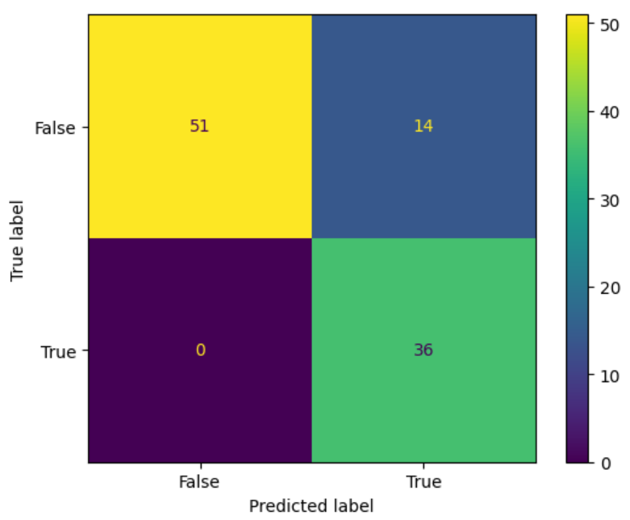

##### **Figure 5.3** Confusion Matrix for LR Model

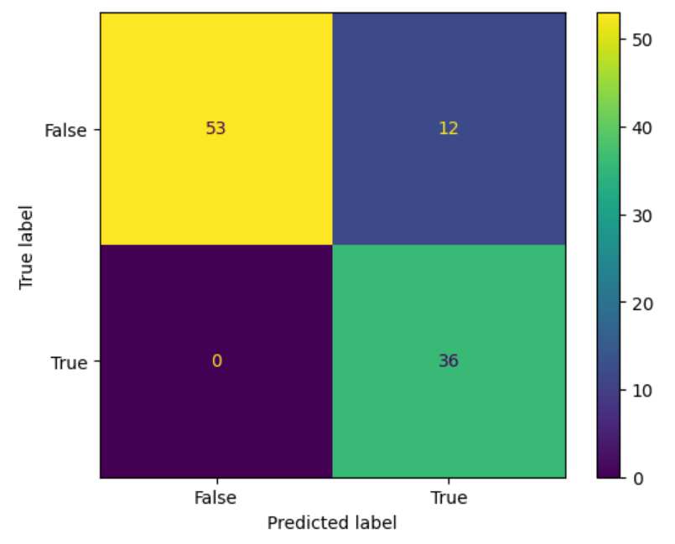

Meticulously fitting five folds for each of 15,552 parameters for a total of 77,760 fits for eight different types of parameters including max_features, splitter, ccp_alpha, max_depth, criterion, min_samples_leaf, random_state, max_features. This exhaustive search helped us find the optimal parameters for the DT model which helped in improving the accuracy for the predictions. Despite the process being computationally intensive, it was a one-time process to fine tune the model to give the best predictions while also avoiding overfitting to help give a more generalized model to work with real time data. The high accuracy achieved is product of the above method.

With the use of Grid Search CV along with data scaling resulted in increase in accuracy from 88% to 92% as compared to the base paper showcasing the effectiveness of the process. Moreover, the process of different parameter fitting for model optimization increases the reproducibility of the above process which helps in further advancements in the respective field.

The code running on ESP8266 module helps to fetch real-time sensor data and crop information and sends them via virtual pins to the Blynk cloud which then displays the sensor data on the mobile application. The figure 5.4 shows how the output on the serial monitor, with the sensor values. The python script running on the cloud servers fetches the data from the Blynk platforms and formats and processes them and then passes them though the pre-trained DT model which gives the output and sends it to the Blynk cloud platform.

Based on the prevailing conditions and crop needs, the algorithm determines the optimal watering duration and frequency. On the mobile application, the data received is displayed on a dashboard which offers real-time insights into system performance and environmental parameters such as temperature, soil moisture, humidity, and pump state as depicted in 5.5. This targeted approach ensures that water is delivered precisely when and where it's most needed, promoting significant water conservation efforts.

##### **Figure 5.4** Output of the ESP8266 on the serial monitor

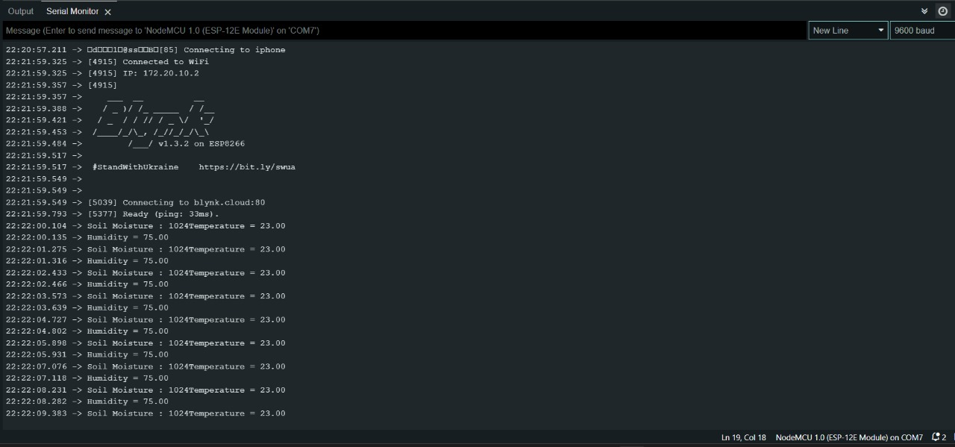

##### **Figure 5.5** Output of the ESP8266 on the serial monitor

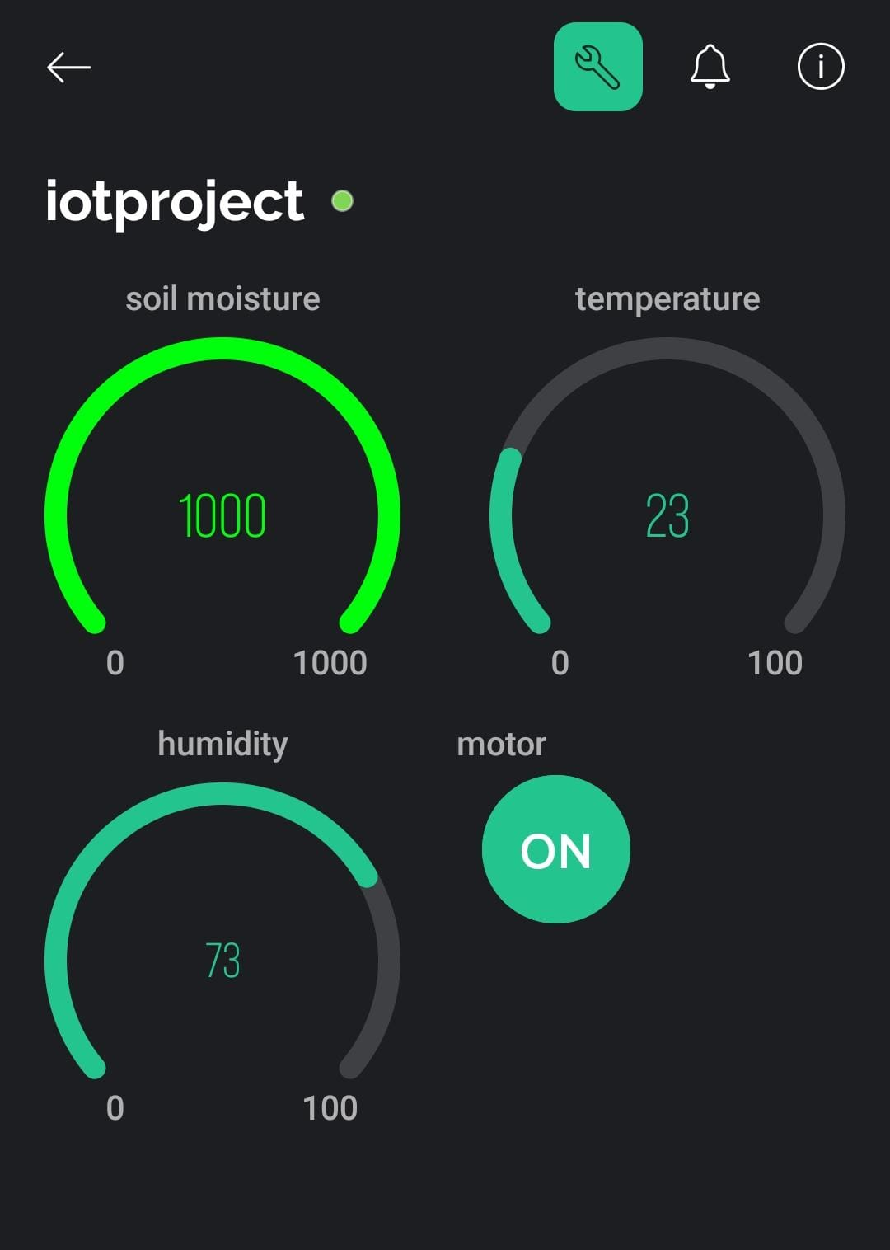

Various models used in different reference papers have been evaluated and compared with the proposed model. The proposed ML models in this paper outperforms most of the other existing models in terms of accuracy and effectiveness as depicted in Table 2.

##### **Table 2**. Comparison of the proposed model with other existing models

|  |  |  |  |
| --- | --- | --- | --- |
| **Reference** | **Supervised Model** | **Features** | **Accuracies** |
| **Proposed Model** | Decision Tree | The paper proposes an IoT-based smart irrigation system that uses a decision tree model to automate irrigation decisions and a mobile app for remote monitoring, achieving significant water conservation. | DT - 92.079%  SVM – 86.138%  LR – 88.118% |
| **Development of a Digital Twin for smart farming: Irrigation management system for water saving [6]** | Linear Regression | The paper aims to forecast the amount of water required using data collected through several detection sensors | - |
| **IoT based Smart System for Enhanced Irrigation in Agriculture [10]** | KNN, SVM, Logistic regression | The paper presents a threshold-based classification using sensor data and is implemented at ThinkSpeak IOT cloud. | KNN – 71%  Naive Bayes – 76%  SVM – 87.5 % |
| **Precision sugarcane monitoring using SVM classifier [11]** | KNN and SVM | The paper is about detection of infection in plant samples. | SVM – 96% |
| **Smart irrigation system using IoT and machine learning methods [12]** | Linear Regression  Decision Tree  SVM | The paper talks about ML model-based prediction on sensor data to maximize crop yield and minimize water wastage. | LR – 85%  DT – 89.6%  SVM – 84% |
| **IoT-digital twin-inspired smart irrigation approach for optimal water utilization [13]** | Artificial Neural Network (ANN)  Fuzzy Inference System (FIS)  Adaptive Neuro-Fuzzy System (ANFIS) | The paper talks about a IoT based smart irrigation system which uses a digital twin concept for efficient water usage. The system monitors soil condition in real time and sends data for analysis. | ANN – 91%  FIS – 89.68%  ANFIS - 91.77% |

We can infer from the above results that the proposed system is a sustainable and energy efficient practice that can help farmers reduce their water and energy usage and improve crop yield.

### **6. Conclusion**

This paper describes a study that effectively created and tested a unique smart irrigation system that uses the Internet of Things (IoT) to optimize agricultural water usage. The system makes use of real-time data from the farm such as temperature, humidity, and soil moisture level that is gathered by a sensor connected to ESP8266. This data acts as input to decision tree model and it decides whether the soil requires water or not for the user defined crop type.

After continuous testing decision tree model was found to be the most effective machine learning model which uses sensor data and user input analysis to automate irrigation decisions. This approach helps in delivering water only till the threshold of soil moisture is reached. The integration of a mobile application blynk with a user-friendly dashboard allows remote monitoring of the soil moisture level by farmers, allowing for real-time data. the smart irrigation system helps in overall development of agricultural ecosystem by encouraging water conservation, improving crop health, reduced man power and increases work efficiency, this project creates a way for farmers to manage their resources wisely and contribute to a more sustainable agricultural future.

In future, many more changes can be done such as including Light sensors which can help to get a clearer image of the environment also including historical weather data and machine learning algorithms can increase accuracy also enables it to water the crops according to the weather condition

### **References:**

[1] Ankush Manocha, Sandeep Kumar Sood, Munish Bhatia, “IoT-digital twin-inspired smart irrigation approach for optimal water utilization,” Elsevier, Sustainable Computing: Informatics and Systems 41 (2024) 100947.

[2] Asif Irshad Khan, Fawaz Alsolami, Fahad Alqurashi, Yoosef B. Abushark, Iqbal H. Sarker, “Novel energy management scheme in IoT enabled smart irrigation system using optimized intelligence methods,” Elsevier, Engineering Applications of Artificial Intelligence 114 (2022) 104996.

[3] Neelesh Yadav, Balasundaram Pattabiraman, Narsa Reddy Tummuru, B.S. Soundharajan, K.S. Kasiviswanathan, Adebayo J. Adeloye, Subhamoy Sen, Mukesh Maurya, S. Vijayalakshmanan, “Toward improving water-energy-food nexus through dynamic energy management of solar powered automated irrigation system,” 50 Cell Press, Heliyon 10 (2024) e25359.

[4] Hamza Benyezza, Mounir Bouhedda, Samia Rebouh, “Zoning irrigation smart system based on fuzzy control technology and IoT for water and energy saving,” Elsevier, Journal of Cleaner Production 302 (2021) 127001.

[5] Rafael Gomes Alves, Rodrigo Filev Maia, Fábio Lima, “Development of a Digital Twin for smart farming: Irrigation management system for water saving,” Elsevier, Journal of Cleaner Production 388 (2023) 135920.

[6] Anusha Kumar, Aremandla Surendra, Harine Mohan, Muthu Valliappan K, N. Kirthika. “Internet of Things Based Smart Irrigation Using Regression Algorithm”, 2017 International Conference on Intelligent Computing, Instrumentation and Control Technologies (ICICICT).

[7] Lining Liu, Qiang Zuo, Jianchu Shi, Xun Wu, Congmin Wei, Jiandong Sheng, Pingan Jiang, Quanjia Chen, Alon Ben-Gal, “Balancing economic benefits and environmental repercussions based on smart irrigation by regulating root zone water and salinity dynamics,” Elsevier, Agricultural Water Management 285 (2023) 108366.

[8] Rodrigo Togneri, Ronaldo Prati, Hitoshi Nagano, Carlos Kamienski, “Data-driven water need estimation for IoT-based smart irrigation: A survey,” Elsevier, Expert Systems with Applications 225 (2023) 120194.

[9] B. Parvathi Sangeetha, Neeraj Kumar, Ambresh P. Ambalgi, Sulaima Lebbe Abdul Haleem, K. Thilagam, P. Vijayakumar, “IOT based smart irrigation management system for environmental sustainability in India,” Elsevier, Sustainable Energy Technologies and Assessments 52 (2022) 101973.

[10] K. N. Bhanu; H. S. Mahadevaswamy; H. J. Jasmine.” IoT based Smart System for Enhanced Irrigation in Agriculture”. 2020 International Conference on Electronics and Sustainable Communication Systems (ICESC).

[11] Kumar S, Mishra S, Khanna P. “Precision sugarcane monitoring using SVM classifier”. Procedia Computer Sci 2017.

[12] Ahmed A. Esmail, et.al. “Smart irrigation system using IoT and machine learning methods”. October 2023.

[13] Ankush Manocha, Sandeep Kumar Sood, and Munish Bhatia. “IoT-digital twin-inspired smart irrigation approach for optimal water utilization”. December 2023. Sustainable Computing Informatics and Systems 41(2):100947

[14] Youness Tace, Mohamed Tabaa, Sanaa Elfilali, Cherkaoui Leghris, Hassna Bensag, Eric Renault. "Smart irrigation system based on IoT and machine learning", Energy Reports, 2022

[15] Muruganandam, K., RuqaiyaKhanam, D., & Balamurugan, D. B. (2019, June). IOT BASED ENERGY EFFICIENT ROUTING STRATEGY FOR AUTOMATED IRRIGATION SYSTEM. International Journal of Current Engineering and Scientific Research, 6(6), 66–72.