### **1. Classification of Abnormalities**

The **SNOMED-CT codes** chosen for classification are:

**Normal Sinus Rhythm (426783006)**

**Myocardial Infarction (164865005)**

**Left Axis Deviation (39732003)**

**Abnormal QRS (164951009)**

**T Wave Abnormal (164934002)**

**Left Ventricular Hypertrophy (164873001)**

**Myocardial Ischemia (164861001)**

(listed in increasing order of occurrence). These abnormalities were selected because they are the **top 7 most frequently occurring** abnormalities in the dataset, making them suitable for efficient training.

### **2. ECG Signal Processing**

The **Pan-Tompkins QRS Detection Algorithm** (available on the official GitHub page) was used to convert ECG signals into **moving window signals**. This facilitated the identification of **R-peaks, P-peaks, and T-peaks**. The **PhysioNet/CinC Challenge 2020** also addressed this problem, and solutions from the challenge finalists are publicly available. The **PRNA finalist** released a paper detailing their approach to training on ECG signals, including the extraction of **wide features**.

### **3. Dataset Preparation**

A **10-second interval** of the ECG signals was considered for training (**10s at 500Hz = 5000 data points per 12-lead signal**). The **Pan-Tompkins QRS Algorithm** was applied to convert ECG signals into **Moving Window Signals**, after which **R-peaks, T-peaks, and P-peaks** were identified.

From these peaks, various **signal features** were extracted:

* **Max HR**
* **Mean HR**
* **Min HR**
* **P-wave correlation coefficient**
* **RMSSD**
* **RR interval (Mean)**
* **RR interval (Median)**
* **RR interval Fisher information**
* **T-wave permutation entropy (Median)**
* **T-wave permutation entropy (Standard Deviation)**

These **10 features** are among the **top 20 dominant ECG features** identified in the **PRNA paper**. Additionally, **age and gender** were retrieved from the .hea files, giving a total of **12 features per ECG signal**.

The **labels** were stored as a **binary array** for the **7 abnormalities**. The dataset was then split into **90% for training** and **10% for testing**.

### **4. Model Architecture**

The model architecture is as follows:

CTN(

(encoder): Sequential(

(0): Conv1d(12, 128, kernel_size=(14,), stride=(3,), padding=(2,), bias=False)

(1): BatchNorm1d(128)

(2): ReLU(inplace=True)

(3): Conv1d(128, 256, kernel_size=(14,), stride=(3,), bias=False)

(4): BatchNorm1d(256)

(5): ReLU(inplace=True)

(6): Conv1d(256, 256, kernel_size=(10,), stride=(2,), bias=False)

(7): BatchNorm1d(256)

(8): ReLU(inplace=True)

(9): Conv1d(256, 256, kernel_size=(10,), stride=(2,), bias=False)

(10): BatchNorm1d(256)

(11): ReLU(inplace=True)

(12): Conv1d(256, 256, kernel_size=(10,), stride=(1,), bias=False)

(13): BatchNorm1d(256)

(14): ReLU(inplace=True)

(15): Conv1d(256, 256, kernel_size=(10,), stride=(1,), bias=False)

(16): BatchNorm1d(256)

(17): ReLU(inplace=True)

)

(transformer): Transformer(

(pe): PositionalEncoding(

(dropout): Dropout(p=0.1)

)

(transformer_encoder): TransformerEncoder(

(layers): ModuleList(

(0-7): 8 x TransformerEncoderLayer(

(self_attn): MultiheadAttention()

(linear1): Linear(in_features=256, out_features=512)

(dropout): Dropout(p=0.1)

(linear2): Linear(in_features=512, out_features=256)

(norm1): LayerNorm((256,))

(norm2): LayerNorm((256,))

(dropout1): Dropout(p=0.1)

(dropout2): Dropout(p=0.1)

)

)

)

)

(fc1): Linear(in_features=256, out_features=64)

(fc2): Linear(in_features=76, out_features=7)

(dropout): Dropout(p=0.1)

)

The model was trained using **12-lead ECG signals**, extracted **wide features**, and abnormality labels. The **training approach** is explained in the **PRNA paper**.

The model takes **3 inputs** (n is dataset size):

1. **ECG signals** – Shape: **(n,12,5000)** (12 leads, each with **5000 data points**)
2. **Wide features** – Shape: **(n,12)** (Age, Gender, Max HR, Mean HR, etc.)
3. **Labels** – Shape: **(n,7)** (Binary values indicating abnormality presence)

**Key insights:**

* ECG signals contain **R-peaks, T-peaks, and P-peaks**, which **indicate heart activity**.
* These peaks help calculate features that **correlate with abnormalities**, improving classification accuracy.

**Optimizer:** **Noam optimizer** (which wraps around Adam optimizer: **β1 = 0.9, β2 = 0.98, lr = 10⁻⁹**). The **learning rate** follows a **warm-up schedule** and then decreases **proportionally to the inverse square root of the step number**.

The dataset was **split into 90% training and 10% testing**, with **shuffling during training**.

### **5. Feature Distribution**

**Patient Information:**

* **Age**: 59.79 years
* **Gender (Male: 0, Female: 1)**: 0 (Male)
* **Max Heart Rate**: 74.06 bpm
* **Mean Heart Rate**: 55.87 bpm
* **Min Heart Rate**: 39.07 bpm

**Heart Rate Variability & Cardiac Features:**

* **P-Wave Correlation Coefficient**: 0.6053
* **RMSSD**: 275.78 ms
* **Mean RR Interval**: 202.63 ms
* **Median RR Interval**: 255.64 ms
* **RR Interval Fisher Information**: 8.34e-05

**T-Wave Analysis:**

* **T-Wave Permutation Entropy (Median)**: 1.7848

**Top 7 classified abnormalities and their occurrence rates:**

* **Normal Sinus Rhythm (426783006)** – 0.8350
* **Myocardial Infarction (164865005)** – 0.2327
* **Left Axis Deviation (39732003)** – 0.2227
* **Abnormal QRS (164951009)** – 0.1394
* **T-Wave Abnormality (164934002)** – 0.1100
* **Left Ventricular Hypertrophy (164873001)** – 0.1077
* **Myocardial Ischemia (164861001)** – 0.0966

### **6. Model Performance**

* **Loss function:** **Binary Cross Entropy (BCE)** (averaged over each class)
* **Evaluation metric:** **ROC AUC score**

The **ROC AUC score** on the **test dataset** is **0.9098**, which is considered **excellent**. Since the **training and test datasets are separate**, **over-fitting is unlikely**. The trained model has been provided along with the code.

The losses are the following -

[8.0942, 2.2865, 0.4602, 0.3343, 0.2776, 0.2547, 0.2400, 0.2306, 0.2197, 0.2143, 0.2072, 0.2013, 0.1939, 0.1887, 0.1826, 0.1765, 0.1697, 0.1643, 0.1561, 0.1497, 0.1445, 0.1348, 0.1291, 0.1211, 0.1137, 0.1069, 0.0989, 0.0918, 0.0863, 0.0824, 0.0762, 0.0715, 0.0677, 0.0634, 0.0586, 0.0554, 0.0528, 0.0501, 0.0456, 0.0430, 0.0422, 0.0421, 0.0381, 0.0388, 0.0350, 0.0350, 0.0333, 0.0329, 0.0301, 0.0302]

The accuracy in percentage are the following -

[53.35, 70.20, 82.12, 86.71, 88.85, 89.74, 90.41, 90.73, 91.20, 91.41, 91.70, 91.98, 92.29, 92.48, 92.85, 93.11, 93.30, 93.56, 93.91, 94.23, 94.42, 94.81, 95.11, 95.38, 95.64, 95.92, 96.34, 96.56, 96.77, 96.95, 97.15, 97.33, 97.50, 97.66, 97.87, 97.97, 98.07, 98.17, 98.35, 98.44, 98.51, 98.45, 98.60, 98.61, 98.74, 98.74, 98.81, 98.81, 98.93, 98.89]

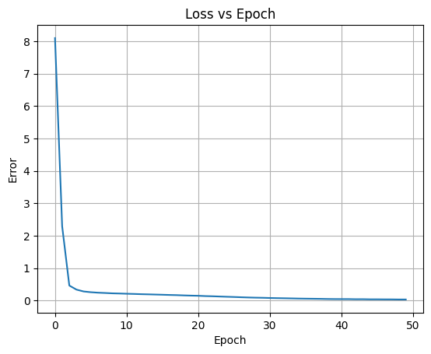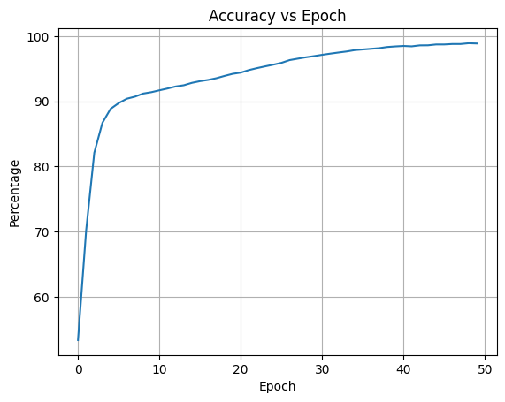

### **7. Computational Requirements**

* **Dataset creation**: **75 minutes** for **21,837 files** (~**12.36 sec per file** )
* **Training**: **500 minutes for 50 epochs** (~**1.8 second for per (epochs)(file)** )
* **Testing**: **21 seconds for 2,184 test samples** (~**0.01 sec per file** )

**Hardware used:**

* **CPU**: **Intel i5 12th Gen**
* **GPU**: **Nvidia RTX 3050 Mobile**

50 epochs were destined to run. A loss threshold of 0.003 and max loss count of 5 was set. This means that if the loss had stopped changing within the range of 0.003 for 5 continuous epochs, the model will stop training. The model had stopped at the 49th epoch due to this criteria.

### **8. Limitations and Future Improvements**

* Due to **hardware and time constraints**, only **12 features** were used instead of the **22 wide features** in the **PRNA paper**.
* **Only 7 abnormalities** were classified; with a **larger dataset**, **more abnormalities** could be detected.
* Additional **computational resources** could further **improve performance**.