Multiple Disease Prediction System using Machine Learning

|  |  |  |  |  |  |
| --- | --- | --- | --- | --- | --- |
|  |  |  |  |  |  |

**Introduction:**

Machine Learning Algorithms and it approaches are generally helpful for healthcare and biomedical sectors for predicting the disease.

For trivial symptoms, the difficulty is to meet the doctors at any time in the hospital.

Thus, Machine Learning provides essential data regarding the diseases on the basis of the patient's symptoms.

For several medical organizations, disease prediction is important for making the best feasible health care decisions.

**Why Multiple Disease Prediction ?**

Data in the healthcare industry consists of all the information related to patients. **So, we have designed a general architecture for predicting the disease in the healthcare Industry.**

Many of the existing systems can predict only one disease at a time and that too with lower accuracy. **So, we have designed a Multiple Disease Prediction System which can predict multiple diseases at a time.**

All the parameters which cause the disease is included so it is possible to detect the disease efficiently and more accurately.

**PROBLEM SYSTEM:**

* Many of the existing **machine learning** models for health care analysis are concentrating on one disease per analysis.
* **For example**, first is for liver analysis, one for cancer analysis, one for lung diseases like that. If a user wants to predict more than one disease, user should go through different sites.
* When a company wants to analyze patient health information, they must use numerous models, which drives up the cost and time. Some of the current systems take extremely few parameters into account, which can lead to false results.

**PROPOSED SYSTEM:**

* In **multiple disease prediction**, it is possible to predict more than one disease at a time.
* So, the user doesn’t need to traverse different sites in order to predict the diseases.
* To implement multiple disease, we have used machine learning algorithms and Stream lit.
* When the user is accessing this **API**, the user should send the parameters of the disease along with the disease name

**LITREATURE SURVEY:**

*"Prediction of Heart Disease Using Machine Learning Algorithms," 2019*

* **This paper aims to predict heart disease using different machine learning techniques**

*“Multi Disease Prediction Model by using Machine Learning and Flask API," 2020*

* **This Paper aims to predict all diseases at once using Machine Learning and developed a user interface using Flask API**

**REQUIREMENTS**

**Functional Requirement:** The system allows the patient to predict the disease

The user adds the input for the disease and based on the trained model of the user input the output will be displayed .

**Non-Functional Requirement:**

* The website will provide a range of values when the disease is predicted.
* The website should be reliable and consistent.

**DESIGN**

**HEART:**

* Heart Disease or in other words cardiovascular disease is the common health problem in most of countries these days

Causes of Heart Disease:

* Physical inactivity and malnutrition, overweight and obesity, tobacco and substance abuse are amongst the leading causes for cardiovascular disease
* Out of All Random Forest which yielded better results
* This prediction of Heart Disease through machine learning will help us reduce the errors made by doctors in diagnosis of Heart Disease

**KIDNEY:**

* **Chronic Kidney Disease**(CKD) is a major issue worldwide which is a condition characterized by a gradual loss of kidney function over time.
* Over 2 million people worldwide currently receive treatment with dialysis or a kidney transplant to stay alive.
* Chronic kidney disease causes more deaths than breast cancer or prostate cancer
* Out of all **machine learning** methods considered, **logistic regression** shown the highest accuracy and minimal bias to the attributes.

**PARKINSONS’ DISEASE:**

* Parkinson’s disease is a central nervous system disorder. Its symptoms occur because of low dopamine levels in the brain.
* Four Primary symptoms are tremor, rigidity, slow movement and balance problems.
* Till now no cure for Parkinson’s Disease is known, treatment aims to reduce the effects of the symptoms.
* By Comparing Several ML algorithms for the prediction of Parkinson’s disease out of which we found **DecisionTree** as the most accurate model.

**DIABETES:**

* It  is  a  kind  of  metabolic diseases in which patients suffer from blood glucose problems due to abnormal production and release of insulin.
* Caused when there is inadequate production of insulin, or insulin resistance.
* Symptoms of diabetes include frequent urination, excessive thirst or hunger, and weight changes.
* For Diabetes, various machine learning algorithms are applied on the dataset and the classification has been done using various algorithms of which RandomForest gives highest accuracy of 95%

**ABOUT THE INPUT PARAMETERS:**

**DIABETES:**

* Pregnancies
* Glucose
* Blood Pressure
* Skin Thickness
* Insulin
* BMI
* DiabetesPedigreeFunction
* Age

**Output:**

**HEART:**

* Age
* Sex
* Chest pain type
* Resting blood pressure
* Serum chol mg/dl
* Fasting blood sugar
* Resting electrocardiographic results
* Maximum heart rate achieved
* Exercise included angina
* Old peak
* The slope of the peak
* Number of major vessels colored by fluoroscopy
* Thal

**Output:**

**KIDNEY:**

* Age
* Blood Pressure
* specific gravity
* albumin
* sugar
* red blood cells
* pus cell  
  pus cell clumps
* bacteria

**Output:**

**PARKINSON’S:**

* Average vocal fundamental frequency
* Maximum vocal fundamental frequency
* Minimum vocal fundamental frequency
* Several measures of variation in fundamental frequency
* Several measures of variation in amplitude
* NHR, HNR - Two measures of the ratio of noise to tonal components in the voice
* health status
* RPDE, D2
* **DFA**- Signal fractal scaling exponent
* spread1
* spread2

**Output:**

**COMPARISON:**

|  |  |  |  |
| --- | --- | --- | --- |
| **DISEASES** | **RandomForest** | **LogisticRegression** | **Decision Tree** |
| **HEART** | **90.16%** | **85.25%** | **81.97%** |
| **KIDNEY** | **89.831%** | **97%** | **96.25%** |
| **PARKINSONS’** | **90%** | **81.5%** | **99.52%** |
| **DIABETES** | **95.7%** | **77.73%** | **77.87%** |

**MODELS USED:**

* **Logistic Regression**
* **Random Forest**
* **SVM**
* **K means**
* **DECISION TREE**
* **NAÏVE BAIS**
* **KNN**

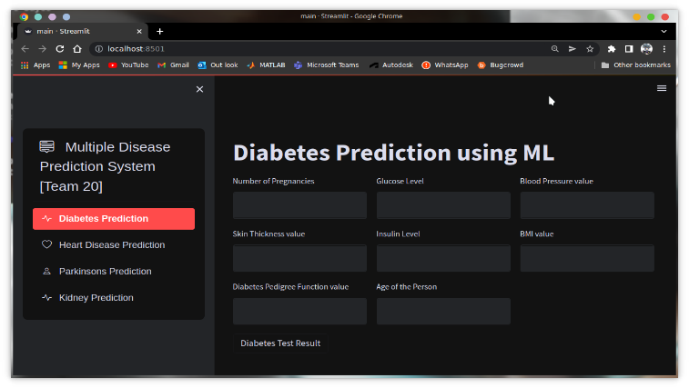**GUI AND MODULES USED:**

scikit-learn

* Pandas
* Pickle
* Streamlit
* Streamlit option menu

**CONCLUSION:**

* Our Proposed System aims at bridging gap between Doctors and Patients which will help both classes of users in achieving their goals.
* Diseases if predicted early can increase your life expectancy as well as save you from financial troubles**.**

**REFERENCES:**

[Disease Prediction Using Machine Learning Over Big Data by Vinitha S, Sweetlin S, Vinusha H, Sajini S :: SSRN](https://papers.ssrn.com/sol3/papers.cfm?abstract_id=3458775)

[Diabetes Prediction Using Different Machine Learning Approaches | IEEE Conference Publication | IEEE Xplore](https://ieeexplore.ieee.org/abstract/document/8819841)

[Applying Machine Learning Methods in Diagnosing Heart Disease for Diabetic Patients | Request PDF (researchgate.net)](https://www.researchgate.net/publication/319606366_Applying_Machine_Learning_Methods_in_Diagnosing_Heart_Disease_for_Diabetic_Patients)

[Multi Disease Prediction Model by using Machine Learning and Flask API | IEEE Conference Publication | IEEE Xplore](https://ieeexplore.ieee.org/abstract/document/9137896)