WHIRLPOOL

Team-4

Game: **Drown me not**

This is the game where you will experience the mixture of controlling our Scuba Diver by controlling the enemy and some crazy physics.

The aim is to keep the player alive while collecting maximum points.

**Setting**

The game has an underwater theme. It is set inside the deep ocean where the enemies are lurking here and there.

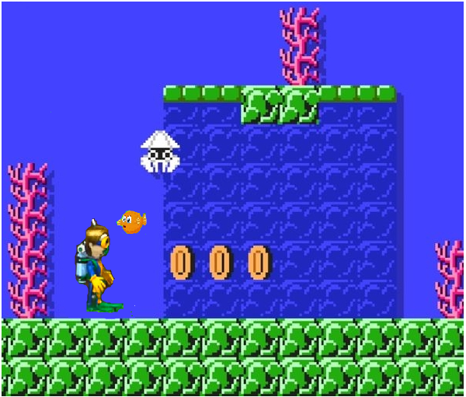

**Character**

The main character is the Scuba Diver, who is on a hunt for the treasure deep buried under the sea. The cursor would be in the form of Puffer Fish. The other characters include the enemies like Sharks, Sea urchins, and Coral Reefs. The Diver uses Rocks to throw at the enemies to protect itself.

**Challenge**

As we advance through the level, the enemies will be more frequent and will be tough to kill. Also, the mechanics of controlling the diver and shooting rocks adds an extra layer of challenge for the players of the game.

**General idea of the game**

The Scuba Diver fears the puffer fish, so the player will control the puffer fish to move the player in the required direction by moving the puffer fish close to the Diver, and in turn, the Diver will try to move away from it.

The Diver can also jump above the upcoming obstacles by pressing the left mouse button.

The diver can collect power-ups like:

1. Shooting rocks: It allows the Diver to shoot at the enemies.
2. Oxygen tanks: It increases the number of lives of the player.

There will be collectible coins and gems which increase the points of the player.

**TIMELINE**

Week 1

* Diver game object.
* Terrain and background creation by the artist.
* Adding cursor repel feature.

Week 2

* Lives, Power-ups working.
* Terrain and its movement.
* Adding jump and shooting mechanics to Diver.
* Coins, jewels, puffer fish, and enemies by the artist.

Week 3

* Enemies’ movements and mechanics.
* Home screen and end screen by the artist.
* Enemies’ death conditions and game-over conditions
* Score counter and distance traveled meter.

Week 4

* Blackout

Week 5

* Main screen and audio.
* Enter and exit screen.
* Finishing the game.

**Team Members**

* Ayush Singh (Programmer)
* Maurya Aryan S (Programmer)
* Isha Verma (Programmer)
* Deepanshu (Artist)
* Sarthak Kalankar (Programmer)
* Sunil Janghu (Artist)