**UNDERSTANDING THE PROBLEM**

The aim of our project lies in comprehending the problem and defining our objectives. We aim to construct a database for prospective customers who are considering subscribing to fund houses. These fund houses manage various funds, each investing in a multitude of stocks. Our goal is to provide our users with a wealth of data and insights, assisting them in making informed decisions about which funds to invest in and the amount to allocate to each.

To achieve this, we identify various entities and their attributes, and establish relationships among these entities using an Entity-Relationship (ER) Diagram. This diagram serves as a blueprint for our database creation, ensuring a structured and efficient design. By doing so, we strive to empower our users with the necessary tools to navigate the complex world of investment, thereby aligning with our mission of facilitating informed financial decision-making.

* **Identifying The Entities:**

**Fund Houses**: [Fund houses, also known as Asset Management Companies (AMCs), are organizations that pool money from investors and invest it into various financial instruments like equities, mutual funds, and securities1](https://groww.in/p/mutual-fund-house). [These companies make investment based on various market conditions and risks.](https://groww.in/p/mutual-fund-house)

**Funds**: [In the context of fund houses, funds refer to the pooled money from multiple investors that is set aside for investment](https://www.etmoney.com/mutual-funds/fund-houses). [These funds are managed by the fund houses or Asset Management Companies (AMCs) and are invested in various financial instruments like equities, mutual funds, securities, etc](https://www.etmoney.com/mutual-funds/fund-houses).

**Stocks**: [In the context of fund houses and funds, stocks represent the individual shares of a company that are available for investment](https://groww.in/blog/top-stocks-bought-and-sold-by-mutual-funds). [Fund houses, through their various funds, invest in these stocks based on extensive research and analysis](https://groww.in/blog/top-stocks-bought-and-sold-by-mutual-funds). [The fund managers, employed by the fund houses, select stocks to invest in based on market trends, macroeconomic and microeconomic factors, and other relevant information](https://groww.in/blog/top-stocks-bought-and-sold-by-mutual-funds).

* **Identifying the relationships:**

We have 3 different relationships between the entities. Namely:

1. Users SUBSCRIBING to fund houses.
2. Fund houses MANAGING various funds.
3. Funds in turn have various stocks to their name to which they INVEST.
4. Fund house consists of portfolio
5. Investors hold shares in fund house
6. Fund manager supervise funds
7. Funds have risk information
8. Funds have grading in the market
9. Funds have strategies to invest in the market
10. Stock has its details

* **Identifying the Attributes:**

1.Fund Houses:

1. Fund House Name
2. Fund House ID
3. Profit/Loss Ratio
4. Market Rating
5. Category

2.Funds:

1. Fund ID
2. Name Of Fund
3. Fund Size
4. Risk
5. Rating
6. Returns

3.Stocks

1. Name Of Stock
2. Stock ID
3. SName
4. Value
5. Quantity

4.Sector

1. Stock id

2. SName

5.Company

1.Company id

2.Value

3.Name

4.Sname

6.Stock price

1.Stock ID

2.1Yhigh

3.1Ylow

7.Riskmetric

1.Risk metric id

2.fund id

3.metric type

4.value

8.Fundmanager

1.Manager id

2.Name

3.Experience

9.Benchmark

1.Benchmark id

2.Index value

3.Index name

4.date

10.Market

1.Market id

2.Index name

3.fund id

4.Value

11.Fund strategy

1.Strategy id

2.fund id

3.Strategy type

12.Performance metric

1.Performance id

2.fund id

3.Metric type

4.Value

13.Transactions

1.Transaction id

2.date

3.amount

14.Portfolio

1.Portfolio id

2.Invester id

3.fund id

4.Quantity

15.Investors

1.Investor id

2.Name

3.Email

4.Phone Number

* **ER DIAGRAM:**

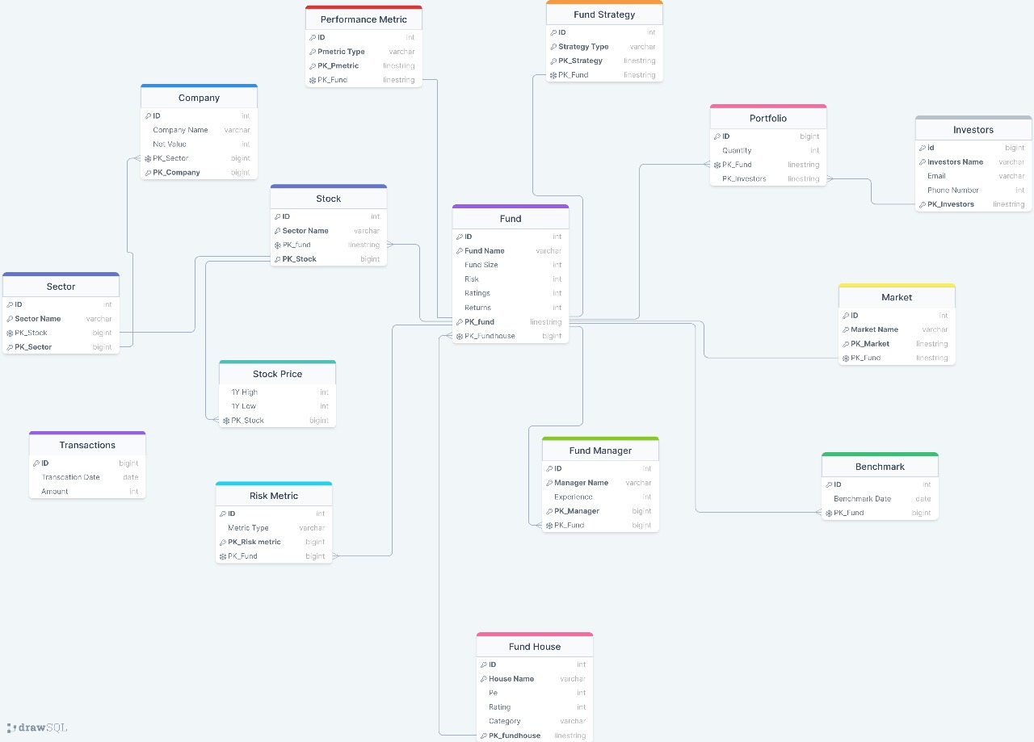

**CREATE QUERIES:**

CREATE TABLE FUNDHOUSE(

    house_id INT NOT NULL,

    housename VARCHAR(256),

    pe INT,

    rating INT,

    category VARCHAR(256),

    PK_fundhouse VARCHAR(100) UNIQUE

    CONSTRAINT FK_fundhouse PRIMARY KEY (house_id,housename)

);

-- FUNDS

CREATE TABLE FUND(

    fund_id INT NOT NULL,

    fund_name VARCHAR(256),

    fund_size INT,

    risk INT,

    rating INT,

    returns INT,

    PK_fund VARCHAR(100) UNIQUE,

    FK_funhouse VARCHAR(100) UNIQUE,

    CONSTRAINT PK_fund PRIMARY KEY (fund_id, fund_name),

    FOREIGN KEY (FK_fundhouse) REFERENCES FUNDHOUSE(PK_fundhouse)

);

-- STOCKS

CREATE TABLE STOCKS(

    stock_id INT NOT NULL,

    stock_name VARCHAR(256),

    net_value INT,

    quantity INT,

    PK_stock VARCHAR(100) UNIQUE,

    FK_fund VARCHAR(100) UNIQUE,

    CONSTRAINT PK_stock PRIMARY KEY (stock_id, stock_name),

    FOREIGN KEY (FK_fund) REFERENCES FUND(PK_fund)

);

-- SECTOR

CREATE TABLE SECTOR(

    sector_id INT NOT NULL,

    sector_name VARCHAR(256),

    PK_sector VARCHAR(100) UNIQUE,

    FK_stock VARCHAR(100) UNIQUE,

    CONSTRAINT PK_sector PRIMARY KEY (sector_id, sector_name),

    FOREIGN KEY (FK_stock) REFERENCES STOCKS(PK_stock)

);

-- COMPANY

CREATE TABLE COMPANY(

    company_id INT NOT NULL,

    company_name VARCHAR(256),

    net_value INT NOT NULL,

    PK_company VARCHAR(100) UNIQUE,

    FK_stock VARCHAR(100) UNIQUE,

    CONSTRAINT PK_company PRIMARY KEY (company_id, company_name),

    FOREIGN KEY (FK_stock) REFERENCES STOCKS(PK_stock)

);

-- STOCK_PRICE

CREATE TABLE STOCK_PRICE(

    sprice_high INT NOT NULL,

    low INT NOT NULL,

    FK_stock VARCHAR(100) UNIQUE,

    FOREIGN KEY (PK_stock) REFERENCES STOCKS(PK_stock)

);

-- RISK_METRIC

CREATE TABLE RISK_METRIC(

    rmetric_id INT NOT NULL,

    rmetric_type VARCHAR(100),

    PK_riskmetric VARCHAR(100) UNIQUE,

    FK_fund VARCHAR(100) UNIQUE,

    CONSTRAINT PK_riskmetric PRIMARY KEY (rmetric_id, metric_type),

    FOREIGN KEY (PK_fund) REFERENCES FUND(PK_fund)

);

-- FUND_MANAGER

CREATE TABLE FUND_MANAGER(

    manager_id INT NOT NULL,

    manager_name VARCHAR(256),

    experience INT,

    PK_manager VARCHAR(100) UNIQUE,

    FK_fund VARCHAR(100) UNIQUE,

    CONSTRAINT PK_manager PRIMARY KEY (manager_id, manager_name),

    FOREIGN KEY (PK_fund) REFERENCES FUND(PK_fund)

);

-- BENCH_MARK

CREATE TABLE BENCHMARK(

    benchmark_id INT NOT NULL PRIMARY KEY,

    benchmark_date DATE,

    FK_fund VARCHAR(100) UNIQUE,

    FOREIGN KEY (FK_fund) REFERENCES FUND(PK_fund)

);

-- MARKET

CREATE TABLE MARKET(

    market_id INT NOT NULL,

    market_name VARCHAR(256),

    PK_market VARCHAR(100) UNIQUE,

    FK_fund VARCHAR(100) UNIQUE,

    CONSTRAINT PK_market PRIMARY KEY (market_id, market_name),

    FOREIGN KEY (FK_fund) REFERENCES FUND(PK_fund)

);

-- FUND_STRATEGY

CREATE TABLE FUND_STRATEGY(

    strategy_id INT NOT NULL,

    strategy_type VARCHAR(256),

    PK_strategy VARCHAR(100) UNIQUE,

    FK_fund VARCHAR(100) UNIQUE,

    CONSTRAINT PK_strategy PRIMARY KEY (strategy_id, strategy_type),

    FOREIGN KEY (FK_fund) REFERENCES FUND(PK_fund)

);

-- PERFORMANCE_METRIC

CREATE TABLE PERFORMANCE_METRIC(

    pmetric_id INT UNIQUE NOT NULL,

    pmetric_type VARCHAR(256),

    PK_pmetric VARCHAR(100) UNIQUE,

    FK_fund VARCHAR(100) UNIQUE,

    CONSTRAINT PK_pmetric PRIMARY KEY (pmetric_id, pmetric_type),

    FOREIGN KEY (FK_fund) REFERENCES FUND(PK_fund)

);

-- INVESTORS

CREATE TABLE INVESTORS(

    investor_id INT UNIQUE NOT NULL,

    investor_name VARCHAR(256),

    email VARCHAR(100),

    phone_number INT,

    PK_investor VARCHAR(100) UNIQUE,

    CONSTRAINT PK_investor PRIMARY KEY (investor_id, investor_name)

);

-- PORTFOLIO

CREATE TABLE PORTFOLIO(

    portfolio_id INT UNIQUE NOT NULL PRIMARY KEY,

    quantity INT,

    FK_fund VARCHAR(100) UNIQUE,

    FK_investor VARCHAR(100) UNIQUE,

    FOREIGN KEY (FK_fund) REFERENCES FUND(PK_fund),

    FOREIGN KEY (FK_investor) REFERENCES FUND(PK_investor)

);

-- TRANSACTIONS

CREATE TABLE TRANSACTIONS(

    transaction_id INT UNIQUE NOT NULL PRIMARY KEY,

    transaction_date DATE,

    amount INT

);

**TABLES:**

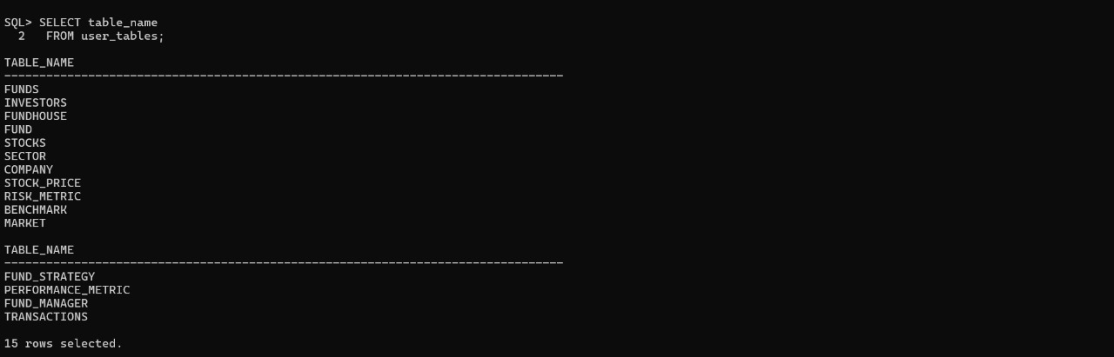

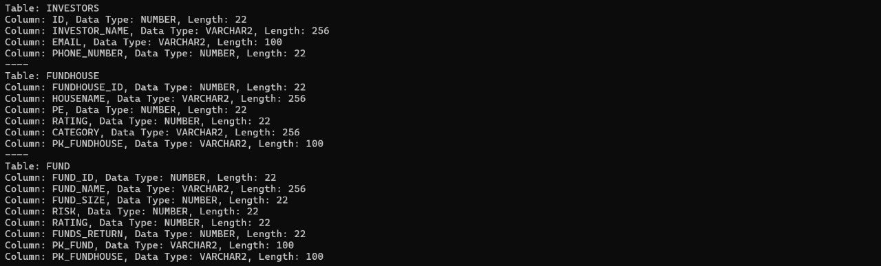

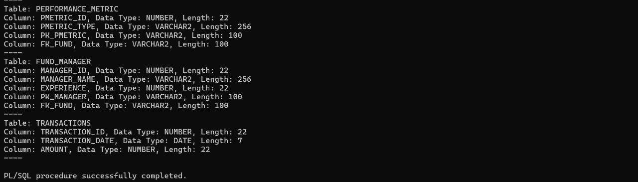

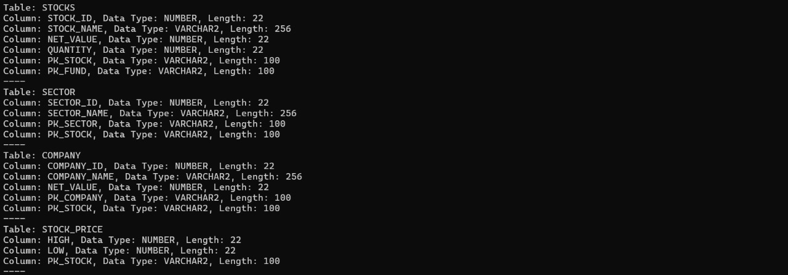

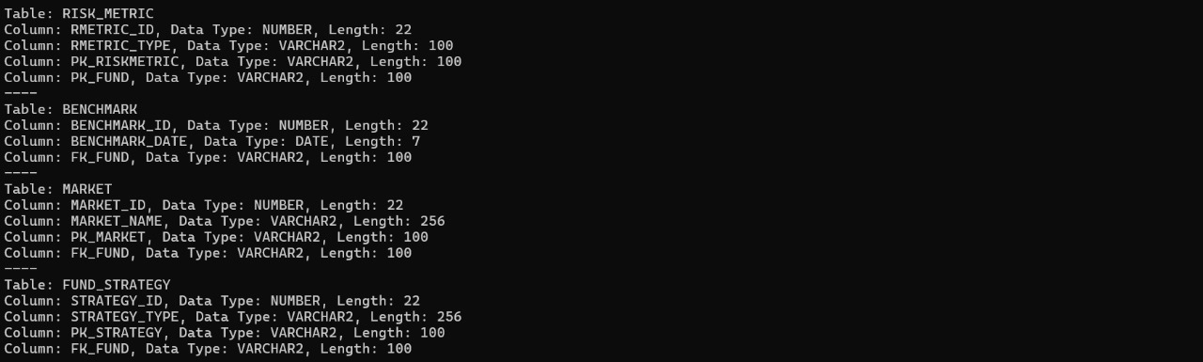

**INSERT QUERIES:**

FUNDHOUSE:

INSERT INTO FUNDHOUSE VALUES (1, 'Reliance MF', 20, 4, 'Large Cap', 'R_MF_001');

INSERT INTO FUNDHOUSE VALUES (2, 'HDFC AMC', 25, 5, 'Mid Cap', 'HDFC_AMC_001');

INSERT INTO FUNDHOUSE VALUES (3, 'ICICI Prudential', 18, 3, 'Small Cap', 'ICICI_AMC_001');

FUNDS:

INSERT INTO FUND VALUES (101, 'Reliance LC Fund', 10000000, 3, 4, 12, 'R_LCF_001', 'R_MF_001');

INSERT INTO FUND VALUES (102, 'HDFC Mid-Cap Fund', 5000000, 4, 5, 15, 'HDFC_MCOF_001', 'HDFC_AMC_001');

INSERT INTO FUND VALUES (103, 'ICICI Small Cap Fund', 2000000, 5, 3, 18, 'ICICI_SCF_001', 'ICICI_AMC_001');

STOCKS:

INSERT INTO STOCKS VALUES (201, 'Reliance Ind', 2000, 1000, 'RIL_001', 'R_LCF_001');

INSERT INTO STOCKS VALUES (202, 'Infosys', 3000, 500, 'INFY_001', 'HDFC_MCOF_001');

INSERT INTO STOCKS VALUES (203, 'Tata Motors', 500, 200, 'TML_001', 'ICICI_SCF_001');

SECTOR:

INSERT INTO SECTOR VALUES (301, 'Oil & Gas', 'OilGas_001', 'RIL_001');

INSERT INTO SECTOR VALUES (302, 'IT', 'IT_001', 'INFY_001');

COMPANY:

INSERT INTO COMPANY VALUES (401, 'Reliance Ind', 2000, 'RIL_001', 'RIL_001');

INSERT INTO COMPANY VALUES (402, 'Infosys', 3000, 'INFY_001', 'INFY_001');

INSERT INTO COMPANY VALUES (403, 'Tata Motors', 500, 'TML_001', 'TML_001');

RISK_METRIC:

INSERT INTO RISK_METRIC VALUES (501, 'Std Deviation', 'SD_001', 'R_LCF_001');

INSERT INTO RISK_METRIC VALUES (502, 'Beta', 'Beta_001', 'HDFC_MCOF_001');

INSERT INTO RISK_METRIC VALUES (503, 'VaR', 'VaR_001', 'ICICI_SCF_001');

FUND_MANAGER:

INSERT INTO FUND_MANAGER VALUES (601, 'John D', 10, 'John_Doe_001', 'R_LCF_001');

INSERT INTO FUND_MANAGER VALUES (602, 'Jane S', 15, 'Jane_Smith_001', 'HDFC_MCOF_001');

INSERT INTO FUND_MANAGER VALUES (603, 'David S', 8, 'David_Singh_001', 'ICICI_SCF_001');

BENCHMARK:

INSERT INTO BENCHMARK VALUES (701, '2024-04-01', 'R_LCF_001');

INSERT INTO BENCHMARK VALUES (702, '2024-04-01', 'HDFC_MCOF_001');

INSERT INTO BENCHMARK VALUES (703, '2024-04-01', 'ICICI_SCF_001');

MARKET:

INSERT INTO MARKET VALUES (801, 'BSE', 'BSE_001', 'R_LCF_001');

INSERT INTO MARKET VALUES (802, 'NSE', 'NSE_001', 'HDFC_MCOF_001');

INSERT INTO MARKET VALUES (803, 'NSE', 'NSE_001', 'ICICI_SCF_001');

FUND_STRATEGY:

INSERT INTO FUND_STRATEGY VALUES (901, 'Growth', 'Growth_001', 'R_LCF_001');

INSERT INTO FUND_STRATEGY VALUES (902, 'Value', 'Value_001', 'HDFC_MCOF_001');

INSERT INTO FUND_STRATEGY VALUES (903, 'Blend', 'Blend_001', 'ICICI_SCF_001');

PERFORMANCE_METRIC:

INSERT INTO PERFORMANCE_METRIC VALUES (1001, 'Sharpe Ratio', 'Sharpe_001', 'R_LCF_001');

INSERT INTO PERFORMANCE_METRIC VALUES (1002, 'Treynor Ratio', 'Treynor_001', 'HDFC_MCOF_001');

INSERT INTO PERFORMANCE_METRIC VALUES (1003, 'Alpha', 'Alpha_001', 'ICICI_SCF_001');

INVESTORS:

INSERT INTO INVESTORS VALUES (1101, 'Amit K', 'amit@example.com', 9876543210, 'Amit_001');

INSERT INTO INVESTORS VALUES (1102, 'Rajesh S', 'rajesh@example.com', 9876543211, 'Rajesh_001');

INSERT INTO INVESTORS VALUES (1103, 'Sunita J', 'sunita@example.com', 9876543212, 'Sunita_001');

PORTFOLIO:

INSERT INTO PORTFOLIO VALUES (1201, 100, 'R_LCF_001', 'Amit_001');

INSERT INTO PORTFOLIO VALUES (1202, 50, 'HDFC_MCOF_001', 'Rajesh_001');

INSERT INTO PORTFOLIO VALUES (1203, 200, 'ICICI_SCF_001', 'Sunita_001');

TRANSACTIONS:

INSERT INTO TRANSACTIONS VALUES (2001, '2024-04-01', 5000);

INSERT INTO TRANSACTIONS VALUES (2002, '2024-04-02', 7000);

INSERT INTO TRANSACTIONS VALUES (2003, '2024-04-03', 10000);

STOCK_PRICE:

INSERT INTO STOCK_PRICE VALUES (1501, 1000, 'RIL_001');

INSERT INTO STOCK_PRICE VALUES (1502, 1500, 'INFY_001');

INSERT INTO STOCK_PRICE VALUES (1503, 200, 'TML_001');

**SCREENSHOTS:**

**ALTER QUERIES:**

ALTER TABLE FUNDHOUSE MODIFY (housename VARCHAR(10));

ALTER TABLE FUNDHOUSE MODIFY (category VARCHAR(10)),

ALTER TABLE FUNDHOUSE MODIFY (PK_fundhouse VARCHAR(10));

ALTER TABLE FUND MODIFY (FK_fundhouse VARCHAR(10));

ALTER TABLE FUND MODIFY (PK_fund VARCHAR(10));

ALTER TABLE FUND MODIFY (fund_name VARCHAR(10));

ALTER TABLE STOCKS MODIFY (stock_name VARCHAR(10));

ALTER TABLE STOCKS MODIFY (PK_stock VARCHAR(10));

ALTER TABLE STOCKS MODIFY (FK_fund VARCHAR(10));

ALTER TABLE SECTOR MODIFY( sector_name VARCHAR(10);

ALTER TABLE SECTOR MODIFY (PK_sector VARCHAR(10));

ALTER TABLE SECTOR MODIFY (FK_stock VARCHAR(10));

ALTER TABLE COMPANY MODIFY(company_name VARCHAR(10));

ALTER TABLE COMPANY MODIFY (PK_company VARCHAR(10));

**SCREENSHOTS:**

**CONTRAINT QUERIES:**

Check Constraint for Non-Empty Company Names:

ALTER TABLE COMPANY

ADD CONSTRAINT chk_non_empty_company_name

CHECK (LENGTH(company_name) > 0);

Check Constraint for Positive Net Value (assuming net_value should be positive):

ALTER TABLE COMPANY

ADD CONSTRAINT chk_positive_net_value

CHECK (net_value > 0);

**SCREENSHOTS:**

**SQL FUNCTIONS QUERIES:**

Scaler function:

SELECT TO_CHAR(transaction_date, 'YYYY-MM-DD') FROM

TRANSACTIONS;

SELECT length(fund_name) from FUND;

GROUP FUNCTION:

SELECT COUNT(*) FROM FUNDHOUSE;

**SCREENSHOTS:**

**SUBQUERY:**

To find amount of money investor has invested:

SELECT SUM(amount) AS total_investment

FROM TRANSACTIONS

WHERE transaction_id IN (

SELECT transaction_id

FROM PORTFOLIO

WHERE FK_investor = (SELECT PK_investor FROM INVESTORS WHERE investor_name = 'InvestorName')

);

To find sum of portfolios of an investor:

SELECT SUM(quantity) AS total_portfolio

FROM PORTFOLIO

WHERE FK_investor = (SELECT PK_investor FROM INVESTORS WHERE investor_name = 'InvestorName');

**SCREENSHOTS:**

**JOINS:**

Intersect to find common investors in 2 funds:

SELECT SUM(p.quantity * s.net_value) AS portfolio_value

FROM PORTFOLIO p

JOIN STOCKS s ON p.FK_fund = s.PK_stock

WHERE p.FK_investor = (SELECT PK_investor FROM INVESTORS WHERE investor_name = 'InvestorName');

Intersect to find companies in same sector:

SELECT company_id, company_name

FROM COMPANY

WHERE FK_sector = (SELECT PK_sector FROM SECTOR WHERE sector_name = 'Sector X')

INTERSECT

SELECT company_id, company_name

FROM COMPANY

WHERE FK_sector = (SELECT PK_sector FROM SECTOR WHERE sector_name = 'Sector Y');

Minus to find exclusive investors in fund a not fund b:

SELECT investor_id, investor_name

FROM PORTFOLIO

WHERE FK_fund = (SELECT PK_fund FROM FUND WHERE fund_name = 'Fund A')

MINUS

SELECT investor_id, investor_name

FROM PORTFOLIO

WHERE FK_fund = (SELECT PK_fund FROM FUND WHERE fund_name = 'Fund B');

Join To find the sum of investors portfolio:

SELECT SUM(p.quantity * s.net_value) AS portfolio_value

FROM PORTFOLIO p

JOIN STOCKS s ON p.FK_fund = s.PK_stock

WHERE p.FK_investor = (SELECT PK_investor FROM INVESTORS WHERE investor_name = 'InvestorName');

Join to find investor transaction history:

SELECT t.transaction_id, t.transaction_date, t.amount

FROM TRANSACTIONS t

JOIN PORTFOLIO p ON t.transaction_id = p.transaction_id

WHERE p.FK_investor = (SELECT PK_investor FROM INVESTORS WHERE investor_name = 'InvestorName');

Join to find fund vs benchmark performance:

SELECT f.fund_name, b.benchmark_date, f.returns, b.benchmark_value

FROM FUND f

JOIN BENCHMARK b ON f.PK_fund = b.FK_fund

WHERE f.rating >= 4

ORDER BY f.fund_name, b.benchmark_date;

Join to find top performing funds based on rating/returns:

SELECT f.fund_name, fh.housename, f.rating, f.returns

FROM FUND f

JOIN FUNDHOUSE fh ON f.FK_fundhouse = fh.PK_fundhouse

WHERE f.rating >= 4

ORDER BY f.returns DESC;

**SCREENSHOTS:**

**VIEWS QUERIES:**

View for top performing funds:

CREATE VIEW TopPerformingFunds AS

SELECT fund_name, returns, rating

FROM FUND

WHERE rating >= 4

ORDER BY returns DESC;

View for Investor portfolio:

CREATE VIEW InvestorPortfolioView AS

SELECT i.investor_id, i.investor_name, p.quantity, f.fund_name

FROM INVESTORS i

JOIN PORTFOLIO p ON i.PK_investor = p.FK_investor

JOIN FUND f ON p.FK_fund = f.PK_fund;

View for fundmanagers and their associated funds:

CREATE VIEW FundManagerView AS

SELECT fm.manager_id, fm.manager_name, fm.experience, f.fund_name, fh.housename

FROM FUND_MANAGER fm

JOIN FUND f ON fm.FK_fund = f.PK_fund

JOIN FUNDHOUSE fh ON f.FK_fundhouse = fh.PK_fundhouse;

**SCREENSHOTS:**

**TRIGGERS QUERIES:**

Trigger to update portfolio:

CREATE OR REPLACE TRIGGER UpdatePortfolioQuantity

AFTER INSERT ON TRANSACTIONS

FOR EACH ROW

BEGIN

UPDATE PORTFOLIO

SET quantity = quantity + :NEW.amount

WHERE portfolio_id = :NEW.portfolio_id;

END;

/

Trigger to log investor activities:

CREATE OR REPLACE TRIGGER LogInvestorActivity

AFTER INSERT ON INVESTORS

FOR EACH ROW

BEGIN

INSERT INTO INVESTOR_ACTIVITY_LOG (activity_type, activity_date)

VALUES ('New Investor Added', SYSDATE);

END;

/

Trigger to fundsize:

CREATE OR REPLACE TRIGGER UpdateFundSize

AFTER INSERT ON TRANSACTIONS

FOR EACH ROW

BEGIN

UPDATE FUND

SET fund_size = fund_size + :NEW.amount

WHERE fund_id = :NEW.fund_id;

END;

/CREATE OR REPLACE TRIGGER UpdateFundSize

AFTER INSERT ON TRANSACTIONS

FOR EACH ROW

BEGIN

UPDATE FUND

SET fund_size = fund_size + :NEW.amount

WHERE fund_id = :NEW.fund_id;

END;

/

**SCREENSHOTS:**

**CURSORS:**

Cursor to retrieve portfolio details:

DECLARE

v_portfolio_id PORTFOLIO.portfolio_id%TYPE;

v_quantity PORTFOLIO.quantity%TYPE;

CURSOR portfolio_cursor IS

SELECT portfolio_id, quantity

FROM PORTFOLIO;

BEGIN

OPEN portfolio_cursor;

LOOP

FETCH portfolio_cursor INTO v_portfolio_id, v_quantity;

EXIT WHEN portfolio_cursor%NOTFOUND

DBMS_OUTPUT.PUT_LINE('Portfolio ID: ' || v_portfolio_id || ', Quantity: ' || v_quantity);

END LOOP;

CLOSE portfolio_cursor;

END;

/

Cursor to calc total net val of stocks:

DECLARE

v_total_net_value NUMBER := 0;

CURSOR stock_net_value_cursor IS

SELECT SUM(net_value) AS total_net_value

FROM STOCKS;

BEGIN

OPEN stock_net_value_cursor;

FETCH stock_net_value_cursor INTO v_total_net_value;

DBMS_OUTPUT.PUT_LINE('Total Net Value of Stocks: ' || v_total_net_value);

CLOSE stock_net_value_cursor;

END;

/

Cursor to retriev investor names and email:

DECLARE

v_investor_name INVESTORS.investor_name%TYPE;

v_email INVESTORS.email%TYPE;

CURSOR investor_cursor IS

SELECT investor_name, email

FROM INVESTORS;

BEGIN

OPEN investor_cursor;

LOOP

FETCH investor_cursor INTO v_investor_name, v_email;

EXIT WHEN investor_cursor%NOTFOUND;

DBMS_OUTPUT.PUT_LINE('Investor: ' || v_investor_name || ', Email: ' || v_email);

END LOOP;

CLOSE investor_cursor;

END;

/