ASSIGNMENT 4

Blaine Blasdell

2020-06-16

library(rmarkdown) library(tinytex) library(pandoc)

# Markdown Basics

## Favorite Foods

1. Dairy Queen Blizzard
2. Coffee
3. Chicken Wings

## Images

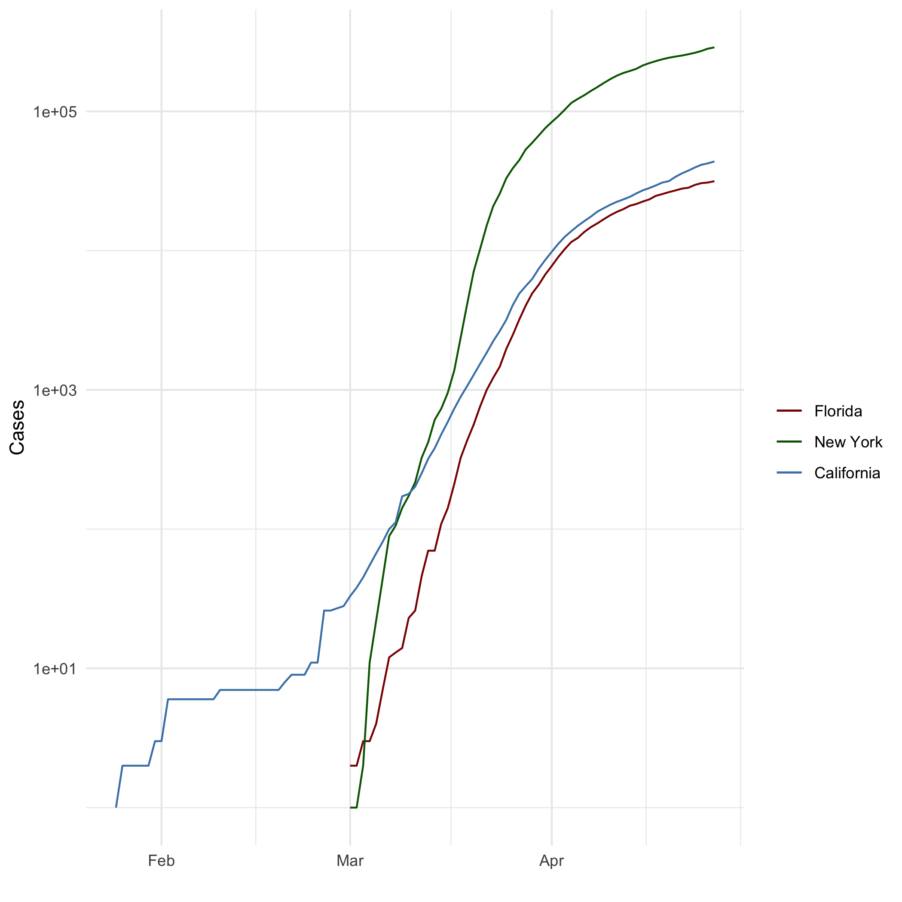

All Cases (Log Plot)

## Add a Quote

Yoda said: “Do or do not. There is no try.”

## Add an Equation

$$pie=(4/1)−(4/3)+(4/5)−(4/7)+(4/9)−(4/11)+(4/13)−(4/15)...$$

## Add a Footnote

Yoda: Star Wars. Empire Strikes Back (1980)[1]:

## Add Citations

* " When I was 8 years old, my parents bought me a guitar for Christmas. Even then, I’d desperately wanted to play the guitar for years." (Field, Miles, and Field 2012)
* R for Everyone (Lander 2014)

# Inline Code

## NY Times COVID-19 Data

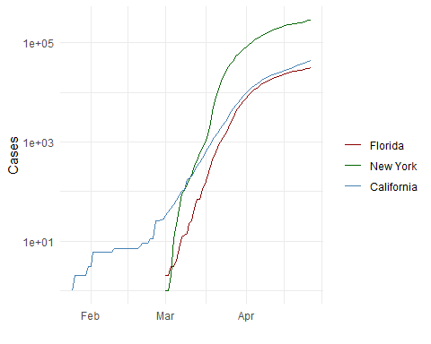

## R4DS Height vs Earnings

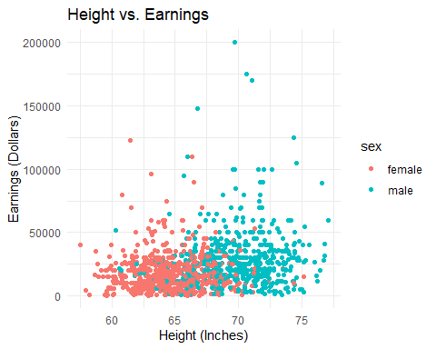

# Tables

## Knitr Table with Kable

One Ring to Rule them all

|  |  |  |  |  |
| --- | --- | --- | --- | --- |
| Name | Race | In Fellowship | Ring Bearer | Age |
| Aragon | Men | TRUE | FALSE | 88 |
| Bilbo | Hobbit | FALSE | TRUE | 129 |
| Frodo | Hobbit | TRUE | TRUE | 51 |
| Galadriel | Elf | FALSE | FALSE | 7000 |
| Sam | Hobbit | TRUE | TRUE | 36 |
| Gandalf | Maia | TRUE | TRUE | 2019 |
| Legolas | Elf | TRUE | FALSE | 2931 |
| Sauron | Maia | FALSE | TRUE | 7052 |
| Gollum | Hobbit | FALSE | TRUE | 589 |

## Pandoc Table

##   
##   
## +--------+--------+--------+---------------+-------------+------+  
## | &nbsp; | Name | Race | In Fellowship | Ring Bearer | Age |  
## +========+========+========+===============+=============+======+  
## | **1** | Aragon | Men | TRUE | FALSE | 88 |  
## +--------+--------+--------+---------------+-------------+------+  
## | **2** | Bilbo | Hobbit | FALSE | TRUE | 129 |  
## +--------+--------+--------+---------------+-------------+------+  
## | **3** | Frodo | Hobbit | TRUE | TRUE | 51 |  
## +--------+--------+--------+---------------+-------------+------+  
## | **5** | Sam | Hobbit | TRUE | TRUE | 36 |  
## +--------+--------+--------+---------------+-------------+------+  
## | **8** | Sauron | Maia | FALSE | TRUE | 7052 |  
## +--------+--------+--------+---------------+-------------+------+  
##   
## Table: One Ring to Rule them all

# References

Field, A., J. Miles, and Z. Field. 2012. *Discovering Statistics Using R*. SAGE Publications. <https://books.google.com/books?id=wd2K2zC3swIC>.

Lander, J. P. 2014. *R for Everyone: Advanced Analytics and Graphics*. Addison-Wesley Data and Analytics Series. Addison-Wesley. <https://books.google.com/books?id=3eBVAgAAQBAJ>.

1. 1