Programming Fundamentals
First Assignment — BSE-1C
Pseudocode and Flowcharts — Questions 1 to 17
Note:
Using same format for output as example given and using the same variable names as given in example input/output.
Flowcharts were made on a website on google and then the screenshots/downloads were uploaded.

Question 1: The Bacterial Outbreak
Pseudocode
BEGIN
// Get the starting population and the doubling time from the user
DISPLAY "Enter p0: "
INPUT p0
DISPLAY "Enter t: "
INPUT t
totalMinutes = t * 3 // 3 full doubling cycles have passed
hours = totalMinutes / 60
minutes = totalMinutes % 60
// Double the population 3 times over; keep it in a long long since it grows fast
population = p0 * 2 * 2 * 2
DISPLAY "Elapsed Time = " hours " hours " minutes " minutes"
DISPLAY "Final Population = " population
END
Flowchart
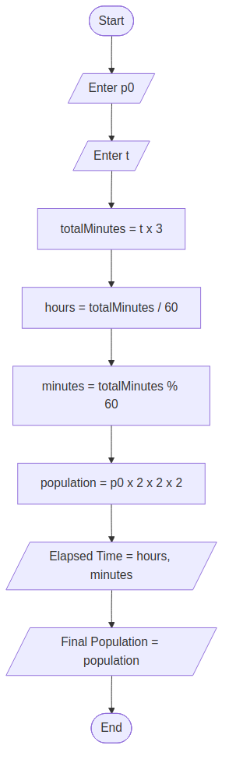

Question 2: The ATM Cash Dispenser
Pseudocode
BEGIN
DISPLAY "Enter amount = "
INPUT amount
remaining = amount
// Work down from the biggest note to the smallest, one at a time
notes5000 = remaining / 5000
remaining = remaining % 5000
notes1000 = remaining / 1000
remaining = remaining % 1000
notes100 = remaining / 100
remaining = remaining % 100
// Whatever is left at this point is only 10-rupee notes
notes10 = remaining / 10
DISPLAY "Rs. 5000 notes: " notes5000
DISPLAY "Rs. 1000 notes: " notes1000
DISPLAY "Rs. 100 notes: " notes100
DISPLAY "Rs. 10 notes: " notes10
END
Flowchart
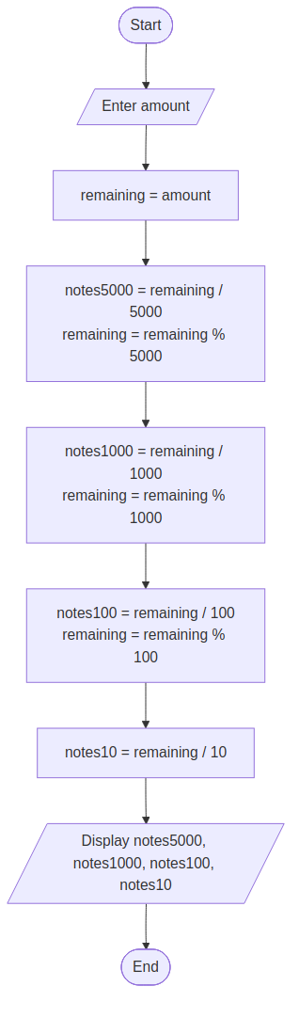

Question 3: The Relay Race Analyst
Pseudocode
BEGIN
DISPLAY "Enter d1: " ; INPUT d1
DISPLAY "Enter t1: " ; INPUT t1
DISPLAY "Enter d2: " ; INPUT d2
DISPLAY "Enter t2: " ; INPUT t2
DISPLAY "Enter d3: " ; INPUT d3
DISPLAY "Enter t3: " ; INPUT t3
totalDistance = d1 + d2 + d3
totalTime = t1 + t2 + t3
// This is the actual team speed, not an average of the 3 individual speeds
overallSpeed = totalDistance / totalTime
runner2Speed = d2 / t2
// Can be positive or negative -- just show it as is
speedDifference = runner2Speed - overallSpeed
DISPLAY "Total Distance: " totalDistance
DISPLAY "Total Time: " totalTime
DISPLAY "Overall Average Speed = " overallSpeed " m/s"
DISPLAY "Runner 2 Speed = " runner2Speed " m/s"
DISPLAY "Speed Difference = " speedDifference " m/s"
END
Flowchart
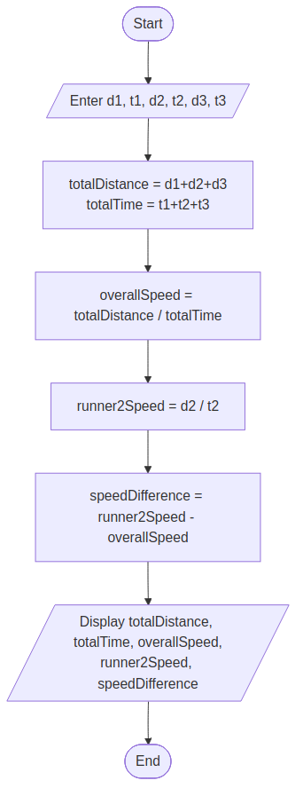

Question 4: The ID Verification System
Pseudocode
BEGIN
DISPLAY "Enter id: "
INPUT id
// Pull out each digit using only / and %, never as text
d1 = id / 1000
d2 = (id / 100) % 10
d3 = (id / 10) % 10
d4 = id % 10
// Weighted formula given in the assignment
code = (d1*4 + d2*3 + d3*2 + d4*1) % 9
// Same digits, just written back in reverse order
mirrorID = d4*1000 + d3*100 + d2*10 + d1
DISPLAY "Digits: " d1 d2 d3 d4
DISPLAY "Verification Code: " code
DISPLAY "MirrorID: " mirrorID
END
Flowchart
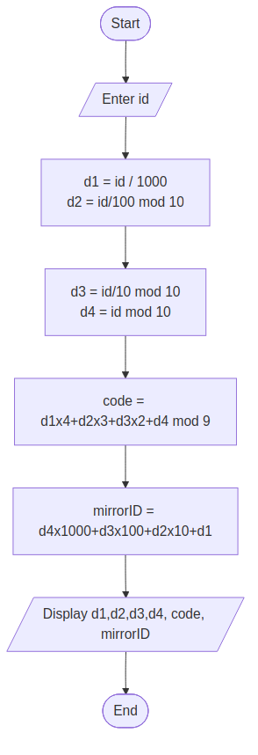

Question 5: The Garden Designer
Pseudocode
BEGIN
DISPLAY "Enter length: " ; INPUT length
DISPLAY "Enter width: " ; INPUT width
DISPLAY "Enter pathWidth: " ; INPUT pathWidth
DISPLAY "Enter fenceCost: " ; INPUT fenceCost
DISPLAY "Enter paveCost: " ; INPUT paveCost
DISPLAY "Enter turfCost: " ; INPUT turfCost
gardenArea = length * width
// Shrink both sides by the path width to get the inner lawn
lawnLength = length - 2 * pathWidth
lawnWidth = width - 2 * pathWidth
lawnArea = lawnLength * lawnWidth
// Whatever isn't lawn must be the path
pathArea = gardenArea - lawnArea
perimeter = 2 * (length + width)
// Add up the three separate costs
totalCost = perimeter*fenceCost + pathArea*paveCost + lawnArea*turfCost
DISPLAY "Garden Area = " gardenArea
DISPLAY "Lawn Area = " lawnArea
DISPLAY "Path Area = " pathArea
DISPLAY "Perimeter = " perimeter
DISPLAY "Total Cost = " totalCost
END
Flowchart
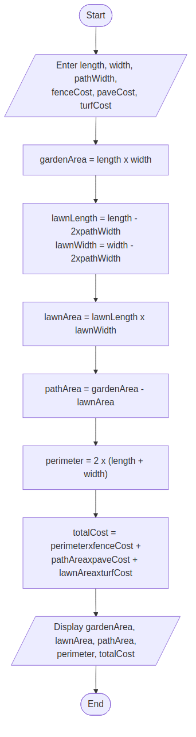

Question 6: Time Conversion
Pseudocode
BEGIN
DISPLAY "Enter total seconds: "
INPUT totalSeconds
hours = totalSeconds / 3600
// Whatever is left once the full hours are removed
remainingSeconds = totalSeconds % 3600
minutes = remainingSeconds / 60
// Final remainder is pure seconds
seconds = remainingSeconds % 60
DISPLAY hours " hour(s), " minutes " minute(s), " seconds " second(s)"
END
Flowchart
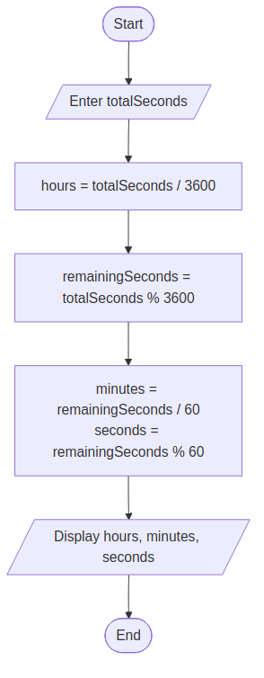

Question 7: Three-Digit Number Analysis
Pseudocode
BEGIN
DISPLAY "Enter a three-digit number: "
INPUT number
// Extract digits with / and % only -- no strings, loops or arrays allowed
hundreds = number / 100
tens = (number / 10) % 10
ones = number % 10
sumDigits = hundreds + tens + ones
// Same digits, rearranged back to front
reversedNumber = ones*100 + tens*10 + hundreds
DISPLAY "Hundreds digit: " hundreds
DISPLAY "Tens digit: " tens
DISPLAY "Ones digit: " ones
DISPLAY "Sum of digits: " sumDigits
DISPLAY "Reversed number: " reversedNumber
END
Flowchart
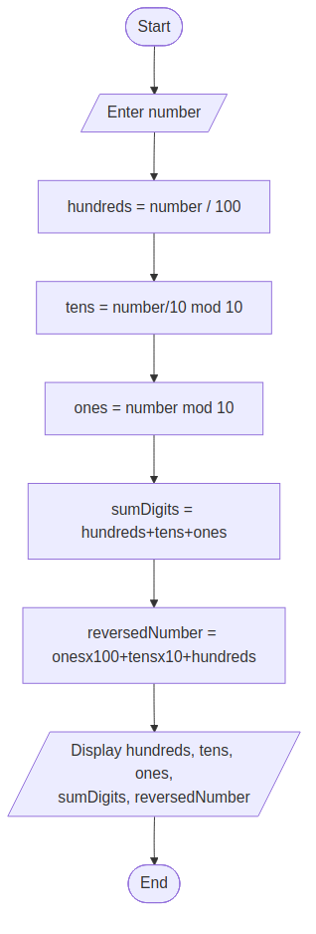

Question 8: Digital Clock Calculation
Pseudocode
BEGIN
DISPLAY "Enter hour: " ; INPUT hour
DISPLAY "Enter minute: " ; INPUT minute
DISPLAY "Enter second: " ; INPUT second
DISPLAY "Enter seconds to add: " ; INPUT secondsToAdd
// Collapse the current time into one number of seconds
totalSeconds = hour*3600 + minute*60 + second
// Add the extra seconds, then wrap around a single day
totalSeconds = (totalSeconds + secondsToAdd) % 86400
newHour = totalSeconds / 3600
remainingSeconds = totalSeconds % 3600
newMinute = remainingSeconds / 60
newSecond = remainingSeconds % 60
DISPLAY "New time: " newHour ":" newMinute ":" newSecond
END
Flowchart
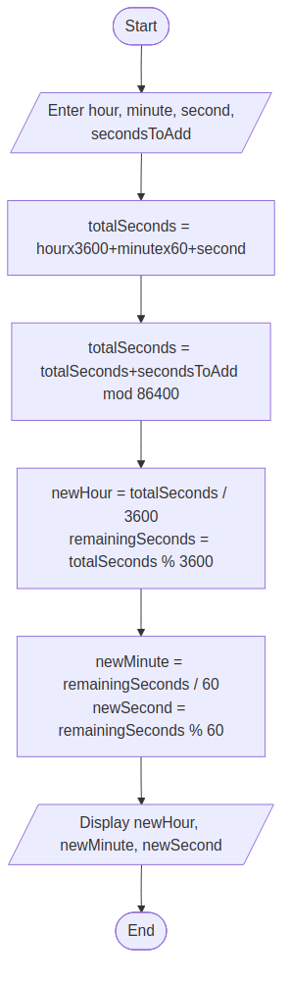

Question 9: Compound Interest Calculator
Pseudocode
BEGIN
DISPLAY "Enter initial amount: " ; INPUT P
DISPLAY "Enter annual interest rate: " ; INPUT ratePercent
DISPLAY "Enter compounds per year: " ; INPUT n
DISPLAY "Enter number of years: " ; INPUT t
// Turn the percentage into a plain decimal
r = ratePercent / 100
A = P * (1 + r/n) ^ (n*t)
//in c++ power function is used for this formula.
// Interest earned is just the growth over the original amount
compoundInterest = A - P
DISPLAY "Final amount: " A
DISPLAY "Compound interest: " compoundInterest
END
Flowchart
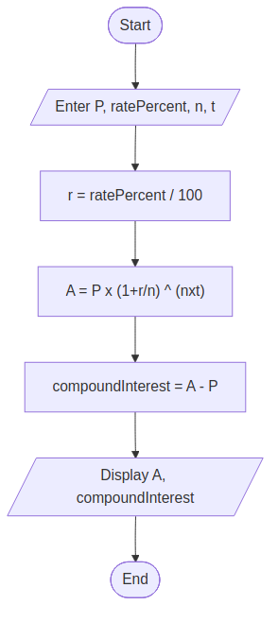

Question 10: Cricket Chirp Temperature Calculator
Pseudocode
BEGIN
DISPLAY "Enter chirps per minute: "
INPUT chirpsPerMinute
// Apply the given formula directly, no shortcuts
temperature = 50 + (chirpsPerMinute - 40) / 4
DISPLAY "Estimated Temperature: " temperature " F"
END
Flowchart
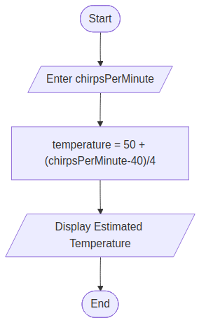

Question 11: Student Average Calculator
Pseudocode
BEGIN
DISPLAY "Enter Math marks: " ; INPUT math
DISPLAY "Enter Physics marks: " ; INPUT physics
DISPLAY "Enter Programming marks: " ; INPUT programming
// Use 3.0, not 3, so the decimal part isn't lost
average = (math + physics + programming) / 3.0
DISPLAY "Average Marks: " average
END
Flowchart
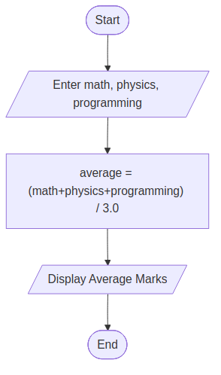

Question 12: The Kinetic Energy Trap
Pseudocode
BEGIN
DISPLAY "Enter mass: " ; INPUT m // whole number
DISPLAY "Enter velocity: " ; INPUT v // decimal number
// Force floating-point division here, or 1/2 truncates to 0 before it multiplies anything
KE = (1.0/2) * m * v * v
DISPLAY "Kinetic Energy: " KE
END
Flowchart
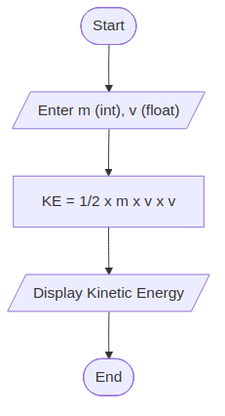

Question 13: Logical Access Matrix
Pseudocode
BEGIN
DISPLAY "Enter Age: " ; INPUT age
DISPLAY "Enter Clearance: " ; INPUT clearance
DISPLAY "Enter OverrideCode: " ; INPUT overrideCode
// Access needs age + clearance together, OR the override code by itself
access = (age >= 18 AND clearance > 3) OR (overrideCode == 999)
DISPLAY "Access Granted: " access
END
Flowchart
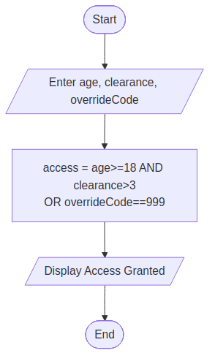

Question 14: Network Packet Fragmentation
Pseudocode
BEGIN
DISPLAY "Enter Total Bytes: " ; INPUT totalBytes
DISPLAY "Enter Packet Size: " ; INPUT packetSize
fullPackets = totalBytes / packetSize
// Bytes that don't add up to one more complete packet
leftoverBytes = totalBytes % packetSize
DISPLAY "Full packets to transmit: " fullPackets
DISPLAY "Leftover bytes: " leftoverBytes
END
Flowchart
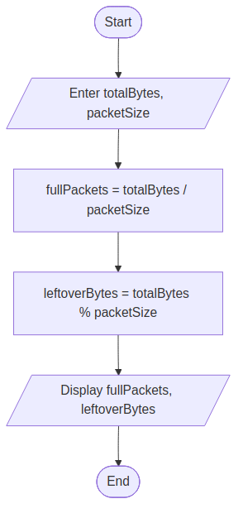

Question 15: Structural Stress Polynomial
Pseudocode
BEGIN
DISPLAY "Enter x: "
INPUT x
// Same polynomial and operator order as given in the assignment
y = 3*x*x*x*x - 2*x*x*x + x - 7
DISPLAY "Stress factor y: " y
END
Flowchart
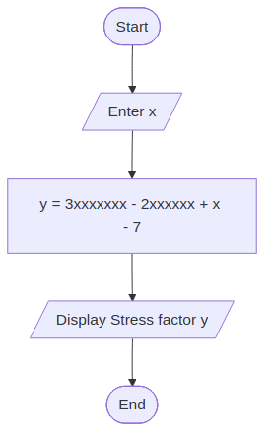

Question 16: Digital Clock Converter
Pseudocode
BEGIN
DISPLAY "Enter total seconds: "
INPUT totalSeconds
hours = totalSeconds / 3600
remainingSeconds = totalSeconds % 3600
// Turn what's left into minutes...
minutes = remainingSeconds / 60
// ...and whatever remains after that is seconds
seconds = remainingSeconds % 60
DISPLAY "Hours: " hours ", Minutes: " minutes ", Seconds: " seconds
END
Flowchart
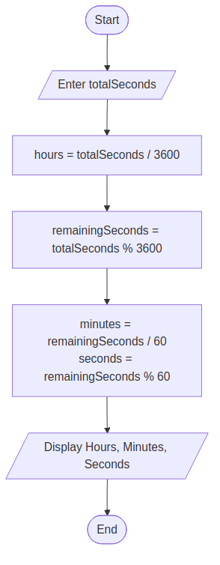

Question 17: 3D Distance Calculator
Pseudocode
BEGIN
DISPLAY "Enter x1: " ; INPUT x1
DISPLAY "Enter y1: " ; INPUT y1
DISPLAY "Enter z1: " ; INPUT z1
DISPLAY "Enter x2: " ; INPUT x2
DISPLAY "Enter y2: " ; INPUT y2
DISPLAY "Enter z2: " ; INPUT z2
// Difference along each axis
dx = x2 - x1
dy = y2 - y1
dz = z2 - z1
// No pow() -- just plain multiplication, as required
squaredDistance = dx*dx + dy*dy + dz*dz
DISPLAY "Squared Distance: " squaredDistance
END
Flowchart
