**SQUARELAND**

How nice there is a state where everything is square.

Rules for districting:

In the districts all precincts must by contiguous by edges, no corners.

4 districts; exactly 16 precincts in each.

**Scenario One**: Squareland: 64 precincts. Each party controls 32

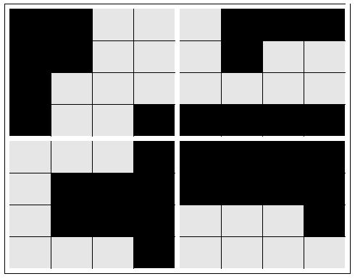

Who wins each district? By how much?

**Scenario Two**: Try to gerrymander in Dark’s favor

Squareland: 64 precincts. Each party controls 32



Who wins each district? By how much?

**Scenario Three**: Try to gerrymander in Light’s favor

Squareland: 64 precincts. Each party controls 32



Who wins each district? By how much?

Some compactness measures:

Polsby-Popper = $\frac{4πA}{p^{2}}$

Schwartzberg: Ratio of perimeter of a district to the perimeter of a circle with the same area of as the district. 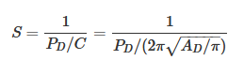

Reock: For each district, the test computes the ratio of the area of the district to the area of the minimum enclosing circle for the district.

Convex Hull:  The Convex Hull measure is the ratio of the area of a district to that of the convex hull of the district.

|  |  |  |  |  |
| --- | --- | --- | --- | --- |
| Scenario 1 | Polsby-Poppe | Schwartzberg | Reock | Convex Hull |
| District 1 |  |  |  |  |
| District 2 |  |  |  |  |
| District 3 |  |  |  |  |
| District 4 |  |  |  |  |

|  |  |  |  |  |
| --- | --- | --- | --- | --- |
| Scenario 2 | Polsby-Poppe | Schwartzberg | Reock | Convex Hull |
| District 1 |  |  |  |  |
| District 2 |  |  |  |  |
| District 3 |  |  |  |  |
| District 4 |  |  |  |  |

|  |  |  |  |  |
| --- | --- | --- | --- | --- |
| Scenario 3 | Polsby-Poppe | Schwartzberg | Reock | Convex Hull |
| District 1 |  |  |  |  |
| District 2 |  |  |  |  |
| District 3 |  |  |  |  |
| District 4 |  |  |  |  |

|  |  |  |  |  |
| --- | --- | --- | --- | --- |
| Scenario 4 | Polsby-Poppe | Schwartzberg | Reock | Convex Hull |
| District 1 |  |  |  |  |
| District 2 |  |  |  |  |
| District 3 |  |  |  |  |
| District 4 |  |  |  |  |