  Deepen your study.  Scan for teachings & devotionals  www.theprayerwhiteboard.com  Scripture quotations are from the NIV, ESV, NKJV, NLT, AMP, and AMPC Bibles. Complete copyright acknowledgments and permissions can be viewed at https://theprayerwhiteboard.com/copyright-disclaimers.  Original Content © 2026 The Prayer Whiteboard. All rights reserved | 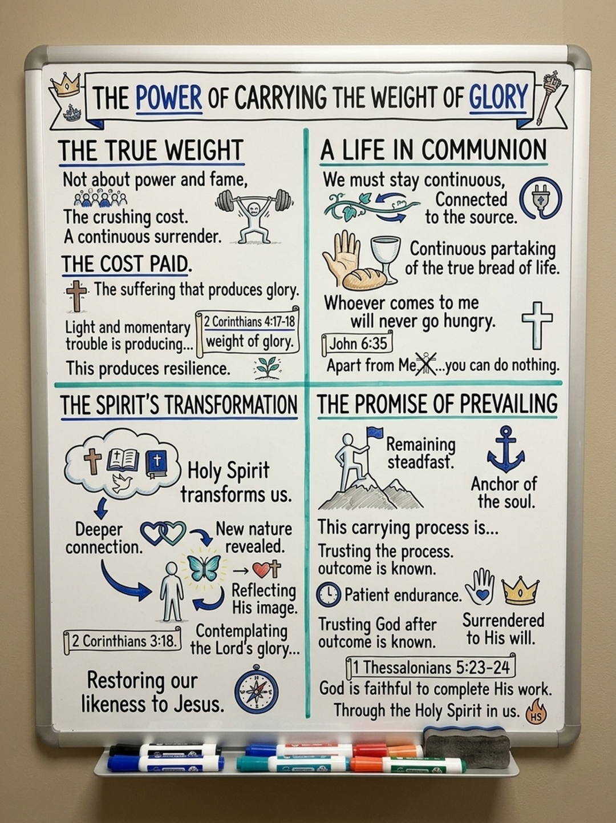  Through surrender, communion with Jesus, and transformation by Holy Spirit, we learn to carry the weight of glory with steadfast faith.

LIVE AWARE OF HIS PRESENCE
A daily pattern of fellowship and obedience
Holy Spirit is not confined to a meeting, a dramatic prayer, or a strong emotion. He lives within God’s people and desires to work through ordinary moments. We do not manufacture glory; we remain near to the Lord and yield ourselves to Him.

BEGIN WITH WHO YOU ARE
Remember your union with Christ. You are joined to the Lord and sealed with Holy Spirit. Your identity rests on God’s work, not on changing feelings (1 Corinthians 6:17; Ephesians 1:13).

PRACTICE HIS PRESENCE
Draw near. Turn your attention purposefully toward the Lord through Scripture, worship, prayer, and thanksgiving (James 4:8).
Listen and respond. Ask Holy Spirit to sharpen your hearing and understanding, then obey promptings that agree with God’s Word.
Release what hinders. Let Him expose distractions, offenses, and habits that compete with fellowship and your freedom in Christ.
Carry His love outward. A sincere smile, gracious word, brief prayer, or quiet act of mercy can become a place where another person encounters God’s kindness.

REMAIN GROUNDED IN THE COVENANT
The bread and cup remind us that spiritual life, freedom, and transformation flow from Jesus—His body given for us and the new covenant established through His blood. Receive His life with gratitude rather than striving to produce it yourself.
Stay close • Stay attentive • Stay available • Obey in love

www.theprayerwhiteboard.com

CARRYING HIS PRESENCE
His glory reaches others through ordinary obedience
Believers are living temples who carry God’s indwelling presence. Others may not recognize what you carry, and you may not feel anything dramatic. Stay near to God, remain available, and trust Him to work through simple obedience.

ENLARGE YOUR VISION OF PRAYER
Prayer is not limited by walls or by the number of people present. Holy Spirit can lead a yielded believer to pray according to God’s heart for people nearby or far away. Even when no result is visible, Spirit-led prayer can bear eternal fruit (Isaiah 54:2; 1 Chronicles 4:10).

EXPECT GLORY IN ORDINARY ENCOUNTERS
Pay attention to people. A cashier, neighbor, coworker, or stranger may be searching for hope. Kindness can carry the light of Christ.
Obey without waiting for a feeling. If Holy Spirit prompts you to encourage, serve, or pray, take the next faithful step. God can use it more deeply than you see understand.
Let love shape your influence. Carrying God’s presence is not about drawing attention to yourself; it allows His mercy and truth to reach another person.

STAY CLOSE AND STAY ALERT
Draw near to the Lord, honor His presence, and keep your heart available. As spiritual perception grows, you may recognize people and situations He has prepared for your spiritual journey. Respond with humility, faith, and love.

REMEMBER THE SOURCE
Every spiritual blessing and work of the Spirit rests upon Christ and His covenant. Communion turns the heart back to Jesus: His body was given, His blood established the covenant, and His finished work is our foundation.
Arise and shine for your light has come — Isaiah 60:1

FROM GLORY TO GLORY
Beholding the Lord and yielding to Holy Spirit
God chose believers in Christ and gave His own Spirit. His love is poured into our hearts through Holy Spirit, so spiritual life flows from His presence rather than our independent ability (Ephesians 1:3–4; Romans 5:5).

JOINED, SEALED, AND DEEPLY LOVED
The one joined to the Lord is one spirit with Him. Believers are sealed with Holy Spirit and called children of God (1 Corinthians 6:17; Ephesians 1:13; 1 John 3:1). Work, errands, and pressure do not cancel this identity. His Spirit remains present throughout the day.

TRANSFORMATION COMES BY THE SPIRIT
When we turn to the Lord, the veil is removed, and where the Spirit of the Lord is, there is freedom. As we behold the Lord’s glory, the Spirit transforms us into His image from glory to glory (2 Corinthians 3:16–18). The change grows as we look toward Him and cooperate with His work.
Behold the Lord. Give Him your attention in Scripture, worship, and prayer—not merely to complete a duty, but to know Him.
Welcome His freedom. If He reveals unforgiveness, distraction, or an unhealthy attachment, release it. His correction clears room for growth.
Honor Him willingly. Faith pleases God. A Releasing a free response—“Holy Spirit, take charge; do more through me”—makes your life available to Him (Hebrews 11:6).
Yield your will. God honors your choice and never forces His way. Offering a free, unforced response—“Holy Spirit, take charge; do more through me”—places your life entirely at His disposal (Hebrews 11:6)

LET WORSHIP AWAKEN AWARENESS
Worship while washing dishes or driving can become genuine fellowship when the heart honors God. His presence is already with you; worship makes you more attentive and responsive to Him.
Transformed into His image from glory to glory
2 Corinthians 3:18

