Production Model Design Report

F2019 – ECE 298

|  |  |  |  |
| --- | --- | --- | --- |
| Lab Section: | 5 | Group: | 16 |

[For your project, your group will complete one Production Model Design Report. The audience is your manager and the manager of the Production Engineering team, so the document should be of high quality. Inside this report, you will each individually select two issues that must be addressed when bringing a project to production scale (one STEM and one non-STEM issues – choose different topics than your partner). Delete all the instructions in brackets before submitting this document. Use IEEE format to note any relevant references or links [1]. You do this in Word by going to References 🡪 Citations & Bibliography 🡪 Manage Sources to add a source, and then to Insert Citation to use it.]

# Team Members

|  |  |  |
| --- | --- | --- |
| # | Name | Role |
| 1 | Simon Cousineau | LCD display, keypad API, PCB assembly |
| 2 | Ben Finch | Limit switches and indicators, stepper motor API, PCB assembly |

# Design Overview

## Problem Statement

Manufacturing facilities have a demand for high-throughput, in order to fulfil large orders. To achieve this goal, they require efficient picker-placer machines which are capable of manufacturing electronic circuits with high speed, high accuracy and minimal downtime. This device should be able to articulate in two axis, within a bounded plane, while navigating through user input coordinates.

## Design Scope

In order to achieve this goal, our device utilizes a keypad to input coordinates, while providing prompts and feedback through the board’s LCD display. Once all coordinates are enterer, the device will actuate its stepper motors to navigate to the specified location, while limit switches enforce and indicate boundaries.

While designing the device, it was assumed that the payload carried would be relatively small, since PCB components are generally light. It was also assumed that the user would input a maximum of 5 coordinates. It was also assumed that the device would run on a low voltage source (5V).

## Project Design Requirements

Functional:

* Must have at least two functional axis of movement.
* Must initialize to center of axis range, for both axis. (start x = width / 2, start y = height / 2)
* Must support coordinates inputs that are positive and negative.
* Must actuate LED indicator upon reaching range limits.
* Must stop appropriate motor upon reaching range limits.
* Must allow user to input coordinate values via keypad.
* Must allow user to start movement sequence via keypad input.
* Must display current movement progress on LCD display (percentage to target).

Non-functional:

* Must be easy to use (input coordinates, start sequence, etc.).
* Must reach coordinates within reasonable time delay.
* Must travel in one smooth motion (no jitter, grinding, skipping).
* Must reach targets with reasonable accuracy and/or precision
* Must be energy-efficient.

Constraint:

* Must cost less than 100$ per unit.

## System-Level Design (High-Level)



## Completed Prototype

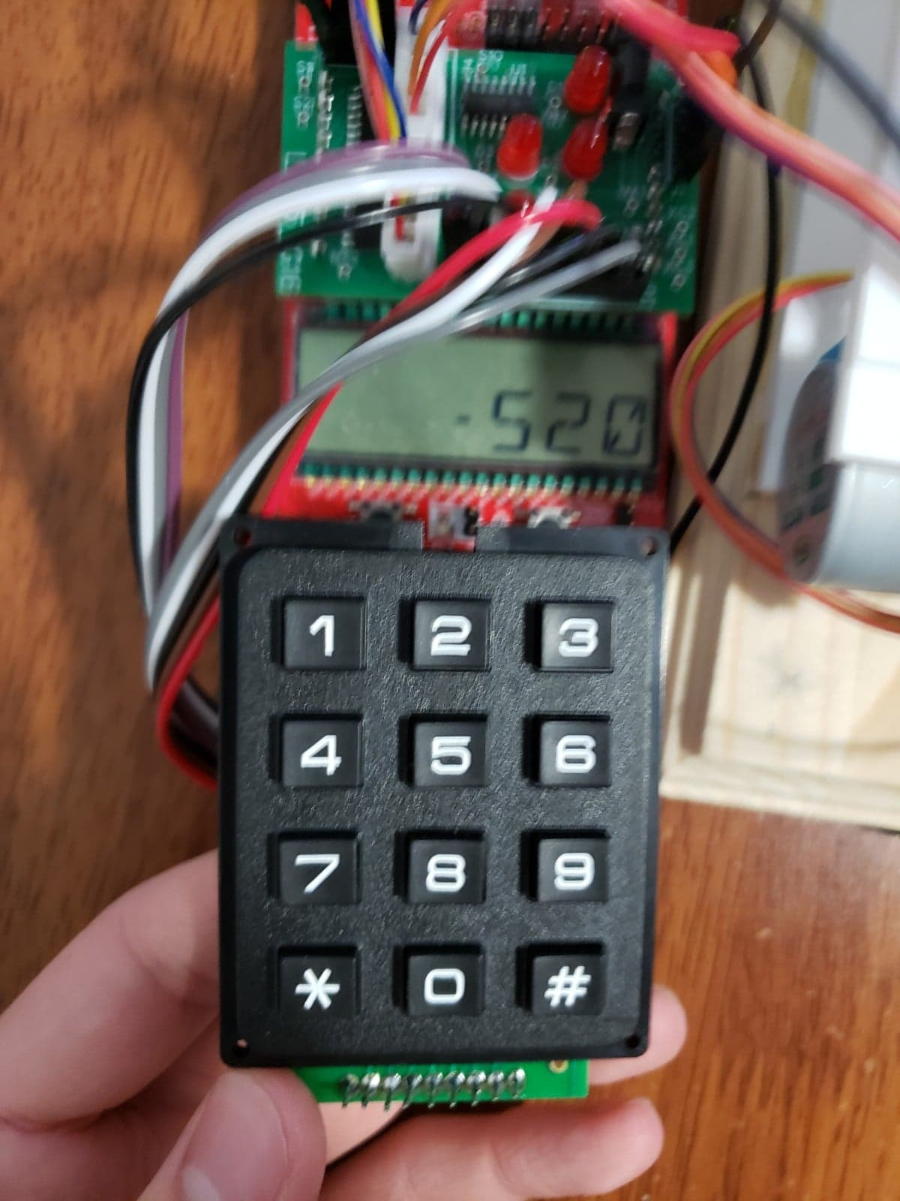

Figure : Negative coordinate input on keypad

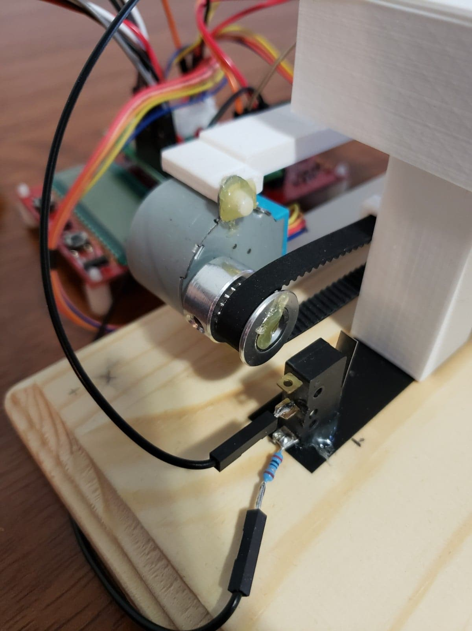

Figure : Limit switch push button and stepper motor setup

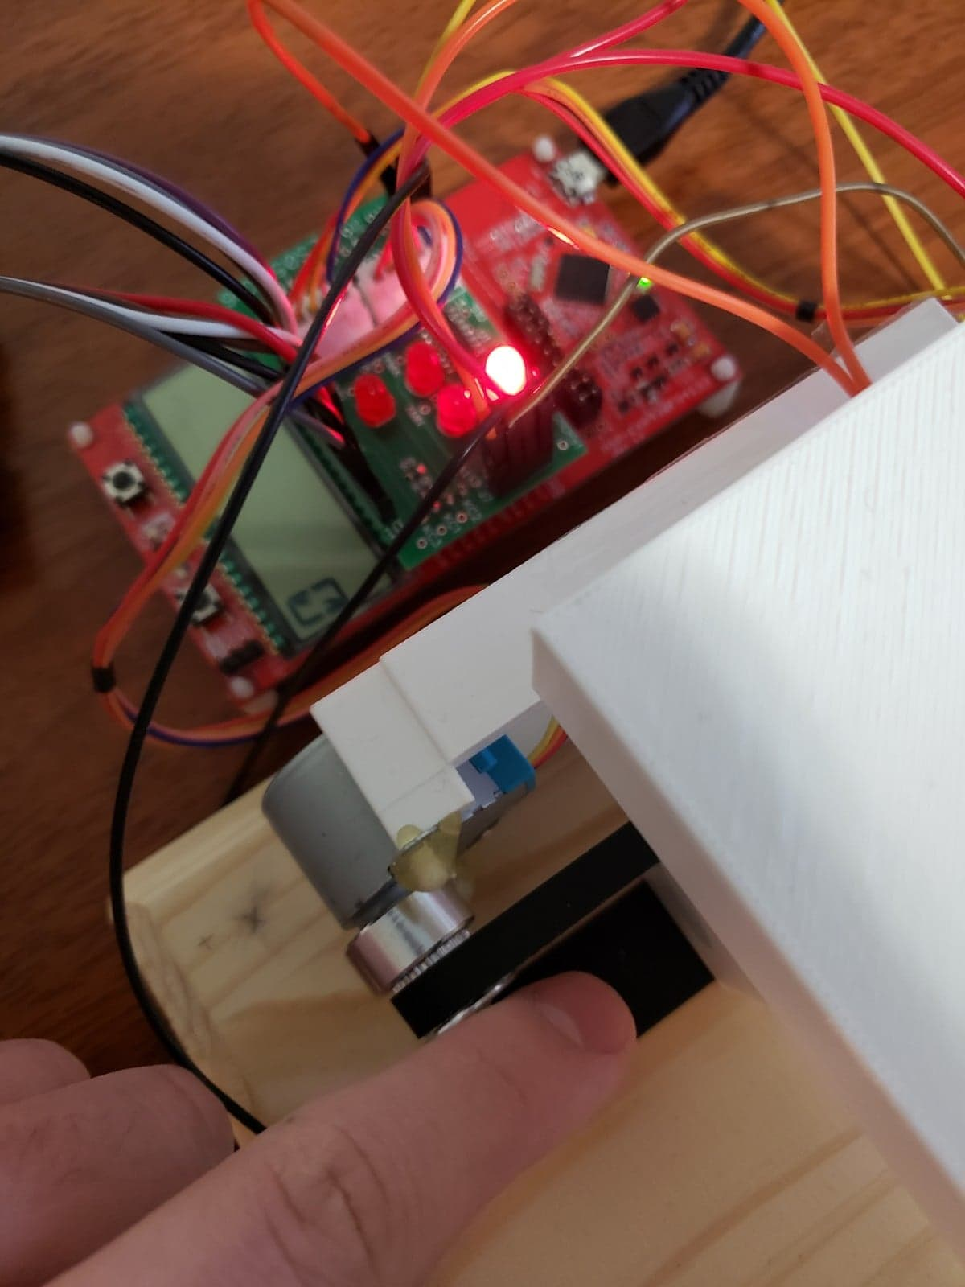

Figure : X-max limit switch activation indicator

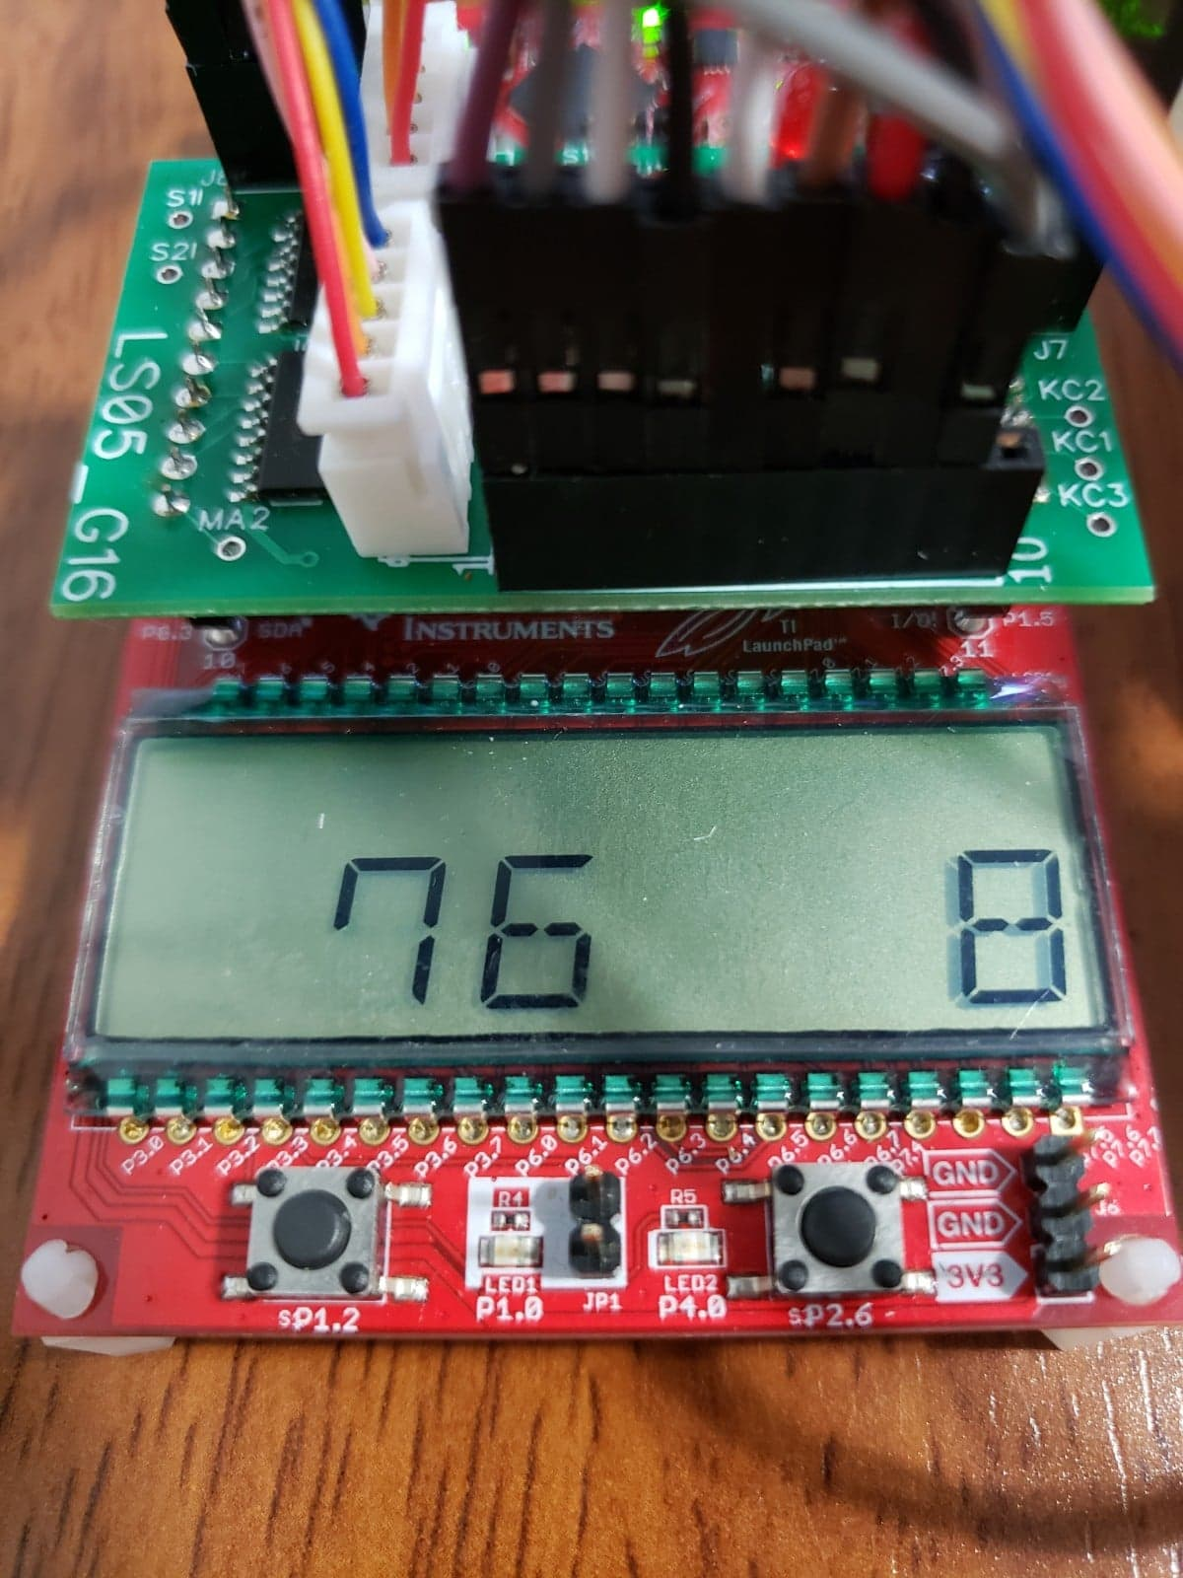

Figure : Stepper motor progress percentage display

## Preliminary Production Design Changes

* Include stronger stepper motors. This would allow us to move the platform faster and move larger payloads.
* Lighter limit switches, to ensure more consistent limit switch activation. The current model will occasionally fail to detect limit switch contact immediately.
* More robust mechanical rig. With stronger motors, this would allow the device to include a larger platform and ensure that the axis do not tip during movement.
* Fix PCB design: Reverse direction of motor header ports, remove LED resistor short circuits, increase LED resistor values to 10k ohms.

# Member 1 Production Details

Simon Cousineau – ID# 20717856

## Further Integration

[Replace heading with one of these topics: Design for Test (DfT), Design for Manufacturability (DfM), Cables and Connectors, Mechanical Enclosure,.]

[Write one paragraph explaining the topic.]

[Write one paragraph explaining how the topic relates to your project.]

[Propose a high-level set of next steps and state any thoughts or issues that should remain top-of-mind for the production engineer who will take your prototype through to a production-ready product. Refer to any codes, standards, or parts that should be noted by the engineer.]

## Energy Efficiency

[Replace heading with one of these topics:, Sustainability, , Cost Analysis at Volume, RoHS / Environmental Safety, Ethical Considerations, Safety Considerations.]

[Write one paragraph explaining the topic.]

[Write one paragraph explaining how the topic relates to your project.]

[Propose a high-level set of next steps and state any thoughts or issues that should remain top-of-mind for the production engineer who will take your prototype through to a production-ready product. Refer to any codes, standards, or parts that should be noted by the engineer.]

# Member 2 Production Details

Ben Finch – ID# 20714219

## Design for Reliability (DfR)

[Replace heading with one of these topics: Design for Test (DfT), Design for Manufacturability (DfM), , Cables and Connectors, Mechanical Enclosure, Further Integration.]

[Write one paragraph explaining the topic.]

[Write one paragraph explaining how the topic relates to your project.]

[Propose a high-level set of next steps and state any thoughts or issues that should remain top-of-mind for the production engineer who will take your prototype through to a production-ready product. Refer to any codes, standards, or parts that should be noted by the engineer.]

## Supply Chain Management

[Replace heading with one of these topics: Energy Efficiency, Sustainability, Supply Chain Management, Cost Analysis at Volume, RoHS / Environmental Safety, Ethical Considerations, Safety Considerations.]

[Write one paragraph explaining the topic.]

[Write one paragraph explaining how the topic relates to your project.]

[Propose a high-level set of next steps and state any thoughts or issues that should remain top-of-mind for the production engineer who will take your prototype through to a production-ready product. Refer to any codes, standards, or parts that should be noted by the engineer.]

# References

|  |  |
| --- | --- |
| [1] | "IEEE Style," 2019. [Online]. Available: https://pitt.libguides.com/citationhelp/ieee. |

# Appendix – Detailed Design

Figure : Feasibility model design

*Notes: The input resistance to the LED is now 10 ohms. Added 10k pulldown resistors to the keypad columns. Keypad rows are now multiplexed.*



Figure : Software flowchart

*Link to code repository:* [*https://github.com/blazingbbq/xyplatform*](https://github.com/blazingbbq/xyplatform)

Table : Design changes from feasibility model

|  |  |  |
| --- | --- | --- |
| # | Change | Reason/Notes |
| 1 | No longer planning to use UART to send commands. Will only be using it in testing context. | Doesn’t offer any additional value over other main components of the project. |
| 2 | We were originally planning to use 2 separate boards, in order to have access to enough GPIO pins. Will only be using one board. | We now realize that we have enough pins on a single board. |
| 3 | No longer planning to use interrupts for button presses (mainly, limit switches). | We use sufficiently small steps, that tight polling the button statuses should be responsive enough for our needs. Moreover, this simplifies our code. |
| 4 | LEDs will not be connected to their own GPIO pin. Instead, they will be wired in-line with the limit switches. | Reduces usage of GPIO pins, allowing us to consolidate the design to a single board. Also, these LEDs should only be on when the button is pressed, therefore there is no need to control them independently from the limit switch push buttons. |
| 5 | Changed the input resistance to the limit LEDs from 300Ω to 200Ω. | Changed this value so that we use less resistors (because at 300Ω, we’d need to use three 100Ω resistors), whereas we only use two 100 Ω resistors now. This resistance still allows us to limit the input current within the nominal range acceptable to drive the LED. |

Table : Important notes from feasibility model

|  |  |
| --- | --- |
| # | Note |
| 1 | As per the suggestion of the TA conducting our Feasibility Model demo, we investigated using hall effect sensors as our limit switches. We found that these were functionally equivalent to the push buttons (but with inverted output), however they also required their output to be amplified to 3.3v, in order to properly read their statuses. This adds unnecessary complexity to our design. Additionally, upon investigating similar products that exist already, we found that they commonly use physical limit switches, similar to our design. |
| 2 | We should always remember to initialize the required pins before attempting to use them. It is best to initialize them with all the other initializers (at the top of the file), since we disable interrupts in this section. |
| 3 | We sample the keypad buttons multiple times, in order to reduce possible noise on these inputs. |
| 4 | We purposefully omit debouncing the limit switch push buttons because, in the event of noise, the steppers will only skip one movement due to this noise and continue normally afterwards. |

Table : Hardware signal test plan

|  |  |  |  |  |  |  |
| --- | --- | --- | --- | --- | --- | --- |
| Signal (TP*) | Test Point name | Property | Required Software Mode | Min | Nominal | Max |
| X Axis MIN | X_MIN_TEST | Voltage | Limit Switch test mode | 0 V | 3.3 V | 5 V |
| X Axis MAX | X_MAX_TEST | Voltage | Limit Switch test mode | 0 V | 3.3 V | 5 V |
| Y Axis MIN | Y_MIN_TEST | Voltage | Limit Switch test mode | 0 V | 3.3 V | 5 V |
| Y Axis MAX | Y_MAX_TEST | Voltage | Limit Switch test mode | 0 V | 3.3 V | 5 V |
| Keypad COL 1 |  | Voltage | Keypad Column 1 test mode |  | 3.3 V |  |
| Keypad COL 2 |  | Voltage | Keypad Column 2 test mode |  | 3.3 V |  |
| Keypad COL 3 |  | Voltage | Keypad Column 3 test mode |  | 3.3 V |  |
| Keypad ROW 1 | ROW_1_TEST | Voltage | Keypad Column [1|2|3] test mode |  | 3.3 V |  |
| Keypad ROW 2 | ROW_2_TEST | Voltage | Keypad Column [1|2|3] test mode |  | 3.3 V |  |
| Keypad ROW 3 | ROW_3_TEST | Voltage | Keypad Column [1|2|3] test mode |  | 3.3 V |  |
| Keypad ROW 4 | ROW_4_TEST | Voltage | Keypad Column [1|2|3] test mode |  | 3.3 V |  |
| Stepper 1 IN 1 | STEPPER_1_OUT_TEST | Voltage | Stepper test mode | 0 V |  | 5V |
| Stepper 1 IN 2 |  | Voltage | Stepper test mode | 0 V |  | 5V |
| Stepper 1 IN 3 |  | Voltage | Stepper test mode | 0 V |  | 5V |
| Stepper 1 IN 4 |  | Voltage | Stepper test mode | 0 V |  | 5V |
| Stepper 2 IN 1 | STEPPER_2_OUT_TEST | Voltage | Stepper test mode | 0 V |  | 5V |
| Stepper 2 IN 2 |  | Voltage | Stepper test mode | 0 V |  | 5V |
| Stepper 2 IN 3 |  | Voltage | Stepper test mode | 0 V |  | 5V |
| Stepper 2 IN 4 |  | Voltage | Stepper test mode | 0 V |  | 5V |

Table : Hardware signal connectivity

|  |  |  |  |
| --- | --- | --- | --- |
| Signal | MSP430FR4133 Pin | LaunchPad J1/J2 Pin | Prototype Connection |
| Stepper 1 IN 1 | P8.1 | J1 pin 2 | IC1 1B |
| Stepper 1 IN 2 | P1.1 | J1 pin 3 | IC1 2B |
| Stepper 1 IN 3 | P1.0 | J1 pin 4 | IC1 3B |
| Stepper 1 IN 4 | P2.7 | J1 pin 5 | IC1 4B |
| Stepper 2 IN 1 | P8.0 | J1 pin 6 | IC2 1B |
| Stepper 2 IN 2 | P5.1 | J1 pin 7 | IC2 2B |
| Stepper 2 IN 3 | P2.5 | J1 pin 8 | IC2 3B |
| Stepper 2 IN 4 | P8.2 | J1 pin 9 | IC2 4B |
| Keypad COL 2 | P8.3 | J1 pin 10 | J4 pin 1 |
|  |  |  |  |
| Keypad ROW 2 | P1.5 | J2 pin 1 | J5 pin 2 |
| Keypad ROW 3 | P1.4 | J2 pin 2 | J5 pin 1 |
| Keypad COL 3 | P1.3 | J2 pin 3 | J4 pin 5 |
| Keypad ROW 4 | P5.3 | J2 pin 4 | J4 pin 4 |
| Y Axis MIN | P5.2 | J2 pin 5 | J1 (3.3 V) |
| Y Axis MAX | P5.0 | J2 pin 7 | J1 (3.3 V) |
| X Axis MIN | P1.6 | J2 pin 8 | J1 (3.3 V) |
| X Axis MAX | P1.7 | J2 pin 9 | J1 (3.3 V) |
|  |  |  |  |
| Keypad COL 1 | P2.6 | J3 pin 1 | J4 pin 3 |
| Keypad ROW 1 | P4.0 | J3 pin 2 | J4 pin 2 |

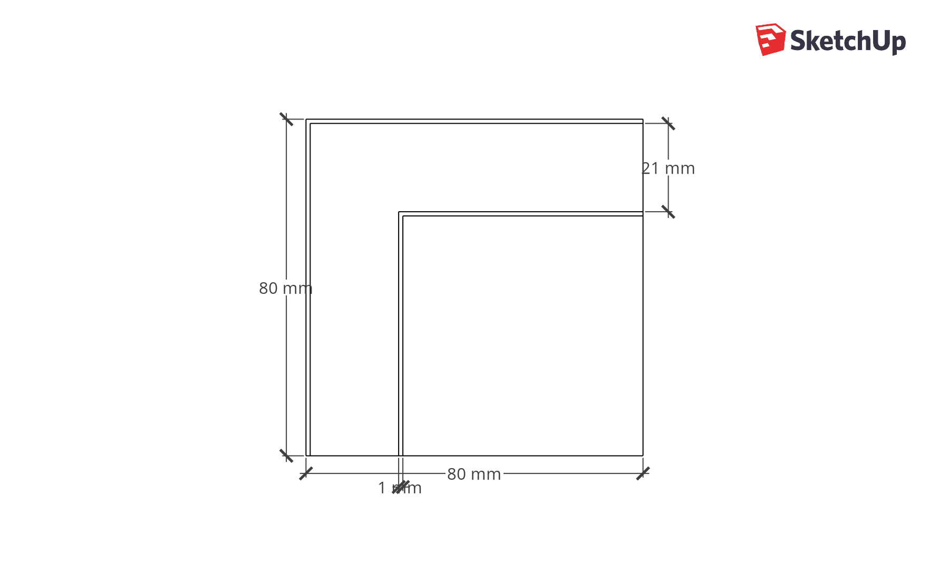

Figure : Mechanical drawing of prototype platform

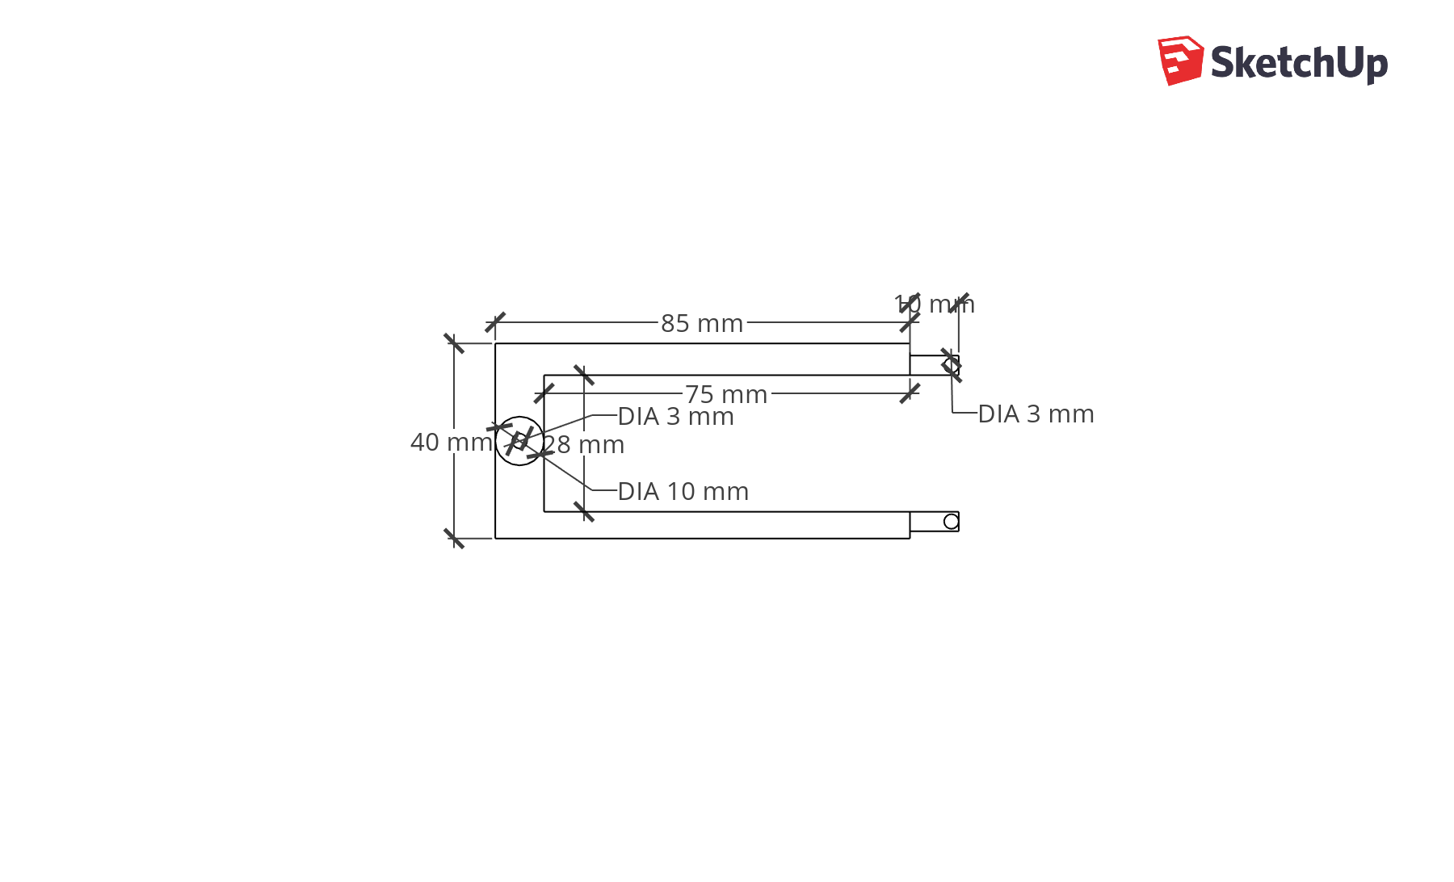

Figure : Mechanical drawing of axis mount

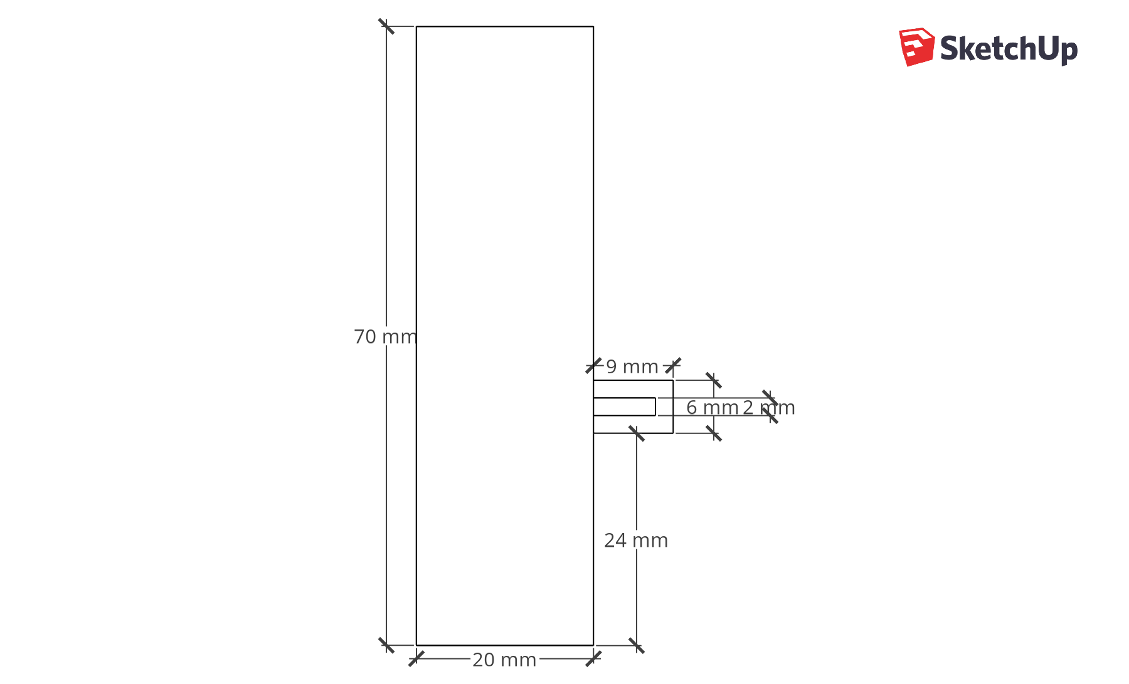

Figure : Mechanical drawing of axis beam