I apologies for using an unsupportive format, This is an explanation of my code with screenshots.
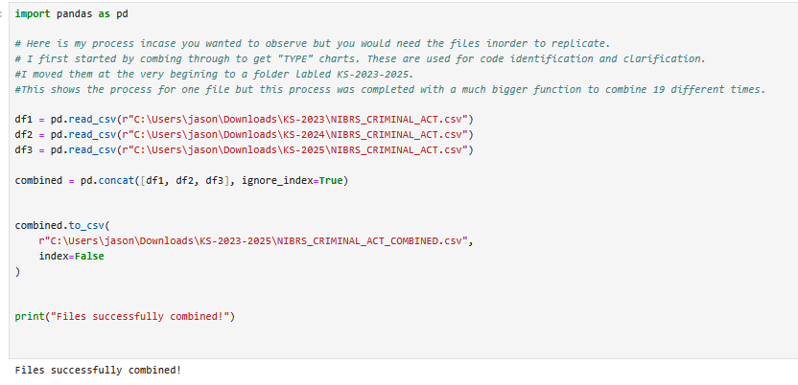

Combine 2023, 2024, and 2025. This was preformed multiple times to complete on all required files
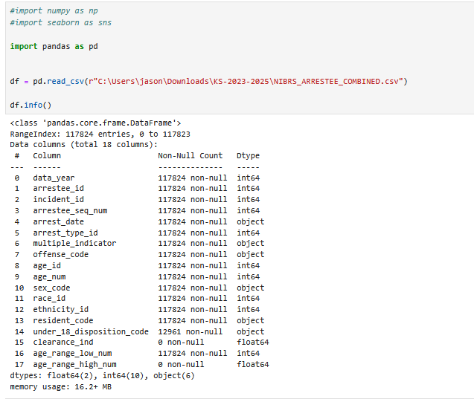
Obtain column titles, used to merge related columns

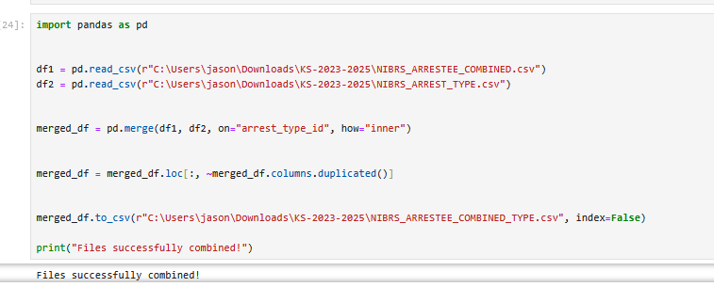
Merging files, done to tie data together. This will allow me to pull in a particular way.
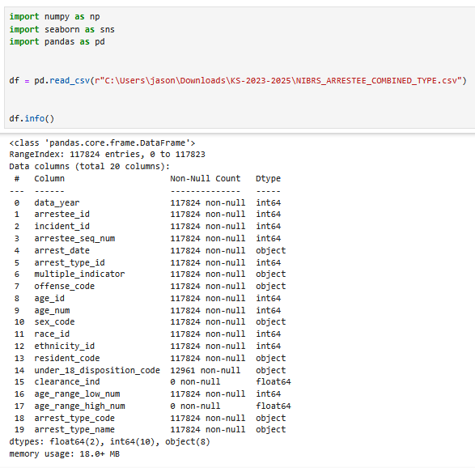
Successful merge, there are the new columns. Performed multiple times.

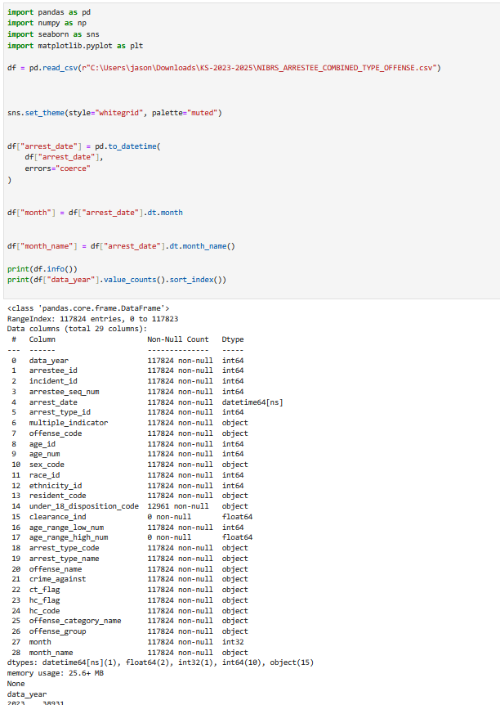
Using the arrest date, created new columns to break arrests by month.

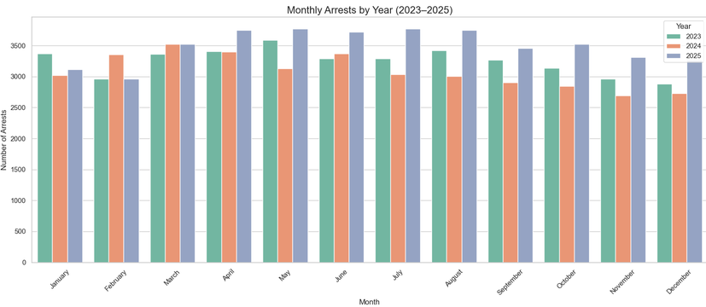
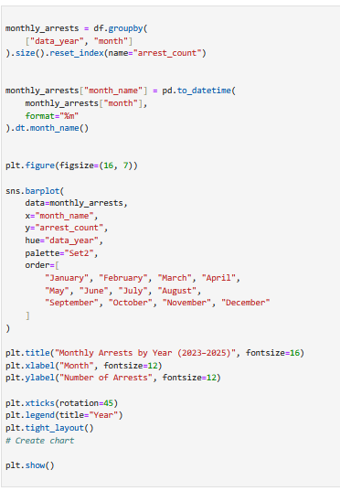
Created bar chart, to represent arrests by month and year.
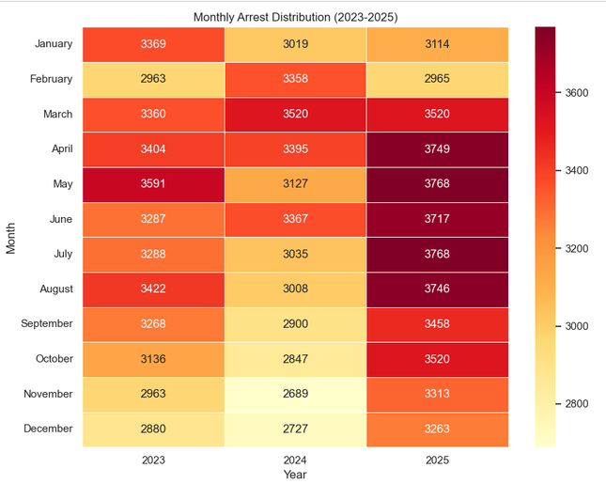
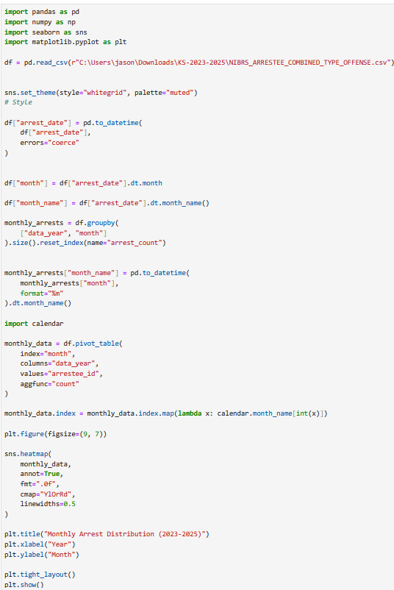

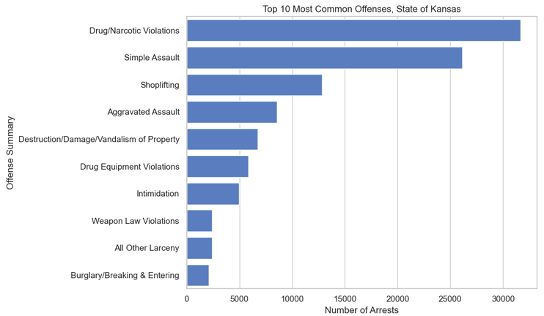
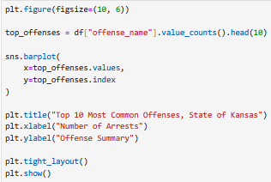

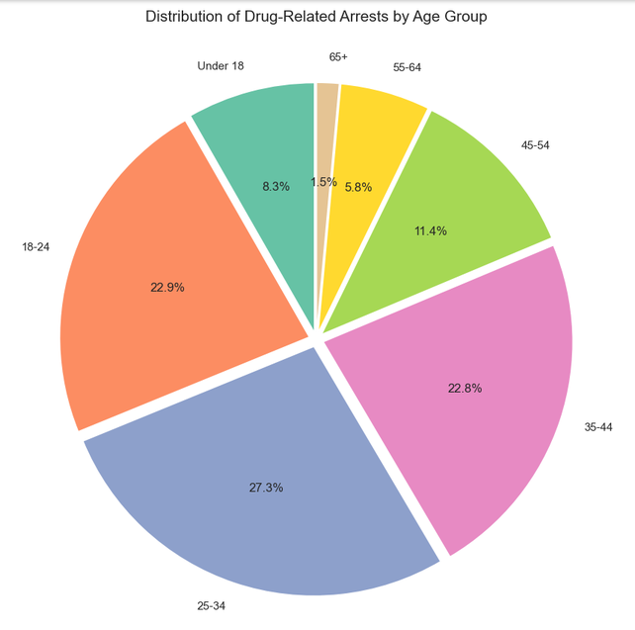
A bar chart of 10 most common arrests in Kansas.
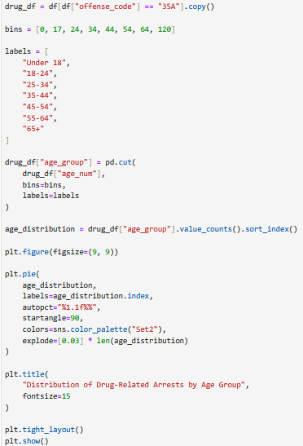
Broke down the number 1 result by age.

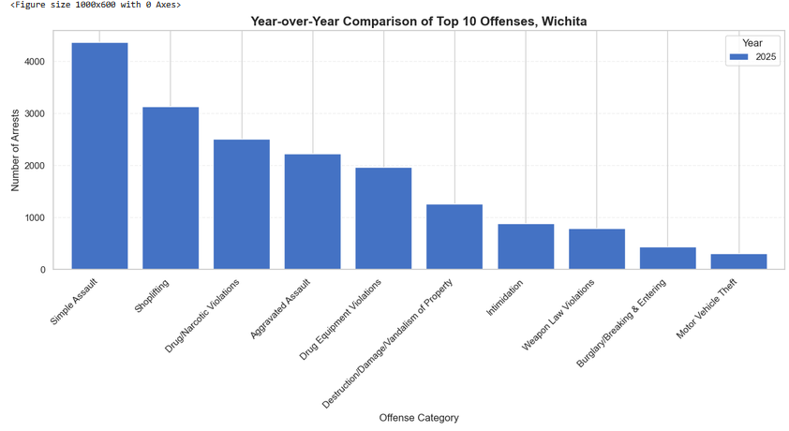
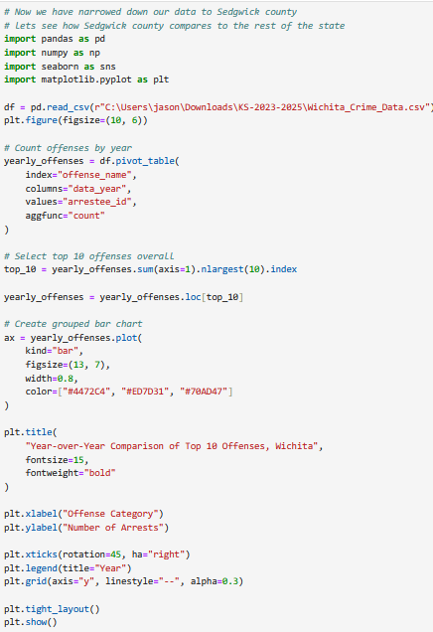
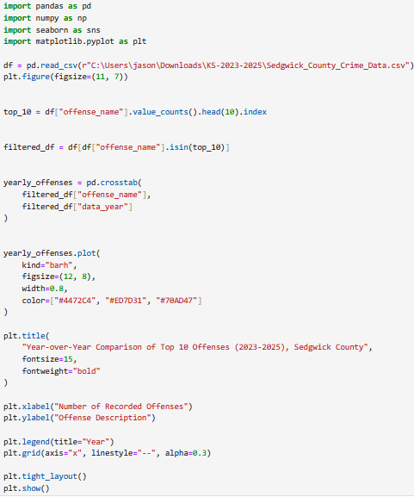
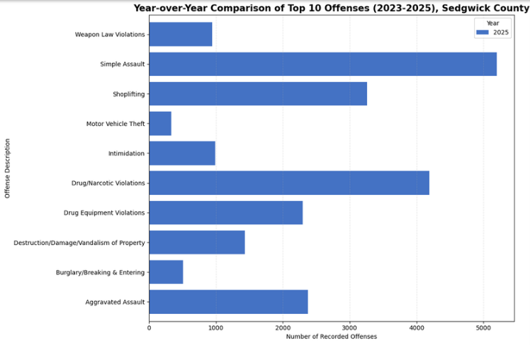
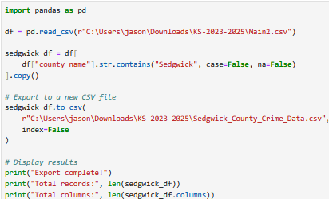
Pulled out the data from the state of KS into 2 different sub-file. Sedgwick county and Wichita. Then compared the top 10 from these sub-groups.

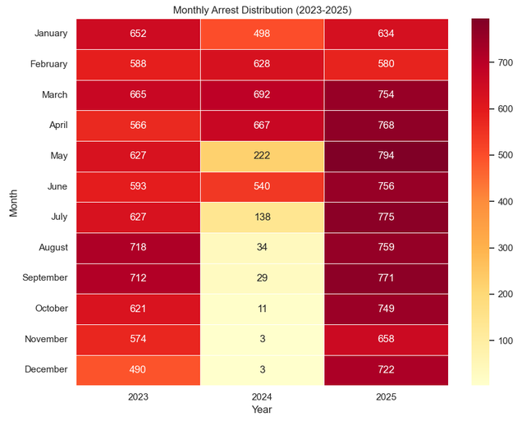
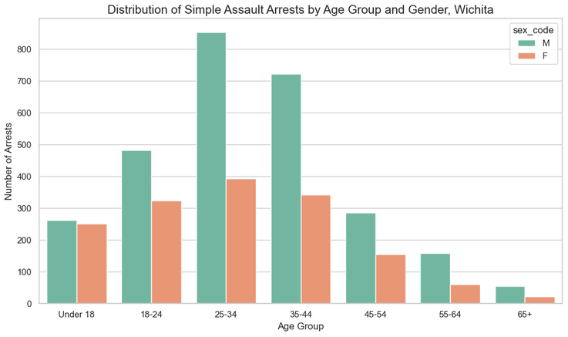
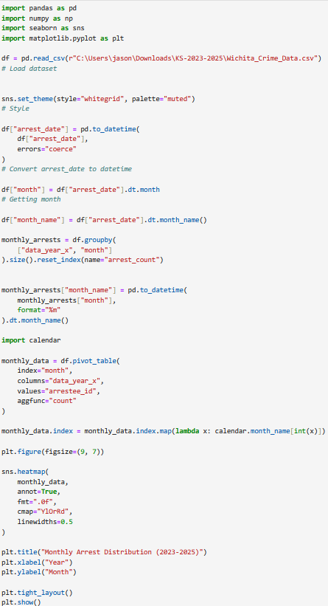
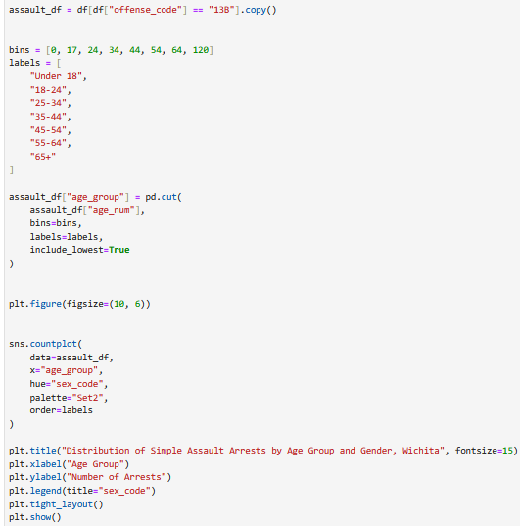
Created bar chart for new top arrest for Wichita by age and sex
Created heat chart for Wichita

So for this next part I would try and imitate ArcGIC. I downloaded Folium, obtained percentages for crimes in the top 10 cities, added city coordinates, Got an API Key from Carto, created an outline of Kansas, Added leader lines in order to create an image to present.
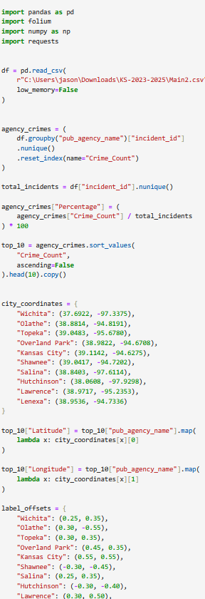

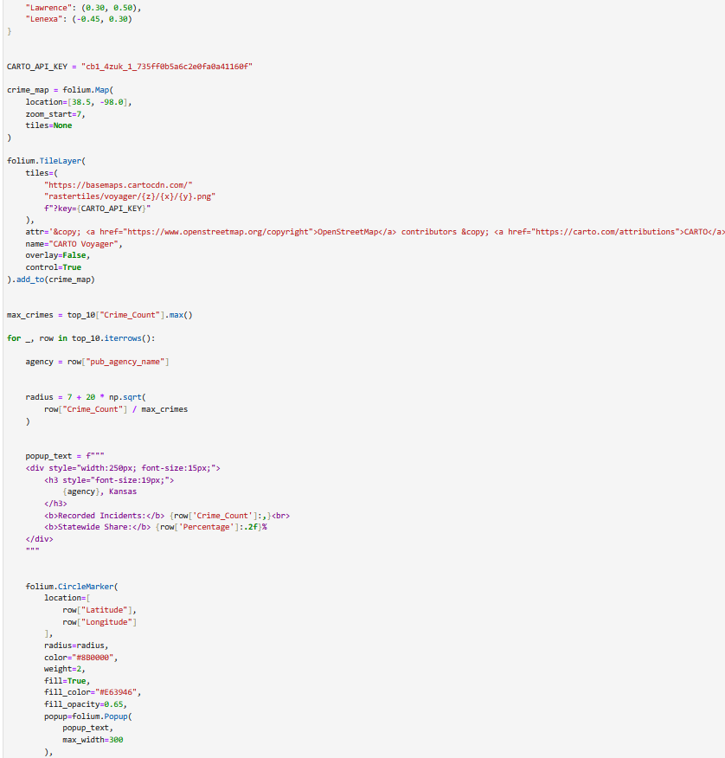

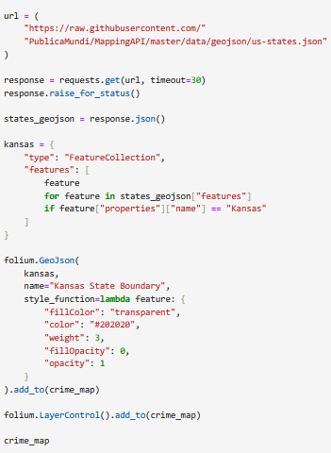
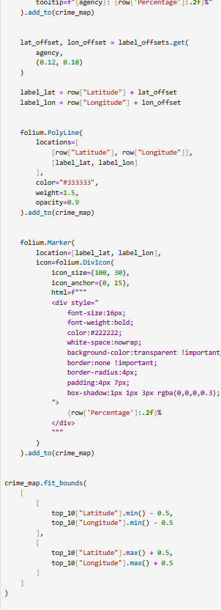

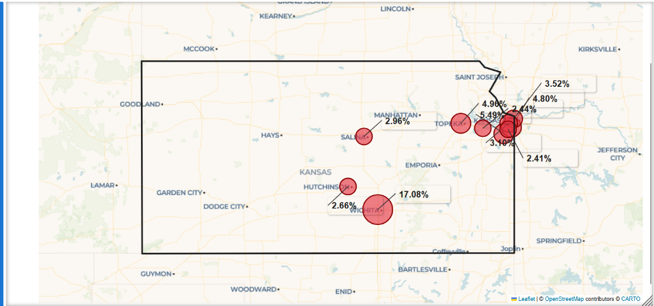

Thank you for your time.

