**Exercise 1: Create and Configure a Virtual Machine**

**Objective:** Create and configure Ubuntu and Windows Virtual Machines on Azure

Portal.

**1. Create an Ubuntu VM:**

o Log in to the Azure Portal.

o Navigate to Virtual Machines > Create.

o Choose Ubuntu Server 20.04 LTS.

o **Configure:**

▪ **Size:** Standard_B1s (or similar)

▪ **Authentication Type:** SSH (generate a key pair if not available).

▪ **Inbound Port:** Allow SSH (port 22).

o Deploy and connect using SSH.

**2. Create a Windows VM:**

o Follow similar steps, selecting Windows Server 2022.

o **Configure:**

▪ **Size:** Standard_B1s (or similar)

▪ **Authentication Type:** Username and Password.

▪ **Inbound Port:** Allow RDP (port 3389).

o Deploy and connect using RDP.

**3. Task:**

o Install Apache or IIS on the respective VMs.

o Verify by accessing the default web page from your local browser.

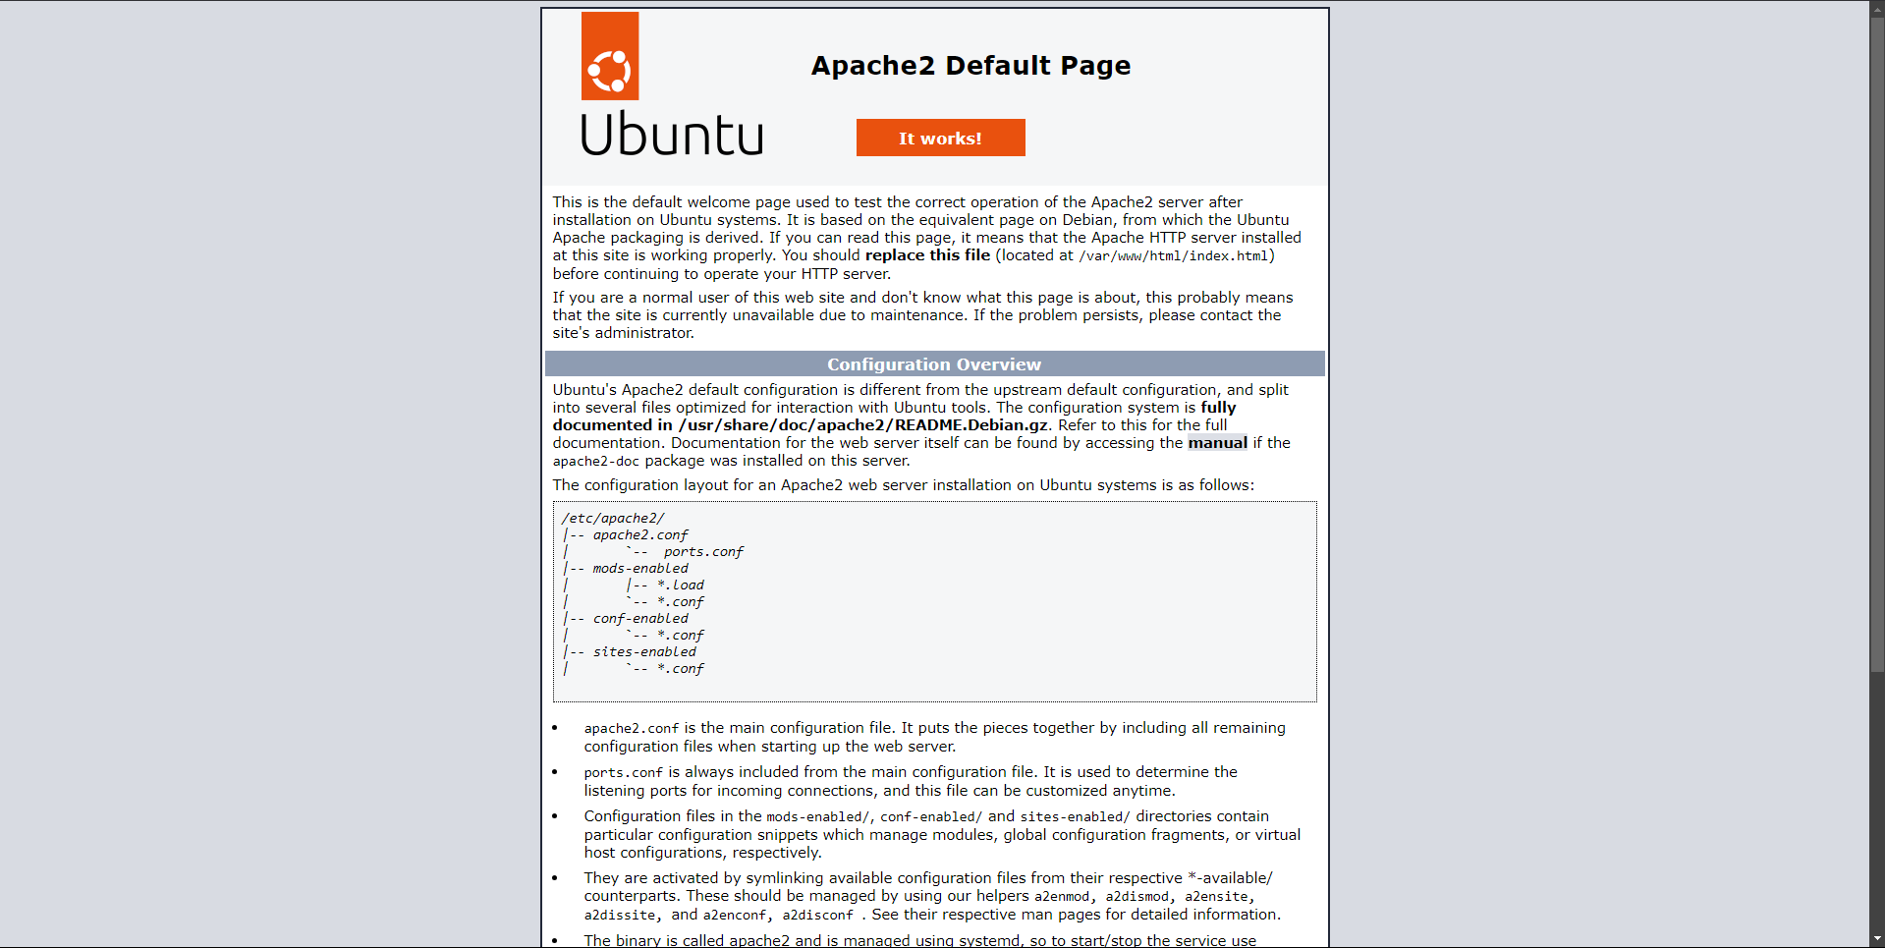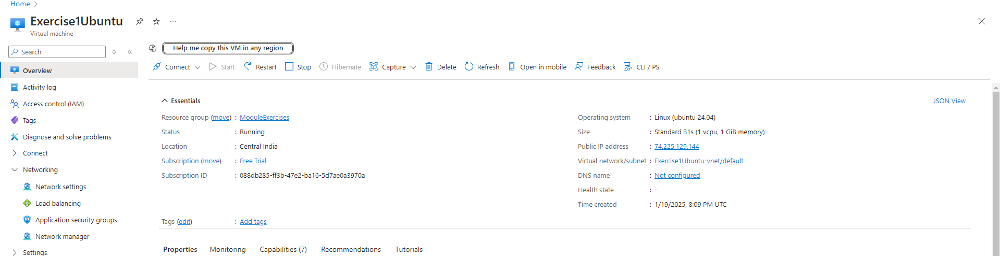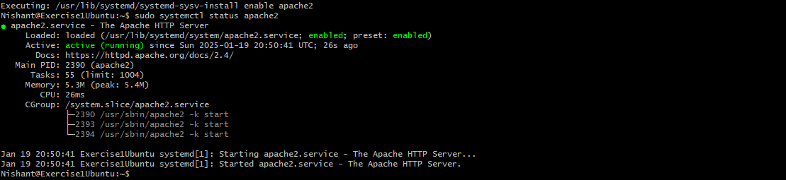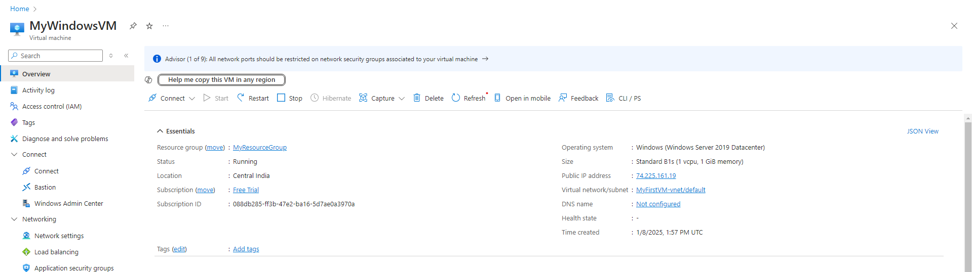

**Exercise 2: Deploy a Static Web Application**

**Objective:** Host a static website using Azure App Service.

1. Navigate to App Services > Create.

**2. Choose:**o **Runtime Stack:** Python 3.10 (or latest).

o **Operating System:** Linux.

o **Region:** Closest to your location.

3. Deploy the application.

4. Upload a simple static website (e.g., index.html and CSS files) using FTP or the

Kudu console.

**5. Task:**

o Verify the deployment by accessing the site via its public URL.

o **Modify the HTML to include a message like:** "Welcome to Azure Static

Web Apps!"

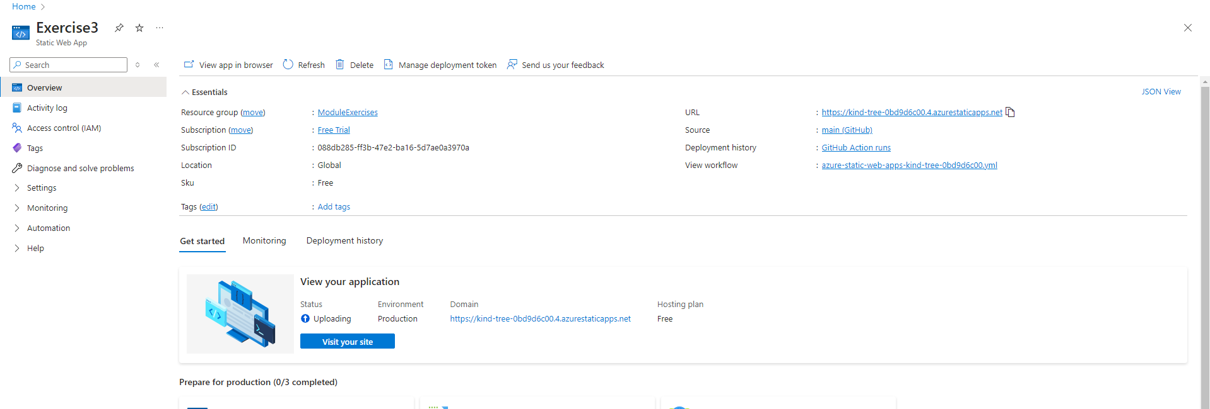

**Exercise 3: Deploy a Flask Application (Dynamic Web App)**

**Objective:** Deploy a Python Flask application using Azure App Service.

**1. Create a Flask app:**

from flask import Flask

app = Flask(__name__)

@app.route('/')

def home():

return "Hello, Azure Flask App!"

if __name__ == '__main__':

app.run(debug=True)

2. Push the code to a GitHub repository.

3. In the Azure Portal, navigate to App Services > Create.

**4. Configure:**

o **Runtime Stack:** Python 3.10 (or latest).

o **Deployment Source:** Connect your GitHub repository.

5. Deploy the Flask app and verify it by accessing the public URL.

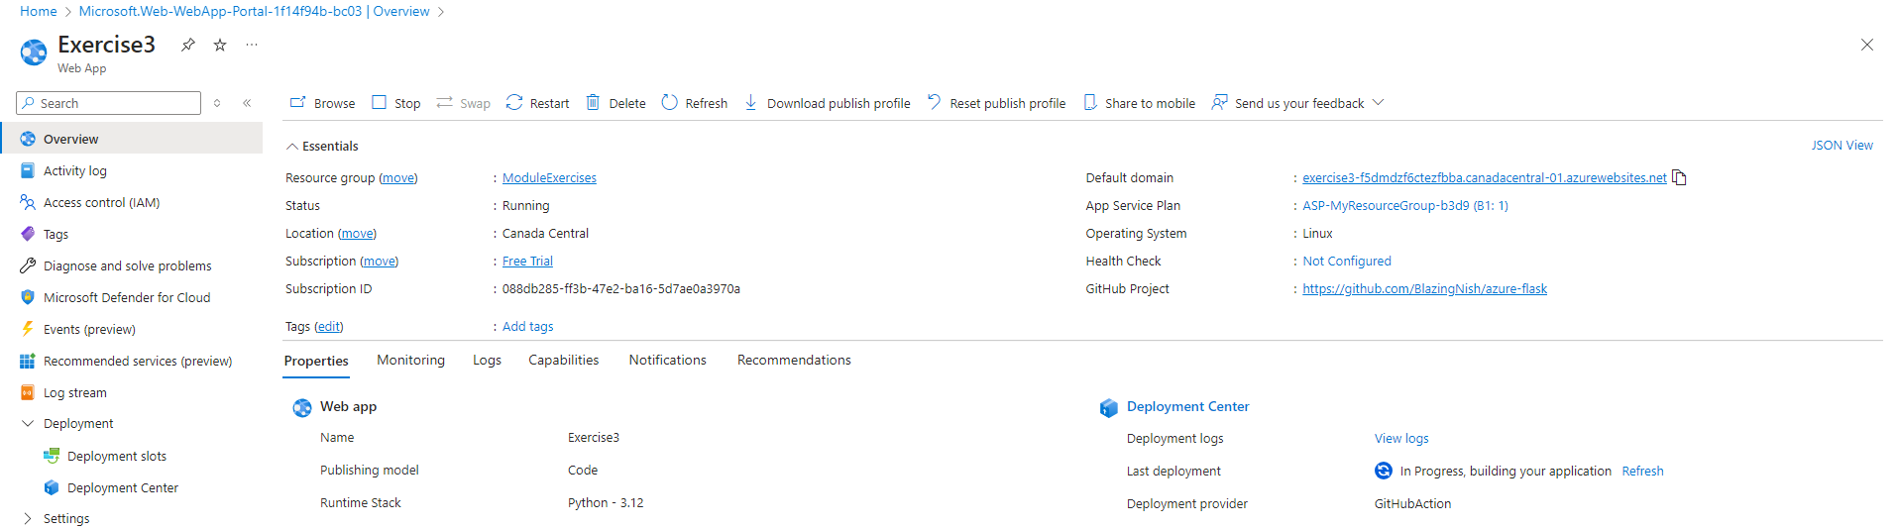

**Exercise 4: Set Up and Use an Azure SQL Database**

**Objective:** Create an Azure SQL Database and connect to it from your local machine.

1. Navigate to SQL Databases > Create.

**2. Configure:**

o Database Name: StudentDB.

o **Server:** Create a new server with username and password.

o Compute + Storage: Use the free tier.

3. Deploy the database.

4. Connect using Azure Data Studio or SQL Server Management Studio (SSMS).

**5. Task:**

o Create a table Students with columns ID, Name, and Age.

o Insert sample data and query it

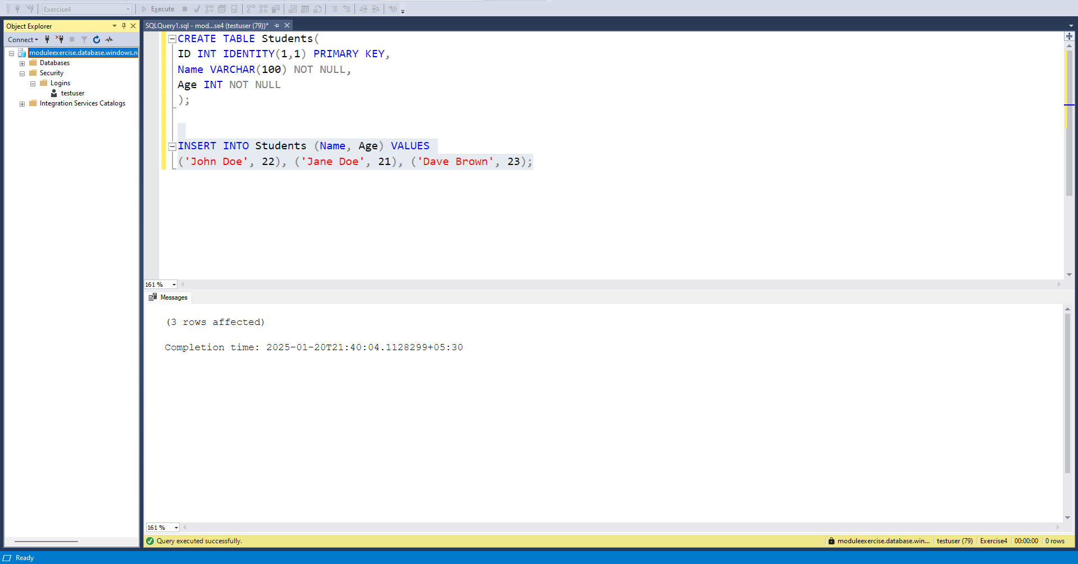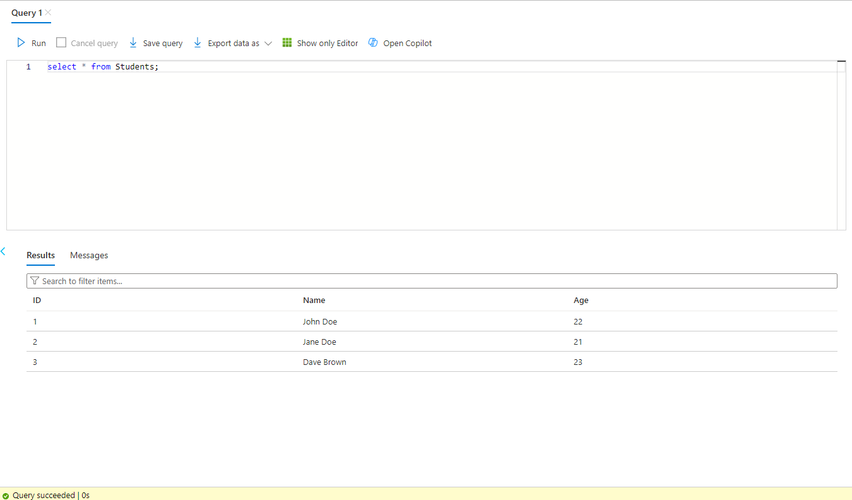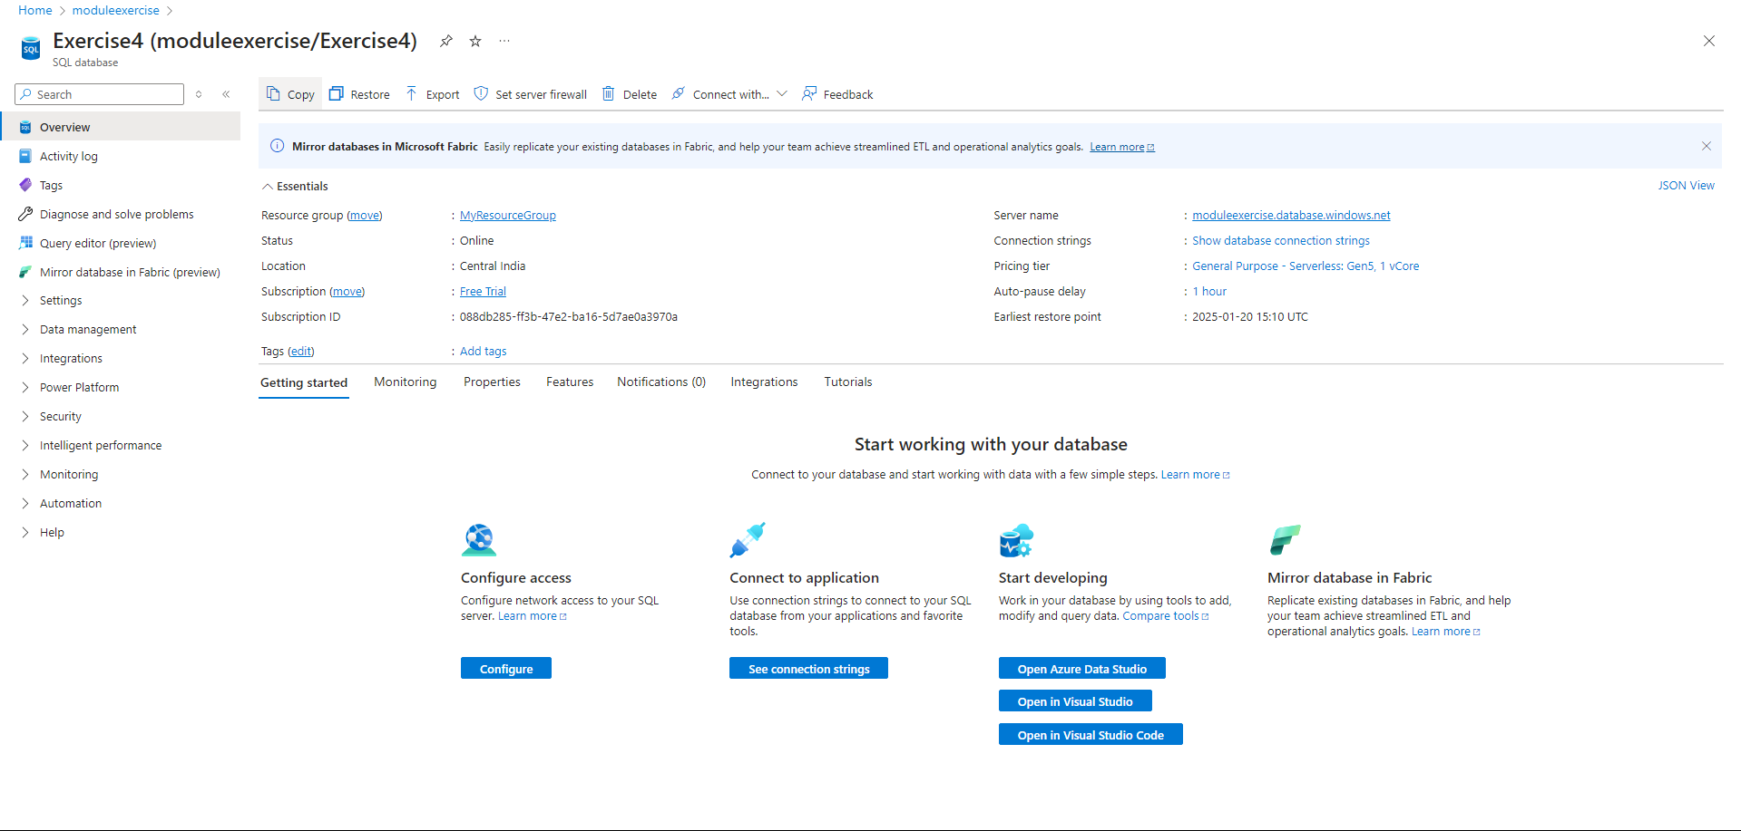

**Exercise 5: Integrate Flask App with Azure SQL Database**

**Objective: Connect a Flask app to Azure SQL Database and perform CRUD**

**operations.**

1. Use the Flask app from Exercise 3.

**2. Install required libraries:**

pip install flask pyodbc

**3. Modify the app to connect to the SQL Database:**

import pyodbc

conn = pyodbc.connect(

'DRIVER={ODBC Driver 17 for SQL Server};'

'SERVER=<your_server>.database.windows.net;'

'DATABASE=StudentDB;'

'UID=<your_username>;'

'PWD=<your_password>')

cursor = conn.cursor()

4. Add a route to fetch and display data from the Students table.

5. Deploy the updated app to Azure App Service.

**6. Task:**

o Verify CRUD functionality by interacting with the app via its public URL.

