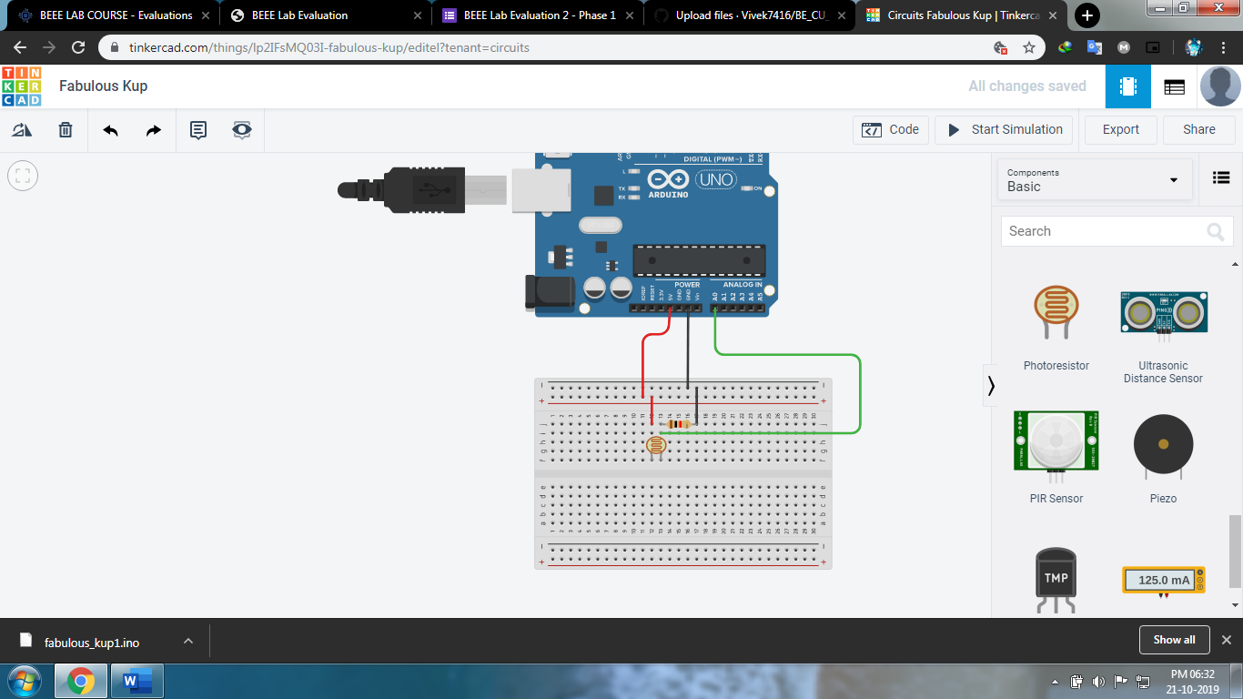Exp 1:

Theory:

Concept Used: In the given problem we have use the concept the working principle of an LDR is photo conductivity, that is nothing but an optical phenomenon.When the light is absorbed by the material then the conductivity of the material reduces. When the light falls on the LDR, then the electrons in the valence band of the material are eager to the conduction band. But, the photons in the incident light must have energy superior than the band gap of the material to make the electrons jump from one band to another band (valance to conduction).

Learning and Observation:

We learn how to use LDR in real life and are able to practice its application in real life.