**Dhash Programming Language (D#) .d#**

1. Installation guide
2. windows
3. open explorer
4. create C:\D#\
5. copy there all contents of dist
6. right click on this pc

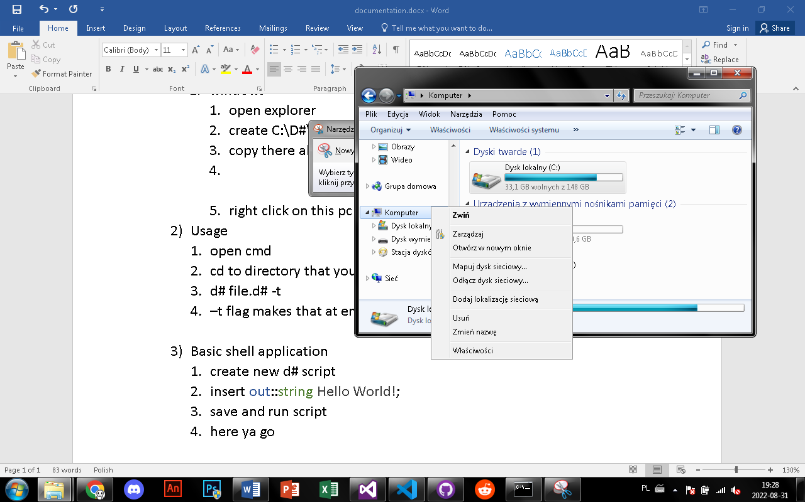

1. click on properties
2. click advanced system properties
3. click on enviremental variables
4. edit path
5. at end of path add ;C:\D#
6. click OK
7. click OK
8. click apply, OK
9. congrats you have installed D#
10. Usage
11. open cmd
12. cd to directory that you have script in
13. d# file.d# -t
14. –t flag makes that at end of script there isnt loop
15. Basic shell application
16. create new d# script
17. insert out::string Hello World!;
18. save and run script
19. here ya go