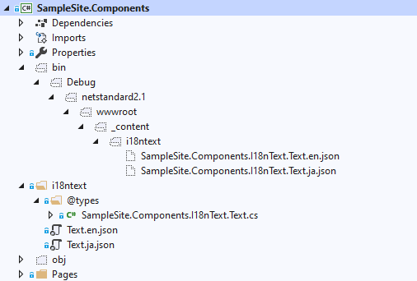



**Localized Text Source**

**Typed Text Table class**

**Localized Text Resource JSON**