Medical Insurance Costs
Mostafa Ibrahim
SUNY New Paltz
New Paltz, NY
ibrahimm3@newpaltz.edu

1.0 Dataset
In the dataset chosen for this project we are looking at the costs of Medical Insurance in the United States of America and tracking certain data points that affect the costs. The important data points for this dataset are age, sex, BMI, children, smoker, and region. For each of the respective variables we can attribute importance to these reasons: health costs will rise with age, sex is a demographic factor that’s not always going to be predictive but is always included in health care, obesity strongly correlates with health costs, dependents can influence insurance costs, smoking is one of the strongest predictors of insurance costs, and geographically prices will differ depending on the region a person is in.
2.0 Task
The task at hand is predicting Medical Insurance Charges. The target variable will be charges which is continuous and numeric. In the end the charges can be bucketed into categories such as low, medium, or high to be able to give the “charges” variable multiclass classification. As data is provided from the dataset, I would also like to use the model to analyze which factors influence the costs the most and in what order.
3.0 Problem
The problem is a real-world issue trying to be addressed. From the insurance dataset, the problem I would like to solve is “how can a person’s future medical costs be estimated based on demographics, lifestyle, and health indicators?”.
4.0 Motivation/Introduction
My main motivation for using this dataset is due to having many friends from Canada talk to me about how much people in America must worry about paying for Health Insurance. In Canada the health insurance/health care is free for everybody. However, that is not the case in the United States of America. As someone who has a family that has many underlying health problems, this directly affects me and my family. This dataset isn’t encapsulating enough medical issues as there are much too many overall however, it may be just enough to get a standing ground that can be adjusted for more variables to be added in the future.
5.0 Literature Review/Related Works
Over the course of machine learning’s growth, it has been used to predict too many things to count. On Kaggle there have been several people who have also used this dataset to make their own regression models based on it. Namely a user named MariaPushkareva [4] demonstrated a very effective way to use the dataset for simple linear regression and then built more on it with adding more learning models in a similar fashion to how my work is done. MariaPushkarev’s work highlighted the importance of preprocessing techniques and used her feature importance to further eliminate certain factors from the dataset that didn’t affect the overall outcome in much of a way. This allowed her to narrow down the main leading decider for insurance companies declaring how much someone would pay for medical insurance. This project somewhat used her work to have a starting guideline of how to begin then built on it from there.
6.0 Methods/Results
Currently there are 4 total methods defined in this project: Extreme Gradient Boosting, Simple Linear Regression, Decision Tree Regression, Random Forest Regression with usage of K-Fold Cross Validation and Feature Importance Analysis.

6.1) Extreme Gradient Boosting
The first method to be found in the code is Extreme Gradient Boosting (XGB) [9]. XGB is a hyper efficient regression model that implements the gradient boosting framework. XGB combines boosting and regularization methods to minimize the bias and the variance at the same time to keep its speed and efficiency high. For the XGB model I used, it produced the best results in terms of having the lowest error. Thanks to the way the model incrementally builds several trees at once in attempts to correct the errors of the previous trees, the scalability made XGB very suitable for the tabular structure of the dataset.
6.1.1) XGB Results

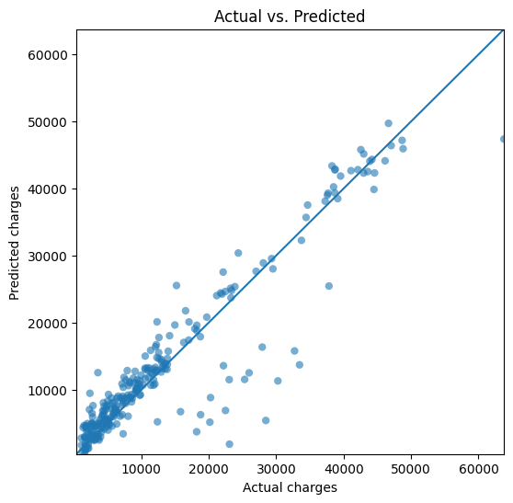

Line of best fit as depicted by matplotlib of the XGB model.
6.1.2) XGB Residual Results vs Predicted Results
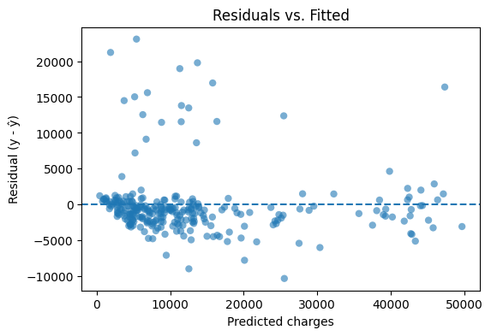

Residual Results (Residual=Actual – Predicted) being compared to the predictions to show our cost/loss in for each prediction.

6.2) Simple Linear Regression
The Simple Linear Regression model from Scikit-Learn’s many models served as a baseline for comparison with the other models. Two versions are present in the code with the difference between them being that one method uses K-Fold Cross Validation, and one doesn’t. For simplicity’s sake, the version without the Cross Validation was used as a baseline.
6.3) Decision Tree Regression
Decision Tree Regression introduced nonlinearity into the analysis of the problem. This allowed for the model to each feature into smaller and more concise regions. This approach was chosen to help account for the complexity of the dataset which included both numeric and string type categories. The Decision Tree Regressor model from Scikit-Learn was used for this method and was trained with a 10-fold cross validation tactic to try to minimize the decision tree overfitting the data and expand on the amount of data the model had to work with in terms of training. This method was good in performance but lacked in variance when tested with unseen data according to the Root Square Mean Error calculated on each fold. This indicated that I needed to use a stronger ensemble model [1].
6.4) Random Forest Regression
The next strongest ensemble model used was the Random Forest Regression model. Once again, the model was trained on a 10-fold cross validation method that reduced the overfitting and improved generalization much better than it did with the Decision Tree Regressor. Using Scikit-Learn’s Random Forest Regressor, the model results demonstrated strong prediction performance along with the very consistent Root Square Mean Error scores across each fold. This model also was used to analyze the importance of each feature as it had the best consistency and interpretability.
6.4.1) Feature Importance
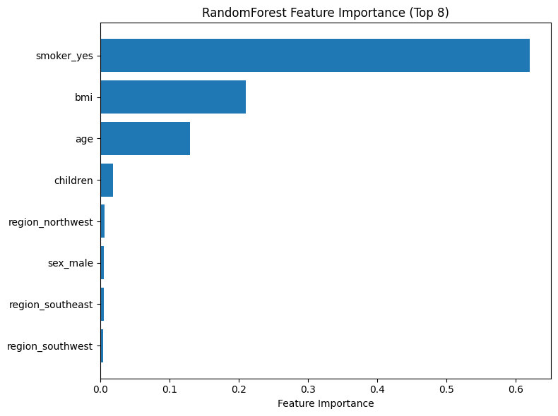
Smoking status, BMI, and age were the topmost influential predictors when it came to insurance costs in this dataset while which region and the sex of the individual played very little role in influencing the cost of insurance.
6.5) Overall Results in Model Comparisons
Once all models are finished with their processing and give back their MSE and prediction accuracy scores in the output the comparison is as follows: XGB had the best overall performance with the lowest mean squared error and best prediction accuracy, Random Forest Regression came in as a close second place as it offered a strong balance between performance and how easily it was interpreted, Decision Tree Regression came third as it performed well but had that issue of lacking in variance between each fold.

7.0 References
[1] Data School. “Selecting the Best Model in Scikit-Learn Using Cross-Validation.” YouTube, 28 June 2015, www.youtube.com/watch?v=6dbrR-WymjI.
[2] GeeksforGeeks. “Multiple Linear Regression Using Python ML.” GeeksforGeeks, 18 Jan. 2019, www.geeksforgeeks.org/machine-learning/ml-multiple-linear-regression-using-python/.
[3] Kariuki, Mathew. “Simple Linear Regression Model in Python with Scikit-Learn.” Www.youtube.com, 15 Aug. 2025, www.youtube.com/shorts/DkAVYmp466E.
[4] mariapushkareva. “Medical Insurance Cost with Linear Regression.” Kaggle.com, Kaggle, 14 July 2020, www.kaggle.com/code/mariapushkareva/medical-insurance-cost-with-linear-regression/comments.
[5] Matplotlib. “Matplotlib: Python Plotting — Matplotlib 3.3.4 Documentation.” Matplotlib.org, 2024, matplotlib.org/stable/index.html.
[6] NumPy. “NumPy Documentation.” Numpy.org, 2022, numpy.org/doc/.
[7] Pandas. “Pandas Documentation — Pandas 1.0.1 Documentation.” Pandas.pydata.org, 2024, pandas.pydata.org/docs/.
[8] Scikit-learn. “Scikit-Learn: Machine Learning in Python.” Scikit-Learn.org, 2024, scikit-learn.org/stable/.
[9] xgboost developers. “XGBoost Documentation — Xgboost 1.5.1 Documentation.” Xgboost.readthedocs.io, 2022, xgboost.readthedocs.io/en/stable/.

