
IT342-Section
SYSTEMS INTEGRATION AND ARCHITECTURE 1

FUNCTIONAL REQUIREMENTS SPECIFICATION (FRS)

Project Title: Mini App – User Registration & Authentication
Prepared By: Chavez, Bliss B.
Date of Submission: 02/02/2026
Version: 4.0

Table of Contents
1. Introduction 3
1.1. Purpose 3
1.2. Scope 3
1.3. Definitions, Acronyms, and Abbreviations 3
2. Overall Description 3
2.1. System Perspective 3
2.2. User Classes and Characteristics 3
2.3. Operating Environment 3
2.4. Assumptions and Dependencies 3
3. System Features and Functional Requirements 3
3.1. Feature 1: 3
3.2. Feature 2: 3
4. Non-Functional Requirements 3
5. System Models (Diagrams) 4
5.1. ERD 4
5.2. Use Case Diagram 4
5.3. Activity Diagram 4
5.4. Class Diagram 4
5.5. Sequence Diagram 4
6. Appendices 4

Introduction

Purpose
The purpose of this document is to define the functional requirements of the Mini App – User Registration & Authentication system. This document is intended for students, instructors, and developers who need to understand how the system works before implementation.

Scope
The system allows users to create an account, log in, view their profile or dashboard, and log out securely. It also ensures that protected pages cannot be accessed unless the user is authenticated. This project focuses only on basic authentication features and does not include advanced modules such as payment or admin management.

Definitions, Acronyms, and Abbreviations
List and define important terms used in this document.

Overall Description

System Perspective
The system is a web-based application composed of a React frontend, a Spring Boot backend API, and a database. The frontend communicates with the backend to process authentication requests with a fully integrated process, while the backend handles validation, security, and data storage.

User Classes and Characteristics
Identify the different types of users and their characteristics.

Operating Environment
- Client: Web browser (Chrome, Edge, Microsoft)
- Frontend: React
- Backend: Spring Boot
- Database: MySQL / PostgreSQL
- Tools: draw.io / diagrams.net

Assumptions and Dependencies
- Users have internet access
- The backend server is available
- Password encryption and token-based authentication are implemented
- The database is properly configured

System Features and Functional Requirements
Describe each major feature of the system and its functional requirements.

Feature 1:
Description: This feature allows a guest user to create a new account by providing valid personal information.
Functional Requirements:
- The system shall allow users to register using a valid email and password
- The system shall validate user input before saving data
- The system shall prevent duplicate email registrations
- The system shall encrypt the password before storing it in the database

Feature 2:
Description: This feature allows registered users to log in, access protected pages, and log out securely.
Functional Requirements:
- The system shall allow users to log in using email and password
- The system shall authenticate user credentials
- The system shall allow access to the dashboard only when logged in
- The system shall invalidate the session or token upon logout

Non-Functional Requirements
Security: Passwords must be encrypted and protected pages must require authentication
Performance: The system should respond to login and registration requests within a few seconds
Usability: The system should be easy to use and user-friendly
Reliability: The system should handle invalid login attempts properly

System Models (Diagrams)
Insert the necessary diagrams for the system:

ERD
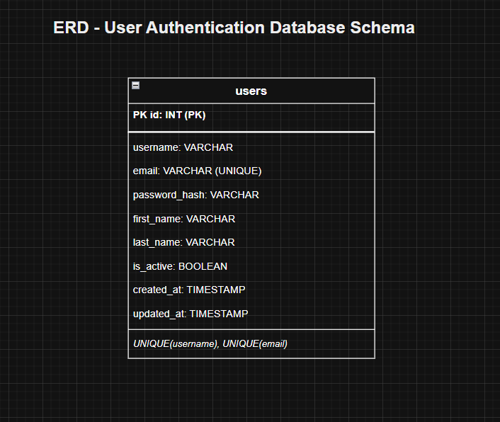

Use Case Diagram
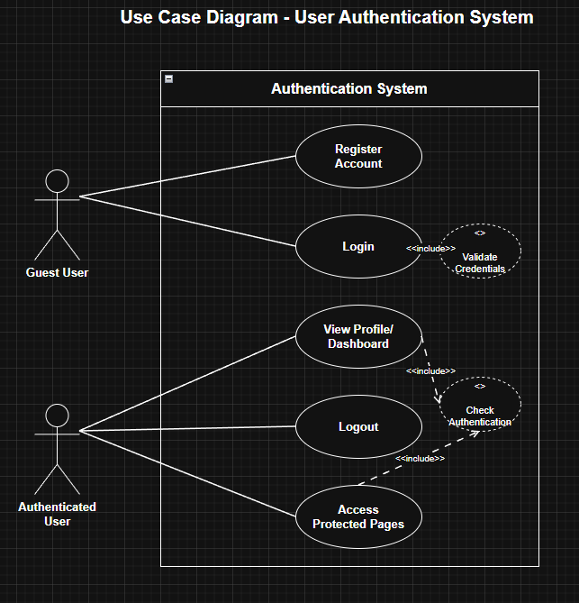

Activity Diagram
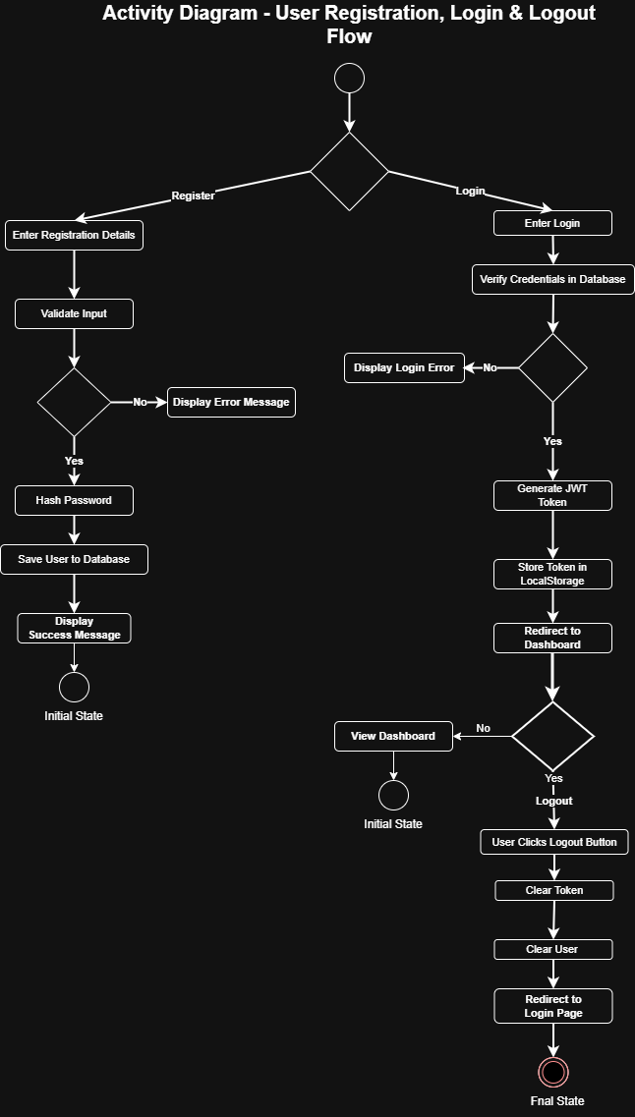

Class Diagram
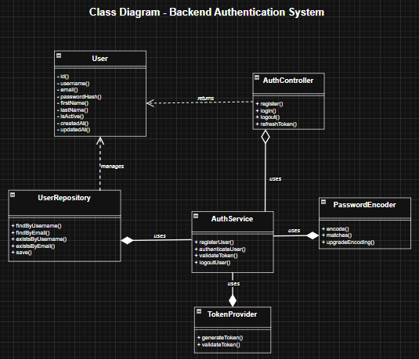

Sequence Diagram
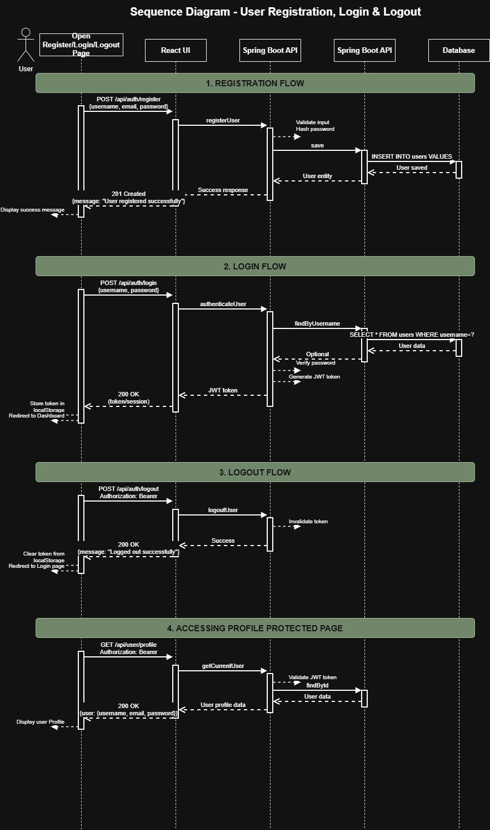

Appendices
Include any additional information, references, or support materials.
- https://www.geeksforgeeks.org/system-design/unified-modeling-language-uml-activity-diagrams/
- https://www.geeksforgeeks.org/dbms/introduction-of-er-model/
- https://www.geeksforgeeks.org/system-design/use-case-diagram/
- https://www.visual-paradigm.com/guide/uml-unified-modeling-language/what-is-activity-diagram/
- https://www.geeksforgeeks.org/system-design/unified-modeling-language-uml-class-diagrams/
- https://www.geeksforgeeks.org/system-design/unified-modeling-language-uml-sequence-diagrams/

Screenshot of the Web UI
7.1 Login
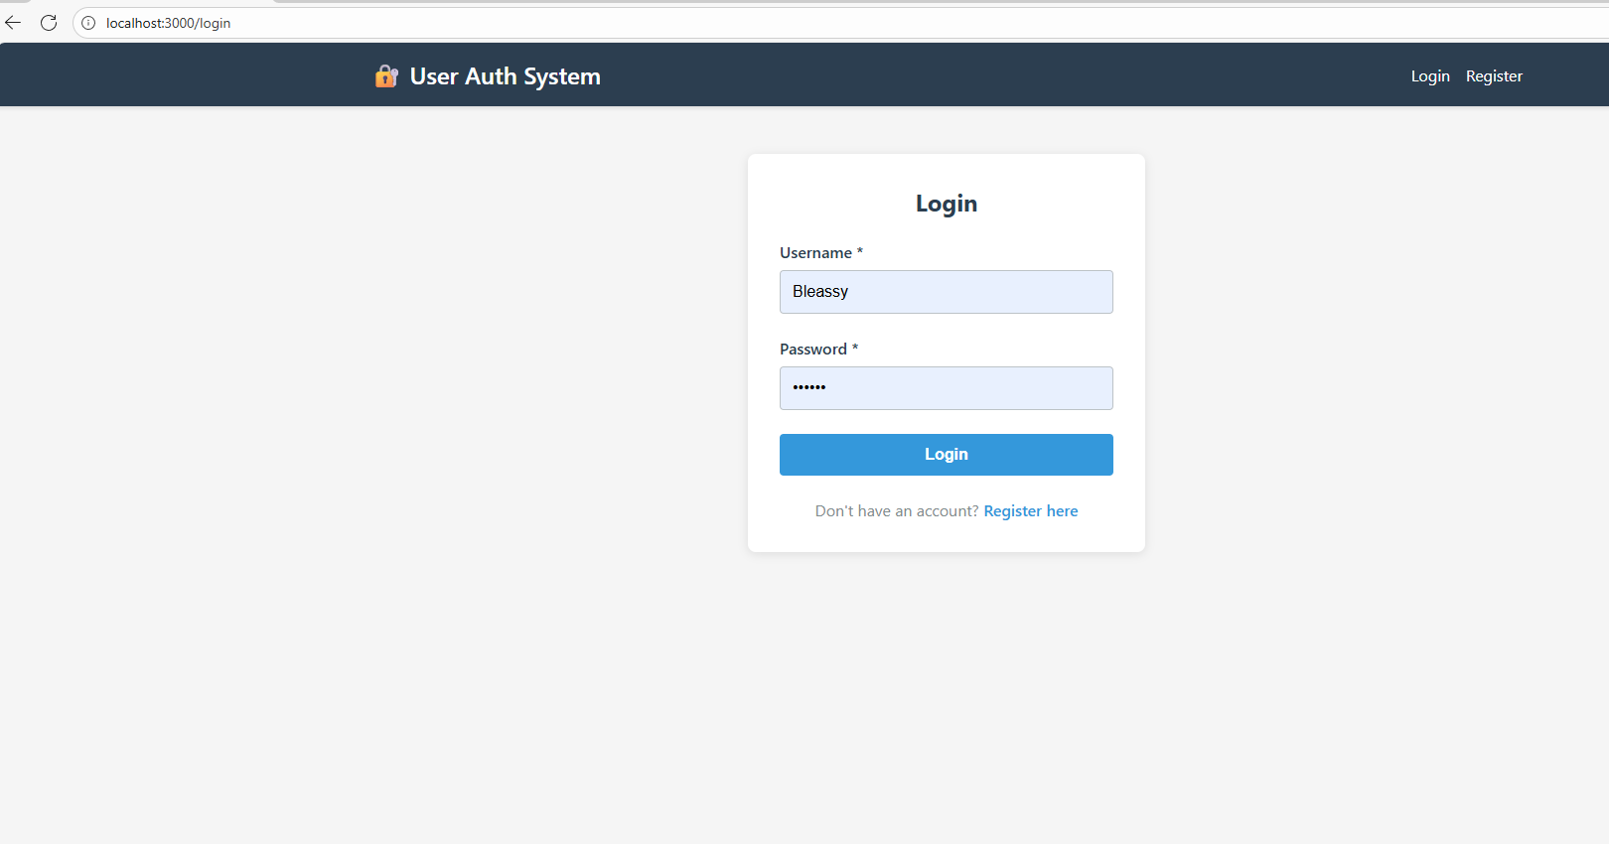
7.2 Registration
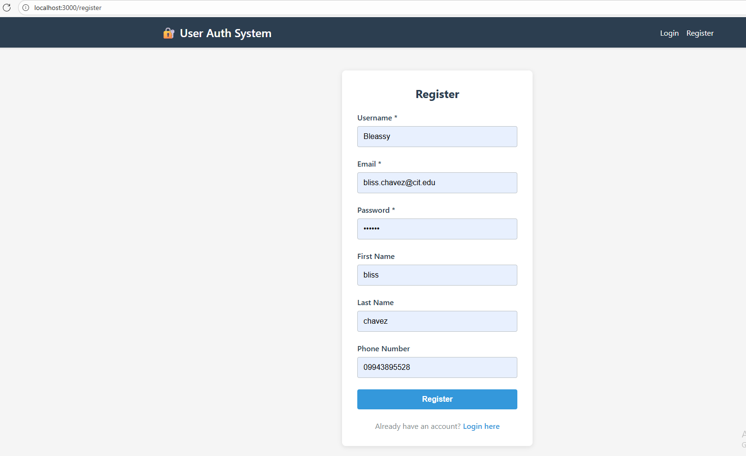
7.3 Dashboard
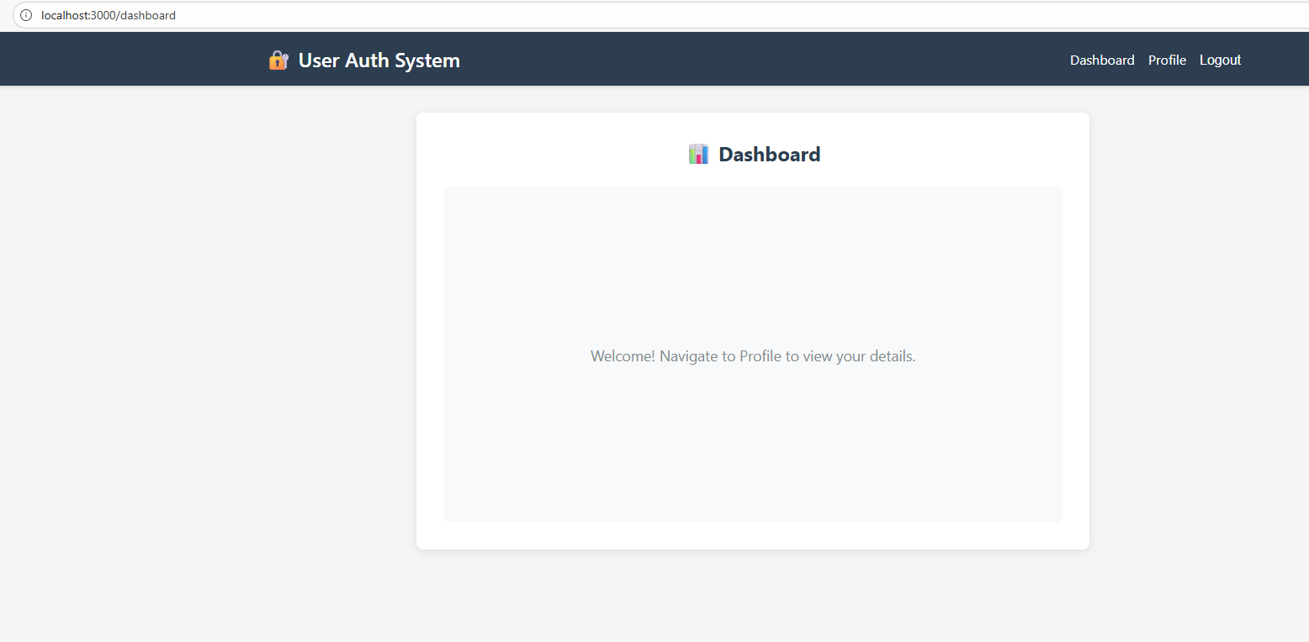
7.4 Profile
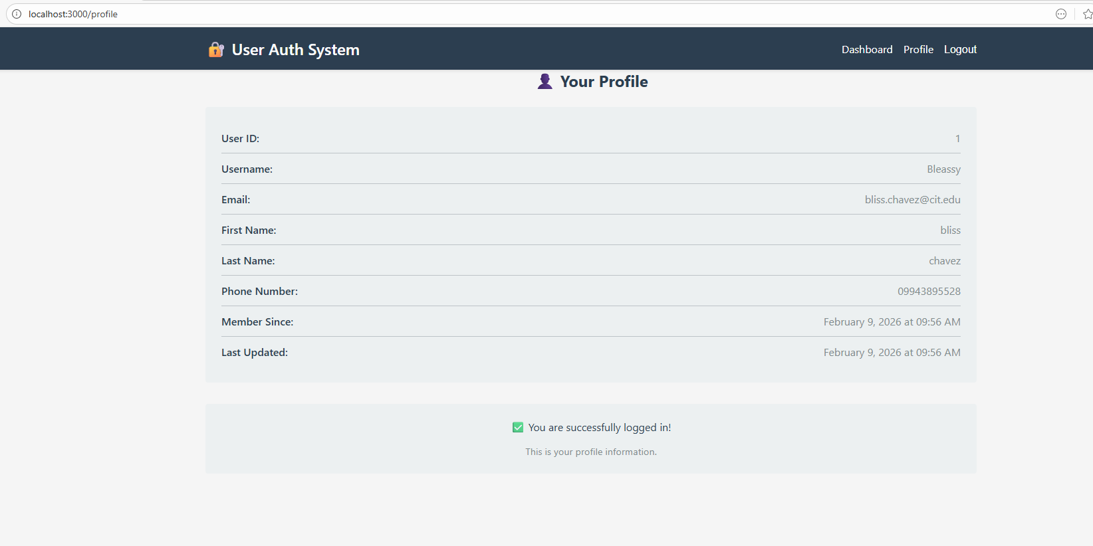
7.5 Logout
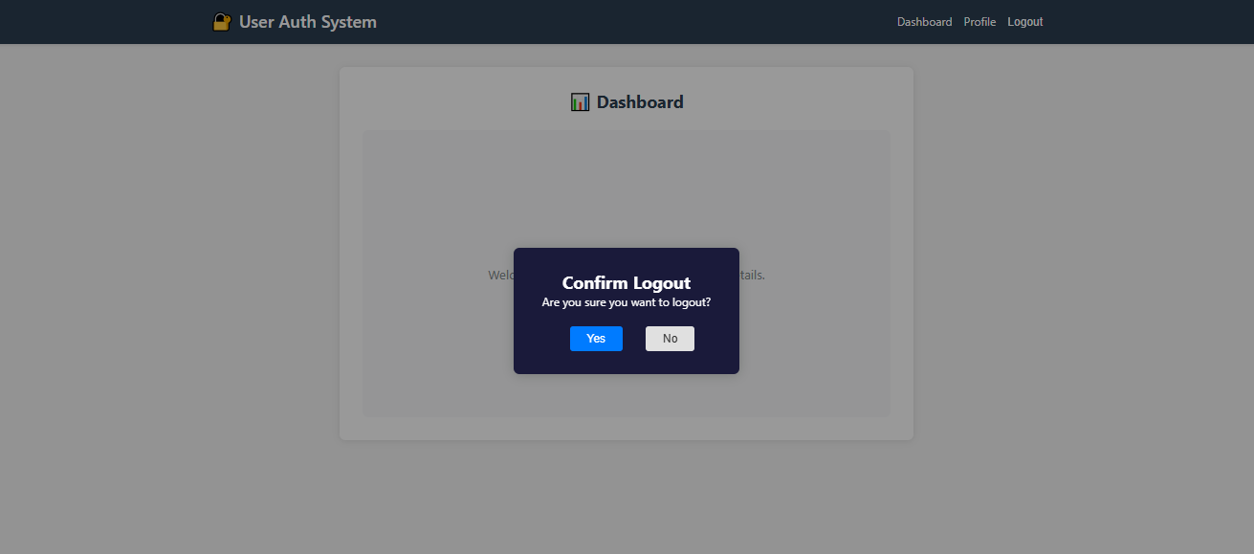
Mobile Application

