Computer Vision Assignment 2
B00152685 Isabella Sturzu

Intro:

Question 1: 208s
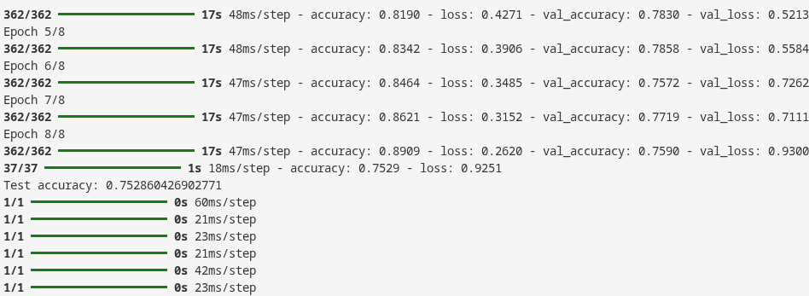
Experiment 0:
Training Time: 208s
Test accuracy: 0.7597253918647766
Notes:
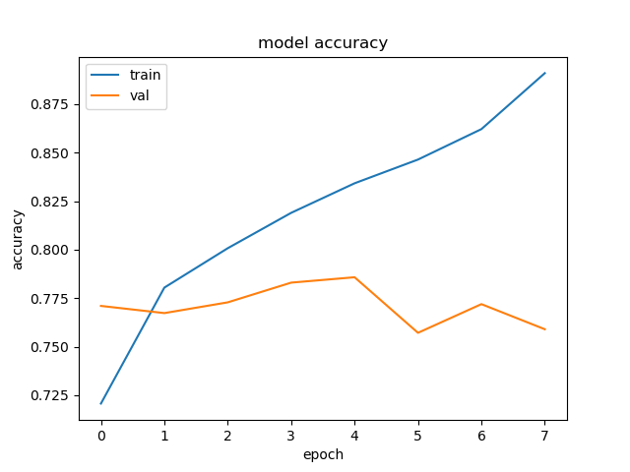

Question 2
There are 2596 Bacterial, 1461 Normal and 1363 Viral. Clearly there is a bias to the bacterial class. As a result, the model may achieve higher accuracy overall while performing worse on the underrepresented classes, particularly normal and viral cases.
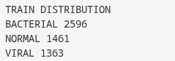

Class imbalance was addressed using class weighting during training. Higher weights were assigned to the underrepresented normal and viral classes, so that misclassification of these classes was penalised more heavily than misclassification of the bacterial class.

Question 3
Yes it is overfitting as the diagram shows clearly that the training accuracy increases streadily yet the validation accuracy improves slightly at first yet then starts going down showing the model isnt improving on training data but getting worse on unseen data.
After adding GlobalAveragePooling2D it improved greatly as seen in my graph:
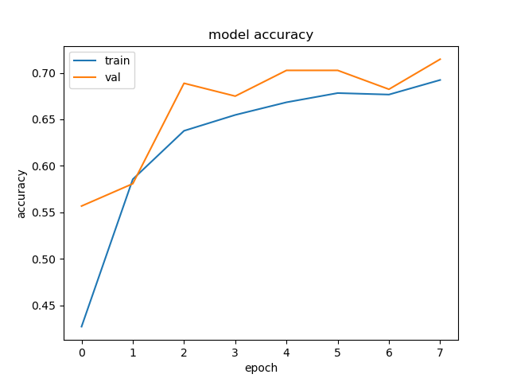

Experiment 1:
Training Time: 180s
Test accuracy: 0.6887871623039246
Notes:This was after getting rid of the overfitting problem. Clearly it improved time and accuracy.

Question 4:
Data augmentation was applied to improve model generalisation and reduce overfitting. Techniques such as small rotations, zoom and horizontal flipping were used to artificially increase the diversity of the training data. This helps the model learn more robust features and prevents it from memorising the training images.
Experiment 2:
Training Time: 158s
Test accuracy: 0.6224256157875061
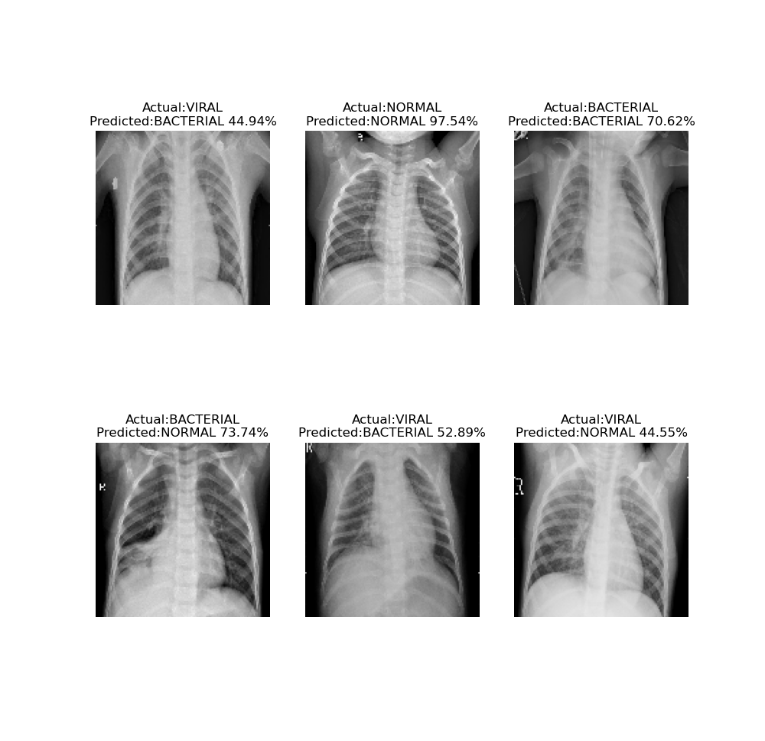
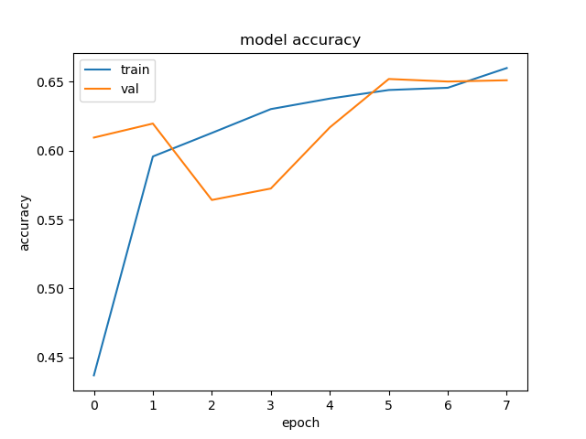

Question 5: What layers are in the network? Can I alter anything here to improve matters?
The current layers are as follows: preprocessing (augmentation layers and rescaling), rescaling layers, Conv2D layers, MAXPooling2D and GlobalAveragePooling2D.
Keras Tuner was used to optimise the CNN hyperparameters. The best trial achieved a validation accuracy of 62.33% using 64, 96 and 96 filters across the three convolution layers, dropout of 0.2, and a learning rate of 0.001. These results indicate that the model performed best with higher filter counts and moderate dropout.
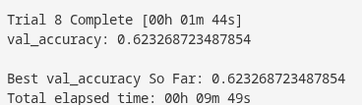

Question 6:
Transfter learning is an option. A pre-trained model such as Mobilenetv2 can be used as a feature extractor, where the earlier layers are frozen and only the final classification layers are trained on the chest X-ray dataset. This can improve performance, reduce training time, and help prevent overfitting from earlier compared to training a model from scratch like before.

Question 7:

