**List of figures and tables.**

1. Initial bioassay screen
2. Phenotype in detail (photo’s or drawing)
3. Bioassay on grafts
4. Screen of IL library
5. Metabolomics, differential compounds: levels of riboflavin candidate
6. Phloem analysis: Prescence of riboflavin in the Phloem
7. Riboflavin feeding assay
8. Riboflavin inhibitor assay

**Layout of figures**

1. Initial bioassay screen



1. Phenotype in detail (photo’s or drawing)  
     
   A picture containing ocean floor

   Description automatically generated

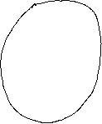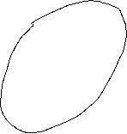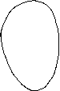

1. Bioassay on grafts

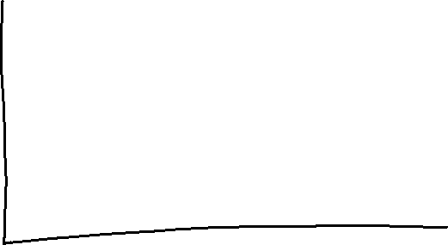

1. Screen of IL library  
     
   IL 1929 is not included in the metabolomics of Arjen. Should I also remove it from this graph? Does it add any info?

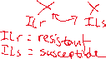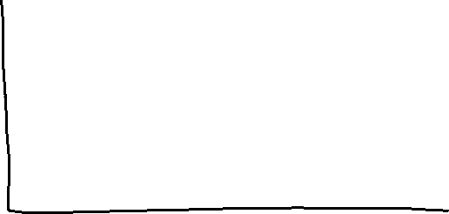

1. Metabolomics, differential compounds: levels of riboflavin candidate

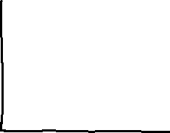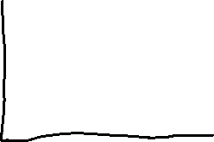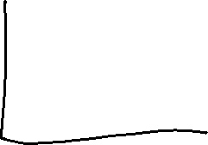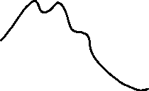

1. Phloem analysis: Prescence of riboflavin in the Phloem  
   Should this be a separate figure or the candidate abundance graph of the previous figure ?
2. Riboflavin feeding assay

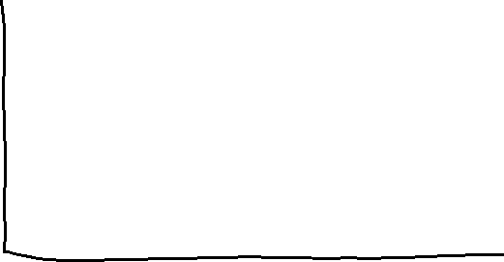

1. Riboflavin inhibitor assay



Do we need 1st 2nd & 3rd instars in this graph?