History of Internet
The Internet has revolutionized the computer and communications world like nothing before. The Internet is at once a world-wide broadcasting capability, a mechanism for information dissemination, and a medium for collaboration and interaction between individuals and their computers without regard for geographic location. The Internet represents one of the most successful examples of the benefits of sustained investment and commitment to research and development of information infrastructure.
The near indestructibility of information on the Internet derives from a military principle used in secure voice transmission: decentralization. In the early 1970s, the RAND Corporation developed a technology (later called “packet switching”) that allowed users to send secure voice messages. In contrast to a system known as the hub-and-spoke model, where the telephone operator (the “hub”) would patch two people (the “spokes”) through directly, this new system allowed for a voice message to be sent through an entire network, or web, of carrier lines, without the need to travel through a central hub, allowing for many different possible paths to the destination.
During the Cold War, the U.S. military was concerned about a nuclear attack destroying the hub in its hub-and-spoke model; with this new web-like model, a secure voice transmission would be more likely to endure a large-scale attack. A web of data pathways would still be able to transmit secure voice “packets,” even if a few of the nodes—places where the web of connections intersected—were destroyed. Only through the destruction of all the nodes in the web could the data traveling along it be completely wiped out—an unlikely event in the case of a highly decentralized network.
In 1973, the U.S. Defense Advanced Research Projects Agency (DARPA) began research on protocols to allow computers to communicate over a distributed network. This work paralleled work done by the RAND Corporation, particularly in the realm of a web-based network model of communication. Instead of using electronic signals to send an unending stream of ones and zeros over a line (the equivalent of a direct voice connection), DARPA used this new packet-switching technology to send small bundles of data. This way, a message that would have been an unbroken stream of binary data—extremely vulnerable to errors and corruption—could be packaged as only a few hundred numbers.
The packets in this packet-switching technology have something that allows the receiving computer to make sure the packet has arrived uncorrupted. Because of this new technology and the shared protocols that made computer-to-computer transmission possible, a single large message could be broken into many pieces and sent through an entire web of connections, speeding up transmission and making that transmission more secure.
One of the necessary parts of a network is a host. A host is a physical node that is directly connected to the Internet and “directs traffic” by routing packets of data to and from other computers connected to it. In a normal network, a specific computer is usually not directly connected to the Internet; it is connected through a host. A host in this case is identified by an Internet Protocol, or IP, address (a concept that is explained in greater detail later). Each unique IP address refers to a single location on the global Internet, but that IP address can serve as a gateway for many different computers. For example, a college campus may have one global IP address for all of its students’ computers, and each student’s computer might then have its own local IP address on the school’s network. This nested structure allows billions of different global hosts, each with any number of computers connected within their internal networks. Think of a campus postal system: All students share the same global address (1000 College Drive, Anywhere, VT 08759, for example), but they each have an internal mailbox within that system.
The early Internet was called ARPANET, after the U.S. Advanced Research Projects Agency (which added “Defense” to its name and became DARPA in 1973), and consisted of just four hosts: UCLA, Stanford, UC Santa Barbara, and the University of Utah. Now there are over half a million hosts, and each of those hosts likely serves thousands of people. Each host uses protocols to connect to an ever-growing network of computers. Because of this, the Internet does not exist in any one place in particular; rather, it is the name we give to the huge network of interconnected computers that collectively form the entity that we think of as the Internet. The Internet is not a physical structure; it is the protocols that make this communication possible.

Popular website observation and assessment

Stack Overflow
Stack Overflow is a question and answer site for professional and enthusiast programmers. It's built and run by you as part of the stack exchange network of Q&A sites.

In MAY 01, 2017 Stack Overflow used to have a web design like shown in Figure 1. The light blue background will make you to focus on the words that are written there and it is very simple to watch. The font size is very nice and readable. At the navigation bar you can choose Questions, Jobs and so on and most importantly you can search any question you want an answer for around the programming area. And also, at the bottom there is a list of Top Questions so you can choose from that too.

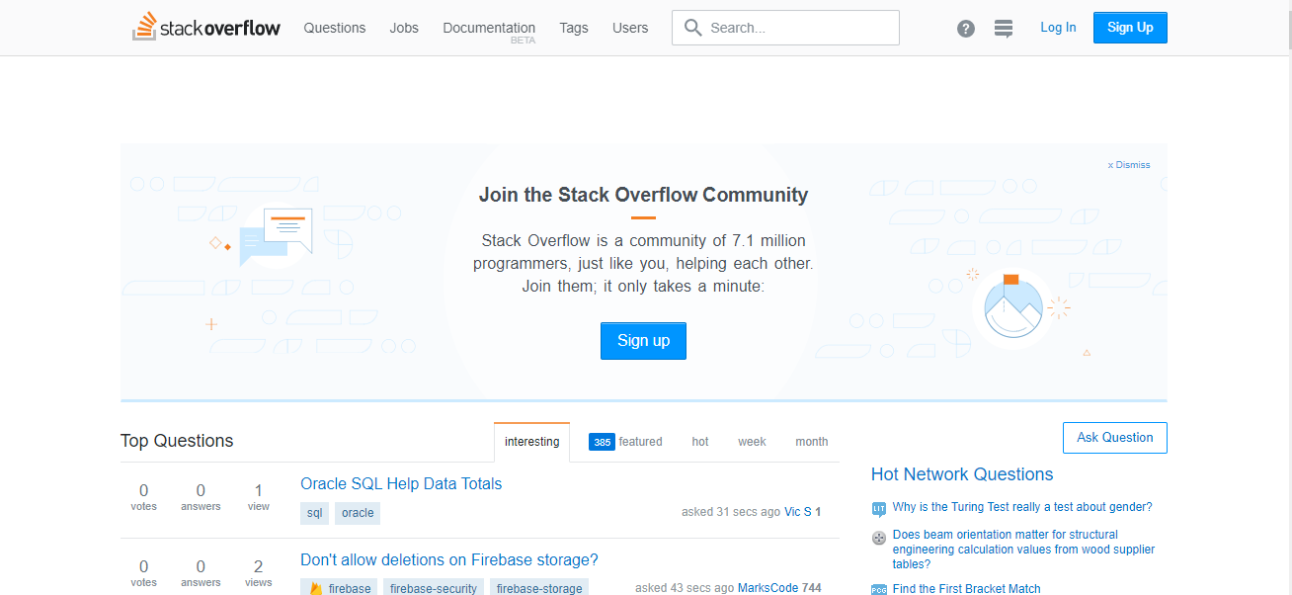

Figure 1 Stack overflow on MAY 01, 2017

In JAN 31, 2019 Stack Overflow used to have a web design like shown in Figure 2. They changed the background color to blue which is not bad. They put the sign-up form at the top right so as the users can find it easily. At the navigation bar they removed the others and cleared the space for question search. More or less other things are the same.

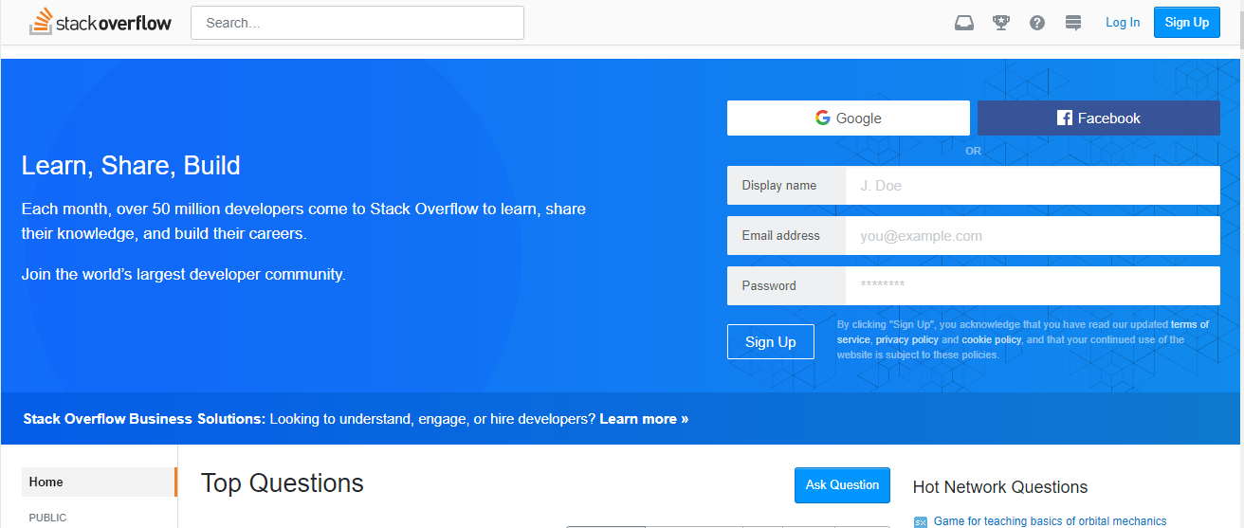

Figure 2 Stack overflow on JAN 31, 2019

In MAR 05, 2020 and also currently Stack Overflow is looking like the Figure 3 shown below. There are major changes like background color became yellow which is very bright and the background image is very good it simply describes the purpose of the website. And they removed the Top questions which is good because the home page is now become very simple.

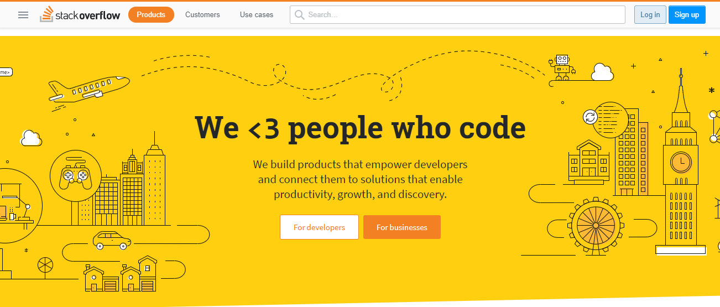

Figure 3 Stack overflow on MAR 05, 2020

Trip Advisor
Trip advisor is an online travel company that operates a global platform with user-generated content, price comparison tools, and online reservations for transportation, lodging, travel experiences, and restaurants.

In SEP 15, 2018 Trip advisor used to have a web design like shown in Figure 4.
They used an attractive background image. At the navigation bar u can choose what you want like Hotels, Flights, Restaurants and so on. At the bottom they will show you popular tourist destinations with great images and also recommended places like Ethiopian is one of them.

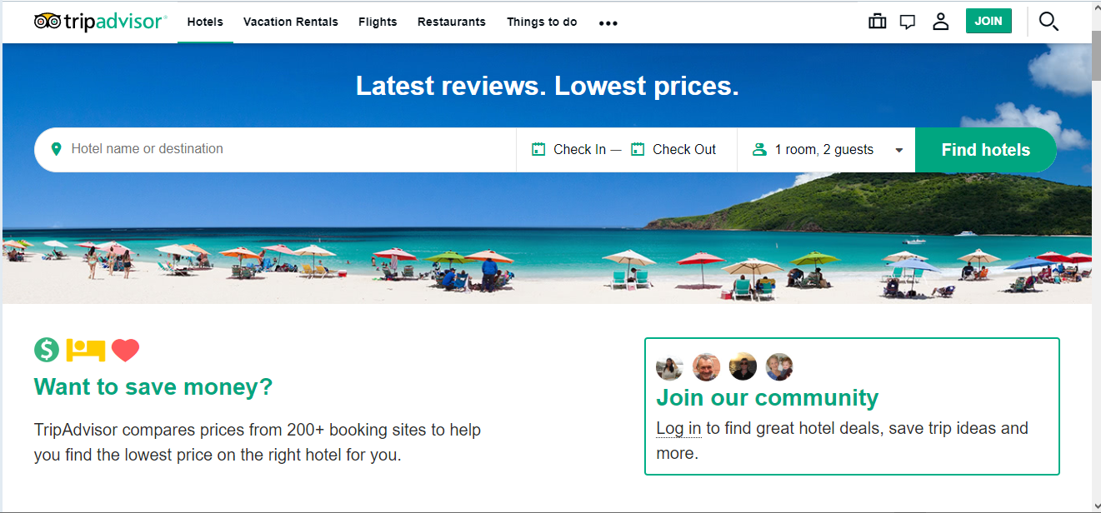

Figure 4 Trip advisor on SEP 15, 2018

In Aug 14, 2019 Trip advisor used to have a web design like shown Figure 5. The only major change is they put the navigation bar at the center. Other than that, they make background image change and some color change.

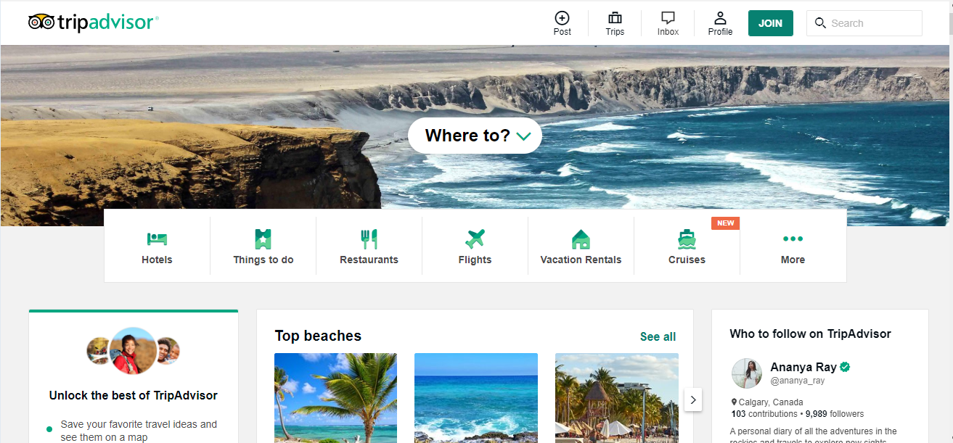

Figure 5 Trip advisor on Aug 14, 2019

In MAR 05, 2020 and also currently Trip advisor is looking like Figure 6. They only change the background image and some coloring and they add Recommended for you section. This website is a very good website they always change their background images to attract the tourist.

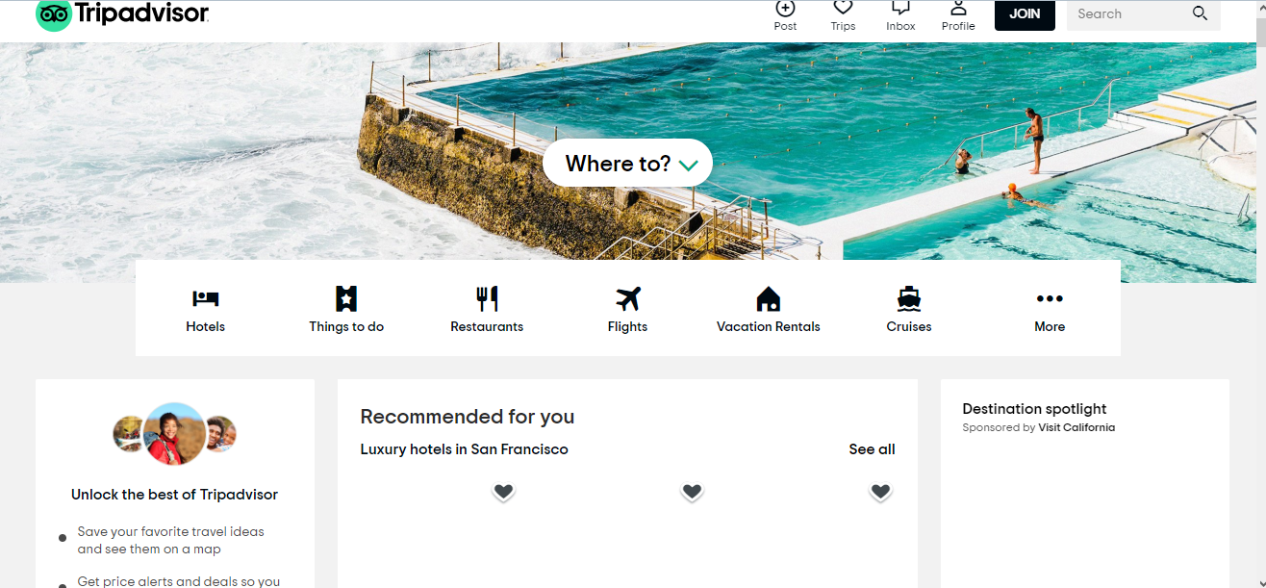

Figure 6 Trip advisor on MAR 05, 2020

Google
Google is an American multinational technology company that specializes in Internet-related services and products, which include online advertising technologies, search engine, cloud computing, software, and hardware.

In OCT 01, 2017 Google used to have a web design like shown in Figure 7.
The simplest web design I have ever seen so far, they have their logo and searching area at center and that is needed.

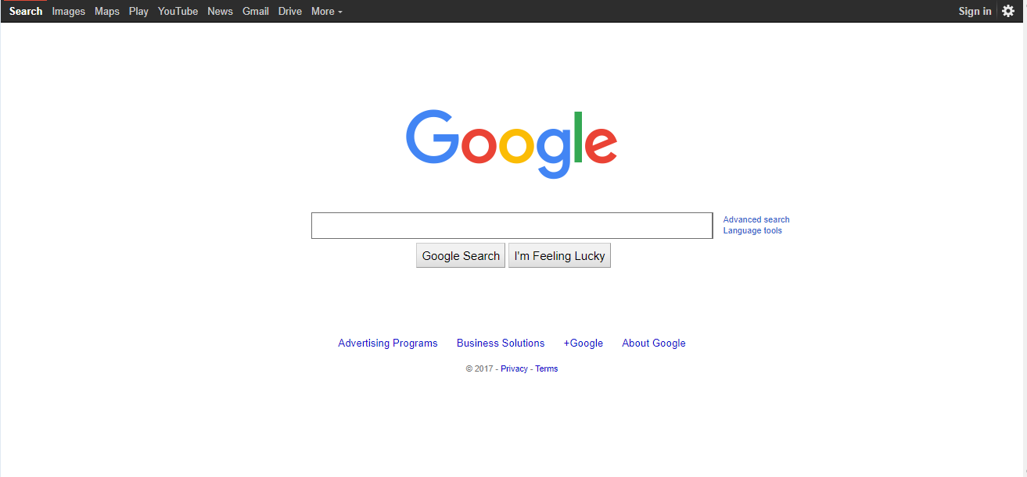

Figure 7 Google on OCT 01, 2017

In MAR 05, 2020 and also currently Google is looking like Figure 8. The only change I see is the now the user can search by voice search.
Goggle is the simplest and consistence website so far.

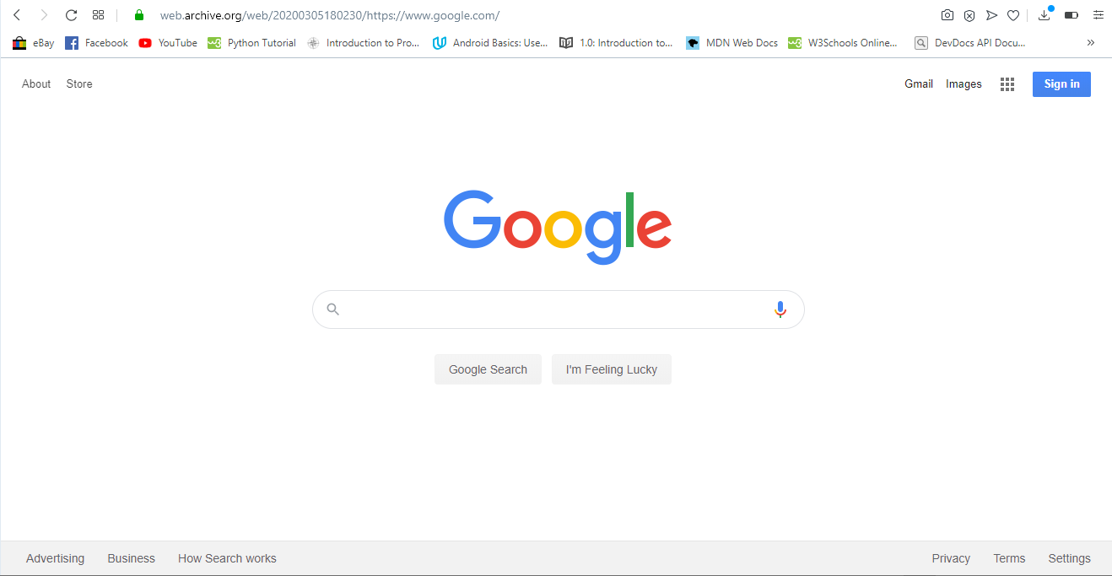

Figure 8 Google on MAR 05, 2020

BBC
The British Broadcasting Corporation is a British public service broadcaster. Its headquarters are at Broadcasting House in Westminster, London. It is the world's oldest national broadcaster, and the largest broadcaster in the world by number of employees.

In SEP 14, 2010 BBC used to have a web design like shown in Figure 9. At the navigation bar you can choose news, sport, weather and also you can search a specific news. At the main body there are Top stories and breaking news. As you can see the website is not attractive to watch it lacks a lot of styling to do.

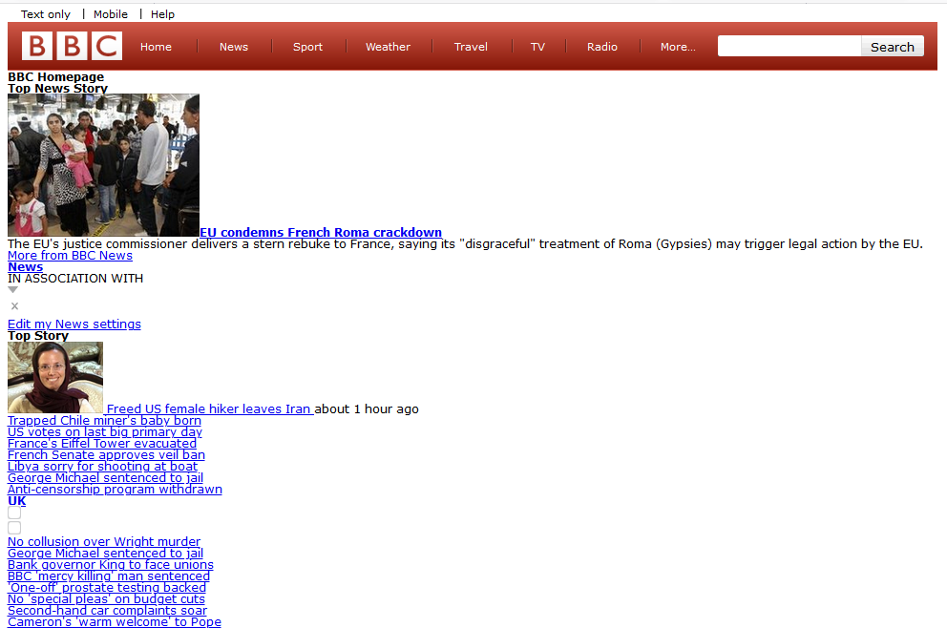

Figure 9 BBC on SEP 14, 2010

In APR 30, 2018 BBC used to have a web design like shown in Figure 10. They changed some coloring. They tried to style the page which is better than the previous one

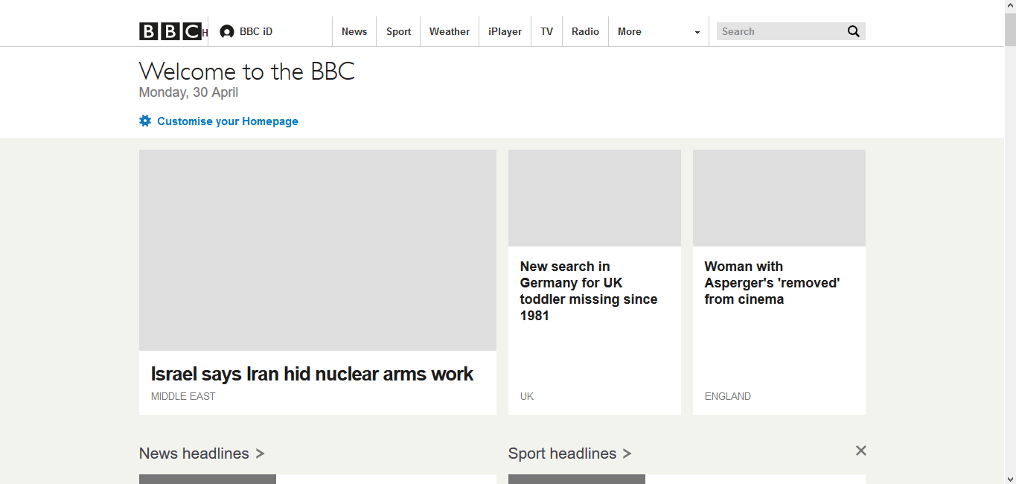

Figure 10 BBC on APR 30, 2018

In FEB 1, 2020 and also currently BBC is looking like Figure 11. Within this 2 year they only modified a little bit the navigation bar. In my opinion within those year gaps they could have done a lot of modifications to make the website interesting.

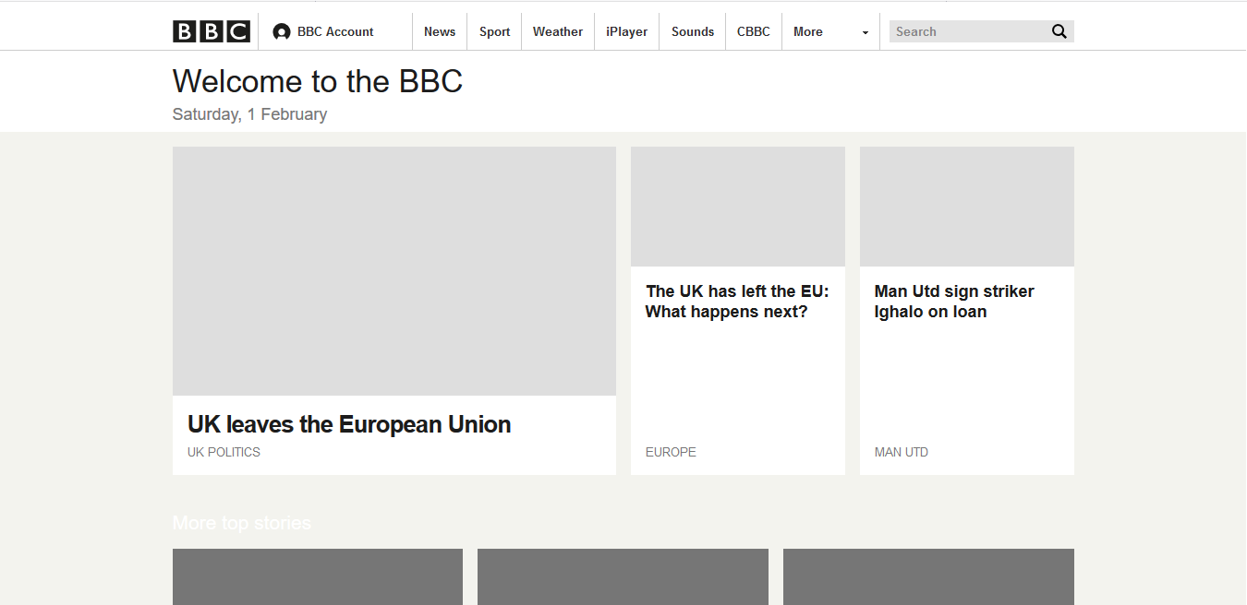

Figure 11 BBC on FEB 1, 2020

Fortune
Fortune is an American multinational business magazine headquartered in New York City. It is published by Fortune Media Group Holdings, owned by Thai businessman Chatchaval Jiaravanon.

In DEC 01, 2014 Fortune used to have a web design like shown in Figure 12. Very simple and easy to watch. Simply search for a specific information or choose from the navigation bar. We can find Top stories simply on the front page.

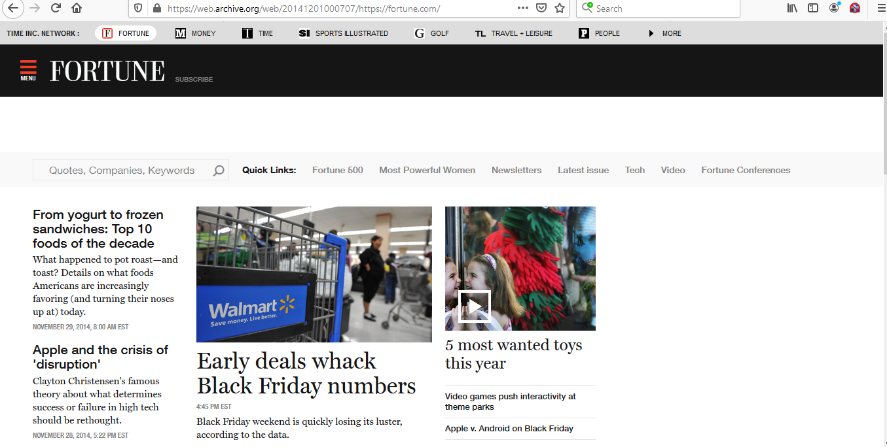

Figure 12 Fortune on DEC 01, 2014

In JAN 31 2020 and also currently Fortune is looking like Figure 13. They did a major change on the styling. They make it a very simple website to see and use. They reduce the number of Top stories so that the website looks simple and easy. Fortune is comfortable for user interface.

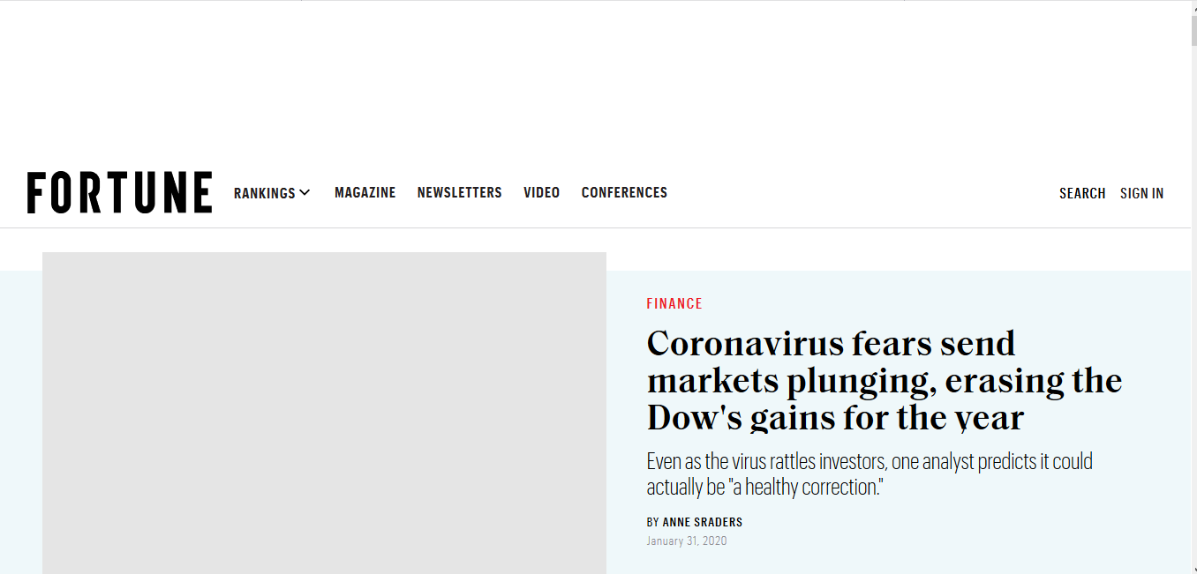

Figure 13 Fortune on JAN 31 2020

3. List and description of website categories

3.1 Portal
- Stanford University AXESS, Student and Faculty Portal
URL - https://axess.sahr.stanford.edu
Stanford University developed a consolidated online platform called AXESS for the academic community to access information and record various transactions. The portal enables functions as related to student enrollment & financials, academic advising, teaching & grading, employment & training, and workflow-enabled administrative processes. The site is based on a user-centric design with modern UX standards.

- Santander Bank, Retail Banking Portal
URL - https://www.santanderbank.com/us/personal
As one of the largest banks in the eurozone, Santander looked to build a new enterprise web platform that would integrate with existing software (CMS, Search Engine, Product Catalog) while allowing room for new content and features. Their site includes several retail banking features and ability to open new accounts and manage day-to-day banking operations.

- UAB Medicine, Patient Portal
URL - https://www.uabmedicine.org
UAB's top-ranked medical professionals found a platform through which they can reach many visitors and actual patients with health concerns. Their site hosts a free patient portal with a directory of various healthcare providers categorized by specialty, gender and location. It also features various subsections for knowledge about conditions and treatments, locations, contact info and FAQs.

- AutoZone, Employee Portal
URL - https://www.autozone.com
AutoZone built an employee portal known as the Daily Online Communications (DOC) to help serve its 47,000 store employees. DOC is the place for employees to find what they need to know about their weekly tasks, benefits, and training. Also, the numerous portlets included with Liferay make any content and style changes easy and fast; this has proven beneficial in keeping information up-to-date in a fast-moving retail environment.

- York University Passport York, Student & Faculty Portal
URL - https://passportyork.yorku.ca/ppylogin/ppylogin
My.Yorku.ca is the central information source for 55,000 students and a convenient one-stop shop for both internal resources and external data. The site includes personal course information (instructor, times, course Web site, etc.), grades, student account information, subscriptions to non-York newsfeeds and more. What's more, personal portal calendars are automatically loaded with class times and locations for registered courses while other campus events can be added if desired.

3.2 News
- Yahoo! News
URL - https://news.yahoo.com
Yahoo! News have over 175 million unique visitors every month. The website offers news related to almost every section, such as sports, finance, politics, and entertainment.

- Google News
URL - https://news.google.com/?hl=en-IN&gl=IN&ceid=IN:en
Google News have over 150 million unique visitors every month. Google is the most visited website or search engine in the world.

- CNN
URL - https://edition.cnn.com
CNN have over 95 million unique visitors every month. It is one of the fastest growing online news portals on the planet. The fanbase is so huge that the website also has its own App on the AppStore and Play store. They even have a TV news channel which is viewed by millions of viewers across the globe.

- New York Times
URL - https://www.nytimes.com
New York Times have over 70 million unique visitors every month. It’s an American based newspaper from New York city. Due to its high popularity, as we already mentioned earlier the website receives the love of nearly 70 million unique visitors every month. The layout of the website is similar to a traditional newspaper which makes it even more unique to its competitors.

- NBC News
URL - https://www.nbcnews.com
NBC News have over 63 million unique visitors every month. It’s an American based broadcasting television network NBC, formerly known as the National Broadcasting Company. The website has a huge traffic base in both the US and Europe and also the social media handles are fairly loved by many people.

3.3 Informational
- Mashable
URL - https://mashable.com
One of the world’s most informative websites for all the latest stuff ranging from the latest in technology to trending news stories. Mashable is one website you can visit on a daily basis. Visit Mashable for all the current tech gigs and their ratings. This one is best for today’s youth and their curious minds.

- Web monkey
URL - https://www.wired.com/category/webmonkey/
This is a developer’s hub to get all the firsthand information on web designs, software and applications. The cheat sheets and cut-copy codes that it offers help you in sharpening your coding skills. This website surely is a wonder for web geeks. All budding developers and designers always refer this website for some great tips and tricks.

- Trip Advisor
URL - https://www.tripadvisor.com/?fid=6a1a101e-57a7-4539-b572-8fad794712b0
This one is like a city guide search engine that helps you find the city’s best restaurants and “things to do” while you are away from home. It’s an excellent informative website for people who love travelling as it provides detailed and genuine information. TripAdvisor.com can help you plan you’re a detailed journey from the comfort of your home

- MD Health
URL - https://www.md-health.com
It has wealth of information on various health conditions, symptoms, medicines, procedures etc. The website is a must-visit for ordinary folks looking to do some digging on health problems they’re suffering from and even medicos and doctors who want trusted information on various topics in medical science.

- Road food
URL - https://roadfood.com
This website helps you get your favorite food while on the road. It’s like street food at a click. It’s available in many states across the United States. It helps you get your favorite dishes while you are on the move. A must visit very informative website for food lovers and others who’re always on the move, whether on business or solo trips to different places.

3.4 Business/ Marketing
- Event Marketer
URL - https://www.eventmarketer.com
Event Marketer provides the information needed for strategic brand-side event marketers and agency executives ranging from face-to-face to corporate events. Through many years of success, Event Marketer has established itself as the world’s most respectable and reputable provider of content for the event and trade show category.

- Chief Marketer
URL - https://www.chiefmarketer.com
Chief Marketer serves marketing professionals of consumer and business-to-business brands with rich and thorough information on measurable marketing strategies, tactics, and technique. Chief Marketer provides well thought out insights and ideas, accompanied by resources and technologies in a method to measure return on investment.

- Inc
URL - https://www.inc.com
Inc is the only major brand in the world dedicated exclusively to owners and managers of growing small businesses which aim to provide them with real solutions for their business. Inc has an abundance of small business ideas, information, and inspiration for small businesses.

- Fortune
URL - https://www.fortune.com
Fortune is one of the world’s leading business media brands which is accompanied by a multinational monthly magazine, daily website and conference series. Fortune is dedicated to assisting its readers, viewers, and attendees to succeed in the business sector.

- Marketing Sherpa
URL - https://www.marketingsherpa.com
Marketing Sherpa is a research institute that specializes in tracking the success rate of all elements within marketing. Marketing Sherpa’s ambition is to provide marketers with instructions, statistics, and inspiration to improve their business’s results.

3.5 Educational
- EDX
URL - https://www.google.com/search?client=opera&q=edx.org&sourceid=opera&ie=UTF-8&oe=UTF-8
This website can be most preferred by the students as it was founded by Harvard University and MIT in 2012. EdX is an online learning destination and MOOC provider, offering high-quality courses from the world's best universities and institutions to learners everywhere. Out of the 90 universities, it includes top global rankers.

- Academic Earth
URL - https://academicearth.org
The website gives huge array of academic options to student from traditional to contemporary studies. They provide online degree courses from accounting and economics to engineering and also carries material on niche subjects like behavioral psychology. Moreover, it has had a collaboration with a bunch of reputed colleges such as University of Oxford, Massachusetts Institute of Technology, Stanford University and many other. Keeping in mind the interest level of the students, the portal has videos and podcasts in all the subjects.

- Internet Archive
URL - https://archive.org
From anything to everything, internet archive is an authentic website storing the originals from various big websites. For example, American libraries include the collection of free books directly attached with the college libraries' websites. This is one of the best websites imparting free and accessible knowledge. However, it does not give admission or certificates for learning

- Coursera
URL - https://www.coursera.org
The moment a student opens this website, he is bound to get sucked into the number of courses available in his topic of interest. It is a user-friendly website. Students can find big universities and a sharable electronic Course Certificate. "Courses include recorded video lectures, auto-graded and peer-reviewed assignments, and community discussion forums. When you complete a course, you'll receive a sharable electronic Course Certificate," assures the website.

- Brightstorm
URL - https://www.brightstorm.com
High school scholars can use this site for reference, rather an interactive reference website, which will mitigate their learning problems. Of course, it is not easy for a student to comprehend the intricate technical terminologies, so the website is making the textbooks easier for students. They provide help in all subjects from mathematics to science, history and other subjects. Entrance exams are generally quite gruelling for students, and this website can solve the problem. They have arranged the topics symmetrically, clearing the air and structure of the competitive exams.

3.6 Entertainment
- Netflix
URL - https://www.netflix.com/et/
Netflix is the world’s leading Internet television network with more than 36 million members in 40 countries enjoying more than one billion hours of TV shows and movies per month, including original series. For one low monthly price, Netflix members can watch as much as they want, anytime, anywhere, on nearly any Internet-connected screen.

- Time Magazine
URL - https://time.com
Time has the world’s largest circulation for a weekly news magazine, and has a readership of 25 million, 20 million of which are in the US. The magazine’s site has become the primary source of current news, politics and finances for people who like in-depth, thorough and serious journalism all around the world.

- YouTube
URL - https://www.youtube.com
YouTube allows you to share your videos with friends, family, and the world. Founded in February 2005, YouTube allows billions of people to discover, watch and share originally-created videos. It provides a forum for people to connect, inform, and inspire others across the globe and acts as a distribution platform for original content creators and advertisers large and small.

- ESPN
URL - https://africa.espn.com
ESPN.com is the web extension of the mighty Entertainment and Sports Programming Network which provides comprehensive sports coverage since 1979. It provides complete sports information including NFL, MLB, NBA, College Football, College Basketball scores and news.

- Pogo
URL - https://www.pogo.com/coppa/how/old.do
Pogo.com is a great place to play free online games, including puzzle games, word games, card games, and board games. It is the biggest platform for free online flash games, and unlike other free online games sites.

3.7 Advocacy
- The Heritage Foundation
URL - https://www.heritage.org
Founded in 1973, The Heritage Foundation is one of the most widely respected research and educational institutes in the world. As a think tank, it formulates and promotes conservative public policies based on the principles of free enterprise, limited government, individual freedom, traditional American values, and a strong national defense.

- The Cato Institute
URL - https://www.cato.org
The Cato Institute is one of the nation's leading authorities on public policy and its insight is guided by a strong moral purpose and "the principles of limited government, free market, individual liberty, and peace." Its mission statement is clear: "The Institute will use the most effective means to originate, advocate, promote, and disseminate applicable policy proposals that create free, open, and civil societies in the United States and throughout the world."

- Media Research Center
URL - https://www.mrc.org
The mission of the is to bring balance to the news media. The aim of the Media Research Center is to expose the liberal bias that exists and influence the public's understanding of critical issues. On October 1, 1987, a group of young determined conservatives set out to not only prove—through sound scientific research—that liberal bias in the media does exist and undermines traditional American values, but also to neutralize its impact on the American political scene through advocacy and activism.

- National Right to Life
URL - https://www.nrlc.org
National Right to Life is the nation's largest pro-life organization that focuses on educating the public and promoting pro-life legislation nationwide and in all 50 states. The organization also provides resources for women who are pregnant and seeking help and alternatives to abortion.

- National Rifle Association
URL - https://home.nra.org
The National Rifle Association is the premier defender of the 2nd Amendment and works to promote gun rights. The organization promotes safe gun practices and provides training resources including concealed permit and self-defense classes.

3.8 Blog
- Medium
URL - https://medium.com
Medium is a multipurpose platform tackling diverse topics, where anyone with an account can write. Unlike most other free blogging sites, the big advantage of Medium is that your articles will be exposed to a wide audience since the platform is visited by 60 million readers per month.

- Ghost
URL - https://ghost.org
This is another WordPress-like blogging platform. While the Ghost software can be downloaded for free, you need paid hosting for fuel. Digital Ocean is a great service that supports Ghost: it is cheap and comes with a bunch of nice features to get you started.

- Blogger
URL - https://www.blogger.com/about/?r=2
Blogger is one of the oldest free blog sites, though its popularity has dipped in recent years. It’s a solid solution for personal blogs, but it’s not the best resource for professional use. It works just like the other hosted platforms.

- Tumblr
URL - https://www.tumblr.com
Tumblr is one of the original free blogging sites on the web. It’s just a bit ‘milder’ than the others on the list. Unlike the rest of the platforms that are mostly created for publishing purposes, this one here is more oriented to multimedia or social media-like content. The interface of Tumblr is more playful and is easy to get started with – you can simply sign up and then you’re allowed to start posting.
- Joomla
URL - https://www.joomla.org
Joomla is similar to WordPress.org but not as obvious when considering the free blog sites available out there. Just like WordPress, the software is free but needs hosting and a domain. As in the WordPress case, we recommend Bluehost because it is both very cheap and reliable.

3.9 Wiki
- Wikitravel
URL - https://wikitravel.org/en/Main_Page
When you’re planning a holiday, you should give privately-owned websites like TripAdvisor a wide berth. Wikitravel is a much better source of information. It’s been online since 2003 and is overseen by a team of administrators. They can roll back unwanted edits, delete pages, lock pages, and generally keep the information on the site accurate and free of spam.

- WikiHow
URL - https://www.wikihow.com/Main-Page
WikiHow is a popular wiki for anyone who wants to learn how to do something. The content on offer is extremely varied. The site’s categories include topics such as Sports and Fitness, Pets and Animals, Relationships, and Philosophy and Religion.

- WikiBooks
URL - https://en.wikibooks.org/wiki/Main_Page
WikiBooks makes our list of wiki sites thanks to its incredible repository of open-content textbooks, annotated texts, instructional guides, and manuals. It does not include fiction, primary research, or published texts.

- Wikitionary
URL - https://en.wiktionary.org/wiki/Wiktionary:Main_Page
Print dictionaries can be expensive. Wiktionary, therefore, is an example of a wiki that can save you money. It is a multilingual dictionary of languages, but has a definition for every word supplied in English, regardless of the source language.

- Wikispecies
URL - https://species.wikimedia.org/wiki/Main_Page
Wikispecies is to the 21st century what “On the Origin of Species” was to the 19th century. It aims to be a complete catalog of all Animalia, Plantae, fungi, bacteria, archaea, and Protista in the world.

3.10 Social Network
- Facebook
URL - https://www.facebook.com
Facebook is one of the most popular sites that are used by people on social media. You can easily send pictures, post statuses, post images on Facebook and do so much more in the best way.

- Twitter
URL - https://twitter.com
Twitter is also one of the most famous platforms that you can use. People use it to send tweets.

- Instagram
URL - https://www.instagram.com/?hl=en
Instagram is probably another one of the sites that you can use for posting Instagram stories, photos, and videos.

- WhatsApp
URL - https://www.whatsapp.com
Facebook acquired WhatsApp in the year 2014, but it is still considered to be an independent entity for sure.

- Skype
URL - https://www.skype.com/en/
Skype which is owned by Microsoft is another popular video chatting social media platform. With this, you can connect with others through voice and video chats in the best way.

3.11 Content Aggregator
- Feedly
URL - https://feedly.com/i/welcome
Feedly is one of the most popular news aggregator websites on the internet. It allows you to create a news stream of your own with latest content from your favorite publishers.

- Google News
URL - https://news.google.com/?hl=en-ET&gl=ET&ceid=ET:en
Google News is a powerful news aggregator powered by Google’s sophisticated search technologies, AI, and user’s own search history. By default, it shows you top news stories based on your geographical location.

- AllTop
URL - https://alltop.com
AllTop aggregates news and blog articles from the world’s most popular websites like TechCrunch, Mashable, BBC, CNN, and more. It curates and displays content in the real-time.

- News360
URL - https://news360.com
News360 is one of the most popular news aggregator apps on the internet. It lets you find world news as well as stories around your interests. It is an excellent alternative to Google News and Feedly.

- Panda
URL - https://usepanda.com/app/#/
Quite different from the above news aggregators, Panda aggregates content useful to web designers, developers, and tech entrepreneurs. It gathers content from Dribble, Behance, TechCrunch, Wired, and other similar websites.

3.12 Personal
- Ellen Skye Riley
URL - http://ellensriley.com
This is one of the best personal websites we’ve ever seen. Riley does an excellent job at showcasing her incredibly gifted design skills, and her site is informative and extremely fun to parouse. When a viewer enjoys browsing through your site, you know you’re on the right track to securing some more clients.

- Tim Harford
URL - http://timharford.com
The use of whitespace on this page really works wonders. It drives the eye to the main column where the content is the focal point. There’s also a nice call to action block that takes the visitor to his featured book, but it doesn’t distract from the overall experience.

- Joshua McCartney
URL - https://www.joshuamccartney.com
McCartney’s website grabs your attention as soon as you see it. This is a great example of something that simply looks great. There’s no questioning McCartney’s skill when seeing this website, and the clever use of situating a lot of content in only two simple pages is a near perfect blend of quality content that doesn’t feel cluttered.

- Seth Godin
URL - https://www.sethgodin.com
One of our favorite things about this site is the big subscribe button that you simply can’t miss. It’s obviously the most important action that Seth wants his visitors to take, and he’s not messing around trying to accomplish that. The color is definitely a pattern interrupt from most of the other blogs you see as well, and really makes him stand out.

- Pascal van Gemert
URL - http://www.pascalvangemert.nl
Gemert shows off his skill of web development in a really nice interactive, online resume. Initially, any fans of Marvel (specifically, Captain America) are going to love this site. But if you continue to scroll, there’s really something for everybody in this personal website. You’ll also want to scroll down to the very bottom of Gemert’s site to see how he nicely positions and advertises his past projects.

