Lights controller

06/07/2016

Victor Moyano

INDEX

1. Preamble…………………………………………………………………………..4
2. Functionality of Matlab Class…………………………………………….5
   1. Connecting and disconnecting the bridge…..….…………5
   2. Get Light parameters...............................……...…………5
   3. Set Light parameters.……..........…………………………………6
3. Bridge and Light Parameters..…………...............……….………...8
4. About the Philips Bridge……...........………………………………….10

**Revision History**

|  |  |  |  |
| --- | --- | --- | --- |
| **Data** | **Versió** | **Descripció** | **Autor/s** |
| 06/07/2016 | 1.0 | First version of the documentation. At this point, the software to control the lights is 100% functional, with some additional features. This doc pretends to be a very simple guide of basic use of the software. | Victor Moyano |
|  |  |  |  |
|  |  |  |  |

# **Preamble**

This matlab software has been written in order to control the N lights connected to the Philips Bridge. The Philips Bridge should be connected to your PC via an Ethernet cable. The bridge is connected wireless to each light, and this way we can control any light parameter by sending specific instructions to the bridge.

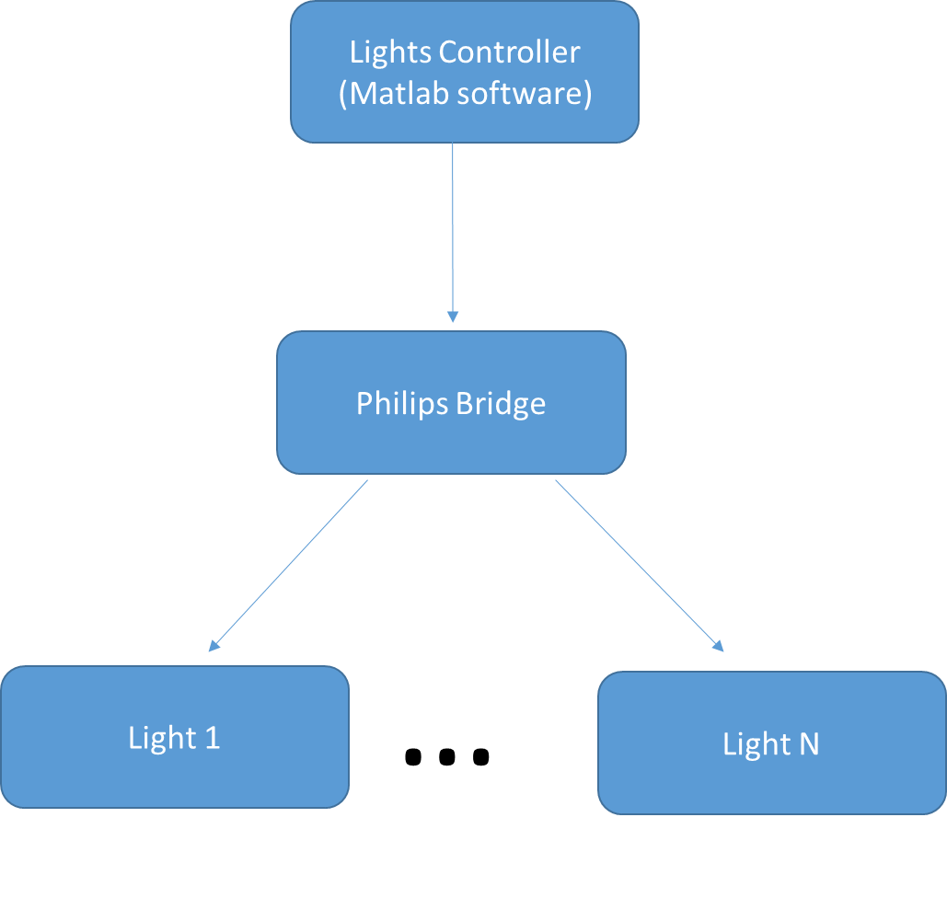

The code is written uniquely as a matlab class and a matlab function. No extra librarys or files are needed for its execution. Only a matlab version, probably higher than 2014b, is needed.

# **Functionality of Matlab Class**

## **Connecting and disconnecting from the bridge**

The connecting and disconnecting procedures are trivial. For connecting to the bridge (which controls the lights), you can do:

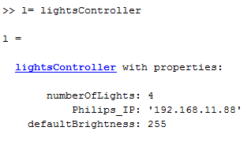

l Is a handle to an object from the lightsController class. When we connect to the bridge, all lights are turned on. When we disconnect from the bridge, all lights are turned off. For disconnecting from the bridge, you should do:



If for some reason in the first try of connecting to the bridge you receive an error, try a second. Sometimes it fails to find the right ip of the bridge, so the matlab program returns an error, but is not a problem, just try again.

* 1. **Get Light parameters:**

Once the bridge is properly connected you can get the light parameters, doing as usual. If you want to get all the lights parameters, you should do:

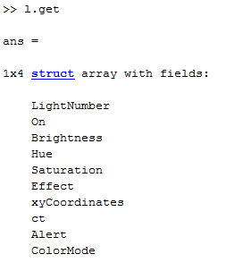

As you can see, I’m getting a 1x4 struct, because we have 4 lights, so we get 4 different structs.

If you only want to get the information of one light, you could do:

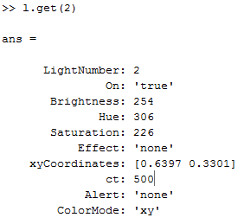

* 1. **Set Light parameters:**

For setting the light parameters, several ways have been implemented, in order to fulfill different purposes:

* If you have a struct (which you got previously using the get function), you could pass this struct to the set function, and the parameters from the struct will be set automatically. This can useful for saving a given scene configuration(all the lights parameters) , and load it whenever you want:

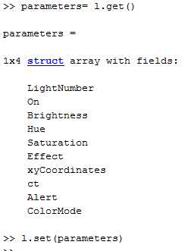

* If you want to turn off one light, you should do the following (In this case, we are turning off light number 2):



* If you want to turn on light, you should do the following (In this case, we are turning on light number 2):



* If you want to change the colour of one light (and you know the xyY coordinates), you should do the following. Remember that the coordinates should be between 0 and 1:



* If you want to change the colour of one light (and you know the rgb coordinates), you should do the following. Remember that not each RGB colour has a representation in the xyY colour space:



* If you want to change the brightness of one light, you should do the following:



* If you want to change the colour and the brightness at the same time of one light, you should do the following (In this case the colour is the one with chromatic coordinates [0.6 0.5] and brightness 255):



* All the previous actions can be done for all the lights at the same time. Some examples here:

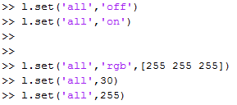

# **Bridge and Light Parameters**

The current bridge parameters supported in this code are shown in the following table:

|  |  |  |  |
| --- | --- | --- | --- |
| **Name of Parameter** | **Short Description** | **Range** | **Recommended Value** |
| defaultBrightness | Default brightness set to the lights when turn on. | From 1 to 255 | 255 |
| Philips_IP | Ip where the bridge is found (Only readable) | - | - |
| numberOfLights | Number of lights connected to the bridge (Only readable) | - | - |

The current light parameters supported in this code are shown in the following table:

|  |  |  |  |
| --- | --- | --- | --- |
| **Name of Parameter** | **Short Description** | **Range** | **Recommended Value** |
| LightNumber | Default brightness set to the lights when turn on.  (Only readable) | From 1 to ? | - |
| On | ‘true’ if the light is on, or ‘false’ if the light is off | ‘true’-‘false’ | - |
| Brightness | Brightness of the current colour | From 1 to 255 | - |
| Hue | (Only readable) | - | - |
| Saturation | (Only readable) | - | - |
| Effect | (Only readable) | - | - |
| xyCoordinates | X,y coordinates (in xyY colour space) of the colour being used. | Vector of two elements with each element from 0 to 1. | - |
| ct | (Only readable) | - | - |
| Alert | (Only readable) | - | - |
| Colour Mode | (Only readable) | - | - |

# **About the Philips Bridge**

**Note: this section is a work in progress.**

Information about the protocols used for communicating with the bridge should be in this section. TO DO.