instance {

name Arrow_Test

geometry Arrow

transform {

translate +2.0000 +0.0000 +0.0000

%rotatex -35.2644

%rotatey +0.0000

%rotatez +90.0000

scaleu +1.0000

}

shaders 3

"white.shader"

"down.shader"

"up.shader"

modifiers 3

"None"

"None"

"None"

}

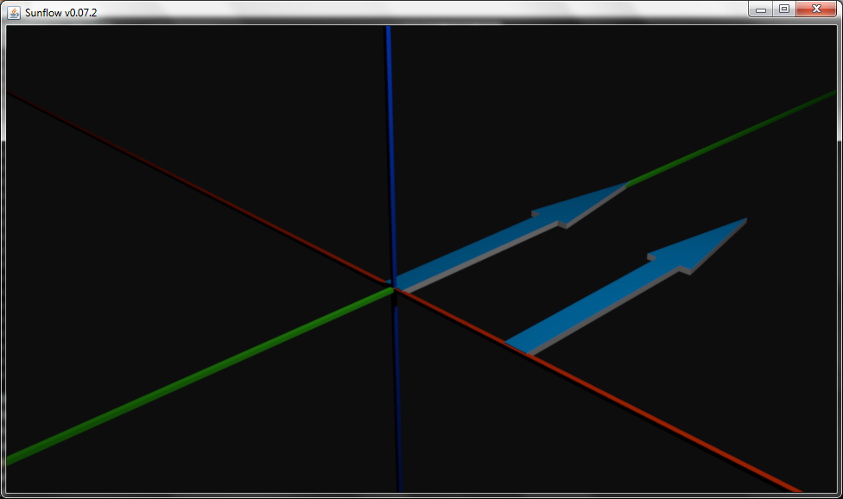

translate +2.0000 +0.0000 +0.0000

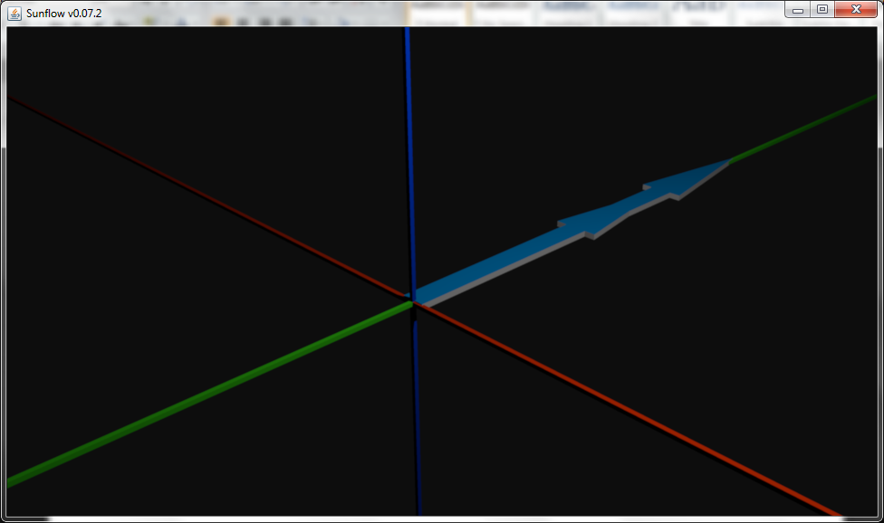

translate +0.0000 +2.0000 +0.0000

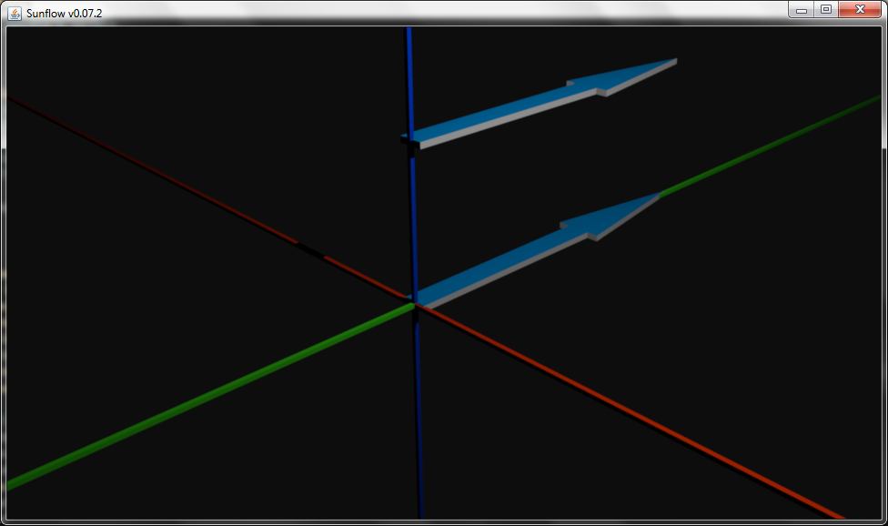

translate +0.0000 +0.0000 +2.0000

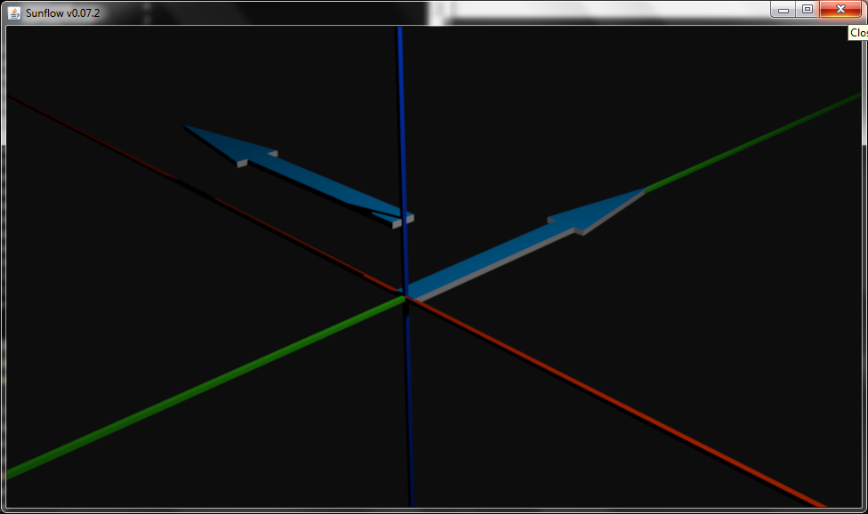

translate +0.0000 +0.0000 +1.0000

rotatez +90.0000

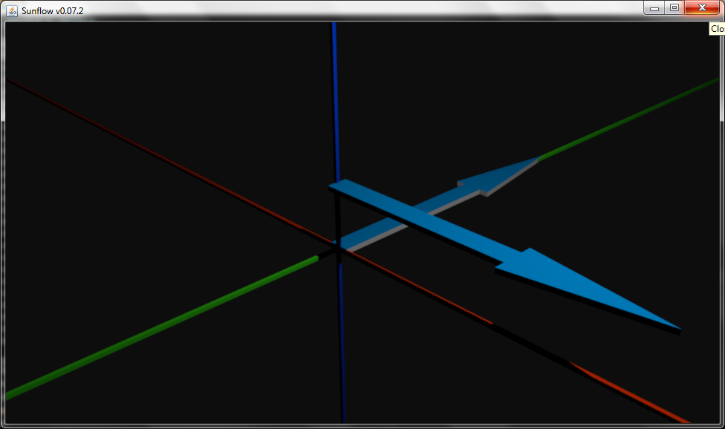

rotatez -90.0000

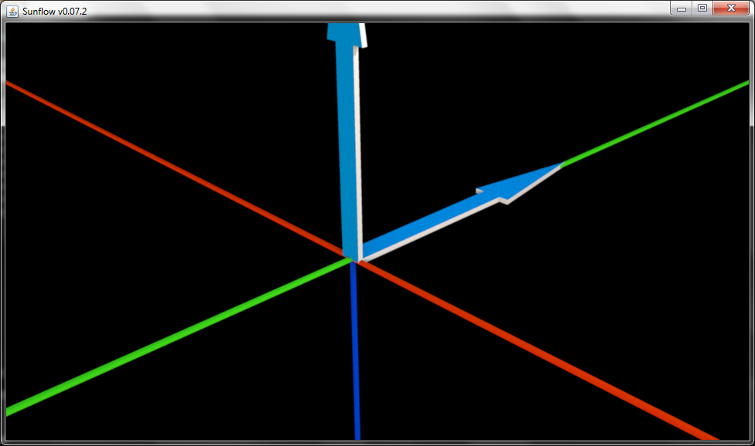

translate +0.0000 +0.0000 +0.0000

%rotatez -0.0000

rotatex +90.0000

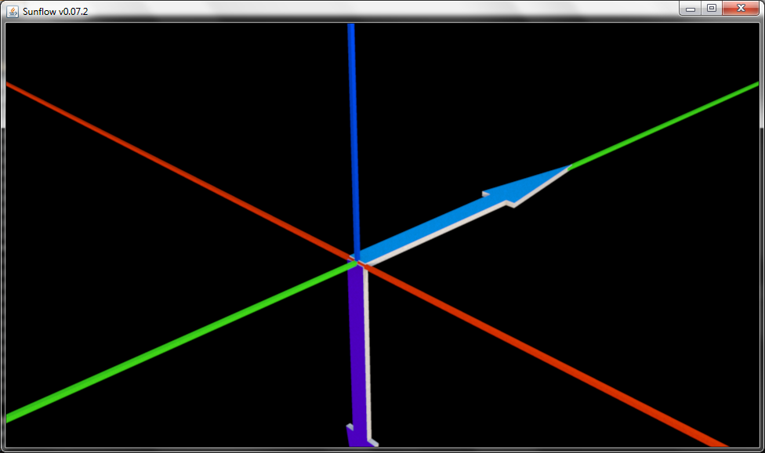

rotatex -90.0000

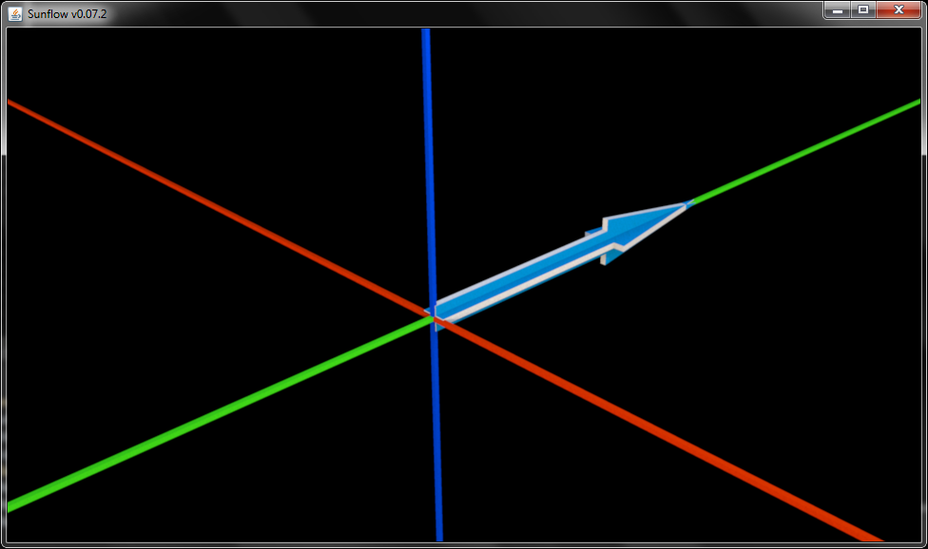

rotatey +90.0000

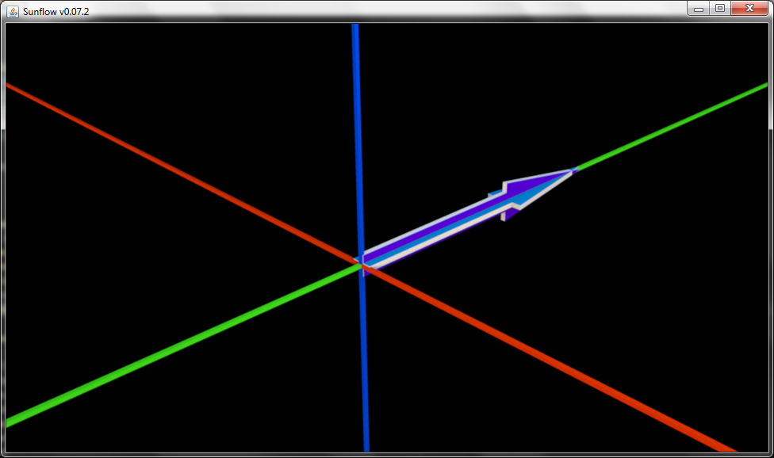

rotatey -90.0000

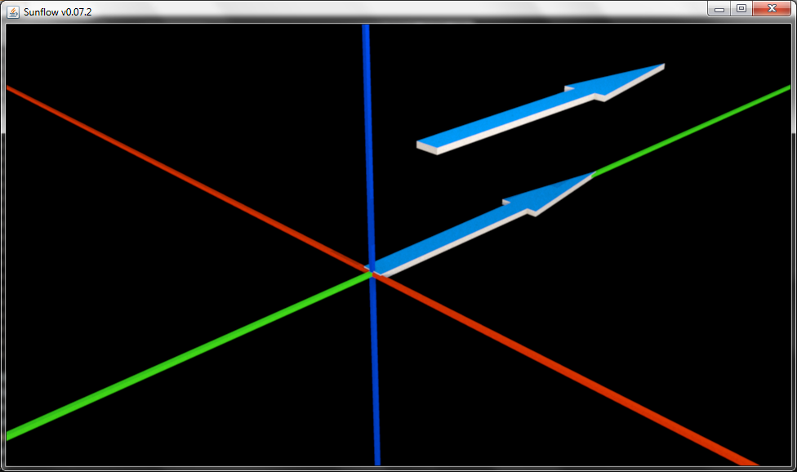

translate +1.0000 +0.0000 +2.0000

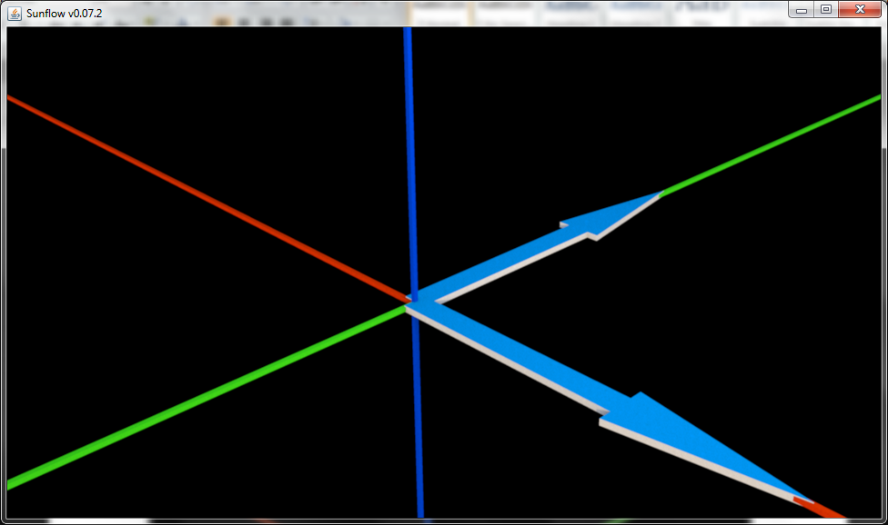

translate +0.0000 +0.0000 +0.0000

rotatez -90.0000

%rotatex -0.0000

%rotatey -0.0000

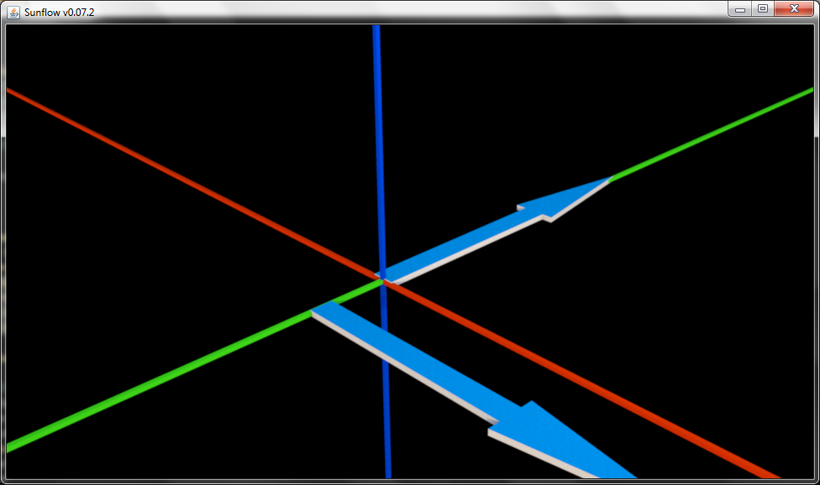

translate +1.0000 +0.0000 +0.0000

rotatez -90.0000

%rotatex -0.0000

%rotatey -0.0000