Rapport

Namn: Xiaorui Wang

Övning 5 randomDice() & print()

To accomplish this task two functions were created one called “randomDice()” and the other called “print()”.

In the “randomDice()” first I create a variable called arr and assigned an empty array to it, which will hold the value that will be returned later. Next a for loop is created and will loop over 1000 times to get 1000 random numbers in the range between one and six. All these random numbers are pushed into the “arr” array. Lastly returns “arr” and stores it.
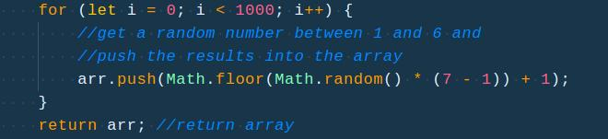
In the second function “print()” a constant variable called “data” is created and holds the “randomDice()” function. Next I use the “reduce()” method to loop over “data” and store it in a variable called “countoccurance”. The way this “reduce()” works is that it takes two parameters, the first one is a anonymous function which has two arguments called “total” and “item” respectively. If an “item” is found in “total”, increment the occurrence of “total[item]” once. Or if this is the first time “total[item] occurs mark it as 1. When it’s all done, return “total”. The “reduce()” method takes a second parameter is set to empty because we do not know for sure what the initial values are so it is tedious to hard-code all the possible initial values. Afterwards, return “coundOccurance” and store it.
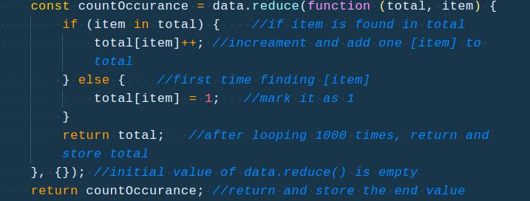
Outside the two functions, console.table(print()) the result. Refresh it a couple of times to get different results.
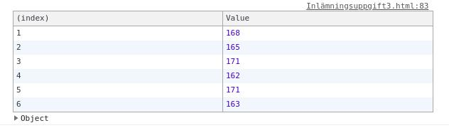
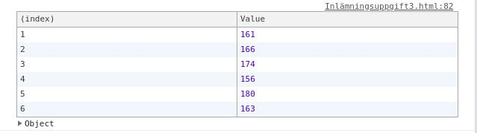
Övning 6 factorialize()

Firstly set up a constant variable “aNum” which is assigned a “prompt()” method that will ask the user to input a random number between 1 and 1000.

Then in a function called “factorialize” which takes a parameter “num” several if/else statements will be run to evaluate a result. If the input number is less than 0 which means a negative number the statement will return -1. If the input number is 0, the statement returns 1 instead. Or if the input number is out of range which means greater than 1000 an alert will be fired up alerting the user “invalid”. Lastly, a recursion is executed if a valid in-range number has been given and evaluated. Outside the function call “factorialize(aNum)” to enable the result.
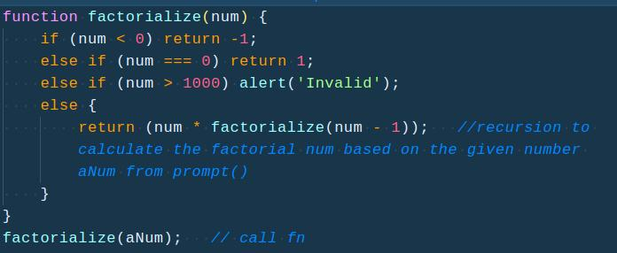
The result from the “factorialize” function is assigned to the variable “text” as a value and displayed in the document marked as id “text”. See the screenshot below:
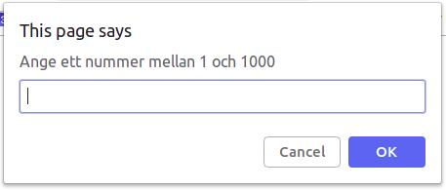

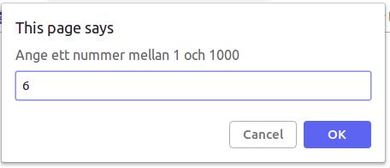


However if the number input is large enough to certain degree, the output will shown “infinity”.

