1. Cka eshte termi Bussines Intelligence ?

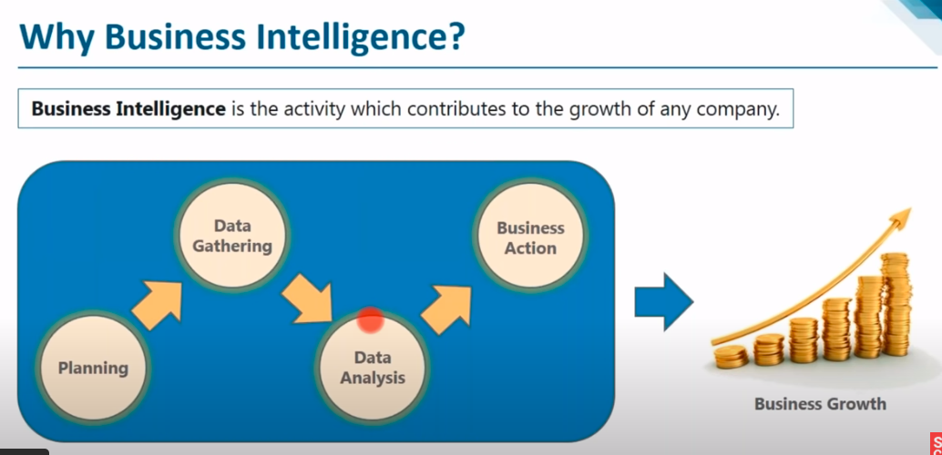



1. Cka eshte Datawarehouse ?

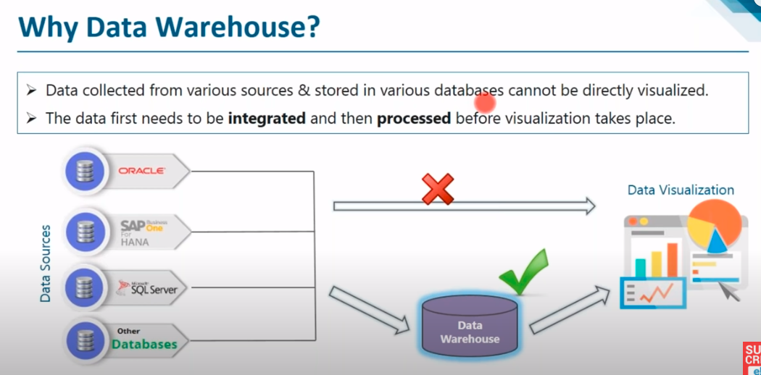

1. Cili eshte dallimin ne mes te nje databaze operacionale si dhe nje DataWarehous?

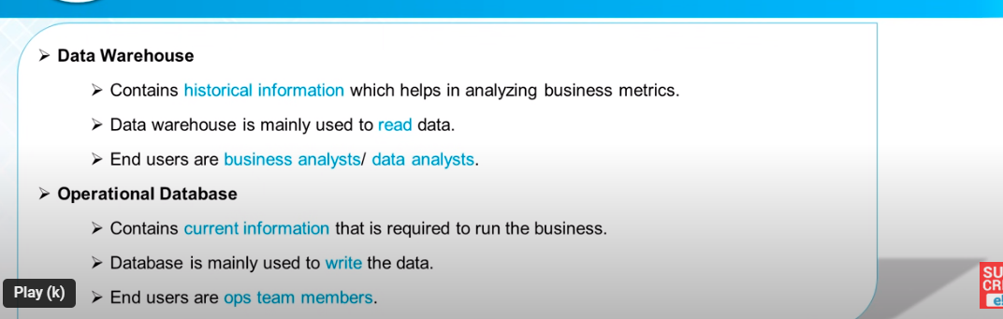

1. Cilat jane 4 fazat e Datawarehaouse?
2. Dallimi ne me OLTP dhe OLAP ?

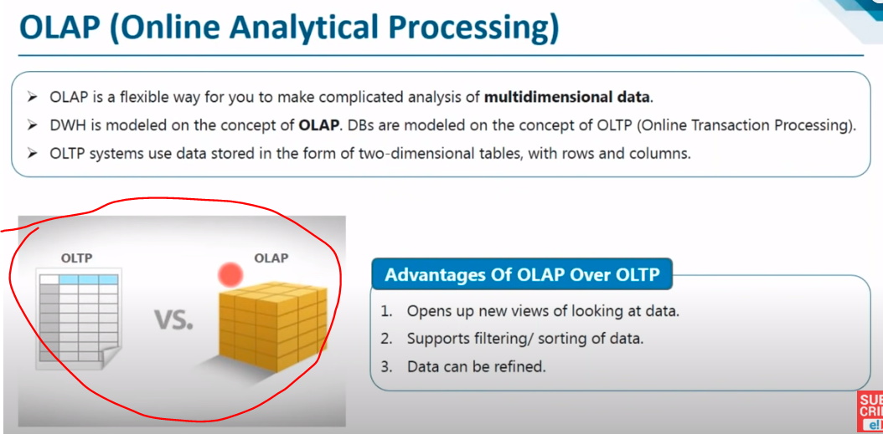

1. Cka jane Metadata ne Datawarehouse ?
2. Cili eshte Dallimi ne mes te Dimensions Table edhe Fact Tables ne Datawarehouse?

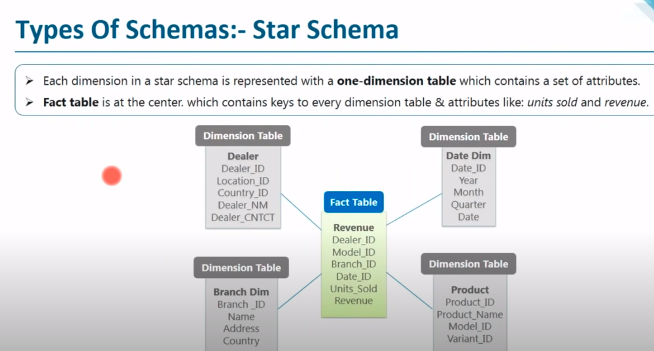

1. **Cka eshte nje ETL ?**

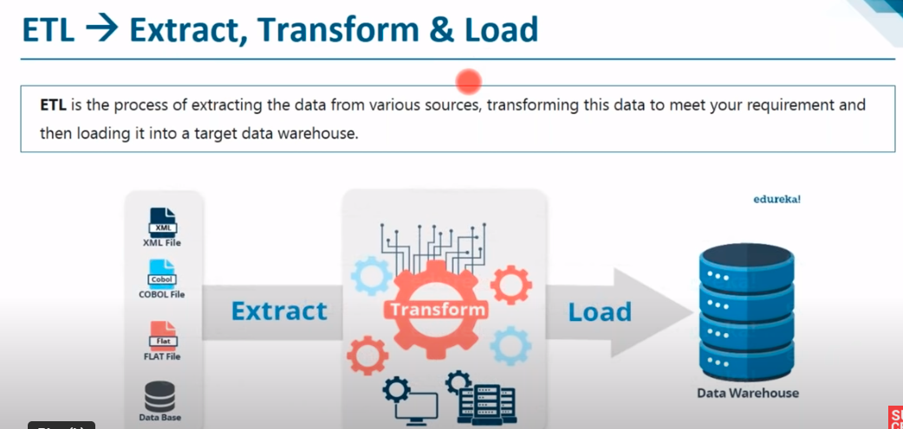

1. **Permendi disa nga tools kryesore qe perdoren per ETL?**
2. Cka eshte **Normalizimi** dhe benefitet e **Normalizimit** ?
3. Cka eshte termi RDBMS?

RDBMS stands for Relational Database Management System. It is a software system that manages relational databases, which are structured collections of data organized in tables with rows and columns.

**Relational Model**, **Structured Query Language (SQL)**:, **Indexing and Query Optimization…etc**

1. Dallimi ne mes DDL, DML?

DDL (Data Definition Language) and DML (Data Manipulation Language) are two categories of SQL (Structured Query Language) statements used in relational databases. Here's a breakdown of the key differences between DDL and DML:

1. **DDL Examples**: CREATE TABLE, ALTER TABLE, DROP TABLE, CREATE INDEX, CREATE VIEW.
2. **DML Examples**: SELECT, INSERT INTO, UPDATE, DELETE.

1. Cili eshte dallimi ne mes ten je **View** dhe nje **Materialized View**?