Hello,

I am Reshat Selmani, I was born on 20.06.1992 in Breznica, municipality of Bujanoc. I finished primary School in my birthplace , then I continued to high school in Gjilan in direction Mathematics and Informatics, which I completed for 3 years with excellent success. It is important to mentioned that during this period I was chosen “Student of generation” and I have won 2 times the first place in the Math competitions organized by the Republic of Kosovo.

After that, I continued my Bachelor degree in Computer Science at the University of Pristina, which I completed for 3 years, In which I was a distinguished student, where I have won a scholarship from the University. After that I finished Master degree in Software engineering in the University of Pristina.

The experience in the field of programming started in 2012, where I was part of the Hemsedal company, for 3 years. Here I worked with c# and sql server. I was part of the team in different projects in Windows and web appliactions

After that I worked as a Software Developer in software development office in one of the Biggest colleges in our country, "AAB Colleague". Here I have been Team Leader and Database Manager for 4 years. During this period, I worked and lead in to many important projects such as:

**E-Student** - Which has been a portal that has served students to easily manage their studies. Through(thruuu) it, they were able to present the exams, see the results, download literature, see the attendance...etc.

**Professor Portal** - has been a portal for professors which helps to manage students, exams, including online testing.

**HR & Payroll** – a program for staff management, including salary calculation

Since 2019, I have been part of one of the most credible banks in Europe, **Raiffeisen Bank,** in the position of Software eng specialist. During this period I worked with big data, including data management, quality assurance and data transformation.

We mainly used Oracle,PostgreSql and Datawarehouse. I was part of the "HO Big Data Tribe" team in which we supported all Raiffeisen International Units in the aspect of Data Engineering.

Since 2022, I am part of the Competence Center in Raiffeisen Bank in the position of Senior Software Developer. CC is a Department that develops programs for RBI and for all their needs. I am currently working on a project called "Ecase", which serves to manage transactions in the Compliance department in Vienna.

Actually we mainly work with programming languages: .Net Core and the SQL Server database.

Also is very important to emphasizes a good part which I consider as a "Strong Gun" for myself, which is Problem Solving, in which I think I am very good.

Pyetje:

**1. How does ALB work?**

The Application Load Balancer effectively distributes network load in the public cloud to improve both stability and availability. It t allows a developer to configure and route incoming end-user traffic to applications based in the AWS public cloud.

**2.How does buffer overflow work?**

A buffer overflow, or buffer overrun, occurs when more data is put into a fixed-length buffer than the buffer can handle. The extra information, which has to go somewhere, can overflow into adjacent memory space, corrupting or overwriting the data held in that space.

**3.How would you design an IDE like Visual Studio?**

1. Develop an environment that allows developers to write, compile, debug, and package code.

2. Create a user interface with a customizable layout that supports multiple views, such as code editors, project navigators, and debugging consoles.

3. Integrate an editor with syntax highlighting and auto-completion capabilities.

4. Add support for multiple programming languages, including C/C++, C#, Java, JavaScript, HTML, and CSS.

5. Include tools for project and file management, such as a version control system and task tracking.

6. Include debugging and testing tools, such as a visual debugger, unit test framework, and code coverage metrics.

7. Create an extensible architecture that allows developers to add plug-ins and extensions for specific programming needs.

8. Incorporate tools for rapid application development, such as drag-and-drop user interface creation and database integration.

9. Provide options for online collaboration, including shared project workspaces and real-time editing.

10. Include support for deployment, including packaging, installation, and distribution.

**4.Design the INSTAGRAM?**

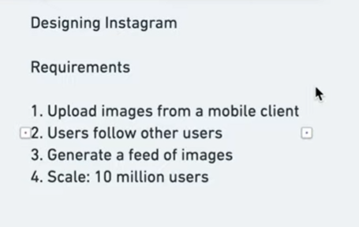

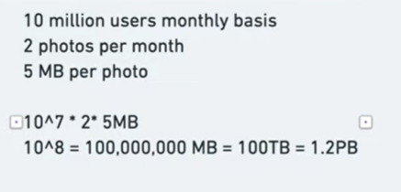

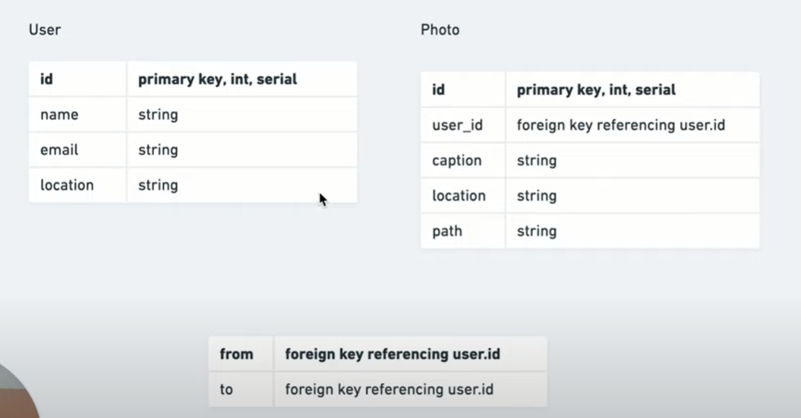

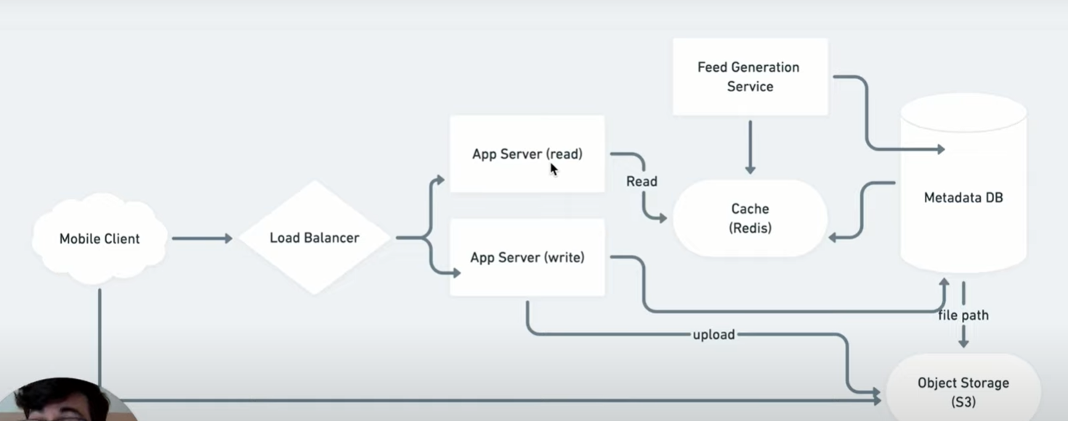

**4.Design the Watsup?**

