Assignment II

Brendan Lensink

OVERVIEW OF YOUR GAME

The purpose of this game is to teach users how arrays operate in Java. The intended audience of this game is students aged 18-25, but realistically anyone who is interested in learning about arrays in an unconventional manner. While the game feels more like a puzzle than an educational game, it seeks to give users a deeper understanding of arrays through metaphor and interaction, at the same time allowing users to learn without really feeling like they are. This game is also designed in such a way that the content is not restricted to arrays, while the main story is about arrays, there is ample opportunity to use the game to practice many other subjects, and even for users to create their own puzzles to practice whatever they like. One example of this could be using the puzzle to learn the Periodic Table of the Elements by tasking users with separating elements by their categories or charges.

GAME SCREENSHOTS

Splash Page with Menu Options
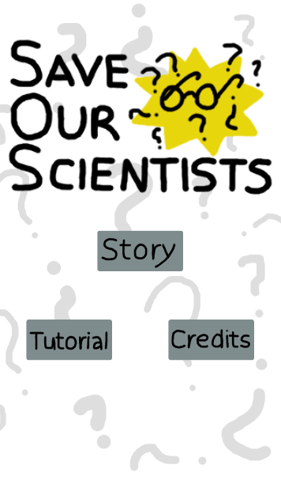
Figure 1: Title Scene

Credits Screen
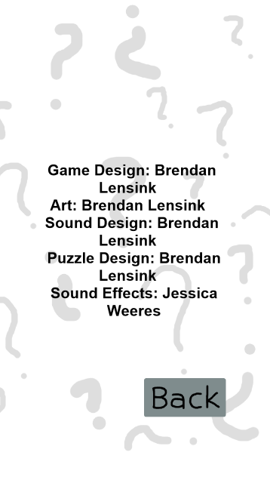
Figure 2: Credits Scene

Tutorial Screen(s)
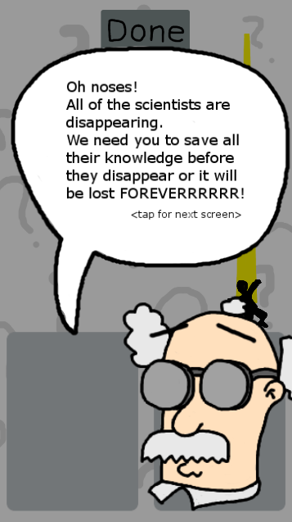
Figure 3: Tutorial Scene 1
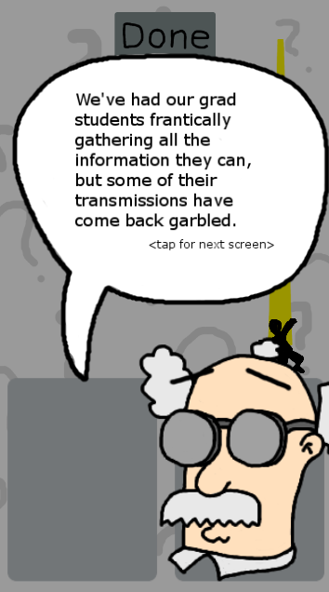
Figure 4: Tutorial Scene 2
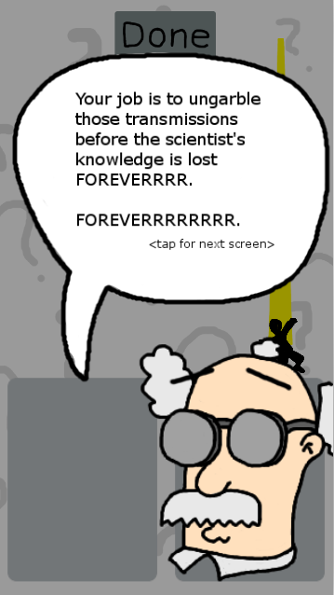
Figure 5: Tutorial Scene 3
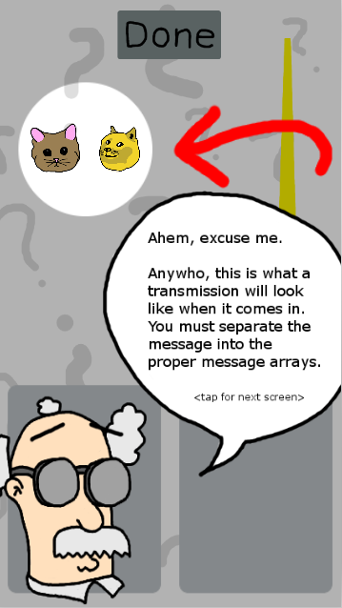
Figure 6: Tutorial Scene 4
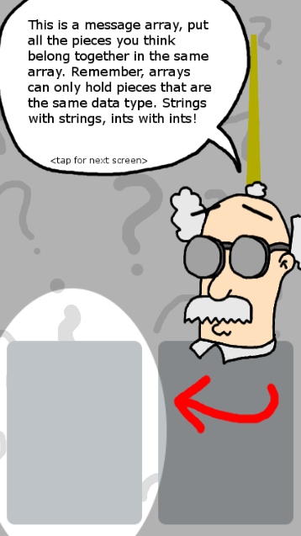
Figure 7: Tutorial Scene 5
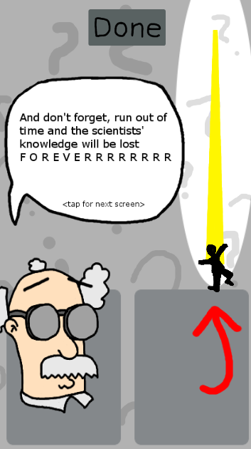
Figure 8: Tutorial Scene 6
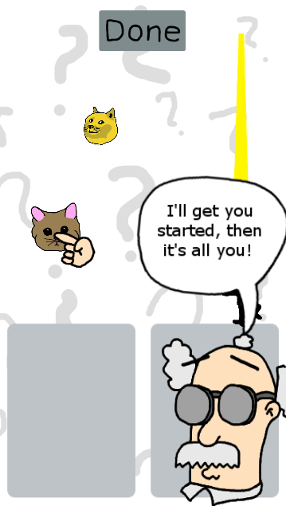
Figure 9: Tutorial Scene 7

Note that scene 7 is animated, the hand appears and drags the cat from its starting location to the box on the left. It appears in the screenshot mid-transition.

Consent Screen
Figure 10: Consent Scene

Game Play Screens
Each level begins with a cutscene that introduces any new concepts the level may contain and serves to progress the story.
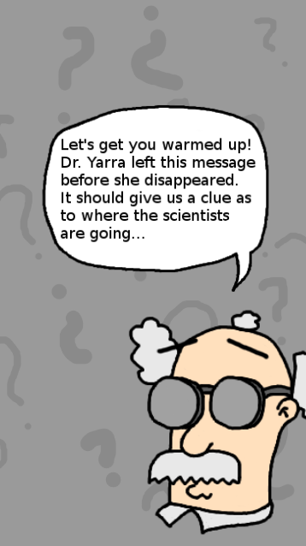
Figure 11: Pre-level cutscene
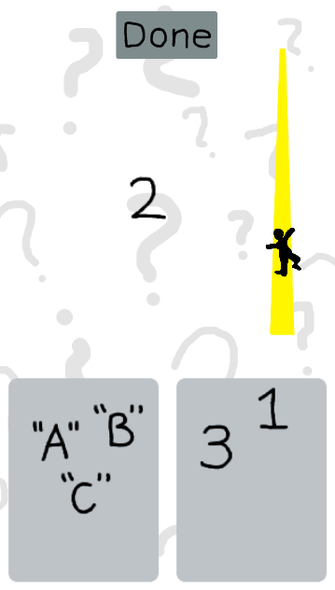
Figure 12: A partially completed level
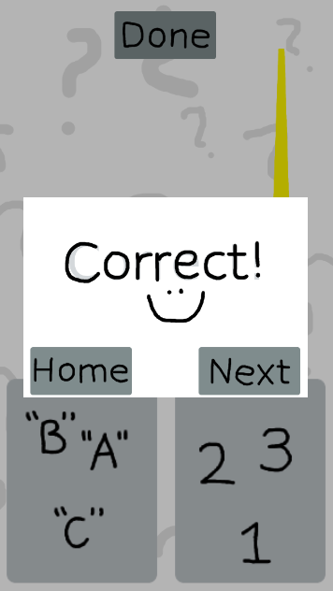
Figure 13: Successfully completed level
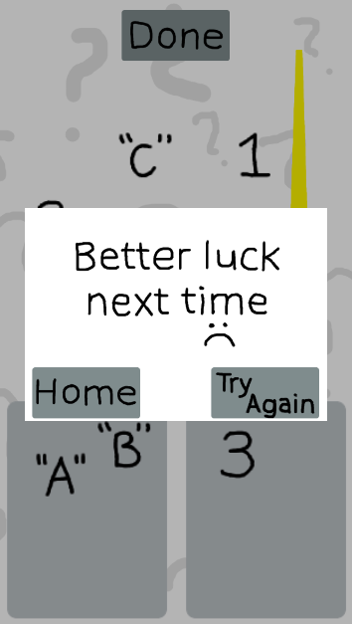
Figure 14: The user is incorrect or runs out of time

INTELLECTUAL PROPERTY

All images and sounds were created by me.

DESIGN RATIONALE

A majority of the complaints with educational games cited in the first assignment revolved around usability and graphics. With that in mind, this game was designed to be easy to understand and play, with minimal distractions.

Rationale for Better UI Design

The UI of the game is intentionally sparse and simple, to prevent it from distracting from the gameplay. Similarly, all of the icons and objects manipulated by the users are black and white, to focus instead on their meaning than the art. As puzzles are generally very short, it is important that users are able to quickly enter the game and begin playing with minimal friction, allowing them to practice whenever it is convenient for them and without requiring any large time commitments.

Rationale for Better Pedagogy

After users have completed the story and gained a thorough understanding of arrays, they will be allowed to create and share their own custom levels, opening up an entire depth of learning not explored in any of the games examined in Assignment 1. While the basic concepts are taught in the story, as with the games analyzed in Assignment 1, the deeper understanding comes with higher level learning outcomes.

PROPOSED DATA LOG

Questions to Address
- How long does it take the average person to complete a puzzle?
- Is the game too easy? Does the story provide enough direct comparisons to arrays that users are able to learn from it?
- What is the ratio of completed to abandoned puzzles?
- Is the tutorial helpful?

These questions address all of the concerns I have with the game, namely that without time constraints the main game becomes too easy. Each of the first three questions answers part of this question, as their composite information should be enough to make informed balance decisions while still keeping the game entertaining.

Data to Collect

For each puzzle, we will track how long the user takes to get a correct answer, how many times they submit an incorrect answer and how often they quit the app or return to the home screen while a puzzle is in progress. While there are a number of reasons this is possible, it is important to know if users are either becoming frustrated and quitting puzzles or if the puzzles take longer than expected.
Additionally, we will keep track of whether a user has completed the tutorial and compare this with their success rate. How many times the tutorial has been completed by a user will also be recorded, as having to go back and repeat the tutorial may indicate that it is not well done or instructions are unclear, forcing users to repeat the tutorial until they are sure of what they are supposed to do.

