Save Our Scientists Final Report

Brendan Lensink
Creator, Developer
blensink192@gmail.com

ABSTRACT
Save Our Scientists is an educational puzzle game meant to provide users with a full and deep understanding off arrays and also provide users with the tools to create their own puzzles about a variety of subjects to further their learning.
This report will serve as a summary and final report for the mobile educational game Save Our Scientists. In it, the educational, design and entertainment goals are first outlined, providing an insight into the guiding principles and ideas that influenced the final game design. Next the game’s implementation and features are highlighted including a summary of all the relevant scenes and their functions.
Keywords

Mobile game, educational game, java, arrays, puzzle games, high quality art.

DESIGN PROBLEM
On the surface, Save Our Scientists is a simple puzzle game designed to teach users how arrays are constructed and work in Java. Users learn through solving a sort of matching puzzle, in which they are given a collection of objects and tasked with sorting them into the groups they would occupy if they were placed into arrays in Java.
Once the user has completed the main story of the game, they are introduced to the custom game section, where they are able to play and create new puzzles to share with other users. The purpose of these custom games is to enrich the user’s learning experience by allowing them to create their own games to further their understanding, while taking the load off of the game creator for making new, more difficult puzzles.
While there may be games like this that exist, in researching what sort of games already existed in the space none were found, as most games were just thinly veiled multiple choice quizzes. As such it was important that this game do something different. Additionally, most games researched lacked much in the way of story, and as such came off as very uninviting and not compelling to return.

DESIGN GOALS
First and foremost, the game should inspire users to come back and play more, and to that end it should be fun. While educational outcomes are undoubtedly important, they mean very little when users play the game for a couple minutes and then close the game and never play it again. As such, the overall focus of the game is on replayability and entertainment value, while trying not a sacrifice educational outcomes.

Pedagogical Goals
This game is designed in such a way that as the user progresses through the different aspects of the game, they learn more and more about arrays, and then finally are opened up to the possibility of applying their learning to other fields or subject matter.
This process begins with the tutorial, which users are strongly encouraged, but not forced, to complete. In the tutorial the users should learn the basic premise of arrays and gameplay. This stage is meant to introduce the users to the concept of arrays and give them an understanding of the expectations of learning outcomes.
Next, users play through the story in which the lower levels of Bloom’s Taxonomy are fulfilled. Here users solve a series of puzzles with increasing difficulty, with the goal being to help users understand which values arrays can hold and how they operate.
By completing the story users unlock the ability to play levels created by other users and potentially create their own levels. This allows users to gain an even deeper understanding of the material as described by the higher levels of Bloom’s Taxonomy.

Entertainment Goals
As mentioned previously, educational games are only effective if users are engaged and want to come back and continue playing the game. To that end, the primary goal of this to have an incentive for users to return and keep playing the game.
This is sort of at odds with the subject matter of the game, as arrays are not a very difficult or complex subject. With that in mind, the game was designed in such a way that the custom games can be created for a number of other subjects, allowing users to use the game for learning other material.

Development Goals
This game is designed to work on both iOS and Android through the Corona build environment. However, due to technical restrictions was only tested on Android, specifically on a Nexus 5.
Conference’10, Month 1–2, 2010, City, State, Country.
Copyright 2010 ACM 1-58113-000-0/00/0010 …$15.00.

Permission to make digital or hard copies of all or part of this work for personal or classroom use is granted without fee provided that copies are not made or distributed for profit or commercial advantage and that copies bear this notice and the full citation on the first page. To copy otherwise, or republish, to post on servers or to redistribute to lists, requires prior specific permission and/or a fee.

The game was architected to use an MVC structure in which all of the game assets including audio, art and text are able to be changed and customized in anticipation of a store. Puzzles are also made using a generic scene that allows new puzzles to be created easily by the developers or by other users and published to a server where they can then be downloaded by other users.

Save Our Scientists

Tutorial and Story Mode
The meat and potatoes of the game, this is the user’s first experience with the game as upon installing the game this is the only functionality available to them. While they are able to start the story without completing the tutorial, they are notified that it is encourage to play through the tutorial.
In the tutorial, users are guided through their first puzzle by a narrator and then asked to complete their first very simple puzzle.
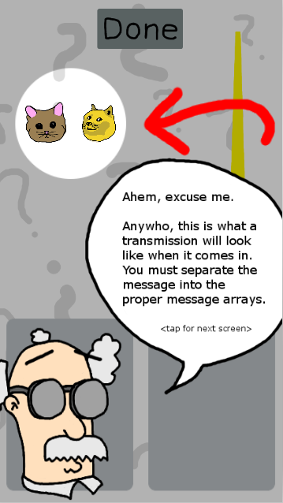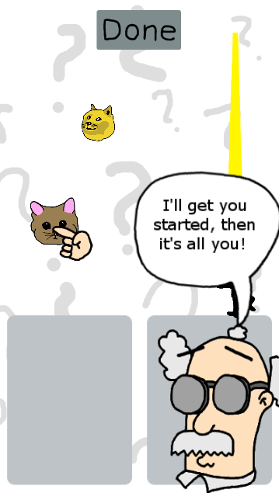

After completing the story, users can play through the story in which progressively difficult concepts of arrays are introduced through a series of puzzles. Each level begins with a small narrative that progresses the story.
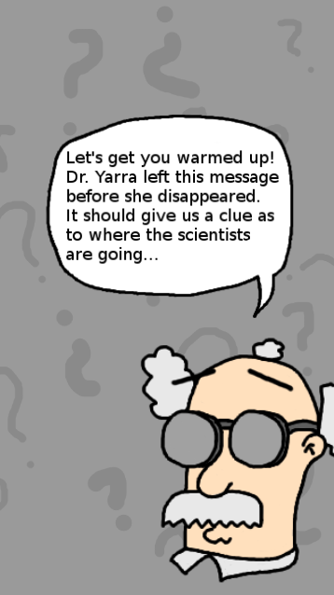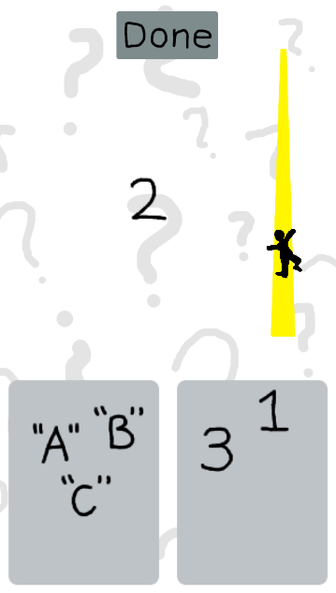

Custom Games and Store
After completing the story, users are able to access the store and the custom games screen from the main menu.
In the store, users can buy a variety of things using points earned completing custom games. They can buy cosmetic items or ones that augment their ability to finish custom games.
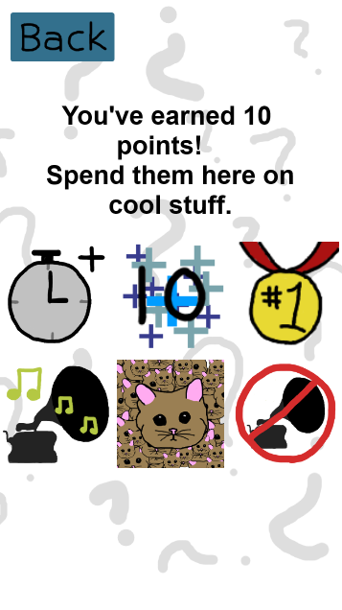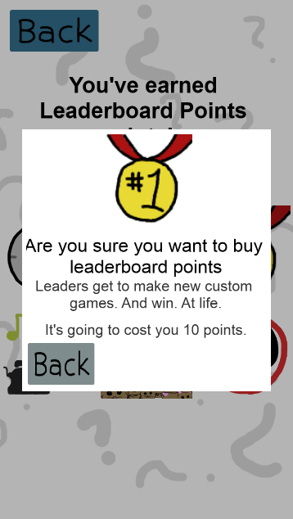
On the custom game screen, users can play custom games and see their current ranking among other users. If they are in the top 50% of all users for leaderboard points, they are also able to create new custom levels.
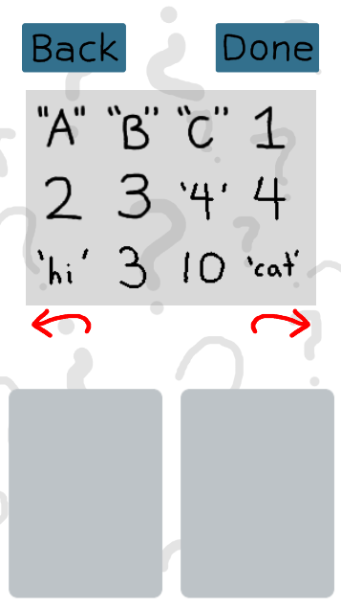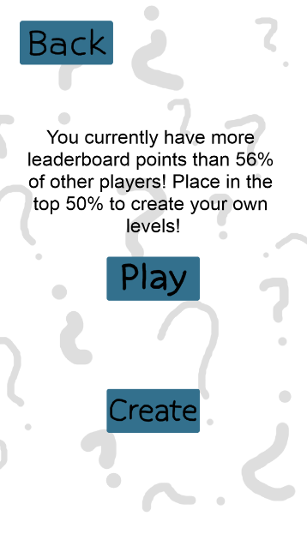

Summary of Features
Once the user has completed story mode, they unlock the ability to explore the additional features in the game, focused on the features added in the final stage of the project listed below.

Scoreboard and User Generated Content
The custom games section allows users to play other puzzles created by their peers. Completing these puzzles correctly awards points on a sliding scale based on their completion time. Since all puzzles are currently timed to last sixty seconds, it is easy to award points in tiers where faster times earn more points. Collecting these points allow users to buy items from the store, including the ability to purchase leaderboard coins. These coins are essentially a points sink, in that they provide no intrinsic value except that each user is able to see how many points they have in comparison to other users in the form of a rank viewable on the custom games page. Additionally, if a user is in the top 10% of all users for leaderboard coins, they are able to create new custom games for other users. The intent is that allowing only productive users to create new puzzles will prevent some amount of dud puzzles.

In-Game Store and User Generated Content
As mentioned above, unlocking the store will allow for the user to purchase a number of different items in addition to the leaderboard coins mentioned above. These items can be divided into two categories: cosmetic and game-effecting. Cosmetic items are priced in such a way that they are relatively expensive, and are intended to be long term goals to reward dedicated players. They provide silly things like changing the in game audio or changing some of the art assets. The other category of items, game-effecting items, provide consumable bonuses that users can use to complete difficult puzzles or boost their points earned.

Availability
Give the URLs of the iOS and Google play store links in this section to let us know where your game can be downloaded.

Google Play Link:
https://play.google.com/store/apps/details?id=com.gmail.blensink192.App
Github Public Repository:
https://github.com/Blensink/Cosc499B

