

EXTERNAL INTERGRATED SUMMATIVE ASSESSMENT
Quality Controller, NQF4

STUDENT NAME & SURNAME
IDENTITY NUMB ER
ASSESSMENT CENTRE
ACCREDITATION NUMBER
QUALIFICATION | QUALITY CONTROLLER
QAQA ID | 117309
NQF LEVEL | 4
CREDITS | 173
PAPER NUMBER | 1D
DATE OF EISA DD/MM/YYYY
DURATION | 2 HOURS
TOTAL MARKS | 120
EXTERNAL INTEGRATED SUMMATIVE ASSESSMENT
QUALITY CONTROLLER
MEMORANDUM 1D

GENERAL EISA RULES

. Students to ensure that their name, surname and EISA registration number appears on the front of your EISA booklet.

. This is a closed book examination; therefore, no other material or belongings are to be brought into the assessment centre. Should you bring any other material or belongings into the assessment centre, you will be required to leave such at the front of the assessment centre examination room. The assessment centre will not be held liable for any loss or damage to property brought into the assessment centre examination room.
. All EISA booklets must be handed back to the invigilator intact. No pages may be torn off from the EISA booklet. The removal of EISA booklets from the examination room is prohibited.
. Students may make use of a calculator in this EISA.
. Unless this is an online examination where access to a computer will be made available to you; the use of any communication devices, including smart watches, cell phones, tablets, iPads, headphones and laptops are prohibited.
. All cell phones are to be switched off for the duration of the EISA.
. The invigilator will not assist you with the explanation of questions related to the EISA.
. Students are prohibited from conversing in any manner with other students.
. Students may not leave the examination venue within one hour of the start of the examination and in the last 10 minutes of the allotted examination period.
. Students who are found to be disruptive and unruly in the assessment centre will be requested to leave the assessment centre by the invigilator.

I HEREBY CONFIRM THAT I HAVE READ THE ABOVE EISA RULES AND DECLARE THAT I
UNDERSTAND AND ACCEPT THE RULES.

________________________
SIGNATURE OF STUDENT

CANDIDATE INSTRUCTIONS

- Candidate must complete all question s in the EISA
- Candidates must ensure that they use only a black pen when completing this EISA.
- Should you require additional space to complete your answer, please request additional paper from your invigilator.
- Ensure that you indicate your name, surname and EISA registration number at the top of the additional paper.
- Also ensure that the question number is clearly marked on your additional paper.

-----------------------------------------------------------------------------------------------------------------
ur Sayzwani Abd Suki;Elmi Abu Bakar ,Shahrul Kamaruddin/ A Case Study on Improvement of Outgoing Quality Control Works for Manufacturing
Products 4(1), pp. 12-21, 2015
1.1.1
Complete a quality inspection checklist for input, inline and endline for product or service
1.1.1 Case Study
Allocate ten mark each for number 1
Use discretion to allocate marks for any other relevant point that may be given by the student.

Case Study:
Quality inspection is the measurements aimed at checking, measuring, or testing one or more product characteristics and relating the results to the requirements to confirm compliance. This task is usually performed by quality inspectors and quality controllers and does not fall within the responsibility of production workers.
Purpose of Quality Inspection
- To distinguish good batches from bad batches
- To distinguish good pieces from bad pieces.
- To determine if the process is changing.
- To determine if the process is approaching the specification limits.
- To rate the quality of the product.
- To rate the accuracy of inspectors.
- To measure the precision of the measuring instrument.
- To secure products – design information.
- To measure process capability.
When creating a check list for quality inspection, the above mentioned purposes of Quality inspection must be taken into consideration. Create a Quality Inspection checklist which will address the purposes of Quality Inspection listed above.

Learner Own answer: Answer must address the purposes of Quality Inspection listed above as per instructions. (10 Marks)
Total | 10

1.1.2
Identify whether testing and/or inspecting is applicable in a product manufactured or service environment.
1.1.2 Constructive Response
Allocate ten marks
Use discretion to allocate marks for any other relevant point that may be given by the student.

Quality parameter refer to the size characterizing the quality level of the final product/service, the quality of final products or services can be described using some of the following Quality Inspection process below:
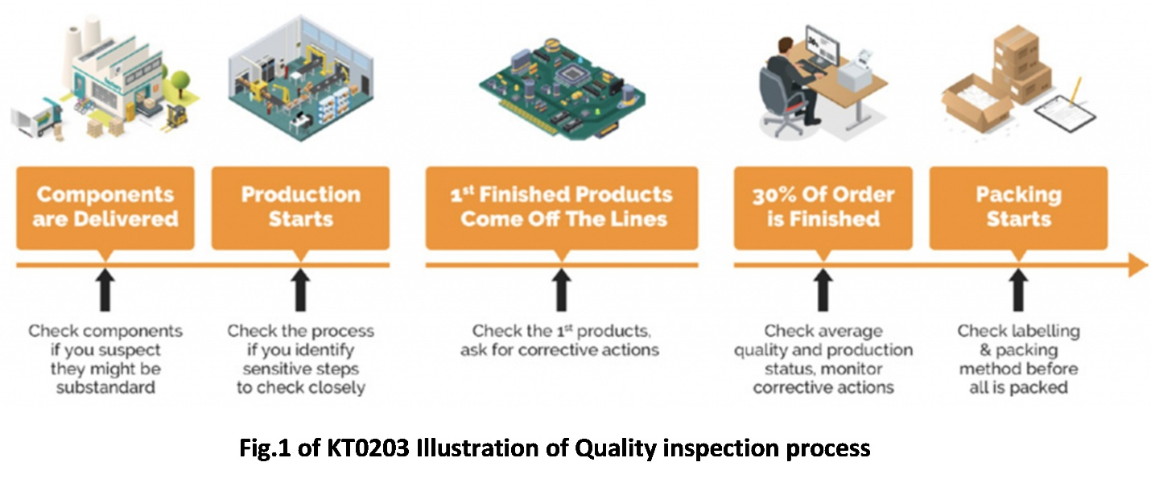

Looking at the process above at what stage will there be a need to perform either inspection or testing. Give industry related example to substantiate your answer.

Stage 1: Components are delivered - Inspection/testing depending on the standard operating procedure. Learner must justify why they chose either one of the two or why they chose the two methods.

Stage 2: Production Starts – Inspection as the operator must verify if they have all the required components to start production and to and to report any discrepancy as per the standard operating procedure.

Stage 3: 1st Finish Product comes off the Line – Testing as the quality controller must test the characteristics of quality as per the batch sheet and ensure that they are within specification before moving to the next stage (in- process testing) and also recommend any corrective measures required.

Stage 4: 30% Of Order is Finished – Testing as the quality controller must test if the recommended corrective measures are working and to ensure that the batch is still within specification and that there is no deviation against the standard.

Stage 5: Packing Start- Inspection as the quality controller must verify the packaging method as per the standard operating procedure and also to check if labelling is done correctly as per the batch card.

Total | 10

1.1.3
Complete a testing checklist for a product or service across all processes (input, inline and endline)

1.1.3 Case Study
Allocate ten mark each for number 1
Use discretion to allocate marks for any other relevant point that may be given by the student.

Service testing starts with the inputs, processing and outputs of services. It is important that inputs of services are tested for quality requirements before the service process starts. That is if the inputs are of good quality, it is likely that the quality services will be rendered.

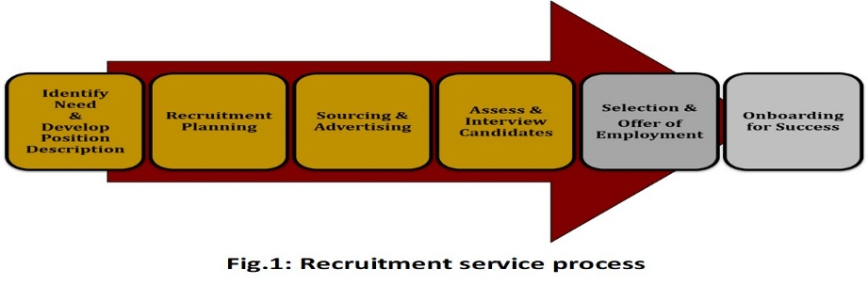

Generate a testing checklist that will ensure that there will be no gaps in the recruitment service process. The checklist should address all the steps in the process.

Learner Own answer: Answer must address the recruitment services process above as per instructions. (10 Marks)
Total | 10

1.1.4
Continuously inspect and test input, inline and endline to prevent non-conformance and make recommendations.

1.1.4 Case Study
Allocate fifteen Marks for number 1
Use discretion to allocate marks for any other relevant point that may be given by the student.

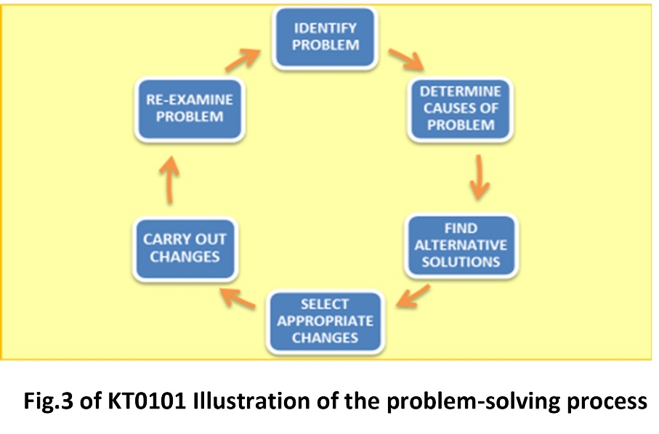
The problem solving process can assist in making recommendations to prevent non-conformance during the input, inline and endline of a process

Number | Question and Answer | Mark
1 | Discuss the problem solving process which will assist in preventing non-conformance for the input, inline and endline  1. Identify the problem or symptom  Take time to document the problem in clear terms that everyone can  understand. Make sure to also explain the impact of the quality problem to the project. The first rule of problem resolution is that if the problem is not defined then it cannot be solved.  2. Identify the root cause  Identify the root cause of the problem and explain how the root cause ultimately results in the problem that has arisen. There are a number of problem-solving techniques that can be utilized, including the root cause analysis and Fishbone Diagrams.  3. Determine alternative solutions and impacts  Once the cause is identified, look at the alternative solutions and the impact of each solution. For each solution, it is important to address the impact it will have in terms of costs, benefits, and risks.  4. Select the best solution  The best solution will be chosen based on the above criteria.  5. Implementation  The best solution will be chosen based on the above criteria.  6. Monitoring and evaluation  The implemented solution needs to be monitored to ensure that the quality has improved as expected. If the quality has improved the implementation maybe allowed to continue. However, if the quality is not improving as expected, further corrective action may be required. | 15
Total |  | 15

1.1.5
Apply knowledge of and adhere to good manufacturing principles (GMP) of product or good laboratory practices (GLP) of services

1.1.5 Constructive Response
Allocate 10 marks for number 1
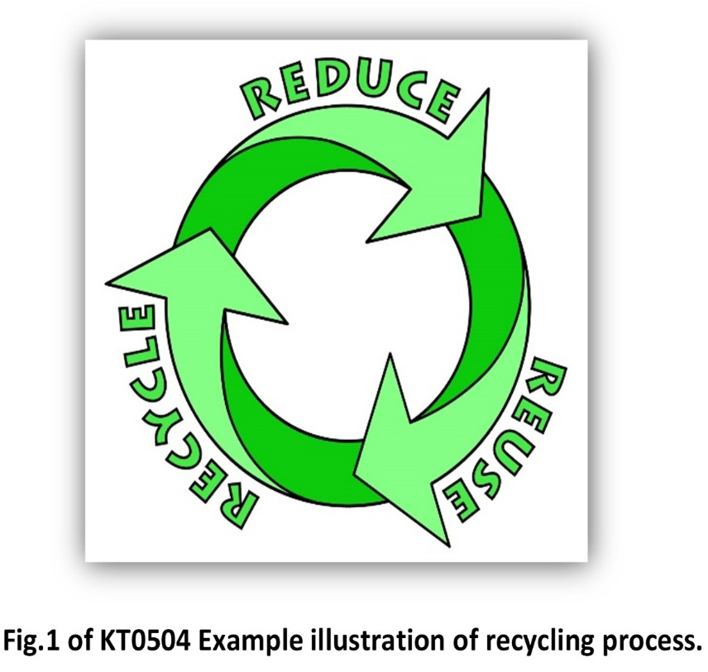

Number | Questions and Answers | Marks
1 | Discuss the recycling process in the picture above applicable to a quality control environment.  Reducing is eliminating the use of materials destined to become solid waste right at the early stages of design and manufacturing. This is known as source reduction. Reducing can increase energy efficiency because disposal processes are avoided. Source reductions can be initially expensive for a company, but it can ultimately be more cost-effective and sustainable in the end.  Reusing refers to reworking a soon-to-be-discarded product or material rather than discarding it. Reusing is more energy efficient than recycling and disposal, as companies can transport used containers (e.g. bottles) to a factory to be washed and then reused for more product. However, repairing requires time, labor, energy, and sometimes more materials.  Recycling is the process of converting certain waste materials into new materials and objects. Recycling utilizes resources that have already been extracted, saving energy, time, and money. Additionally, recycling facilities help create new jobs because they require sorting, processing, cleaning, etc. However, the main issue with recycling is that demand for new raw material is not reduced. It is also more energy-intensive than reducing and reusing due to required processing, cleaning, transporting, and possible modifications. | 10
Total |  | 10

1.1.6
Apply different testing methods for different characteristics to test for product/service quality applicable in their environment

1.1.6 Case Study
Allocate ten marks for no1
Use discretion to allocate marks for any other relevant point that may be given by the student.

Case Study:
Testing methodologies are applied in different types of industries. The types of tests conducted depend on the products/services being produced, these tests are important for a company to grow and to be competitive.

Number | Questions and Answers | Marks
1. | Discuss the five test methodology below in details and give industry example.  - Integration testing is the testing of various modules of the software under development together as a group. This determines whether or not they function together seamlessly as part of the system or whole.  - Unit testing is done on modules or units of the project individually to make sure they function as they should.  - System testing is a level of testing that validates the complete and fully integrated software product. The purpose of a system test is to evaluate the end-to-end system specifications. Usually, the software is only one element of a larger computer-based system.  - Performance testing is a non-functional type of testing and involves the process by which software or an application is tested to know its current system performance. It checks how the current system performs in terms of responsiveness and stability when tested under varying workload conditions.  - Load testing is performed to validate the system (application under test) performance under normal (usually around 70% of peak user load) and peak user load. Companies should adopt load testing as a part of their software development life cycle (SDLC). | 10
Total |  | 10

1.1.7
Apply knowledge of testing procedures of a product or service.

1.1.7 Constructive Response
Allocate ten marks for no1
Use discretion to allocate marks for any other relevant point that may be given by the student.

Random testing is often a difficult practice to approach for businesses in all industries. Both established and growing businesses need the same questions answered in regard to how they should implement a random test program.

Number | Questions and Answers | Marks
1. | Discuss Random testing and the 9 guidelines for an effective random testing program:  Random testing is the most effective way to keep the business compliant with regulations and free from unnecessary liability and risk.  Guidelines for an effective random testing program:  - Establish a testing protocol that meets minimum regulatory requirements.  - Use a statistically valid random generator to ensure each employee has the same probability of selection.  - Employ stratified random sampling to reduce chances of an employee being missed or tested twice in a year.  - Document the entire random testing process in case of an audit or litigation.  - Strictly limit the time between notifying a worker of his or her selection and testing.  - Familiarize yourself with your testing provider’s business hours and testing policies.  - Follow all state regulations in order to remain compliant and avoid penalties.  - Account for any unique testing needs the business has and tailor the testing policy to meet those needs.  - Keep selection notifications and testing as discrete as possible and keep all results confidential. | 10
Total |  | 10

1.1.8
Test if product/service conforms to the required standard

Multiple Choice Questions
Allocate one mark each for number one to five
Number | Multiple Choice Questions | Answers | Marks
1. | The quality of the final product /service is determined by the characteristics of  - Resource Functioning  - Resource Testing  - Resource Allocation  - Resource Analysing | A
2. | A quality problem may occur due to  - Lack of resource,  - Skilled employees  - Poor management  - All of the above | D
3 | When carrying out the remedial measures, The Shewhart PDCA cycle Means  A. Plan, Check, Do, Apply  B. Plan, Check, Do, Adopt  C. Plan, Check, Do, Analyse  D. None of the above | B
4 | When analysing a problem it may be necessary to look beyond the obvious by,  - Seek other perspectives  - Be flexible in your analysis  - Consider various strands of impacts  - All of the above | D
5 | This technique is used to give a rough assessment for the probability of a source of a problem  A. Flow Diagram  B. Pareto Charts  C. Histogram  D. Cause and effect diagram | C
Total |  |  | 5

2.1.1 Identify tools (what) and method (how) to use in processing information during manufacturing and service rendering

2.1.1 Multiple Choice Question
Allocate one mark each for number 1 to 5
Number | Multiple Choice Questions | Answers | Marks
1. | Used by quality assurance personnel to validate the quality of purchased raw materials based on set acceptance criteria  - Technical datasheet  - Certificate of Conformance  - Inspection checklist  - Testing checklist | B
2. | Documented information needs to be maintained by the organization to establish  - The scope of the quality management system.  - The information which will not support the operation of processes.  - Measure to hide the quality policy and procedures.  - None of the above | A
3 | 3 steps constituting the data processing cycle are:  - Input, Output, Process  - Process, Input, Output  - Input, Process, Output  - All of the above | C
4 | Collation plays the following roles:  - Can be used as a tool to control theft.  - Customer complaints are listed in files and can be attended to promptly.  - The prices for different products are listed accordingly.  - All of the above. | D
5 | Customer complaints documents are inputs used to:  - attend to complaints from customers  - Attend customer complaint from employees  - Attend customer complaints from managers  - Attends customer complaints from suppliers | A
Total |  |  | 5

2.1.2 Gather information using tools from samples taken and data from statistical process control (SPC
2.1.2 Case Study
Allocate 10 marks for number 1
Use discretion to allocate marks for any other relevant point that may be given by the student.

The data table can be used to draw charts and combined to summarize information as shown below.

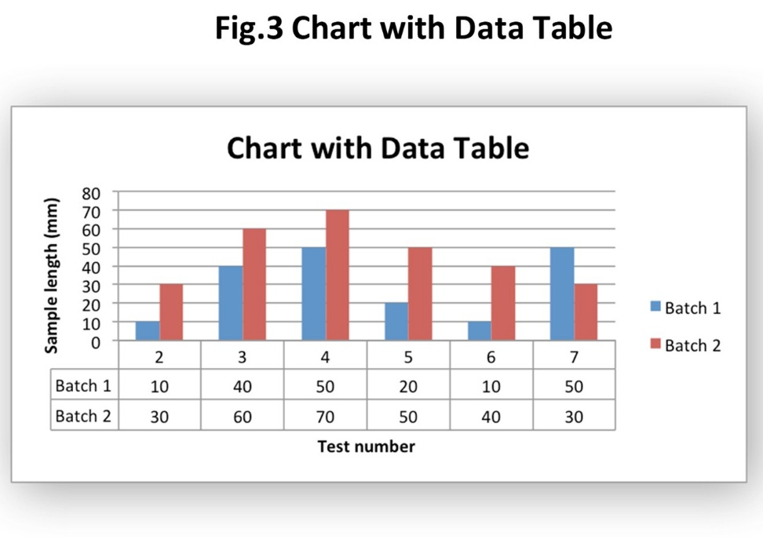
Number | Question and Answer | Marks
1 | Study the data above and discuss why the chart with data table was used to gather the above information.  You must cover the following in your answer:  1.The relationship between the two batches  2.Interptretation of the graph peaks for the two batches  3. If control charts would have provided the same feedback  Learner Own answer: Answer must address the 3 topics listed above as per instructions. (10 Marks)
Total |  | 10

2.1.3 Analyse sample results and data collected from service delivered or manufacturing process
2.1.3 Constructive Respond
Allocate 10 marks for number 1
Use discretion to allocate marks for any other relevant point that may be given by the student.

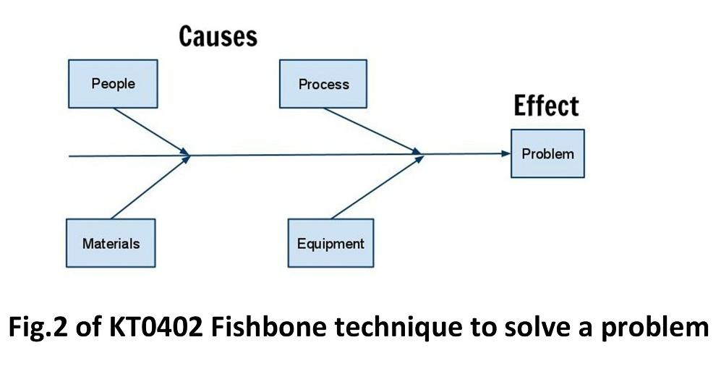

Number | Questions and Answer | Marks
1 | Use the diagram above to collect data and analyse it from a service delivered or a manufacturing process which might have gone wrong.  Learner Own answer: Answer must address the cause and effects of either the service delivery or a manufacturing process covered in the diagram above. (10 Marks)
Total |  | 10

2.1.4 Make recommendation for process improvements based on the analysis
2.1.4 Constructive Respond (Cognitive Category – Medium Order = 10 and High Order = 5)
Allocate 15 marks for number 1
Use discretion to allocate marks for any other relevant point that may be given by the student.

In order to improve a process, data must be collected, interpreted and analysed. Study the diagram below and discuss the 13 steps of problem solving methodology and make recommendation on the process improvement.
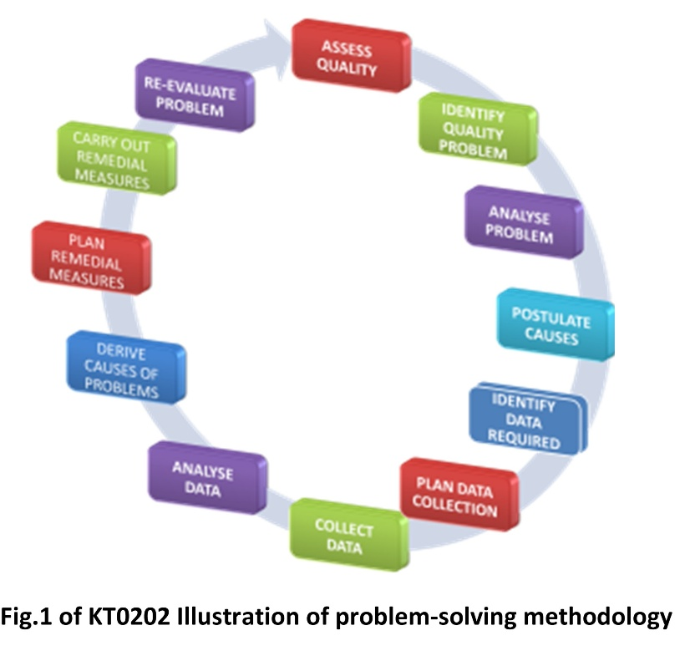

Number | Question and Answer | Marks
1 | Step 1. Assess Quality of Service - the process of assessing quality of service is often aimed at improving customer satisfaction and this will make the customer to be loyal to the brand as well as to give full support.  Step 2. Identify Problem – a quality problem is said to occur if there is a quality gap or deficit (shortfall in quality) based on the outcome results compared to the standard set.  Step 3. Analyze Problem - at this step a theoretical analysis of the factors that may contribute to the occurrence is performed. Factors may include input, processes, the environment and organization of the system as a whole.  Step 4. Postulate Causes - tools such as relations diagram (Bubble chart) and Ishikawa Herring Bone chart may be used to demonstrate and clarify cause and effect.  Step 5. Identify data required and how to obtain them - theoretical postulates put forward at the previous step need to be proven by a study of actual happenings. This would require the collection of relevant data and to do this, questions of what data, where to obtain them and how must be answered.  Step 6. Plan Data Collection - at this stage it is necessary to know whether data required already exists or new data need to be collected.  Step 7. Collect Data - this step is the actual activity of data gathering and collation (put together). Data collection in quality control may take a process of interviewing employees, surveys, questionnaires, or reports which helps to know where the organization is going in terms of delivering quality services to the customers.  Step 8. Analyze Data - data that have been collected are tabulated, analyzed, and presented using simple statistical tools. Data analysis pertaining to quality findings should engage breaking down the information in a way that will be understandable for report purposes. On the other hand, data analysis should entail a simple presentation of the information to customers, employees, and management so that everyone is well-informed of the current findings.  Step 9. Derive Causes of Problems - the results of data analysis are interpreted to prove or disprove postulates made previously. Collected data may also reveal or suggest other possible causes. After analyzing the data, one should be able to make sense and understanding of the development of organizational quality taking place.  Step 10. Plan Corrective/Remedial Measures - strategies for Improvement need to be formulated and planned with care. Based on the causes identified above, various factors requiring correction are identified. Alternative solutions to solving the problem may be identified and shortlisted through Employee suggestion, Literature Review and Benchmarking. In the long term, research and innovation may provide better solutions.  Step 11. Carry out Remedial Measures - the most effective strategy to use in implementation of remedial measures is the use of the Shewhart PDCA cycle  Step 12. Re-evaluate the problem - collect data to determine the frequency and seriousness of the problem. This step means the continuation of the quality control activities. If the problem has not been solved the problem may require re-analysis or study. It may also mean that the remedial measures chosen were not carried out fully or they were not effective.  Step 13. Prevent the problem from recurring - if corrective actions / measures have been successful, all changes made need to be adopted and institutionalized. This usually means that the changes are incorporated into policies, the work procedures and work culture. Continuous vigilance through quality control will ensure that the problems do not recur.
Total |  | 15

Marks Allocation Grid (For use by Assessor Only)
Question | Marks | Allocated Marks
1.1.1 | 10
1.1.2 | 10
1.1.3 | 10
1.1.4 | 15
1.1.5 | 10
1.1.6 | 10
1.1.7 | 10
1.1.8 | 5
Total Question 1.1 | 80
2.1.1 | 5
2.1.2 | 10
2.1.3 | 10
2.1.4 | 15
Total Question 2.1 | 40

Assessor Details
Assessor Name and Surname
Registration Number
Signature
Date

Moderator Details
Moderator Name and Surname
Registration Number
Signature
Date

