**Digital ecosystems – unpacking the evolution of business schools**

# Abstract

Business schools have witnessed a steady decline in their quest for global relevance. The diminishing returns from business schools have been highly publicized. The future of business schools is arguably murky, unless rapid disruption and innovation help to equip their graduates with market -ready skills. Therefore, this study argues for the need for business schools to innovate.

Despite this advertised decline, a master's in business administration remains a sought-after qualification, globally, delivering skills and workplace promotional prospects. The business schools landscape is status orientated with a few accreditation bodies guiding global standards. Curriculum contemporizing and diversification for optimal teaching and research is key to preparing future business leaders. With the onset of digital, business schools are always monitoring, adjusting and redesigning teaching portfolios. Academic skills, supply and demand together with student skills readiness, infrastructure readiness and business schools process maturity are key considerations for success. Systems thinking provides an inclusive and comprehensive view of business schools portfolio.  Big data, analytics and Artificial Intelligence are also key contemporary tools that can provide insights into business schools operations and evolution. This research adopts systems thinking to define all aspects of business schools operation, infuses AI based global searches, extracting time series based big data sets, and adopts AI to further analysis and develop a digital engine for business schools operations

# Introduction

Business schools have increasingly become the essential pillars of modern higher education inclusive of their critical role in fostering managerial competence, emanating from their offerings such as Postgraduate Diploma in Business Administration (PGDip), Master’s in Business Administration (MBA), or Doctorate in Business Administration (DBA) (Schrage et al., 2025). This in turn explains the present proliferation of business schools (Liuzzo & Tsai, 2025). Yet, despite their present widespread proliferation, business schools are under on-going scrutiny which is not only concentrated around particular aspects such as business schools' operations and teaching, but also around aspects such as personal legitimacy, academic legitimacy and societal legitimacy (Schlegelmilch et al., 2025). Personal legitimacy focuses on teaching and learning, and the ability of business schools to deliver towards individualistic student-centric needs. Academic legitimacy is concerned with research, and the propensity of business schools to leverage between relevance and rigor. Societal legitimacy evaluates the societal role and influence of business schools, coupled together with the principles and values that business schools uphold (Schlegelmilch et al., 2025).

Recently, there has been compounding interest to refine the curricula of MBA towards coming to par with the evolutionary manner of the business pedagogy, worldwide, as well as for maintaining competitive relevance (Laasch et al., 2023). Conventional MBA programs have been frequently lamented at, for their oftentimes status-oriented focus, rigidity in terms of structure, and minimal focus on multisectoral integration, pragmatic learning, and soft skills development (Weybrecht, 2022). Additionally, the majority of business schools research is focused on topics that are easily and frequently publishable, in comparison to those topics that are valuable to stakeholders, thus igniting concerns about the actual value that these research activities bring to business schools, let alone to the world of practice at large (Kohli & Haenlein, 2021). Further, accrediting bodies for example, Association to Advance Collegiate Schools of Business (AACSB) have directed increasing focus on the need for business schools to embed and integrate the competencies that have a strong affiliation towards research trends such as information technology, digital transformation, sustainable development, globalization, and environmental and social governance (ESG) within their curricula (Schrage et al., 2025). This therefore means that curriculum contemporizing and diversification for optimal teaching and research must therefore be central to the strategy of business schools, towards preparing future business leaders, and overall, the optimal fulfilment of the role and mandate of business schools (Thind & Yakavenka, 2023). Emanating from the on-going scrutiny surrounding business schools regarding their operations, teaching, and legitimacy, there is a greater need for business schools to continuously monitor and be knowledgeable about evolutionary trends, vis-à-vis global best practices (Sziegat, 2021). Further, there is need for business schools to constantly endeavour to leverage and embed real-time data-driven insights emanating from global best practices together with their business strategies towards maintaining competitive relevance and rigor (Randerson, 2023).

The data driven insights must be cognisant of the diverse considerations that influence business school operations holistically. However, the present conundrum is how to consolidate collective data of all considerations accordingly in a structured manner, and unpack views, for data-driven decision making purposes, given the interlinkages between the considerations, the rapid pace at which knowledge on the business schools landscape is evolving in this present digital age, and the widespread platforms in which this information is positioned. This in turn informs the identified research gap for this study. There is therefore a need to leverage nuanced approaches such as systems thinking, together with disruptive technologies such as artificial intelligence and big data analytics for purposes of extracting the key considerations for the success of business schools, cognizant of the rapid pace at which knowledge is evolving in this digital age. This is because systems thinking provides an inclusive and comprehensive view of business schools portfolio, whereases  BDA and AI are key contemporary tools that can provide insights into business schools operations and evolution. This research study thus adopts systems thinking to define all aspects of business schools’ operation, infuses AI based global searches, extracting time series based big data sets, and adopts AI to further analyze and develop a digital engine, for business schools operations, to enable continuous reporting on latest trends in business schools. Towards this endeavor this research study postulates the following research questions (RQs):

* RQ 1: What are the aspects that must be considered towards a holistic view of business schools’ landscape
* RQ 2: Can AI and BDA be utilized towards integrating these aspects into a digital engine for business schools’ operations
* RQ 3: Can the digital engine be utilized towards unpacking views, and informing strategy regarding competitive advantage and rigor for business schools?

Accordingly, the research questions above are going to be addressed via the following research objectives (ROs):

* RO 1: To landscape the scope of business schools informed by global literature
* RO 2: To leverage systems thinking fundamentals, AI, BDA towards the development of a digital engine for business schools’ operations, cognizant of the knowledge from the landscaping of business schools
* RO 3: To utilize the developed digital engine towards unpacking views, and informing strategy regarding competitive advantage and rigor for business schools

The rest of the research study is guided by the envisaged outline below, which entails literature review, research methods, and the results (to be advised).

# Literature Review

## 2.1 Introduction to business schools

Globally, business schools vary premised on the developmental stages of each country; available knowledge and skills, including skills in demand; and pressing concerns faced by the businesses in different geographical locations, globally (Ilie et al., 2020). Regarding the comprehension of business trajectory particularly in emerging markets, global literature continues to propel the prevalent Global North’s perspective on the development of business schools (Hamann et al., 2020). This deficiency of diversity, and neglect of the Global South perspective has resulted in the systematic underrepresentation of the Global South scholars, and the reinforcement of a skewed hierarchy, pertaining to the dissemination of peer-reviewed knowledge (Bol et al., 2023). This in turn has limited the possibilities of scholarly business and management research publications from the Global South towards offering innovative insights to the field (Demeter, 2020). Regardless, a holistic understanding of the evolution of business is essential (Málovics et al., 2025).

### 2.2.1 An understanding of the development of business schools – a global north lens

The formation of business schools can be categorized into numerous eras, as summarized in table 1 (Ilie et al., 2020):

Table 1: The categorisation of the formation of business schools’ era (Ilie et al., 2020)

|  |  |  |
| --- | --- | --- |
| **Item** | Era |  |
| **1** | 1750s – 1940s | * Business schools were founded either by the business community, universities, and governments. * The creation of the Master of Business Administration (MBA) as the principal professional degree, and the launch of the AACSB as the agglutinating body. |
| **2** | 1945 – 1960s | * At the end of World War 2, business schools advocated for the adoption of a scientific paradigm in their teaching and research. This led to the diffusion of United States of America’s Business School model. |
| **3** | 1960s – 2000s | * National and regional perspectives introduced to the business education, and the global expansion of business education occurred. |
| **4** | 2000s – 2020 | * The internationalization and globalization of business schools, as well as the accreditations, rankings, and standardization of BS. |

There is a concurrence by academics in tracing the birth of business schools to the formation of national systems of higher business education in the late 19th century and, the early 20th century. The first one was the French *É*cole Superi*é*ure de Commerce, in Paris, 1819, encouraged by the business community and Paris Chamber of Commerce, in response to the desire to increase business competitiveness in turbulent times (Passant, 2024). The second one was Wharton School of Finance and Economy, 1881, United States of America, which contrary to the French school, was formed attached to a tertiary education institution, University of Pennsylvania (Ilie et al., 2020). Regardless, the mainstream account of business schools neglected the formation of the Portuguese Aula do Com*é*rcio or School of Commerce in 1759, by the government’s Board of Trade to increase the skills of businesspeople, merchants, or accountants, and thus providing an example to other government-sponsored schools of commerce, such as Vienna, Hamburg, Saint Petersburg, Barcelona and Cadiz. These 3 different business schools’ formation models (business-led, university-led, or government-led), effectively diffused into higher business education frameworks in industrialized nations. While most European schools in Belgium, France, Germany and Italy were founded as stand-alone institutions of higher education, closely inclined to the types of training needed by firms and chambers of commerce, the British and American counterparts that were formed decades later, had an attachment to universities. During this era, business school pedagogy was provided via these newly formed institutions, to address the gap faced by conventional universities, regarding management formation (Kaplan, 2018). Crucial to this era, was formation of Master of Business Education by Harvard Business School, 1908 (a program which evolved into the flagship of business schools), and American Association of Collegiate Schools of Business (AACSB), 1916 (Smith et al., 2017).

The second era, “Americanization era” was characterized by the mandating of business schools to teach management utilizing a more scientific approach (Kaplan, 2018). This era was characterized by a paradigm of well-known, well-branded institutions, supported by large endowments and corporate donors, with valuable positions among international rankings and accreditation agencies, high quality research output cited in high-ranking journals, selective procedures for admissions, and utilization of the case study method as the principal teaching resource (Harvey et al., 2024). A turning point in time was the questioning of business school foundations, criticizing that teaching was chiefly “from field experience rather than theory—thus, business education was considered akin to learning a trade, rather than a true academic discipline” (Málovics et al., 2025). There was an advocacy for “more research and minimal consulting work by faculty, improved regulation, minimal case studies, more theory and analysis, and more teaching of ethics” (Harvey et al., 2024). However, there are other equally important factors that led to this era, such as the diffusion of business education to propel capitalism after World War 2, and the push from other relevant actors, such as the Ford and the Carnegie Foundations, which are easily set aside when addressing the evolution of management education (Ilie et al., 2020). Business schools post-World War 2 were thus criticized for lacking academic rigor, and for their similarity to vocational institutions. However, support from organizations such as Ford and Carnegie Foundation culminated in an advocacy for academic legitimacy. However, this transition was critiqued for moving business schools away from relevancy, and this was argued by the lack of real-world management. The MBA particularly would go on to become the hallmark for business education, however, this did not translate to greater career success (Málovics et al., 2025). The graduates in this program were ridiculed for being too analytical whilst lacking ethical grounding, sound leadership skills and interpersonal skills (Rhodes & Pullen, 2023). The market-driven ranking pressures culminated towards the prioritization of university rankings, and customer satisfaction. This was an approach ridiculed for its consumer-centric practices and neglect of the curricula. In this continued evolution, business schools were critiqued for promoting business practices which lacked morality and social accountability, with its focus on short-term gains (Málovics et al., 2025). This focus was a symptom of the transitions of business schools to serving economic needs through its production of knowledge workers (Vítečková & Houdek, 2025). Furthermore, business schools started to struggle for legitimation, depicting a phenomenon of reduced demand for business school graduates. Conventionally, the career aspects of graduates from business schools culminated in careers in business consulting, however, the emergence of workplace training in basic business knowledge was argued to be a far more efficient curriculum than business schools. These training programs took weeks to train workers on the concepts which business schools took two years to teach (Örtenblad & Koris, 2022).

After the era of the convergence towards a standardized business school paradigm, came the third era whereby regional and national visions were introduced to the systems of business education and the further global expansion of business schools pedagogy across the globe (Kaplan, 2018). Finally, a fourth period is suggested starting in the year 2000, in which internationalization and globalization, accreditations, and rankings have delimited the quality standards and timeliness of business schools globally (Ilie et al., 2020). Again, these studies have neglected the endeavors from the Global South to improve business education, such as the creation of the Asian Forum on Business Education (AFBE) which intends to recognize and standardize business schools within that region (Merrill, 2020).

In this quest for legitimation, business schools have been forced to adapt, and the next section will be a brief discussion in to the programmes offered by business schools and a brief depiction of the debates surrounding this adaptation.

## 2.2 Programs offered by Business Schools

Business schools are described as adaptive institutions that offer an extensive array of programs aimed at fostering leadership competencies, managerial competencies, entrepreneurial skills, and analytical skills, which are essential for market-ready proficiency (Kaplan, 2018). These programs span different academic levels and areas of specialization, including short learning, undergraduate, and postgraduate programs, with their curriculum meticulously crafted to ensure that graduates possess adequate market skills (Roy & Parsad, 2018). These diverse programs offered by business schools, include: Executive Education and Certificate Programs, Undergraduate degree programs, Postgraduate Diploma (PGDip), Master’s degree inclusive of Master of Business Administration (MBA), and Doctoral Programs (Allen & Simpson, 2019; Dey, 2024; Jandrić & Loretto, 2021).

Executive Education and Certificate Programs are usually modular or short-term programs, customized for middle- to senior-management working professionals, with focus on knowledge domains such as Leadership and Management, Strategic Thinking, Digital Transformation, Financial Modeling, Project Management, and Executive Coaching (Dey, 2024). These programs are offered either as Certificate Programs, Postgraduate Diploma in Business Management (PGDip), or Professional Development Courses (Jandrić & Loretto, 2021).The undergraduate programs offer fundamental knowledge in the business domain, and are rooted in knowledge areas such as Finance, Accounting, Management, Marketing, Commercial Law, Operations, Economics and Econometrics, and Statistics. These undergraduate programs usually culminate towards a bachelor’s degree, with examples such as Bachelor of Business Administration (BBA), Bachelor of Commerce (BCom), Bachelor of Management Studies (BMS), Bachelor of Science in Business (BS or BSc), Bachelor of Accounting or Finance, and Dual-degree programs, for example Bachelor of Business Administration and Bachelor or Law joint degree, or Bachelor of Commerce and Computer Science joint degree (Allen & Simpson, 2019; Dey, 2024).

Business schools also offer postgraduate programs, with the Master of Business Administration (MBA) degree being one of those postgraduate programs which has since become the well sought after program, towards the training for leadership and general management skills and techniques (D’Alessio et al., 2019). MBA programs are offered by business schools, either on a part-time or full-time basis, and in the form of Executive MBA (EMBA), Global MBA, and hybrid or online MBA (Hatt & Davidson, 2022). Amidst the constant evolutionary landscape of business pedagogy, international MBA programs have increasingly gained prominence, thus providing an extensive and globally conducive environment that is ideal for students from diverse backgrounds (Schrage et al., 2025). These programs aim to equip students with the knowledge and competencies needed to navigate the complexities of the global business world (Lu, 2022). Central to most MBA curricula are accounting and financial reporting modules, essential for cultivating financial insight and strategic decision-making skills crucial for future managers (Busso & Perri Shkurti, 2025). Also part of foundational (or core) courses in the MBA curricula are modules such as Healthcare Management, Supply Chain, Strategic Management, Operations, Marketing, Human Resources, Technology Management, and Entrepreneurship. Furthermore, some of the modules are offered as elective modules for purposes of allowing students to customize their MBA experience. These elective modules are usually taken after students complete their core modules (Roy & Parsad, 2018). Examples of elective courses include Healthcare Management, Energy, Data Analytics, Digital Business, Sustainability of Artificial Intelligence. A minor dissertation report, or a Capestone project report for some business schools, which is publishable in a peer-reviewed publication is also taken as part of the MBA curricula, with the overall result being a weighted average of the minor dissertation component together with the combination of core and elective modules taken, during the entire course of their MBA. Business schools also offer Specialised Master’s programs, which are heavily focused on knowledge expertise areas such as specialised Master’s programs in Marketing, Finance, Supply Chain Management, Business Analytics, Accounting, Human Resource Management, and Entrepreneurship and Innovation (REF). In the ever-evolving landscape of business education, International MBA programs have gained popularity, offering expansive and globally oriented environment for students from diverse backgrounds. These programs aim to equip students with the knowledge and competencies needed to navigate the complexities of the global business world. Central to most MBA curricula are accounting and financial reporting modules, essential for cultivating financial insight and strategic decision-making skills crucial for future managers. Business schools also offer international and cross-disciplinary programs in the form of dual degrees (for example MBA and Engineering), exchange programs and study abroad such as the Erasmus+ which allows student exchanges between universities, Business and sustainability or ESG-focused programs, as well as global EMBAs, with business school campuses in different geographical locations across the globe (REF).

Business schools also offer doctoral programs in the form of Doctor of Philosophy (PhD or DPhil) and Doctor of Business Administration (DBA). Whilst the PhD in Business Administration is offered for research and academic purposes with specializations such as Finance, Economics, Accounting, Marketing, Strategic Management, Organizational Behavior, and Information Systems; the Doctor of Business Administration (DBA) is usually aimed at business executives with a practice-oriented focus. Other business schools offer the Doctor of Philosophy with a specialization in Digital Transformation.

In recent years, there has been growing interest in refining Master of Business Administration (MBA) curricula to meet the evolving demands of business education globally ([Laasch et al., 2023](https://www.sciencedirect.com/science/article/pii/S1472811725000874" \l "bib38)). Traditional MBA programs have often been criticized for their rigid structures and insufficient emphasis on multidisciplinary integration, practical learning, and the development of soft skills ([Datar et al., 2010](https://www.sciencedirect.com/science/article/pii/S1472811725000874" \l "bib11), [Datar et al., 2010](https://www.sciencedirect.com/science/article/pii/S1472811725000874" \l "bib12); [Mintzberg, 2004](https://www.sciencedirect.com/science/article/pii/S1472811725000874" \l "bib45)). Accrediting bodies such as the **Association to Advance Collegiate Schools of Business (**AACSB) have increasingly emphasized the need for business schools to integrate competencies related to globalization, information technology, corporate social responsibility, and sustainable development into their curricula ([Navarro, 2008](https://www.sciencedirect.com/science/article/pii/S1472811725000874" \l "bib48)). Despite these global shifts, many MBA programs continue to rely on conventional pedagogical approaches that do not fully leverage adult learning theories such as andragogy and self-directed learning to enhance student engagement and practical application of knowledge.

Andragogy, first conceptualized by [Knowles (1977)](https://www.sciencedirect.com/science/article/pii/S1472811725000874" \l "bib33), focuses on the specific needs of adult learners, emphasizing self-directed learning, practical activities, and the application of knowledge in real-world settings ([Knowles et al., 2011](https://www.sciencedirect.com/science/article/pii/S1472811725000874" \l "bib35)). This framework is particularly relevant in the context of MBA education, where students are typically mid-career professionals seeking to develop leadership capabilities and decision-making skills ([Jeanes, 2021](https://www.sciencedirect.com/science/article/pii/S1472811725000874" \l "bib29)). Global trends in business education increasingly reflect a shift toward learner-centered approaches, incorporating active learning strategies such as case-based teaching, industry collaborations, and competency-based assessments ([Merriam & Bierema, 2013](https://www.sciencedirect.com/science/article/pii/S1472811725000874" \l "bib44)). However, there remains a gap in the literature regarding how these elements can be systematically embedded into MBA program, ensuring that students not only acquire technical expertise but also develop autonomy and lifelong learning skills.

Self-directed learning (SDL) has been widely recognized as a crucial component of adult education, fostering autonomy, problem-solving abilities, and critical thinking ([Torrisi-Steele & Drew, 2013](https://www.sciencedirect.com/science/article/pii/S1472811725000874" \l "bib69)). While SDL is increasingly integrated into business education worldwide, there is limited research on its structured implementation within MBA curricula. Developing a clear framework for embedding SDL into coursework—through structured activities, guidance, and assessment methods—remains an area that requires further exploration. A systematic approach to SDL integration ensures that students take ownership of their learning, set personal development goals, and engage meaningfully in professional growth, aligning with the broader objectives of modern business education ([Beddewela et al., 2017](https://www.sciencedirect.com/science/article/pii/S1472811725000874" \l "bib6)).

Moreover, sustainability is becoming a pillar of MBA education, with leading institutions pioneering this shift. Leading business schools, from INSEAD in Europe to the Yale School of Management in the United States, are no longer offering sustainability simply as an elective but are embedding it across their core curricula and, in this manner, signaling a clear change in the priorities of responsible management education ([INSEAD, 2023](https://www.sciencedirect.com/science/article/pii/S1472811725000874" \l "bib28); [Yale School of Management, 2025](https://www.sciencedirect.com/science/article/pii/S1472811725000874" \l "bib75)).

While these global leaders set a clear trend, the application of their models in emerging economies such as Vietnam remains underexplored. Vietnam's economic transformation since the 1990s has spurred demand for business leaders equipped with both technical expertise and social responsibility ([Vietnam News, 2024](https://www.sciencedirect.com/science/article/pii/S1472811725000874" \l "bib73)). However, the country's business education system has traditionally emphasized theoretical instruction over applied learning, leading to a need for reforms that incorporate andragogical principles into MBA programs. Existing studies have examined the relevance of andragogy and SDL in business education, yet few have specifically explored their integration within Vietnam's MBA curricula and their impact on assurance of learning processes.

Let me know if you'd like journal references, rankings, or examples from top global or African business schools.

|  |  |  |
| --- | --- | --- |
| Programme | Purpose | Debates |
|  |  |  |

* Short learning programs, PGDips, MBA, Executive MBA, DPhil
* Unpack more on MBAs specialisation – i.e. Digital Healthcare, MBA in Supply Chain Management lens etc.
* Research
* Online and in person

2.3 **Operational models for business schools**

What makes a business function? Research, academic staff profile, calibre of students attracted, selection criteria, curriculum development, executions, collaboration with industry such as Silicon Valley, funding attracted, sponsors.

**2.4. International Accreditation**

Accreditation has a rich history entrenched in the pursuit of legitimization. Education is a business, and with all businesses competition is rife, and with the prevalence of greed and opportunism, which can plague the market with poor standards. This warrants a regulatory authority that both standardises and accredits these institutions to ensure that the knowledge taught in these institutions is of a suitable standard. The approach to standardize and accredit their institutions allowed for the institutions of higher learning to achieve standardisation, however, this standardisation was perceived through a western lens and as such was highly problematized. In the scholarly debates when it comes to the negation of alternative ways of knowing, in the standardisation criterion, the diverse alternative metrics could be negated in the analysis and rank institutions that are western. Pfeffer and Fong (2002) argue that the accreditation policies emphasize scholarly publications and research output instead of pedagogical excellence. This is argued to lead to graduates who are strong analytically but lack in social, ethical, leadership, and managerial competence. In addition, Western epistemologies emphasised by these institutions negates the diverse knowledge systems, through its promotion of intellectual conformity.Bonavantura Dos Santos (2016), and his conjecture of epistemic violence argued that hegemonic power contributed to knowledge monopoly and the deligitimisation of knowledge of the subjugated. When we apply such logic to the metrics of international accreditation, it is important to incorporate a lens of cultural relativism. This is something discussed above as a key metric

1. **Systems thinking**

Systems thinking for utilization in the consideration of key aspects behind the functioning of business schools

**2.5 Digital, Big Data, and AI**

The role of AI, big data, and digital tech for knowledge gathering/extraction of key considerations behind the business schools. Traditional systems, such as student information systems (SIS) and learner management systems (LMS), capture a vast amount of data, such as course enrollment, demographic data, discussion posts, and more. This vast collection of data can be used for analytical research and dataset gathering and extraction to help optimise AI performance and facilitate business school administrative and pedagogical decision-making.

The elephant in the room is that of the learner bred in the age of AI. The phenomenon of cognitive-offloading, as described by Risko and Gilbert (2016), is a phenomenon in which the overreliance on technology technology leads to a reduction in cognition and critical thinking skills. This is worrisome, and this is similarly argued to worsen due to the reduced overreliance on text-generation large language models (Essien, Bukoye, O’Dea and Kremantzis, 2024). This over-reliance on LLMs could pollute the datasets with hallucinated data, data that could lead to pseudo-scientific conclusions. For example, discussion forums, as discussed above, could be populated by large language models, leading to inaccurate accounts of student opinions.

**Conclusion**

The business school, is highly problematised in the academic literature and is romanticized as an institution that assures career success, but contemporary studies have revealed that business schools need to evolve, and adapt, because their curriculum has been misaligned and has not yielded a fruitful return on investment. The myth of assured success post-graduation has been debunked by CEOs who did not hold an MBA, and institutional training has shown to streamline business school education into weeks, whilst alternate specializations e specialisations and disciplines have offered a far more discipline focused specialization. Digital transformation

**Reference List**

Risko, E.F. and Gilbert, S.J., 2016. Cognitive offloading. *Trends in cognitive sciences*, *20*(9), pp.676-688.

Aniekan Essien, Oyegoke Teslim Bukoye, Xianghan O’Dea & Marios

Kremantzis (2024) The influence of AI text generators on critical thinking skills in UK business

schools, Studies in Higher Education, 49:5, 865-882, DOI: 10.1080/03075079.2024.2316881

Pfeffer, J., & Fong, C. T. (2002). The End of Business Schools? Less Success than Meets the Eye. Academy of Management Learning & Education, 1, 1560-1582.

2.6 Theoretical Framework

# Methods

The study uses a grounded text mining approach to extract and thematically classify text into themes, utilising a multi-layered approach that filters web-scraped data from pages of interest, which cover the study's area of interest. This study's focus is to extract program information, research centers, program distributions and faculty disciplines, and top MBA specializations from the top 10 universities in each continent.The motivation for this particular approach is to benchmark the performance of these institutions and create a measurable engine that can help classify the quality of business schools through juxtaposition.

1. Limitations of this approach:
2. The study uses a regex filtering approach, which entails keyword filtering, an aspect complemented by its natural language processing, which helps to classify the data into thematic areas. The limitation is that this can lead to filtered data based on an array of predefined aspects such as module name and qualification type. The limitation is that the the filtering is based on this selected criterion, and if there areas which exist outside of the dictionary, then the filtering may fail to capture potential areas of interest.

The ideal approach would be to integrate large language models due to their capacity to interpret context from large textual data.

Furthermore, the study is confined by the protections that are present on many websites, which may make the websites difficult to scrape. Due to this the pool of businesss schools queried may vary due to the

* web scaping tool and NLP engine to classify data and build a big data database.
* Comparative analysis versus South Africa, descriptive analysis
* Statistical analysis, clustering, new trends, skills, research, accreditation, courses analysis and new trends

Results:

Figure 1.

The distribution of

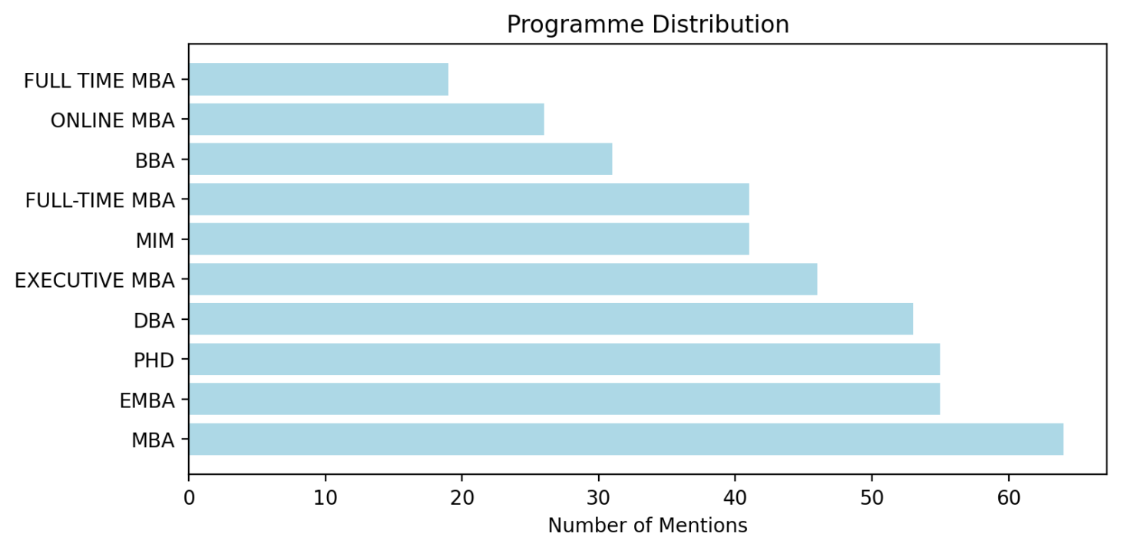

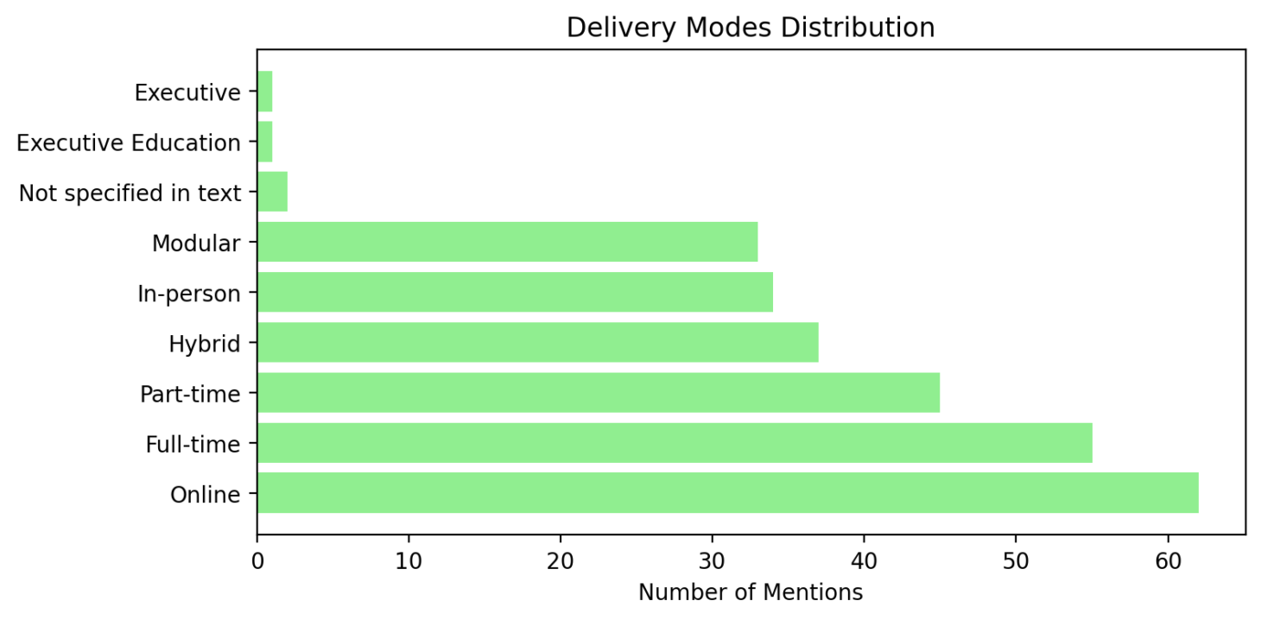Figure 3

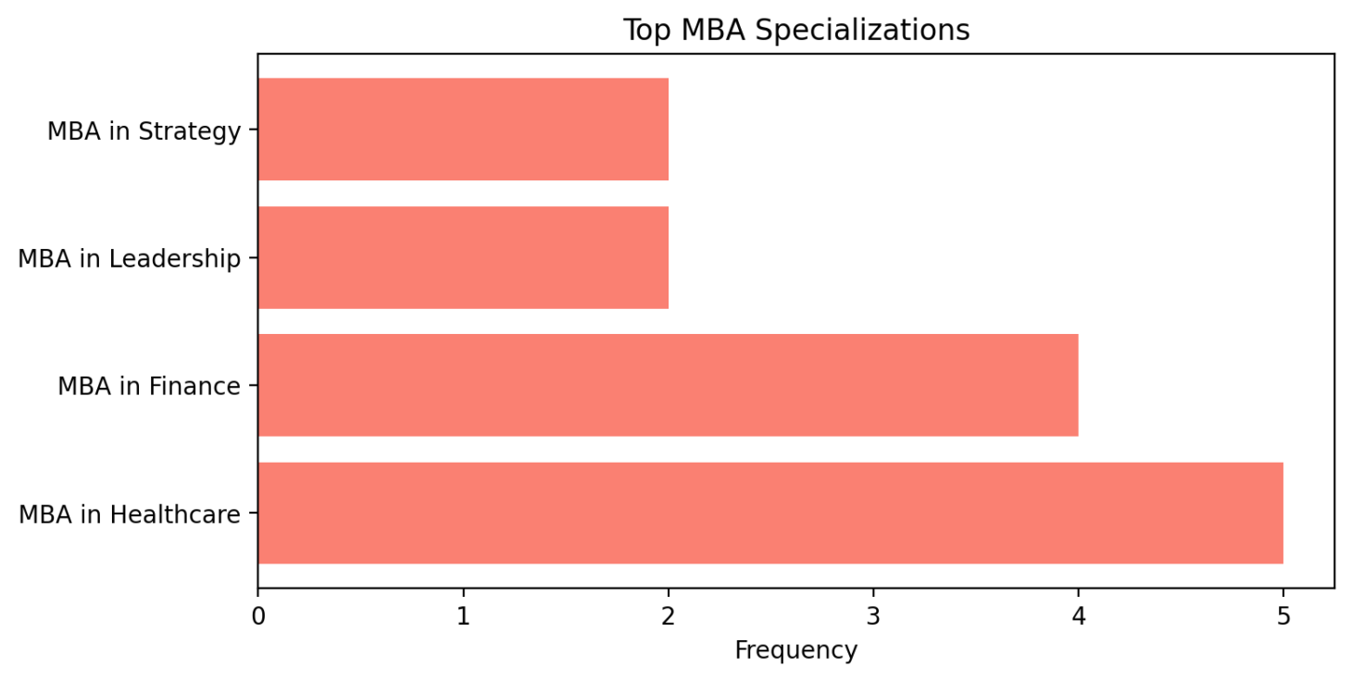

Figure 4

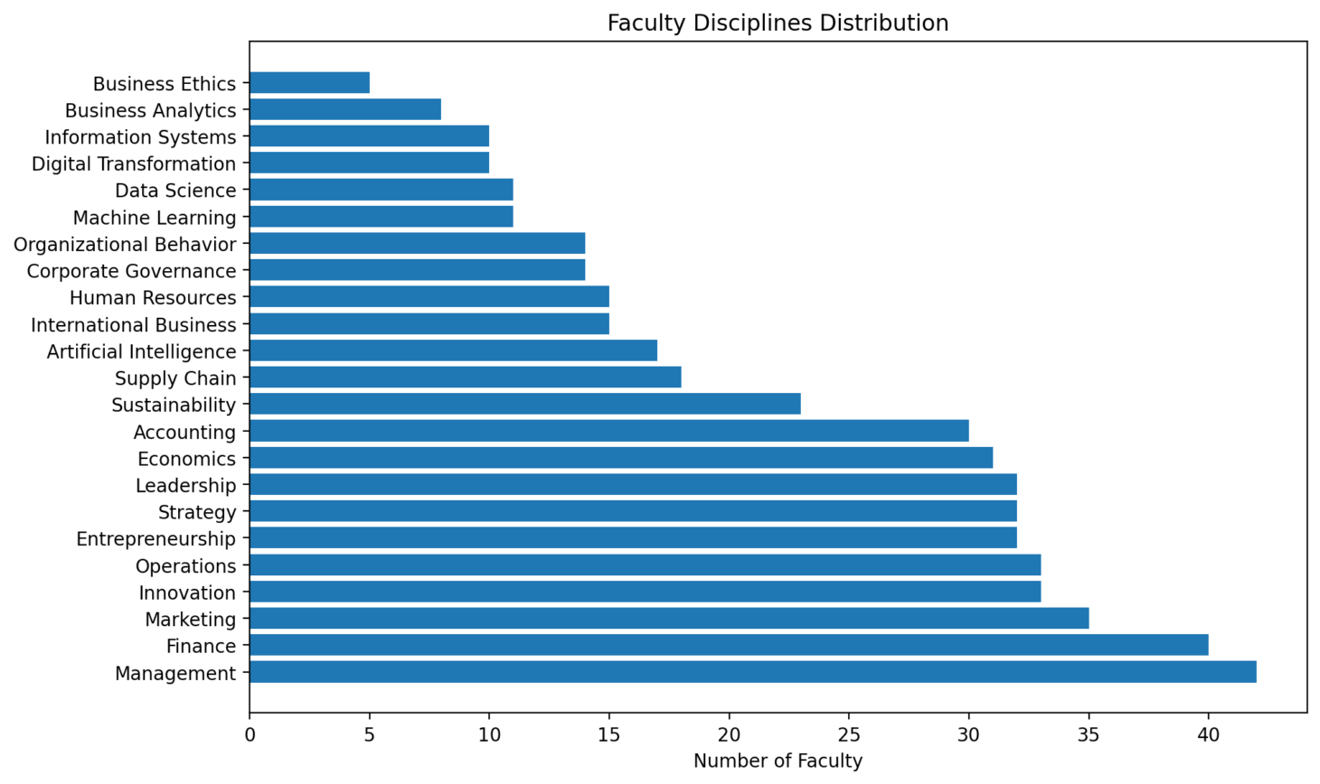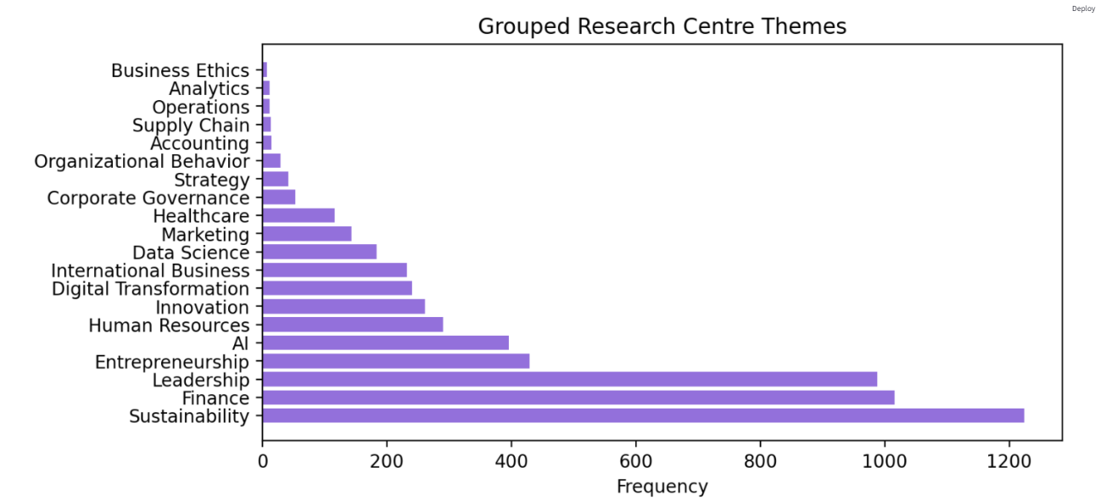

Discussion

From the business schools

In the future

* Development of an annual report on business schools with a business intelligence dashboard
* Develop KPIs linked to SDGs, extract annual reports

# References

Allen, D., & Simpson, C. (2019). Inquiry Into Graduate Attributes: Reviewing the Formal and Informal Management Curricula. In *Journal of Management Education* (Vol. 43, Issue 4, pp. 330–358). SAGE Publications Inc. https://doi.org/10.1177/1052562919839736

Bol, J. A., Sheffel, A., Zia, N., & Meghani, A. (2023). How to address the geographical bias in academic publishing. In *BMJ Global Health* (Vol. 8, Issue 12). BMJ Publishing Group. https://doi.org/10.1136/bmjgh-2023-013111

Busso, D., & Perri Shkurti, R. (2025). Hidden curricula in financial reporting and analysis for MBA students - is the message received? *International Journal of Management Education*, *23*(3). https://doi.org/10.1016/j.ijme.2025.101231

D’Alessio, F. A., Avolio, B. E., & Charles, V. (2019). Studying the impact of critical thinking on the academic performance of executive MBA students. *Thinking Skills and Creativity*, *31*, 275–283. https://doi.org/10.1016/j.tsc.2019.02.002

Demeter, M. (2020). *Academic Knowledge Production and the Global South Questioning Inequality and Under-representation*. Palgrave Macmillan Cham.

Dey, A. K. (2024). Designing and assessing an innovative and evolving MBA curriculum in a mission centric way with benchmarking and stakeholder validation. *International Journal of Management Education*, *22*(1). <https://doi.org/10.1016/j.ijme.2024.100944>

de Sousa Santos, B. (2016). Epistemologies of the South: Justice against epistemicide. Routledge <https://www.taylorfrancis.com/books/e/>9781315634876

Hamann, R., Luiz, J., Ramaboa, K., Khan, F., Dhlamini, X., & Nilsson, W. (2020). Neither Colony Nor Enclave: Calling for dialogical contextualism in management and organization studies. *Organization Theory*, *1*(1). https://doi.org/10.1177/2631787719879705

Harvey, C., Gibson, A., Maclean, M., & Mueller, F. (2024). Philanthropy and the sustaining of global elite university domination. *Organization*, *31*(3), 433–457. https://doi.org/10.1177/13505084221115842

Hatt, L., & Davidson, J. (2022). “You what?!” – The impact of a relational approach to launching an executive MBA in the midst of a global pandemic. *Project Leadership and Society*, *3*. https://doi.org/10.1016/j.plas.2022.100045

Ilie, C., Fornes, G., Cardoza, G., & Quintana, J. C. M. (2020). Development of business schools in emerging markets: Learning through adoption and adaptation. *Sustainability (Switzerland)*, *12*(20), 1–28. https://doi.org/10.3390/su12208448

Jandrić, J., & Loretto, W. (2021). Business school space, the hidden curriculum, and the construction of student experience. *Management Learning*, *52*(3), 311–327. https://doi.org/10.1177/1350507620934068

Kaplan, A. (2018). A school is “a building that has four walls…with tomorrow inside”: Toward the reinvention of the business school. *Business Horizons*, *61*(4), 599–608. https://doi.org/10.1016/j.bushor.2018.03.010

Kohli, A. K., & Haenlein, M. (2021). Factors affecting the study of important marketing issues: Implications and recommendations. *International Journal of Research in Marketing*, *38*(1), 1–11. https://doi.org/10.1016/j.ijresmar.2020.02.009

Laasch, O., Moosmayer, D. C., & Antonacopoulou, E. P. (2023). The Interdisciplinary Responsible Management Competence Framework: An Integrative Review of Ethics, Responsibility, and Sustainability Competences. *Journal of Business Ethics*, *187*(4), 733–757. https://doi.org/10.1007/s10551-022-05261-4

Liuzzo, C., & Tsai, M. (2025). Crisis of imagination: Integrating degrowth pedagogy for sustainability innovation in business schools. *Futures*, *171*. https://doi.org/10.1016/j.futures.2025.103614

Lu, J. (2022). Data science in the business environment: Insight management for an Executive MBA. *International Journal of Management Education*, *20*(1). https://doi.org/10.1016/j.ijme.2021.100588

Málovics, G., Géring, Z. M., Bajmócy, Z., Juhász, J., Csillag, S., & Király, G. (2025). University–community engagement and sustainability change: Opportunities and constraints for business schools. *International Journal of Management Education*, *23*(3). https://doi.org/10.1016/j.ijme.2025.101228

Merrill, M. (2020). Differences in international accreditation: Kyrgyzstan and Kazakhstan. *Asian Education and Development Studies*, *9*(4), 465–478. https://doi.org/10.1108/AEDS-08-2018-0131

Örtenblad, A., & Koris, R. (2022). *Debating Business School Legitimacy - Attacking, Rocking, and Defending the Status Quo*. Palgrave Macmillan.

Passant, A. J. G. (2024). From bookkeepers to entrepreneurs: a historical perspective on the entrepreneurial diversification of a French business school over 200 years. *Management and Organizational History*, *19*(1), 1–33. https://doi.org/10.1080/17449359.2023.2233088

Randerson, K. (2023). The futures of business schools: Identity, strategies, and imagined futures for a pandemic / post-pandemic world. *Futures*, *150*. https://doi.org/10.1016/j.futures.2023.103175

Rhodes, C., & Pullen, A. (2023). The good business school. *Organization*, *30*(6), 1273–1280. https://doi.org/10.1177/13505084231189268

Roy, V., & Parsad, C. (2018). Efficacy of MBA: on the role of network effects in influencing the selection of elective courses. *International Journal of Educational Management*, *32*(1), 84–95. <https://doi.org/10.1108/IJEM-01-2017-0005>

Cummings, S., Dhewa, C., Kemboi, G. and Young, S., 2023. Doing epistemic justice in sustainable development: Applying the philosophical concept of epistemic injustice to the real world. *Sustainable Development*, *31*(3), pp.1965-1977.

Schlegelmilch, B. B., Waltenberger, M., & Teerakapibal, S. (2025). Navigating different stakeholder challenges to legitimacy in business schools: Implications from a systematic literature review. *International Journal of Management Education*, *23*(2). https://doi.org/10.1016/j.ijme.2025.101175

Schrage, B., Maheshwari, G., & Velasquez, S. (2025). Broadening the competencies of MBA students in Vietnam: Integrating andragogical approaches with sustainable development goals. *International Journal of Management Education*, *23*(3). https://doi.org/10.1016/j.ijme.2025.101217

Smith, G. E., Barnes, K. J., & Vaughan, S. (2017). Introduction to the Special Issue on Current Issues in AACSB Accreditation. In *Organization Management Journal* (Vol. 14, Issue 1, pp. 2–6). Routledge. https://doi.org/10.1080/15416518.2017.1293420

Sziegat, H. (2021). The response of German business schools to international accreditation in global competition. *Quality Assurance in Education*, *29*(2–3), 135–150. https://doi.org/10.1108/QAE-01-2020-0008

Thind, R., & Yakavenka, H. (2023). Creating culturally relevant curricula and pedagogy: Rethinking fashion business and management education in UK business schools. *International Journal of Management Education*, *21*(3). https://doi.org/10.1016/j.ijme.2023.100870

Vítečková, K., & Houdek, P. (2025). The Rise of Business Education, the ESG Revolution, and the Limited Impact on Students’ Values. *Interchange*, *56*(2), 143–157. https://doi.org/10.1007/s10780-025-09540-7

Weybrecht, G. (2022). Business schools are embracing the SDGs – But is it enough? – How business schools are reporting on their engagement in the SDGs. *International Journal of Management Education*, *20*(1). https://doi.org/10.1016/j.ijme.2021.100589